Supporting Information For:

Cyclopentadienyl Complexes of Ir(III) for Attempted C-H Bond Activation

Robert Robinson, Jr[b], Werner Kaminsky[b], and Jeremiah J. Scepaniak[a]*

[a] Prof. Jeremiah J. Scepaniak  
Department of Chemistry  
Drexel University  
32 S. 32nd St. Philadelphia, PA 19104  
jjs452@drexel.edu or jjscepaniak@outlook.com

[b] Dr. Robert Robinson Jr, Dr. Werner Kaminsky  
Department of Chemistry  
University of Washington  
Seattle, WA 98195-1700

**Table of Contents**

|  |  |
| --- | --- |
| Experimental details | S3 |
| NMR Spectra | S11 |
| IR Spectra | S33 |
| X-ray data | S35 |

**Experimental Section**

**General Procedures.** All reactions and subsequent manipulations were performed under anaerobic and anhydrous conditions under an atmosphere of argon utilizing standard Schlenk techniques or in a Vac Atmosphere HE-43-2 glovebox unless otherwise noted. Crystallizations were conducted in the glovebox freezer maintained at -20°C. Pentane, toluene, diethyl ether, tetrahydrofuran and dichloromethane were purified using a Glass Contour solvent purification system. CD2Cl2, C7D8 and C6D6 were dried over CaH2 distilled under static vacuum, freeze-pump-thawed 3 times and stored over activated 4Å molecular sieves. All other reagents were purchased from commercial suppliers and used as received. CpIr(C2H4)2,[1] [CpMe4IrCl2]2,[2] and [MeIm]AgI,[3] were prepared as previously reported. 2,6–bistertbutylpyridinium, 2,6-dimethylpyridinium, and pyridinium as the tetrakis-perfluorophenylborane salts were prepared by reaction of the appropriate freshly distilled heterocycle with HB(C6F5)4·Et2O[4] in CH2Cl2 and crystallized by layering with pentane. Similarly, 2,6–bistertbutylpyridinium, 2,6-dimethylpyridinium, and pyridinium as the chloride salts were prepared from the appropriate freshly distilled heterocycle and anhydrous ethereal HCl (1.0M) in CH2Cl2 and crystallized by layering with pentane. Glassware was dried at 160 °C overnight. NMR samples were prepared inside the glovebox unless otherwise noted. NMR data was recorded on either a Bruker AV-300, AV-500 or DRX-500 spectrometers at 22 °C unless otherwise stated. Chemical shifts are given as (*δ*) in ppm, and coupling constants (*J*) in Hz. 1H- and 13C­NMR shifts are relative to residual protio solvent signals (referenced to internal TMS (0 ppm) standard). 19F-NMR shifts are relative to external CF3COOH (-76.55 ppm) and 11B-NMR shifts are relative to external BF3·Et2O (0 ppm). IR spectra were recorded on a Bruker Tensor 27 IR spectrometer. Elemental analyses were performed by the University of Rochester Microanalytical Laboratory.

**X-ray Crystallography.** Data for all complexes were collected on a Bruker KAPPA APEX II single crystal X-ray diffractometer equipped with an APEX II CCD detector using a TRIUMPH monochromater with a Mo Kα X-ray source (α = 0.71073 Å

The crystals all compounds were mounted on a cryoloop under Paratone-N oil and all data was collected at 100(2) K using an Oxford nitrogen gas cryostream system. X-ray data for all complexes were collected utilizing frame exposures of 10 seconds. The data was integrated and scaled using SAINT,

5 SADABS

6 within the APEX27 software package by Bruker. Solution by direct methods (SHELXS, SIR97)8,9 produced a complete heavy atom phasing model consistent with the proposed structure. The structure was completed by difference Fourier synthesis with SHELXL97.

10,11Scattering factors are from Waasmair and Kirfel[5]. Hydrogen atoms were placed in geometrically idealized positions and constrained to ride on their parent atoms with C-H distances in the range 0.95-1.00 Angstrom. Isotropic thermal parameters Ueq were fixed such that they were 1.2Ueq of their parent atom Ueq for CH's and 1.5Ueq of their parent atom Ueq in case of methyl groups. All non-hydrogen atoms were refined anisotropically by full-matrix least-squares.

**Synthesis of Cp(MeIm)IrI2 (1).** This procedure is based on a reported preparation for Cp(L)IrI2; L = phosphines.[1] A 50 mL Schlenk flask was charged with CpIr(C2H2)2, (159 mg, 0.507 mmol) and iodine (199 mg, 0.785 mmol) inside the glovebox. CH2Cl2 (15 mL) was added to the flask and allowed to stir for 4 h, yielding a red slurry. (MeIm)AgI (229 mg, 0.693 mmol) was added to the slurry and stirred overnight. The resulting dark orange solution was sonicated, filtered from solids, and the remaining yellow solid washed with 3 x 10 mL CH2Cl2, combined with the other dark orange solution, and dried *in vacuo* to give **1** as a reddish orange solid. Yield: 235 mg, 0.387 mmol (76.5%). Red single crystals for X-ray analysis were grown by slow vapor diffusion of pentane into a CH2Cl2 solution at -20 oC.

1H-NMR (CD2Cl2, 500 MHz): *δ* 7.02 (s, 2H, C*H*imid); 5.54 (s, 5H, C*H*cp); 4.00 (s, 6H, N­C*H*3).

13C-NMR (CD2Cl2, 125 MHz): *δ* 144.40 (s, Ir-*C*carbene); 123.93 (s,*C*Himid); 80.18 (s, *C*Cp); 44.51 (s, N-*C*H3).

Anal. Found (calcd) **1:** C, 19.82 (19.78); H, 1.98 (2.16); N, 4.20 (4.61).

**Synthesis of Cp(MeIm)IrMe2 (2).** A 50 mL Schlenk flask was charged with **1** (306 mg, 0.503 mmol) and THF (15 mL) inside the glovebox. MeMgBr (6.0 mL, 18 mmol, 3.0 M in Et2O) was added. After stirring overnight, the resulting mixture was hydrolyzed by dropwise addition into DI water (~50 mL) and the organic layer was extracted. Three more Et2O (10 mL) extractions were taken. The combined organic extracts were dried with MgSO4, filtered, and solvent was removed under reduced pressure. The white solid was sublimed at 140° C under dynamic vacuum to yield **2** (160 mg, 0.44 mmol, 88%) as an off-white solid. Colorless single crystals for X-ray analysis were grown by slow evaporation of a pentane solution at -20 oC.

1H-NMR (CD2Cl2, 500 MHz): *δ* 6.87 (s, 2H, C*H*imid); 4.94 (s, 5H, C*H*cp); 3.70 (s, 6H, N­C*H*3); 0.56 (s, 6H, Ir-C*H*3).

13C-NMR (C6D6, 125 MHz): *δ* 161.96 (s, Ir-*C*carbene); 121.25 (s,*C*Himid); 80.89 (s, *C*Cp); 38.79 (s, N­*C*H3); -33.11 (s, Ir-*C*H3).

Elemental analysis consistent with the solid state and solution structures was elusive through multiple trials. Anal. Found (calcd) **2**: C, 38.779 (37.58); H, 5.034 (4.99); 6.981 (7.30).

**Synthesis of Cp(MeIm)Ir(Me)Cl (3).** A 20 mL vial was charged with **2** (62 mg, 0.129 mmol) and [LutH]Cl (19 mg, 0.129 mmol). CH2Cl2 (5 mL) was added, and the mixture stirred for 30 minutes, during which time CH4 effervescence was observed. The solvent was concentrated under reduced pressure to 1 mL, layered with pentane (4 ml), yielding **3** (49 mg, 0.120 mmol, 93%) as a light-yellow microcrystalline material after 48 hrs. Light-yellow single crystals for X-ray analysis were grown by slow diffusion of pentane into a CH2Cl2 solution at -20 oC.

1H-NMR (CD2Cl2, 500 MHz): *δ* 6.93 (s, 2H, C*H*imid); 5.12 (s, 5H, C*H*cp); 3.81 (s, 6H, N­C*H*3); 1.35 (s, 3H, Ir-C*H*3).

13C-NMR (C6D6, 125 MHz): *δ* 155.67 (s, Ir-*C*carbene); 122.67 (s,*C*Himid); 79.44 (s, *C*Cp); 39.38 (s, N­*C*H3); -25.54 (s, Ir-*C*H3).

Anal. Found (calcd) **3**: C, 32.41 (32.71); H, 3.70 (3.99); N, 6.71 (6.94).

**Synthesis of [Cp(MeIm)Ir(Me)CO]+** [BArF20]- **(4).** A 50 mL flask was charged with **2** (66 mg, 0.135 mmol) and [PyrH] [BArF20] (102 mg, 0.135 mmol). CH2Cl2 (5 mL) was vacuum transferred into the flask. The mixture was placed under a CO atmosphere during thawing. After 48 h, the solvent was removed under reduced pressure yielding **4** as a yellow solid (118 mg, 0.123 mmol, 91%). Colorless single crystals for X-ray analysis were grown by slow diffusion of pentane into a CH2Cl2 solution at -20 oC.

1H-NMR (CD2Cl2, 500 MHz): *δ* 7.12 (s, 2H, C*H*imid); 5.77 (s, 5H, C*H*cp); 3.69 (s, 6H, N­C*H*3); 1.18 (s, 3H, Ir-C*H*3).

13C-NMR (C6D6, 125 MHz): *δ* 165.61 (s, Ir-*C*carbene); 148.94 (d, [BArF20]- *C*-F ortho); 139.80 (d, [BArF20]- *C*-F para); 136.53 (d, [BArF20]- *C*-F meta); 133.47 (s, Ir-*CO*); 125.14 (s,*C*Himid); 124.20 (s, [BArF20]- *C* ipso); 89.52 (s, *C*Cp); 40.28 (s, N­*C*H3); -37.10 (s, Ir-*C*H3).

19F-NMR (CD2Cl2, 282 MHz): *δ* -167.60 (bt, 8F, Fmeta); -163.71 (t, 4F, Fpara); -133.21 (bs, 8F, Fortho).

11B-NMR (CD2Cl2, 160 MHz): *δ* -16.67 (s, 1B).

IR (KBr pellet) 2042 (s, νC-O).

Elemental analysis consistent with the solid state and solution structures was elusive through multiple trials. Anal. Found (calcd) **4**: C, 39.99 (37.41); H, 1.38 (1.57); N, 2.51 (2.73).

**Synthesis of CpMe4(MeIm)IrCl2 (5).** A flask was charged with [CpMe4IrCl2]22(160 mg, 0.208 mmol) [MeIm]AgI (138 mg, 0.416 mmol) and CH2Cl2 (15 mL) and stirred 18 hrs to give an orange solution with a grey precipitate. The resulting solution was filtered over a glass frit, and the solvent removed *in vacuo* to give **5** as an orange solid. Yield: 164 mg, 343 mmol, (82%). Orange single crystals for X-ray analysis were grown by slow evaporation of a CH2Cl2 solution.

1H-NMR (CD2Cl2, 500 MHz): *δ* 6.96 (s, 2H, C*H*imid); 4.77 (s, 1H, CpMe4 C*H*cp); 3.94 (s, 6H, N­C*H*3); 1.65 (s, 6H, CpMe4 C*H3*); 1.57 (s, 6H, CpMe4 C*H3*).

13C-NMR (CD2Cl2, 125 MHz): *δ* 156.16 (s, Ir-*C*carbene); 123.78 (s,*C*Himid); 95.48 (s, CpMe4 *C*-Me); 90.81 (s, CpMe4 *C*-Me); 66.98 (s, CpMe4 *C*-H); 39.30 (s, N-*C*H3); 10.94 (s, CpMe4 C-*Me*); 9.03 (s, CpMe4 C-*Me*).

Anal. Found (calcd) **5**: C, 34.62 (35.00); H, 4.17 (4.41); N, 5.73 (5.83).

**Synthesis of CpMe4(MeIm)IrMe2 (6).** A 50 mL Schlenk flask was charged with **5** (304 mg, 0.636 mmol) and diethyl ether (~15 mL). MeMgBr (6.0 mL, 19.2 mmol, 3.2 M in Et2O) was added via syringe and the mixture was stirred overnight. The resulting mixture was hydrolyzed by slow drop-wise addition of DI water (~10 mL) and the organic layer extracted. Three additional Et2O (10 mL) extractions were taken. The combined organic extracts were dried with MgSO4, filtered, and the solvent removed under reduced pressure. The off-white solid was sublimed at 140 °C under dynamic vacuum to give **6** as a white solid. Yield: 170 mg, 0.386 mmol, (61%). Colorless single crystals for X-ray analysis were grown by layering a CH2Cl2 solution with pentane at -20 oC.

1H-NMR (CD2Cl2, 500 MHz): *δ* 6.81 (s, 2H, C*H*imid); 4.30 (s, 1H, CpMe4 C*H*cp); 3.61 (s, 6H, N­C*H*3); 1.66 (s, 6H, CpMe4 C*H3*); 1.60 (s, 6H, CpMe4 C*H3*); 0.04 (s, 6H, Ir-*Me*).

13C-NMR (CD2Cl2, 125 MHz): *δ* 165.33 (s, Ir-*C*carbene); 121.13 (s,*C*Himid); 94.13 (s, CpMe4 *C*-Me); 86.86 (s, CpMe4 *C*-Me); 73.58 (s, CpMe4 *C*-H); 37.93 (s, N-*C*H3); 10.65 (s, CpMe4 C-*Me*); 8.38 (s, CpMe4 C-*Me*); -22.19 (s, Ir-Me);.

Anal. Found (calcd) **6**: C, 43.98 (43.72); H, 6.13 (6.19); 6.23 (6.37).

**Synthesis of CpMe4(MeIm)Ir(Me)Cl (7).** A 20 mL vial was charged with **6** (45 mg, 0.102 mmol) and [LutH]Cl (15 mg, 0.102 mmol). CH2Cl2 (5 mL) was added. After stirring for 30 minutes, during which time CH4 effervescence was observed, the solvent was concentrated under reduced pressure to 1 mL, layered with pentane (4 ml) and stored in the freezer for 48 h at -20 °C, yielding **7** ( 42 mg, 0.092mmol, 90%) as a light-yellow microcrystalline material. Single crystals for X-ray analysis were grown by slow diffusion of pentane into a CH2Cl2 solution of **7** at -20 oC.

1H-NMR (CD2Cl2, 500 MHz): *δ* 6.91 (s, 2H, C*H*imid); 4.42 (s, 1H, CpMe4 C*H*cp); 3.79 (s, 6H, N­C*H*3); 1.70 (s, 3H, CpMe4­C*H*3); 1.65 (s, 3H, CpMe4­C*H*3); 1.60 (s, 3H, CpMe4­C*H*3); 1.53 (s, 3H, CpMe4­C*H*3); 0.90 (s, 3H, Ir-C*H*3).

13C-NMR (CD2Cl2, 125 MHz): *δ* 160.55 (s, Ir-*C*carbene); 122.52 (s,*C*Himid); 97.92 (s, CpMe4 *C*-Me); 90.96 (s, CpMe4 *C*-Me); 89.45 (s, CpMe4 *C*-Me); 87.38 (s, CpMe4 *C*-Me); 71.01 (s, CpMe4 *C*-H); 38.66 (s, N-*C*H3); 10.77 (s, CpMe4 C-*Me*); 8.54 (s, CpMe4 C-*Me*); -16.73 (s, Ir-Me).

Anal. Found (calcd) **7**: C, 39.49 (39.16); H, 5.23 (5.20); 5.95 (6.09).

**Synthesis of [CpMe4(MeIm)Ir(Me)CO]+**[BArF20]- **(8).** A 50 mL bomb flask was charged with **6** (75 mg, 0.170 mmol), [PyrH]B(C6F5)4 (162 mg, 0.170 mmol). CH2Cl2 (5 mL) was vacuum transferred into the flask and mixture was placed under a CO atmosphere during thawing. After 48 h, the solvent was removed under reduced pressure to give **6** as a light-yellow solid (149 mg, 0.158 mmol, 93 %). Colorless single crystals for X-ray analysis were grown by slow diffusion of pentane into a CH2Cl2 solution of **8** at -20 oC.

1H-NMR (CD2Cl2, 500 MHz): *δ* 7.11 (s, 2H, C*H*imid); 5.07 (s, 1H, CpMe4 C-*H*cp); 3.68 (s, 6H, N­C*H*3); 2.07 (s, 3H, CpMe4­C*H*3); 2.00 (s, 3H, CpMe4­C*H*3); 1.90 (s, 6H, CpMe4­C*H*3); 0.84 (s, 3H, Ir-C*H*3).

13C-NMR (CD2Cl2, 125 MHz): *δ* 168.42 (s, Ir-*C*carbene);148.67 (d, [BArF20]- *C*-F ortho); 139.61(d, [BArF20]- *C*-F para); 139.46 (s, Ir-*CO*); 136.23 (d, [BArF20]- *C*-F meta); 125.01(s, *C*Himid); 124.64 (s, [BArF20]- *C* ipso); 107.09 (s, CpMe4 *C*-Me) ; 106.75 (s, CpMe4 *C*-Me); 102.31 (s, CpMe4 *C*-Me); 100.06 (s, CpMe4 *C*-Me); 80.41 (s, CpMe4 *C*-H); 39.55 (s, N-*C*H3); 10.87 (s, CpMe4 C-*Me*) ; 10.54 (s, CpMe4 C-*Me*); 9.68 (s, CpMe4 C-*Me*); 9.41 (s, CpMe4 C-*Me*); -27.77 (s, Ir-*Me*).

19F-NMR (CD2Cl2, 282 MHz): *δ* -167.59 (s, 8F, Fmeta); -163.74 (s, 4F, Fpara); -133.12 (s, 8F, Fortho).

11B-NMR (CD2Cl2, 160 MHz): *δ* -16.66 (s, 1B).

IR (KBr pellet) 2028 (s, νC-O).

Anal. Found (calcd) **8**: C, 42.38 (42.46); H, 2.007 (2.14); 2.338 (2.48).

**Typical procedure for J-Young tube formation of mono-methyl species from 2.**

A J-young NMR tube is charged with a sample of **2** (0.010 g, 0.026 mmol) and pyridinium BArF20 (0.020 g, 0.026 mmol) (alternatively the 2,6-dimethylpyridinium or 2,6-di*tert*butylpyridinium salt). Deuterated solvent is added to the NMR tube by static vacuum transfer on a Schlenk line at -195.8 °C, the tube sealed and subsequently thawed and brought to ambient temperature before collection of spectra.

**Typical procedure for J-Young tube formation of mono-methyl species from 6.**

A J-young NMR tube is charged with a sample of **6** (0.010 g, 0.023 mmol) and an equivalent of pyridinium BArF20 (0.018 g, 0.023 mmol) (alternatively the 2,6-dimethylpyridinium or 2,6-di*tert*butylpyridinium salt). Deuterated solvent is added to the NMR tube by static vacuum transfer on a Schlenk line at -195.8 °C, the tube sealed and subsequently thawed and brought to ambient temperature before collection of spectra.

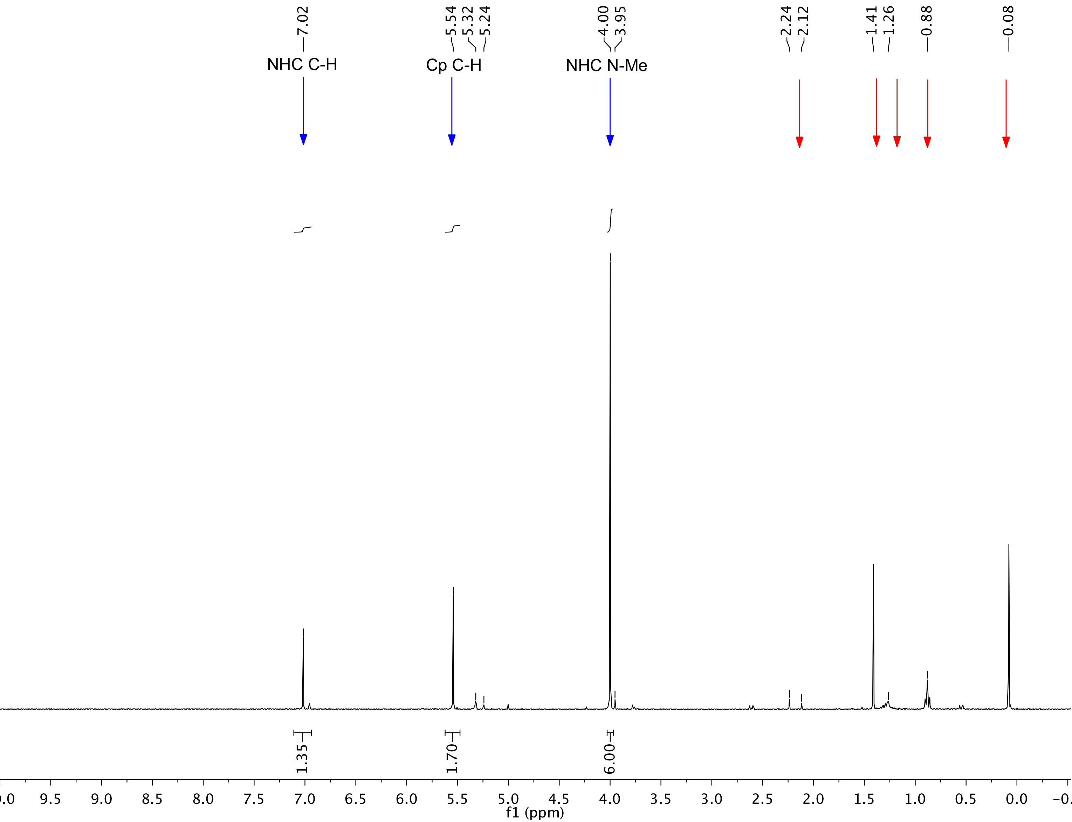

**Figure S1.** 1H NMR spectrum of **1** in CD2Cl2. Blue arrows denote **1**. Red arrows denote residual acetone (2.12 ppm), and hexanes (0.89, 1.26 ppm) from the glovebox atmosphere and silicone grease (0.08 ppm). The weak resonances at 2.24 ppm and 1.41 ppm are inconsistent with any solvents present in the glove box or utilized in the synthesis of **1**.

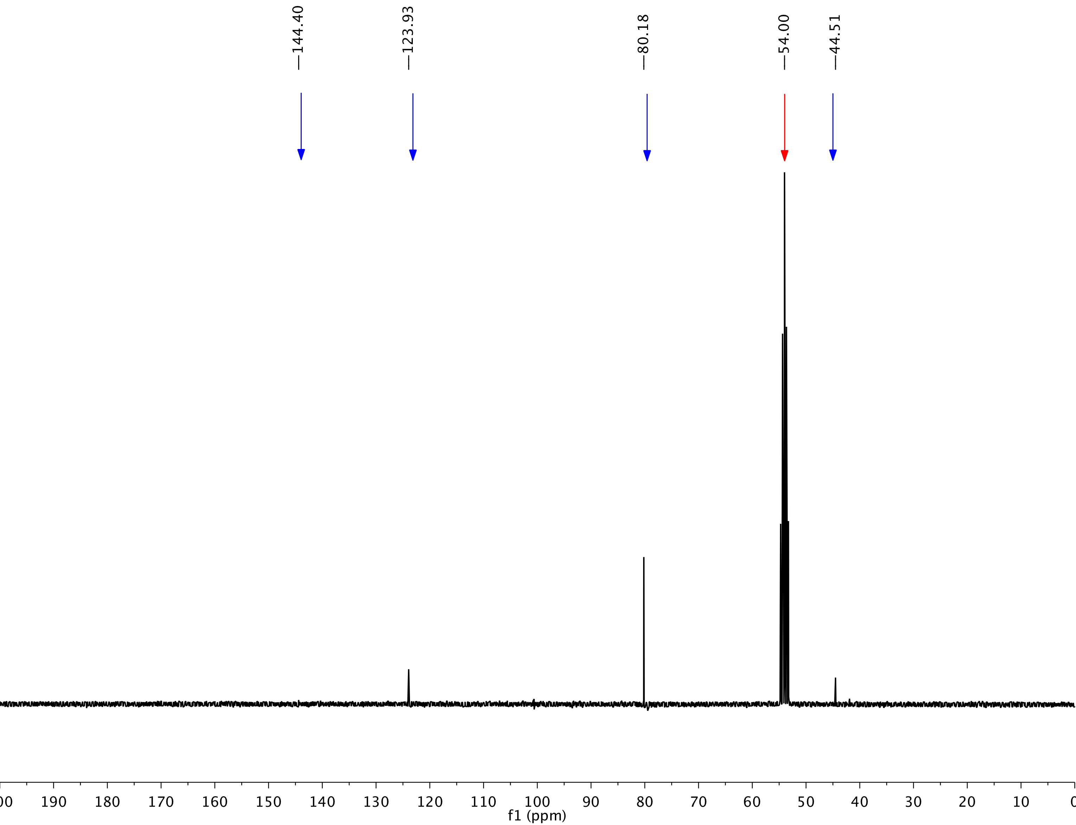

**Figure S2.** 13C NMR spectrum of **1** in CD2Cl2. Blue arrows denote **1**. Red arrow denotes CD2Cl2.

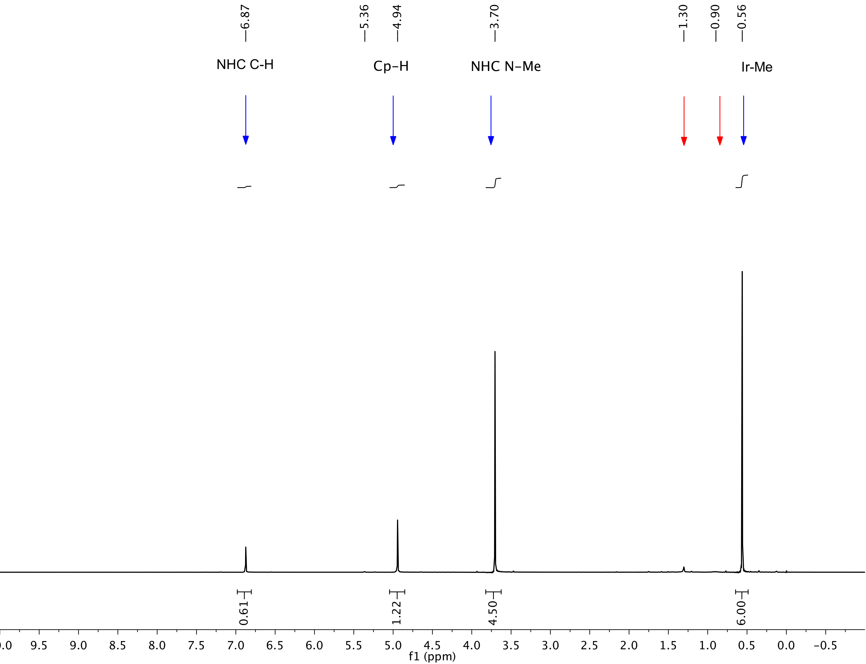

**Figure S3.** 1H NMR spectrum of a crystallized sample of **2** in CD2Cl2. Blue arrows denote **2**, while red arrows denotes residual pentane solvent.

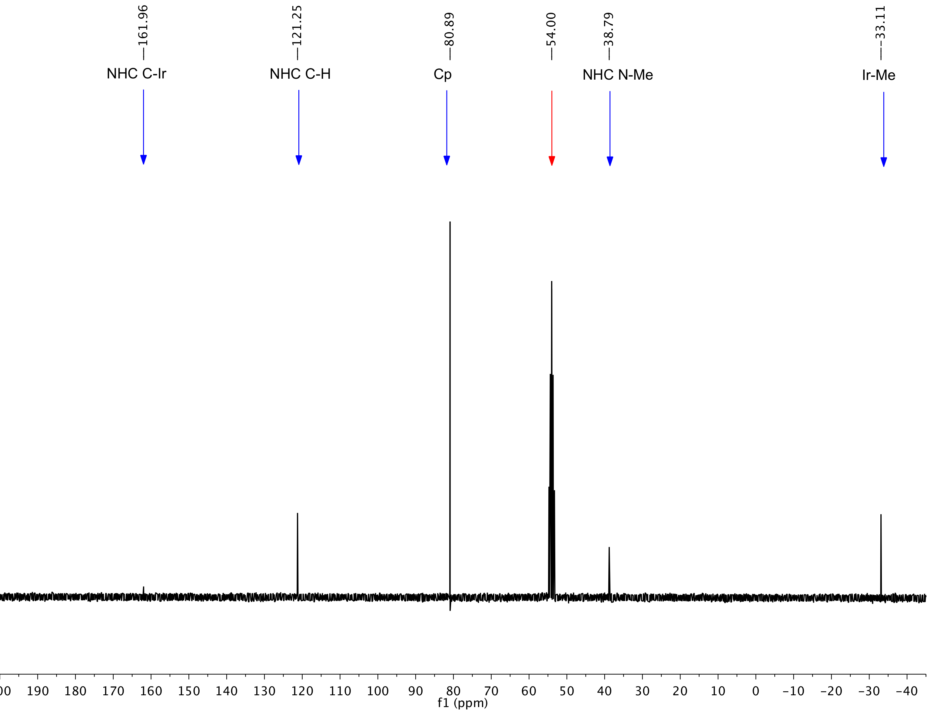

**Figure S4.** 13C NMR spectrum of a crystallized sample of **2** in CD2Cl2. Blue arrows denote **1**, while the red arrow denotes CD2Cl2.

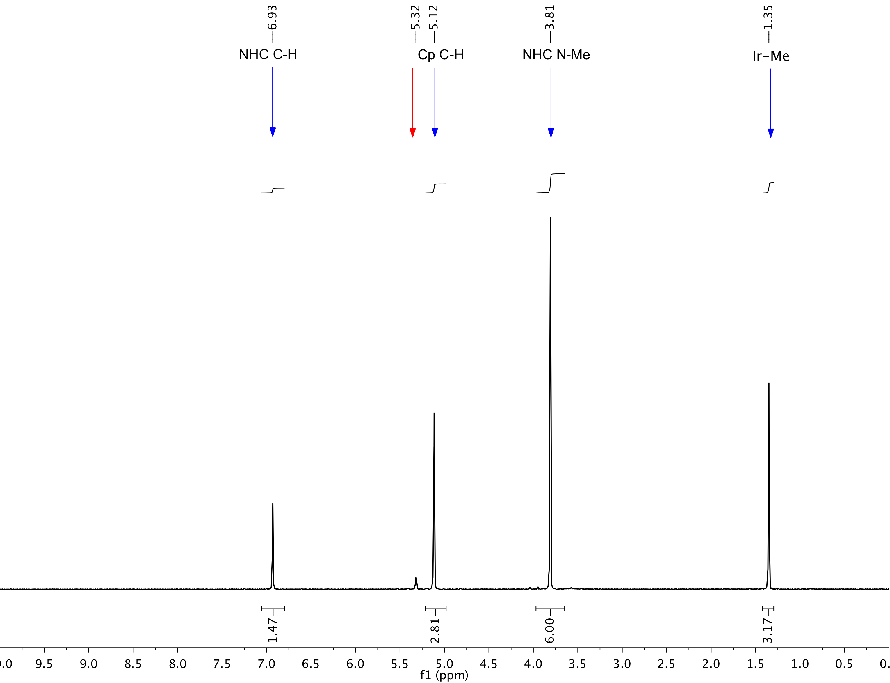

**Figure S5.** 1H NMR spectrum of **3** in CD2Cl2. Blue arrows denote **3**, while the red arrow denotes residual CHDCl2.

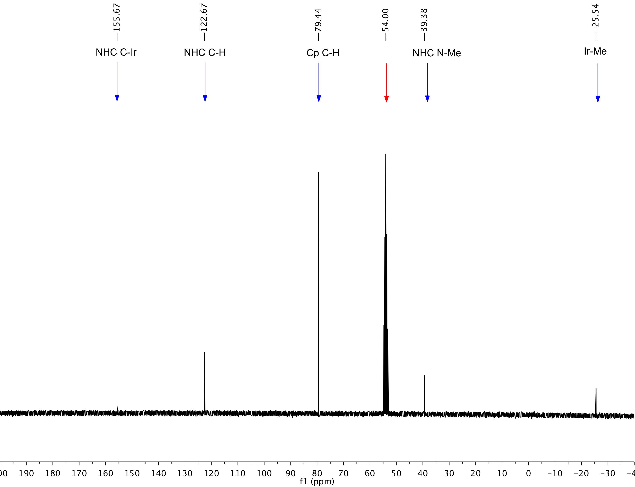

**Figure S6.** 13C NMR spectrum of **3** in CD2Cl2. Blue arrows denote **3**, while the red arrow denotes CD2Cl2 solvent.

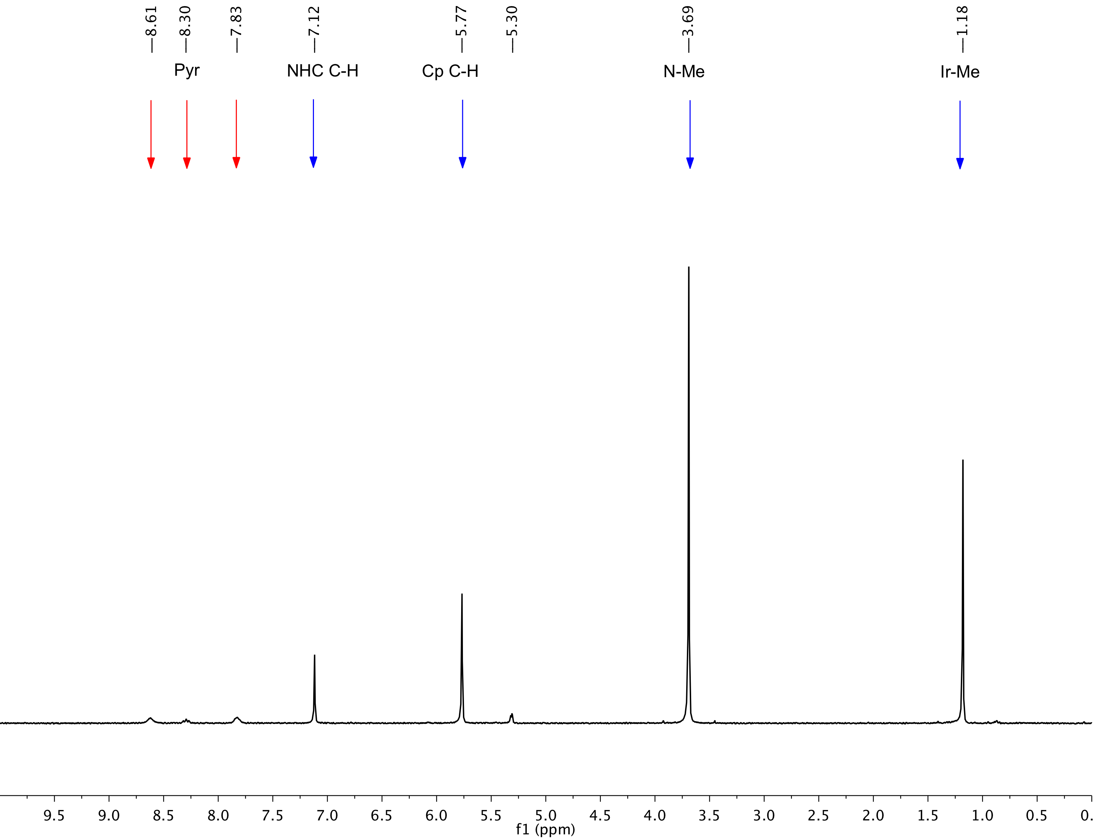

**Figure S7.** 1H NMR spectrum of single crystals of **4** in CD2Cl2. Blue arrows denote **3**; red arrows denote residual pyridine.

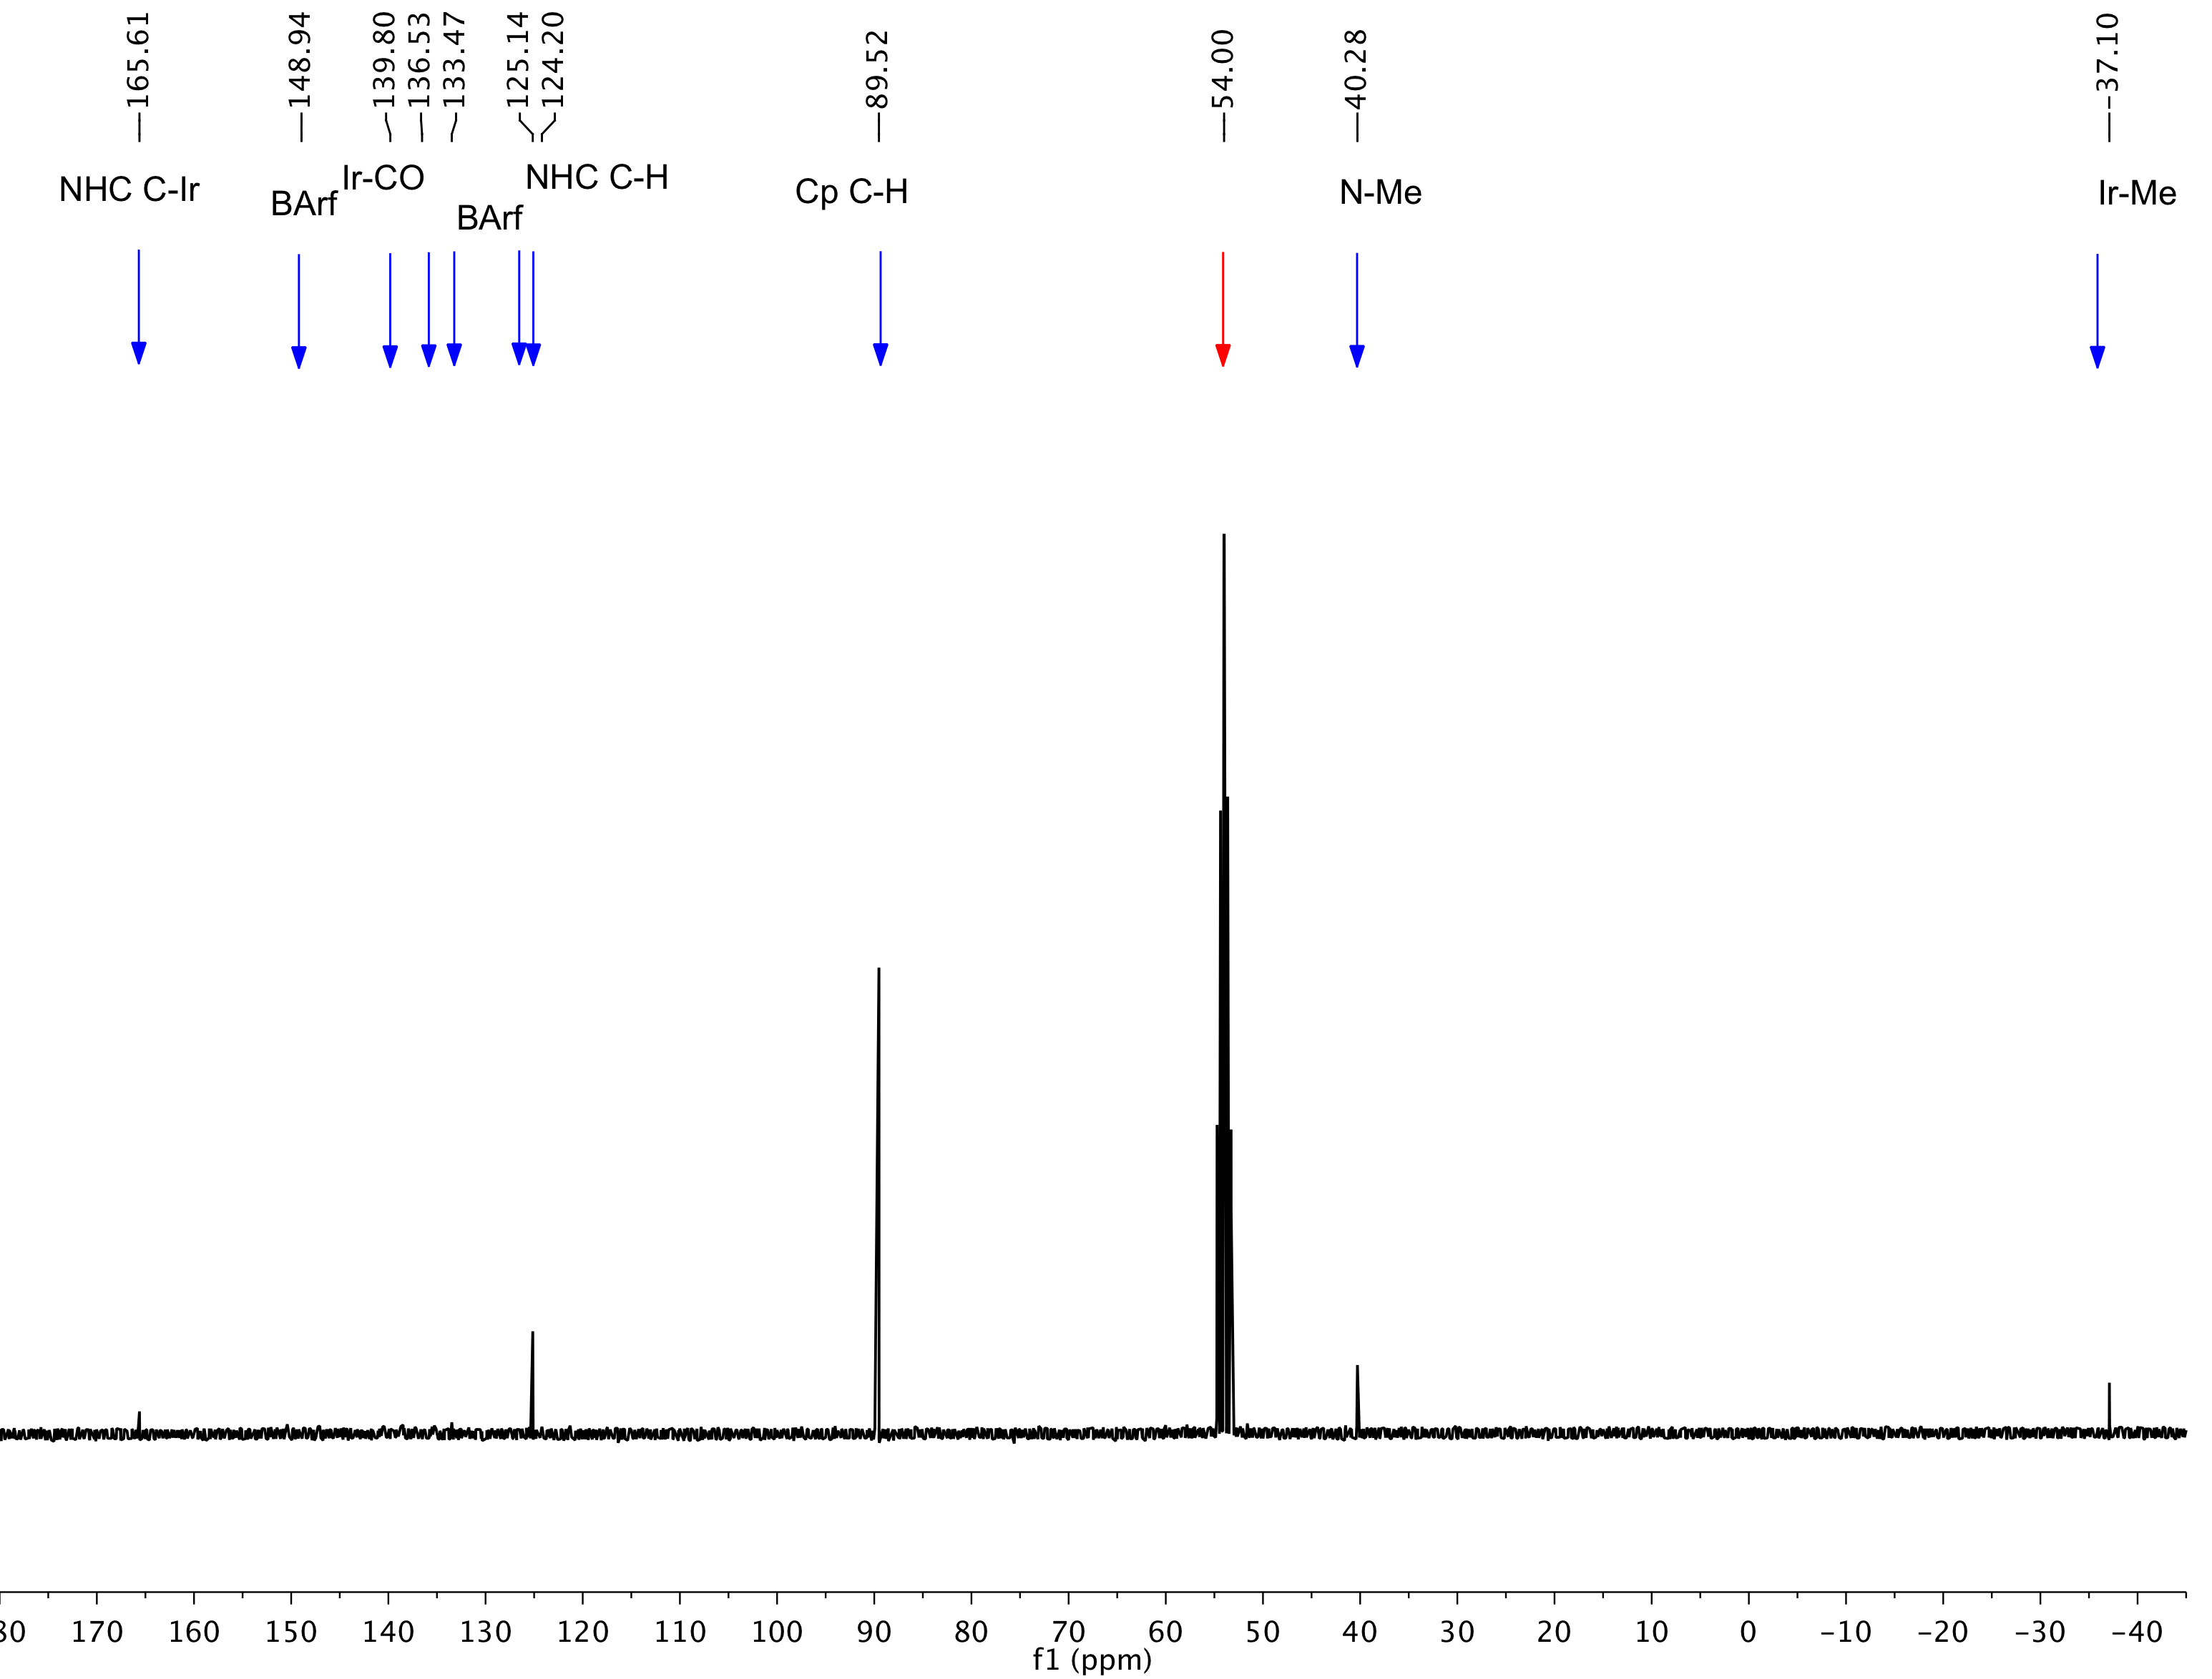

**Figure S8.** 13C NMR spectrum of **4** in CD2Cl2. Blue arrows denote **4**; red arrow denotes CD2Cl2.

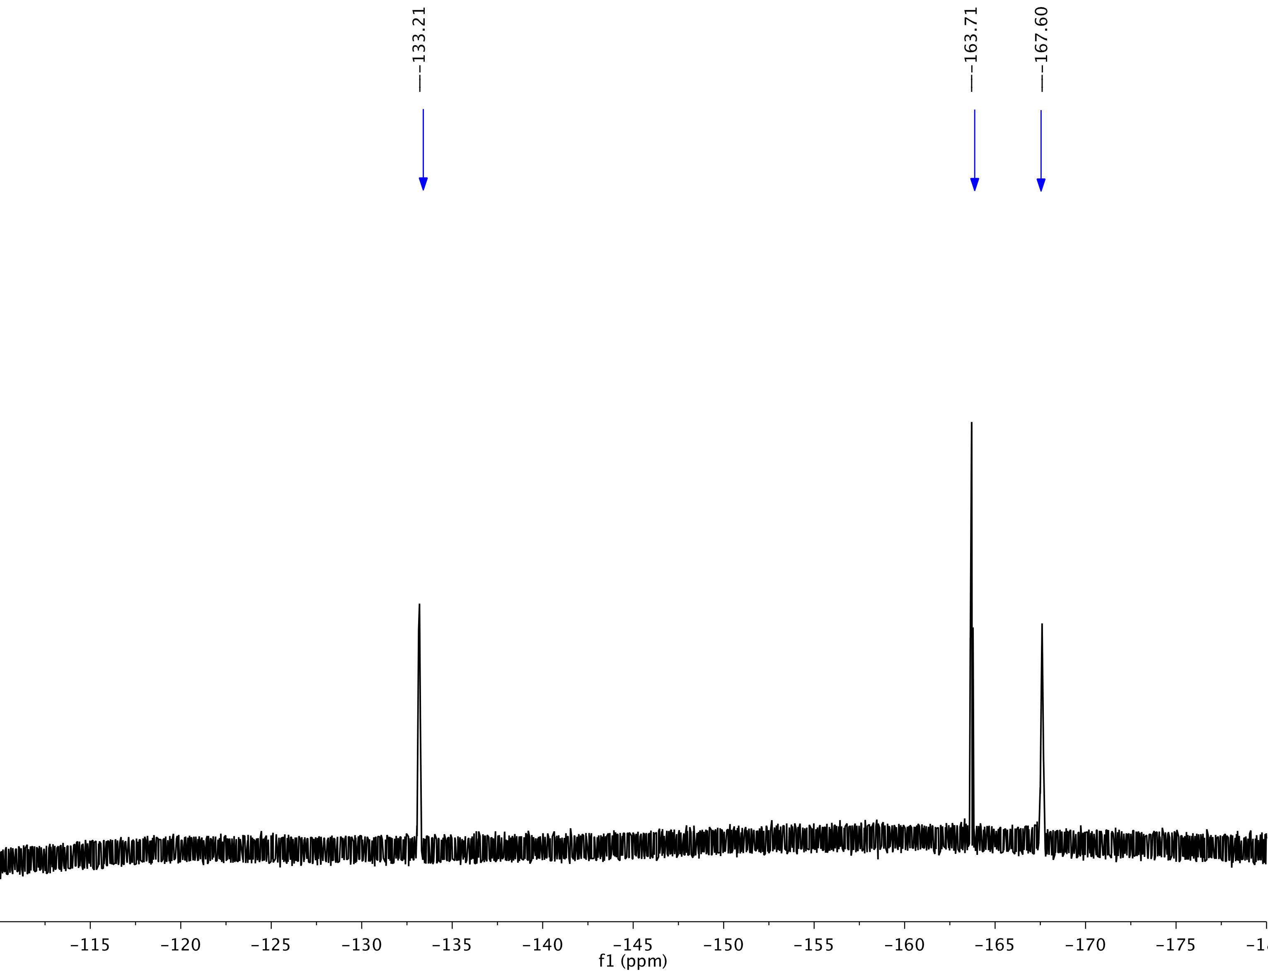

**Figure S9.** 19F NMR spectrum of **4** in CD2Cl2.

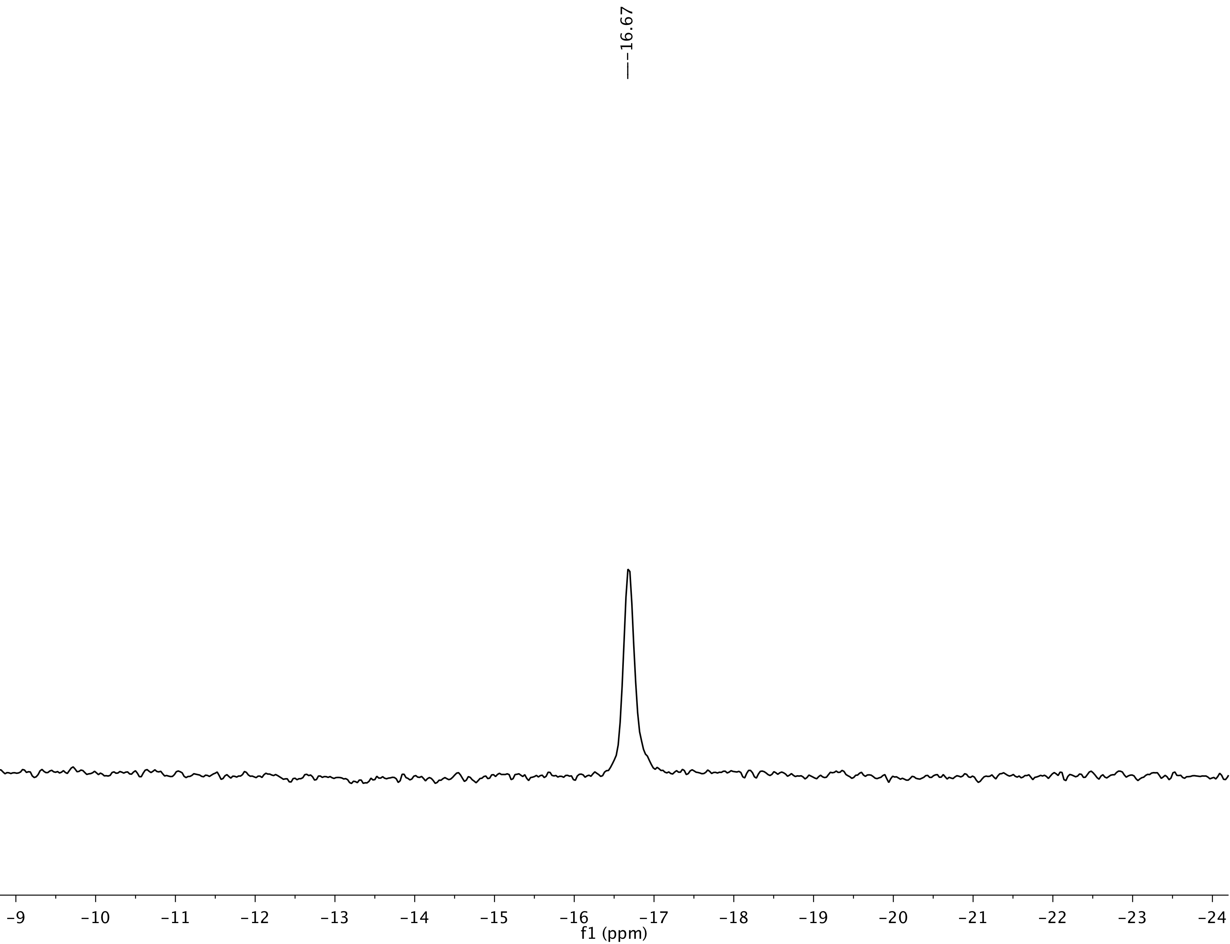

**Figure S10.** 11B NMR spectrum of **4** in CD2Cl2.

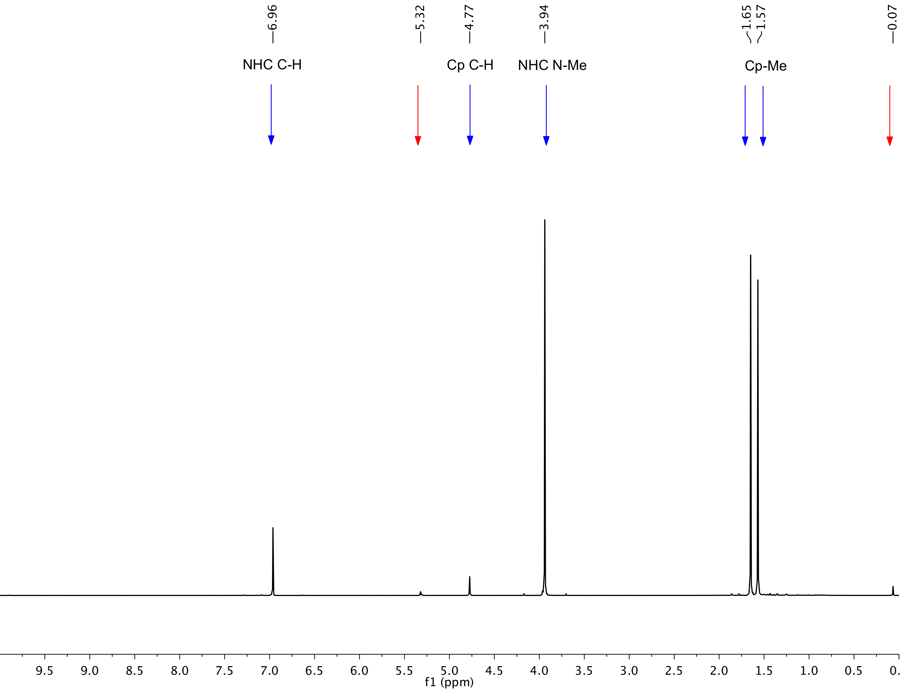

**Figure S11.** 1H NMR spectrum of **5** in CD2Cl2. Blue arrows denote **5**, while red arrows denote residual CHDCl2, and silicone grease.

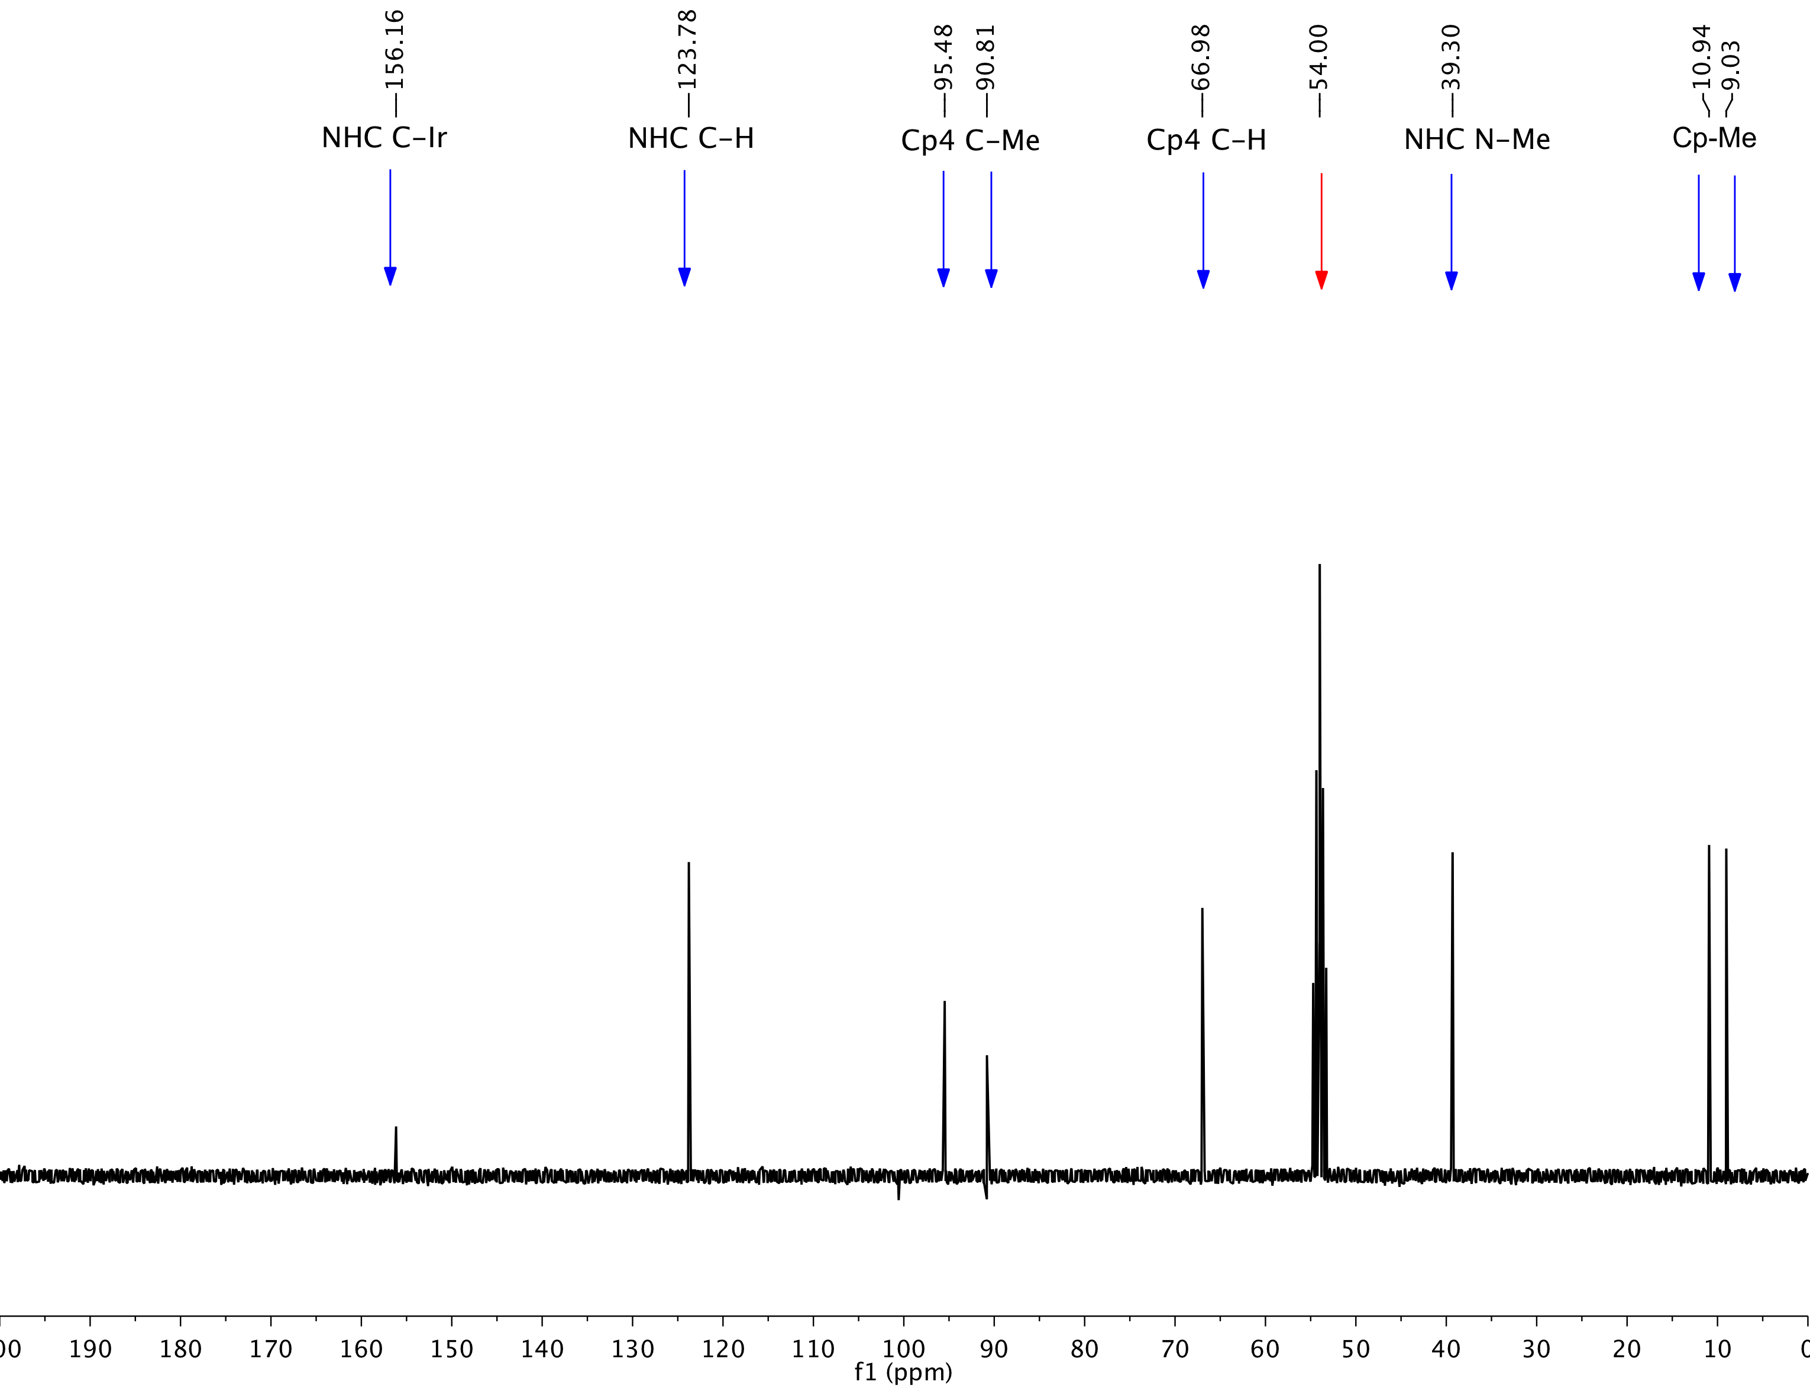

**Figure S12.** 13C NMR spectrum of **5** in CD2Cl2. Blue arrows denote **5**, while the red arrow denotes residual CD2Cl2.

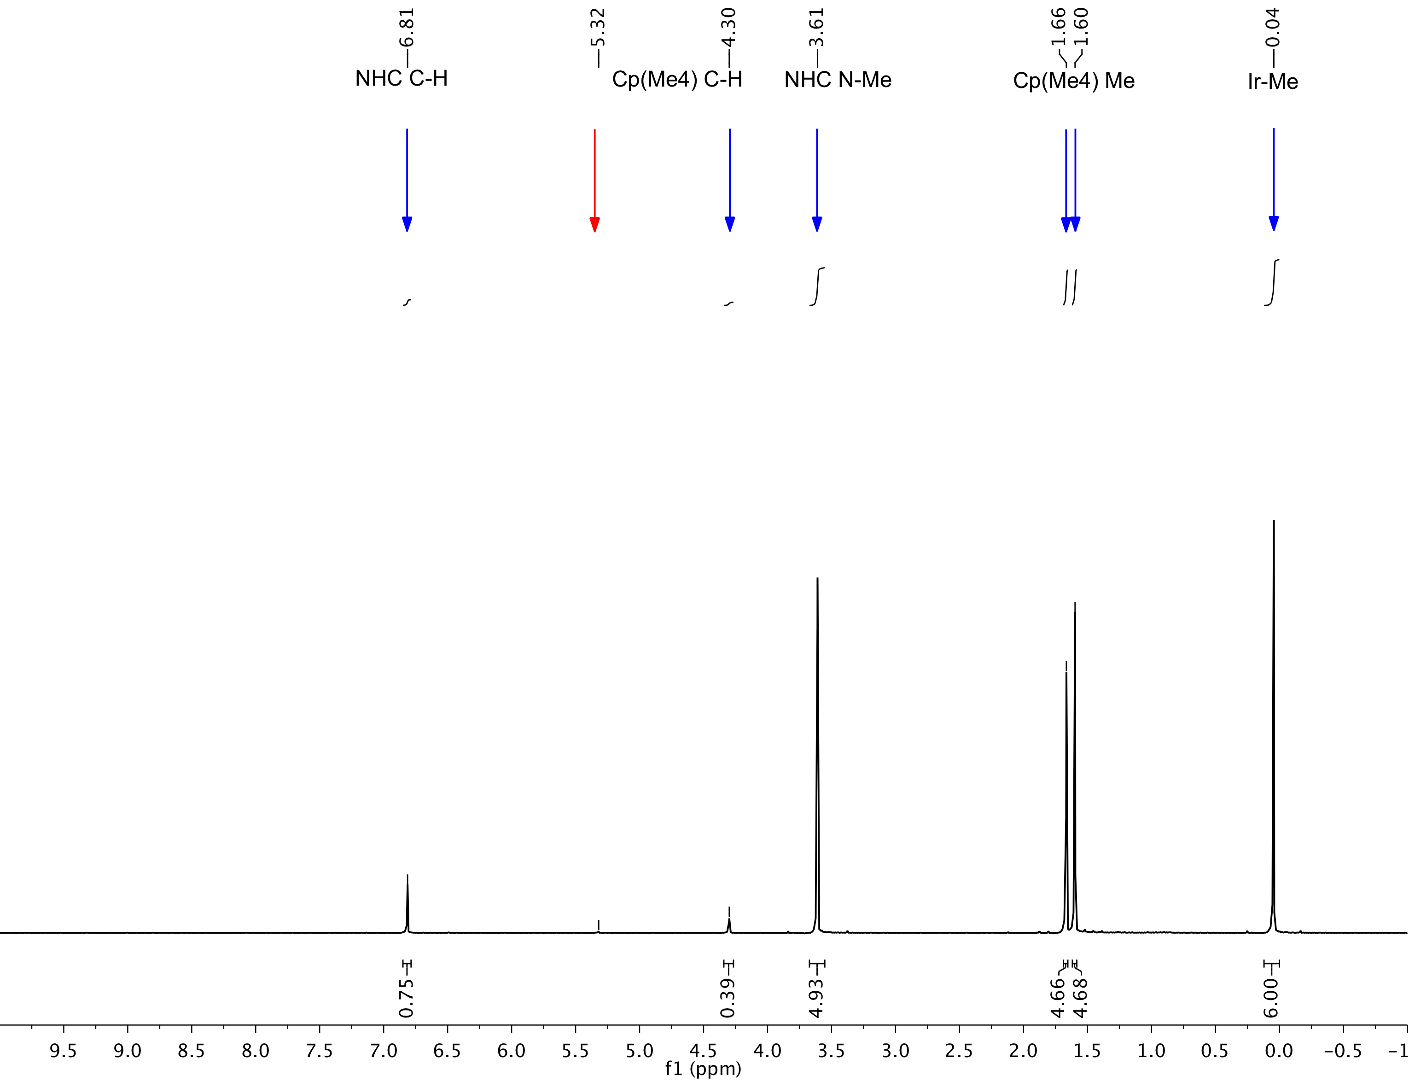

**Figure S13.** 1H NMR spectrum of **6** in CD2Cl2. Blue arrows denote **6**, while the red arrow denotes CHDCl2.

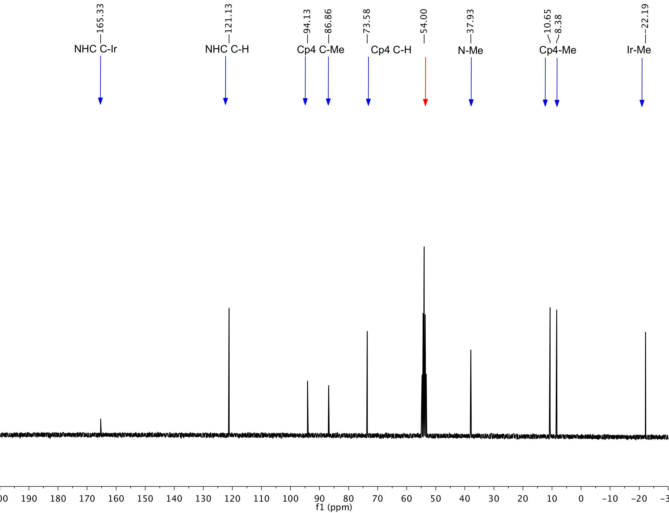

**Figure S14.** 13C NMR spectrum of **6** in CD2Cl2. Blue arrows denote **6** while the red arrow denotes CD2Cl2.

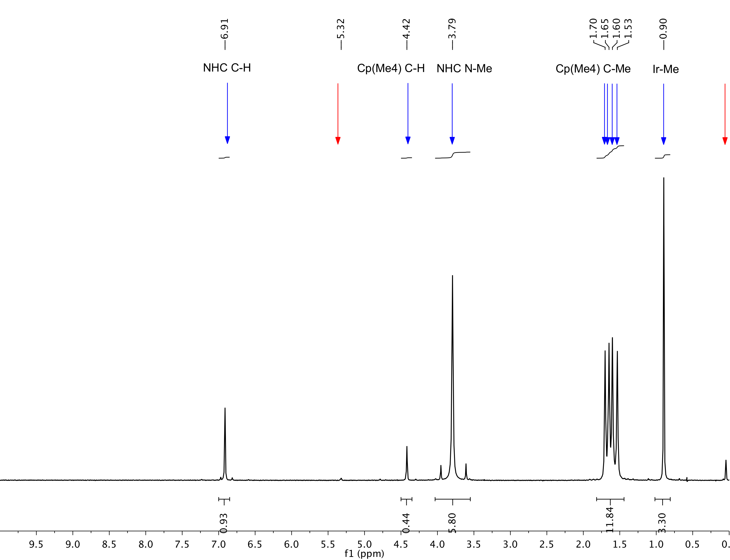

**Figure S15.** 1H NMR spectrum of **7** in CHDCl2. Blue arrows denote **7**; the red arrows denote CHDCl2 and a trace amount of silicone grease.

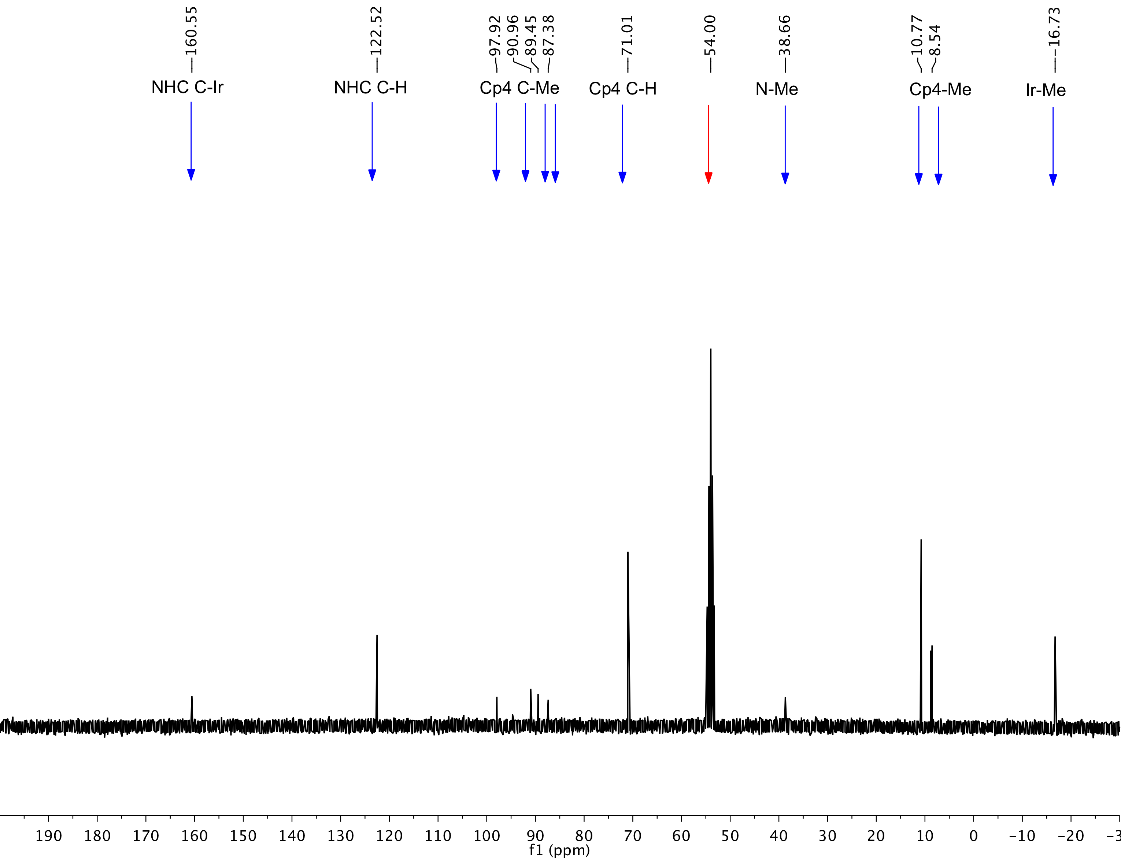

**Figure S16.** 13C NMR spectrum of **7** in CD2Cl2. Blue arrows denote **7**; red arrow indicates CD2Cl2.

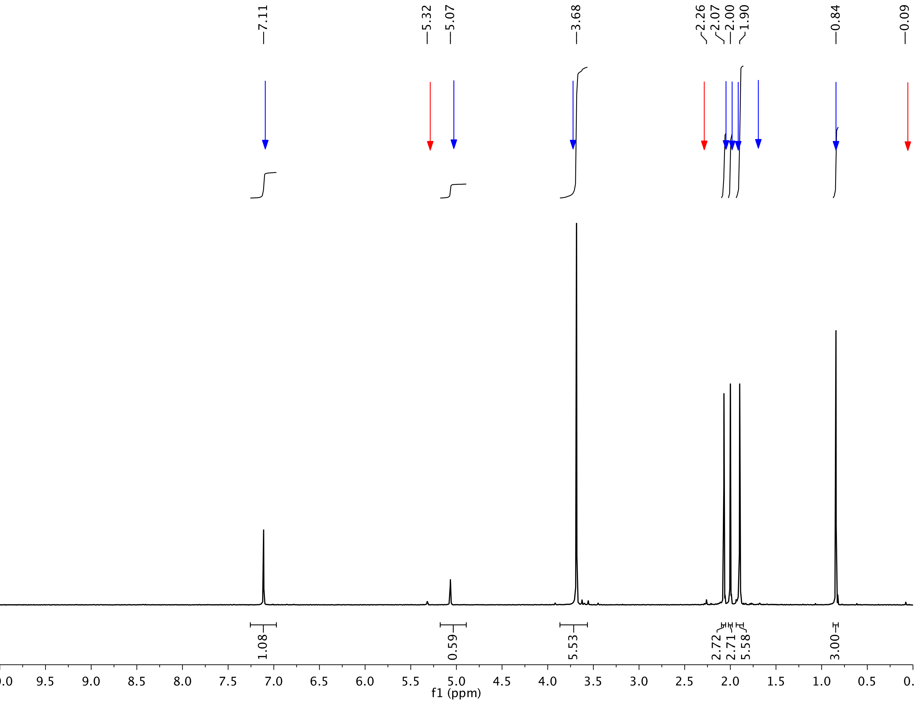

**Figure S17.** 1H NMR spectrum of **8** in CD2Cl2. Blue arrows denote complex **8**; red arrows denote CHDCl2 and an unknown impurity at 2.26 ppm and silicone grease respectively.

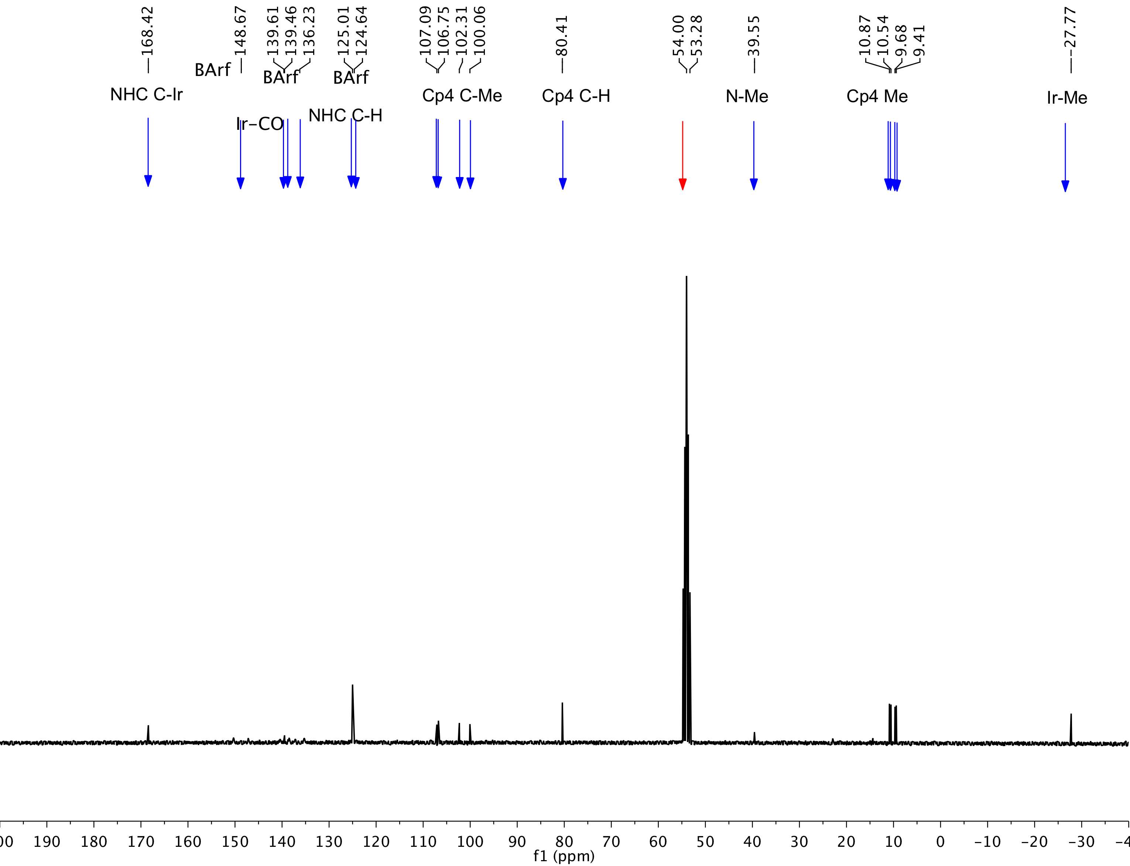

**Figure S18.** 13C NMR spectrum of **8** in CD2Cl2. Blue arrows denote **8**; red arrow denotes CD2Cl2.

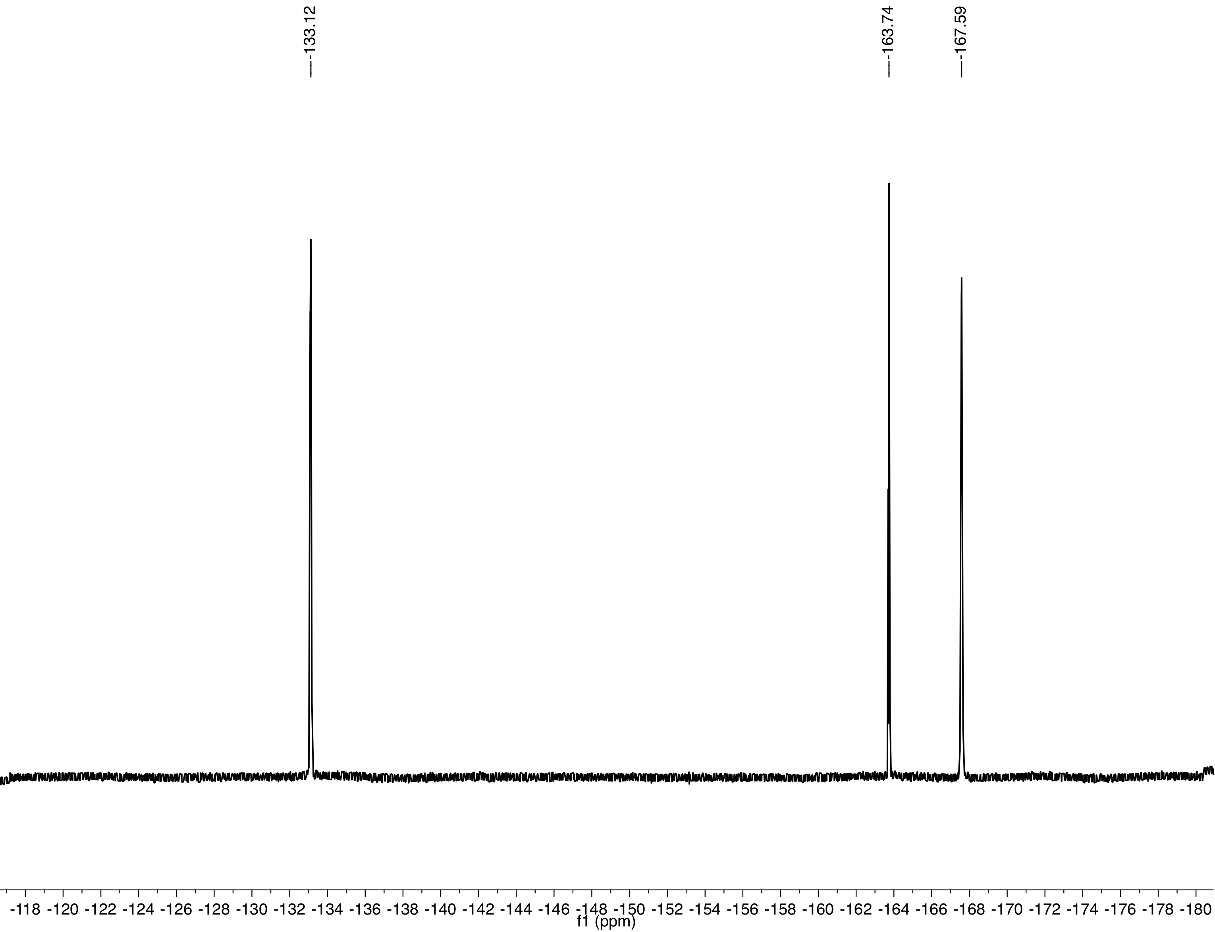

**Figure S19.** 19F NMR spectrum of **8** in CD2Cl2.

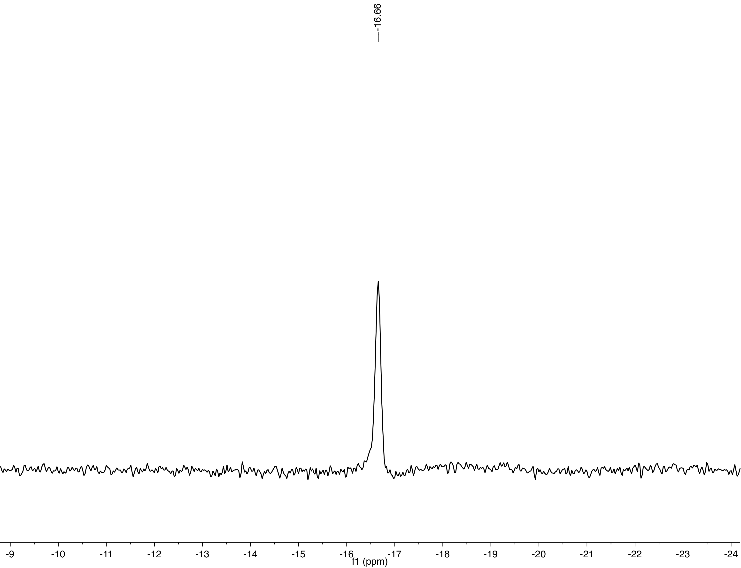

**Figure S20.** 11B NMR spectrum of **8** in CD2Cl2.



**Figure S21.** 1H NMR spectrum of an *in situ* generated sample of [Cp(MeIm)Ir(Me)]+ [BArF20]- from reaction of 1 equiv. of [PyrH]+ [BArF20]- with 1 equiv. of Cp(MeIm)IrMe2 in thawing CD2Cl2. Green arrows denote 2 different pyridine environments, and CH4, blue arrows denote [Cp(MeIm)Ir(Me)(py)]+ and, red arrows denote unreacted Cp(MeIm)IrMe2 , residual pentane.



**Figure S22.** 1H NMR spectrum of an *in situ* generated sample of [CpMe4(MeIm)Ir(Me)]+ [BArF20]- from reaction of 1 equiv. of [PyrH]+ [BarF20]- and 1 equiv. of CpMe4(MeIm)IrMe2 in thawing CD2Cl2. Green arrows denote 2 different pyridine environments and CH4, blue arrows denote [CpMe4(MeIm)Ir(Me)]+ and red arrows denote unreacted CpMe4(MeIm)IrMe2.

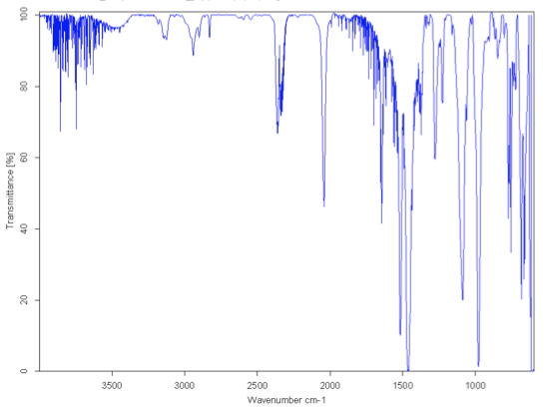

**Figure S23.** IR spectrum of **4** (KBr pellet)

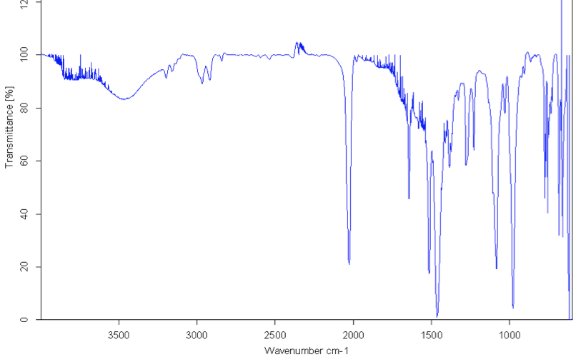

**Figure S24.** IR spectra of **8** (KBr pellet)

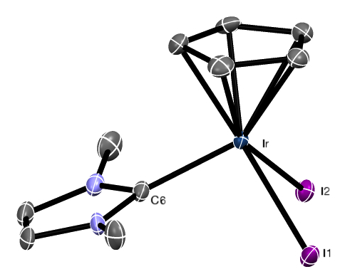

Figure S25. ORTEP of complex **1**. Hydrogen atoms are omitted for clarity. Ellipsoids are displayed at the 50% probability level.

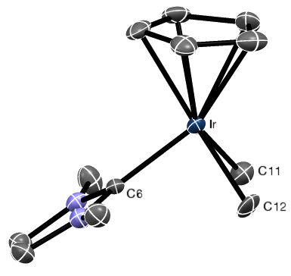

**Figure S26.** ORTEP of complex **2**. Hydrogen atoms are omitted for clarity. Ellipsoids are displayed at the 50% probability level.

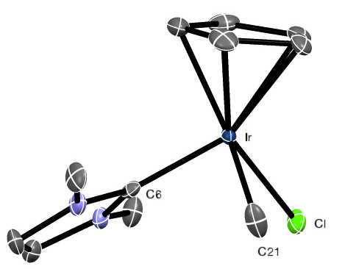

**Figure S27.** ORTEP of complex **3**. Hydrogen atoms are omitted for clarity. Ellipsoids are displayed at the 50% probability level. The structure consists of two different complex molecules, of which only one shows the methyl group on Ir disordered with chlorine at a ratio of 1:1, resulting in loss of the center of symmetry. Instead of the higher pseudo-symmetry Pbca (refinement R1 with similar disorder model: 5.28%, thermal ellipsoids of chlorines and methyl non-positive definite, large residual electron densities), the structure crystallizes as a racemic twin in space group Pca21 (R1: 2.54%).

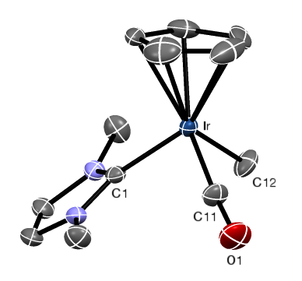

**Figure S28.** ORTEP of the cationic portion of complex **4**. Hydrogen atoms and [BArF20]- anion are omitted for clarity. Ellipsoids are displayed at the 50% probability level. In this acentric structure (Flack enantiopole parameter = -0.005(2)), the dichloromethane and CO, CH3 ligands show a small disorder at 14 percent.

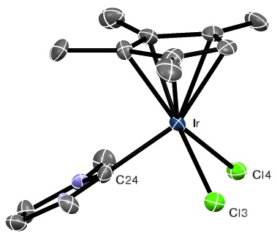

**Figure S29.** ORTEP ofcomplex **5**. Hydrogen atoms are omitted for clarity. Ellipsoids are displayed at the 50% probability level. With 4 molecules in a centrosymmetric monoclinic cell, this structure seems unusual, but no higher symmetry was found.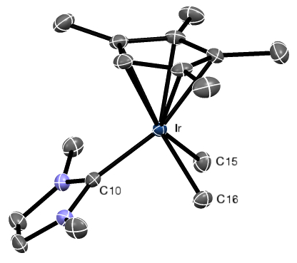

**Figure S30.** ORTEP of complex **6**. Hydrogen atoms are omitted for clarity. Ellipsoids are displayed at the 50% probability level.

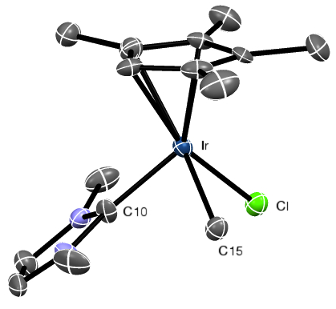

**Figure S31.** ORTEP of complex **7**. Hydrogen atoms are omitted for clarity. Ellipsoids are displayed at the 50% probability level. This structure exhibits disorder, where the molecule appears to be folded into itself via a mirror operation through the Ir atom. This disorder appeared even in an attempt to refine the structure in P 1 symmetry, thus is not a result of having selected too high a symmetry. The methyl and chloride groups bound to Ir are also disordered.

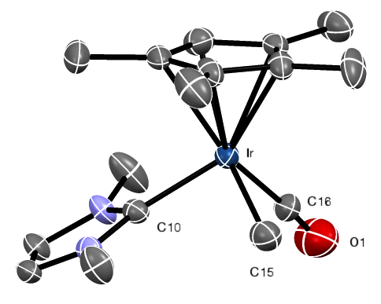

**Figure S32.** ORTEP of the cationic portion of complex **8**. Hydrogen atoms and [BArF20]- anion omitted for clarity. Ellipsoids are displayed at the 50% probability level.

**Table S1.** Crystallographic details for complexes **1**-**4**.

|  |  |  |  |  |
| --- | --- | --- | --- | --- |
|  | **1** | **2** | **3** | **4** |
| Formula | C10H13I2IrN2 | C12H19IrN2 | C43 H61 Cl5 Ir4N8 | C73H34B2F40Ir2N4O2 |
| MW | 607.22 | 383.49 | 1636.05 | 2235.96 |
| crystal system | Monoclinic | Monoclinic | Orthorhombic | Orthorhombic |
| space group | P 21/n | P 21/c | P c a 21 | Pba2 |
| a (Å) | 7.2118(4) | 13.0597(8) | 7.8422(11) | 16.454(4) |
| b (Å) | 13.6267(8) | 21.0092(14) | 23.101(3) | 22.905(5) |
| c (Å) | 13.6252(8) | 8.9248(6) | 13.0474(19) | 9.7212(19) |
| α (°) | 90° | 90° | 90° | 90° |
| β (°) | 104.451(3) | 92.837(3)°. | 90° | 90° |
| γ (°) | 90° | 90° | 90° | 90° |
| V (Å3) | 1296.63(13) | 2445.7(3) | 2363.8(6) | 3663.8(14) |
| Z | 4 | 8 | 2 | 2 |
| T (K) | 100(2) | 100(2) | 100(2) | 100(2) |
| λ (Å) | 0.71073 | 0.71073 | 0.71073 | 0.71073 |
| Rint | 0.0540 | 0.1104 | 0.0525 | 0.0314 |
| R1* | 0.0233 | 0.0465 | 0.0245 | 0.0138 |
| wR2* | 0.0544 | 0.0963 | 0.0611 | 0.0323 |
| GOF | 1.112 | 1.035 | 1.068 | 1.036 |

For [I>2sigma(I)]

**Table S2.** Crystallographic details for complexes **5-8**.

|  |  |  |  |  |
| --- | --- | --- | --- | --- |
|  | **5** | **6** | **7** | **8** |
| Formula | C14H21N2IrCl2 | C16H27IrN2 | C15H24ClIrN2 | C40H24BF20IrN2 O |
| MW | 480.43 | 439.60 | 460.01 | 1131.62 |
| crystal system | Monoclinic | orthorhombic | Orthorhombic | Monoclinic |
| space group | P 21/c | P b c a | C m c a | P 21/c |
| a (Å) | 16.507(3) | 9.0683(7) | 8.956(2) | 24.389(4) |
| b (Å) | 24.982(4) | 14.3257(11) | 14.380(2) | 20.340(3) |
| c (Å) | 15.031(3) | 25.020(2) | 24.831(5) | 15.748(3) |
| α (°) | 90 | 90 | 90 | 90 |
| β (°) | 97.317(10) | 90 | 90 | 95.832(10) |
| γ (°) | 90 | 90 | 90 | 90 |
| V (Å3) | 6147.9(19) | 3250.3(4) | 3197.8(11) | 7771(2) |
| Z | 16 | 8 | 8 | 8 |
| T (K) | 100(2) | 100(2) | 100(2) | 100(2) |
| λ (Å) | 0.71073 | 0.71073 | 0.71073 | 0.71073 |
| Rint | 0.0520 | 0.0613 | 0.1225 | 0.0799 |
| R1* | 0.0535 | 0.0210 | 0.0384 | 0.0395 |
| wR2* | 0.1225 | 0.0453 | 0.0793 | 0.0847 |
| GOF | 1.069 | 1.141 | 1.127 | 1.048 |

* For [I>2sigma(I)]

**References**

(1) Heinekey, D. M.; Millar, J. M.; Koetzle, T. F.; Payne, N. G.; Zilm, K. W. *J. Am. Chem. Soc.* **1990**, *112*, 909–919.

(2) Grote, Z.; Scopelliti, R.; Severin, K. *J. Am. Chem. Soc.* **2004**, *126*, 16959–16972.

(3) Khramov, D. M.; Lynch, V. M.; Bielawski, C. W. *Organometallics* **2007**, *26*, 6042–6049.

(4) Brookhart, M.; Grant, B.; Volpe, A. F., Jr *Organometallics* **1992**, *11*, 3920–3922.

(5) Bruker *SAINT*; 7 ed. BrukerAXS Inc, Madison, Wisconsin, USA, 2007; pp. 1–1.

(6) Bruker *SADABS*; 2007 ed. BrukerAXS Inc, : Madison, Wisconsin, USA. 2007; pp. 1–1.

(7) Bruker *APEX2*; 2nd ed. BrukerAXS Inc, : Madison, Wisconsin, USA, 2007.

(8) Altomare, A.; Burla, M. C.; Camalli, M.; Cascarano, G. L.; Giacovazzo, C.; Gualiardi, A.; Moliterni, A. G. G.; Polidori, G.; Spagna, R. *J. Appl. Cryst (1999). 32, 115-119*  **1999**, 1–5.

(9) Altomare, A.; Cascarano, G.; Giacovazzo, C.; Guagliardi, A. *J. Appl. Cryst (1993). 26, 343-350*  **1993**, 1–8.

(10) Sheldrick, G. M. *SHELXL-97, Program for the Refinement of Crystal Structures.*; Uniersity of Göttingen, Germany., 1997.

(11) Mackay, S.; Edwards, C.; Henderson, A.; Gilmore, C.; Stewart, N.; Shankland, K.; onald, A. *MaXus: a Computer Program for the Solution and Refinement of Crystal Structures From Diffraction Data.*; University of Glasgow, Scotland, 1997; pp. 1–1.

(12) Waasmaier, D.; Kirfel, A. *Acta Cryst (1995). A51, 416-431* **1995**, 1–16.

(13) Budzelaar, P. *Ivorysoft, Nijmegen, Netherlands* **2006**.

[1] D. M. Heinekey, J. M. Millar, T. F. Koetzle, N. G. Payne, K. W. Zilm, *J Am Chem Soc* 1990, *112*, 909–919.

[2] Z. Grote, R. Scopelliti, K. Severin, *J Am Chem Soc* 2004, *126*, 16959–16972.

[3] D. M. Khramov, V. M. Lynch, C. W. Bielawski, *Organometallics* 2007, *26*, 6042–6049.

[4] M. Brookhart, B. Grant, A. F. Volpe, *Organometallics* 1992, *11*, 3920–3922.

[5] D. Waasmaier, A. Kirfel, *Acta Crystallogr Sect Found Crystallogr* 1995, *51*, DOI 10.1107/s0108767394013292.