ROTOPOL

Project description by Werner Kaminsky, Dep. of Chemistry, University of Washington

A technology is presented that extends the range of application of any existing optical microscope to measure quantitatively and simultaneously Birefringence, Extinction, and Transmission images. It consists of two parts:
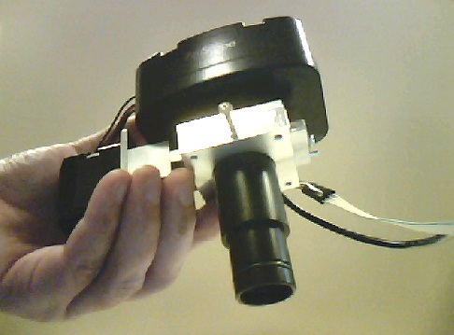
a) The camera-rotating polarizer unit
b) a circular polarizer

Description of unit a)
A rotating polarizer is placed in front of a camera with integrated optical components. The unit can be placed on any microscope replacing a standard ocular or on a C-mount that allows insertion of an ocular. The polarizer is computer controlled through the USB connection and the images of the digital camera are received also via a standard USB port on a Microsoft Windows operating computer.

Below are examples of measurements performed with a 1915 vintage Bausch & Lomb optical microscope. The ROTOPOL device replaced the brass ocular piece on the top. A simple green-filter polarizer plus two quarter wave compensators (one with its slow axis aligned with the polarizer, the other at 45 degrees, which allows calibration to exact quarter wavelength retardation) was fastened underneath the sample table.

The first row of images shows next to the microscope the background which removes all dust and other imperfections. The second row shows a ‘well’ from a crystallization plate with crystals. The third row exhibits the birefringence of a thin birefringent crystal plate.
Old microscope used for ROTOPOL measurements (see text).
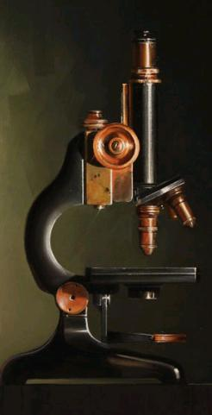 | 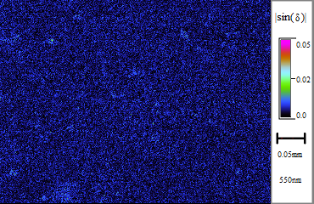 | 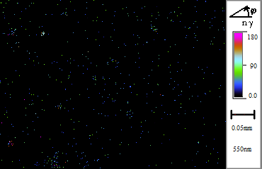 | 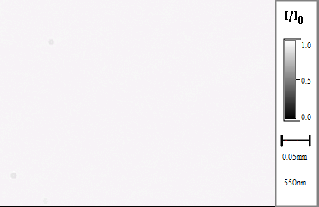
 | 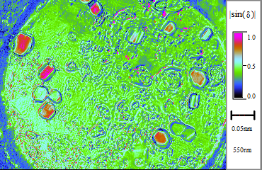 | 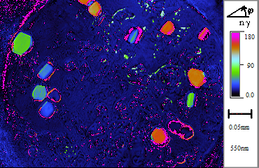 | 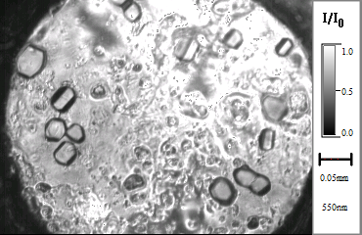
 | 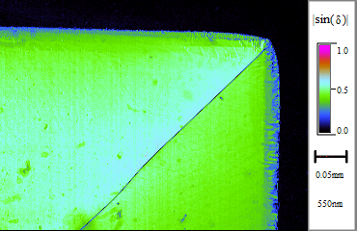 | 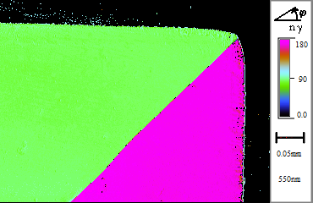 | 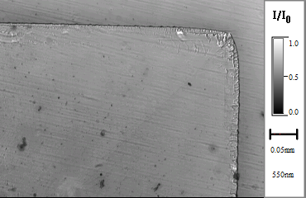
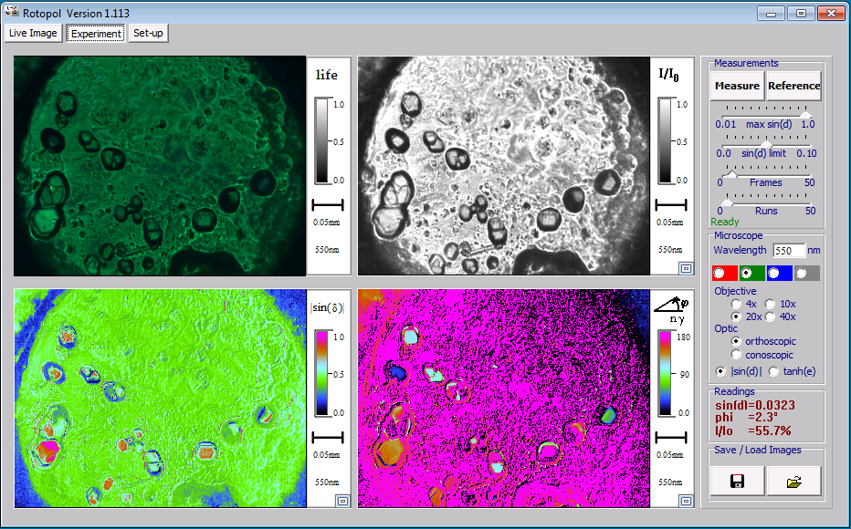
Screenshot of software with a well as sample. The image on the top-left represents a life image of the microscope.

Calibration: the camera needs to be set to linear intensity response and proper dark-current reading (zero signal for zero intensity).The motor zero-position needs to be set once only to place the polarizer "horizontally" for properly referencing the extinction angle reading.

Description of unit b)
There are different options. A very low in cost option combines a simple color filter foil with a calibrated combination of polarizer and quarter wave plates to match a quarter wave retardation with a 1% error margin. In addition, achromatic quarter wave plates can be used in combination with apolarizer at 45 degrees. A third option involves a fresnel rhomb for broad band qurterwave retardation.
In the easiest implementation the foil option is placed on the sample table, but underneath the sample.

SPECS:
Image resolution is that of the camera, typically 2048 x 1536 or as small as 320 x 240. Preferred camera: AmScope MT300 (with Direct Show drivers).

Noise level: For a single measurement with proper background calibration |sin(d)| <> 0.01. With integration, this can be lowered to 0.001 (microscope independent). The extinction angle resolution is better than estimated 0.5 degrees.

Maximum retardation: For simple foil-color filters dispersion limits the applicable range to d=4pi, for 50nm half-width interference color filters this value is considerable higher, but the signal is a modulus of pi/2 if no further measures are taken. However, utilizing measurements of two wavelengths allows to separate out this ambiguity, which is currently in the process of being implemented into the software.

Signal linearity: For properly calibrated camera the sin(d) reading is linear better than 5% (this depends on the quality of the circular polarizer). Similarly, extinction is determined with ca. 2 degree accuracy (improvements possible via calibration, not yet implemented).

Sampling time: This method requires mechanical rotation of a polarizer with sequential reading of images. For better signal to noise readings one can also integrate measurements, thus the range of sampling time is ca. 3 seconds to 10 minutes.

