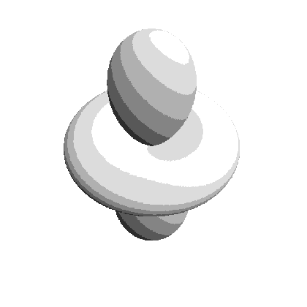
Priv. Doz. Dr. habil Werner Kaminsky
Research Associate Professor
University of Washington
Department of Chemistry, Box 351700
Seattle, Washington, 98195-1700, U.S.A.

tel.: office +(206)543-7585 priv. +(206)729-7305 fax. +(206)685-8665
email: wernerka@u.washington.edu internet: www.wintensor.com

Mary Gates Endowment for Students
Research Training Grants
Office of Undergraduate Education, 310 Mary Gates Hall, Box 352803
University of Washington
Seattle, WA 98195
Friday, 31. July 2026

To whom it may concern

Donald Responte came to me expressing his interest in synthesizing crystals with chiro-optical features beginning of last year. The project he is working on benefits from his bio-chemical background as it involves thiocarbamates that are part of the chemistry around pesticides. Together with solid knowledge in chemistry, I consider Donald most helpful to pursue research on chiro-optical properties in crystals like optical rotation, second harmonic generation and electro-optic effects. In particular we intend not to make pesticides, but to synthesize new materials and target the question of predicting optical features, a central problem in analytical chemistry and material science in general.

The new materials satisfy four important issues:

- The substances that are of the type X-phenyl-NH-CR=S where R is any chiral moiety and X=Cl, Br, etc., will form non-centro symmetric crystals.
- The sulfur is known to enhance crystallization.
- Because of the sulfur, absolute determination of molecular configuration is ensured using X-ray structure determination.
- The number of atoms is small enough so that semi-classical model calculations can be done with the crystal structures as input parameters.

Donald already synthesized some representatives of these materials and obtained their crystal structures implying X-ray diffractometry, all with my personal assistance and supervision.
In total, I found Donald to be perfectly well suited to perform these tasks.

C₉H₁₀ClNOS | C₉H₁₀BrNOS | C₉H₁₀ClNOS | C₉H₁₀N₂O₃S
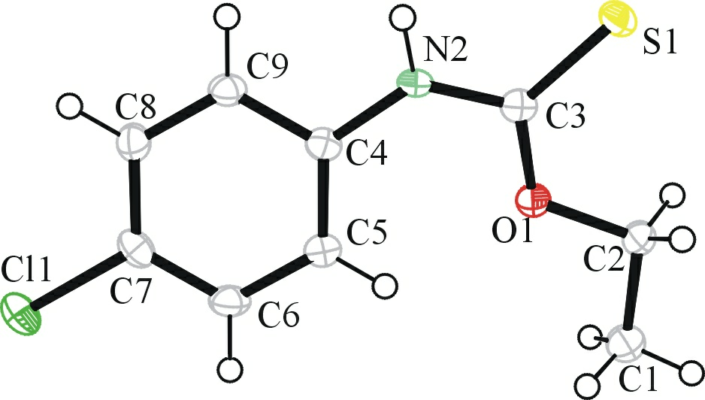 | 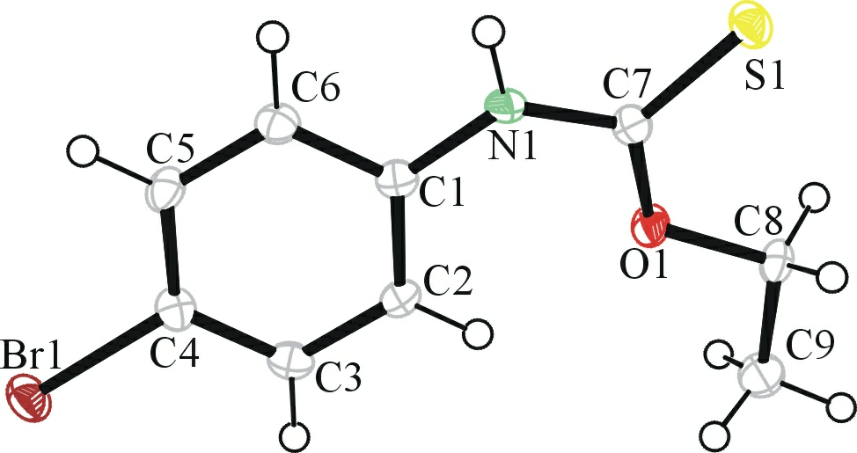 | 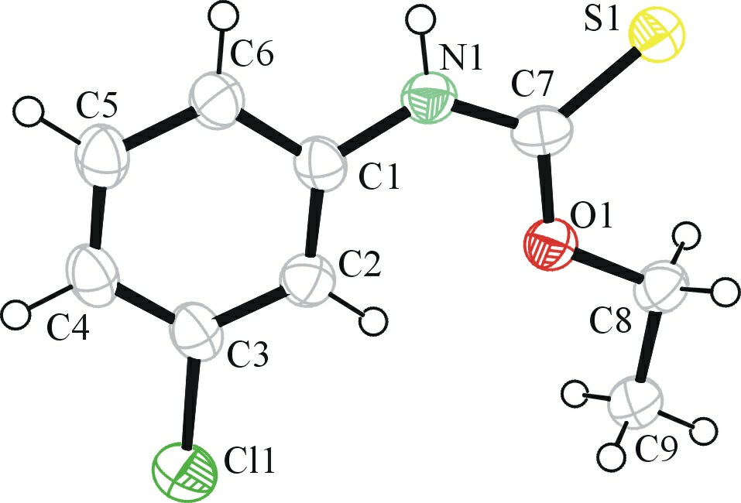 | 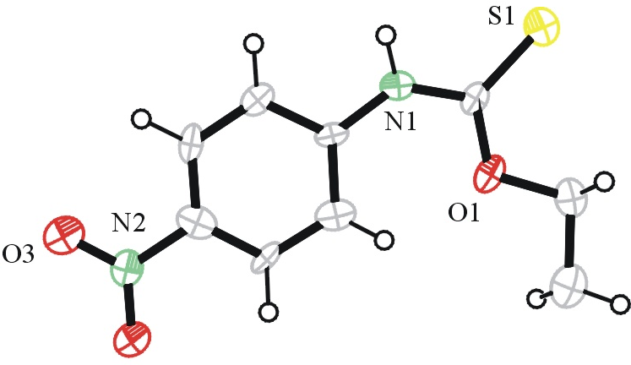
C₉H₁₀N₂O₃S | C₁₃H₁₀Cl₂N2S*  C₃H₇NO | C₁₃H₁₂N₂S | C₁₃H₁₀N₄O₄S*  C₃H₇NO
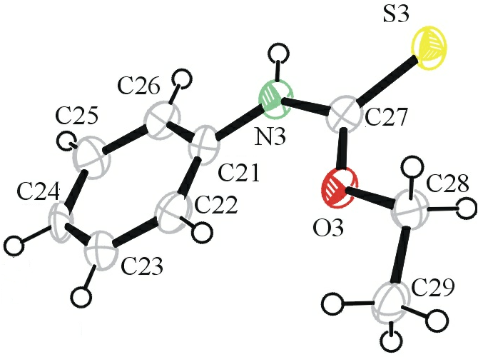 | 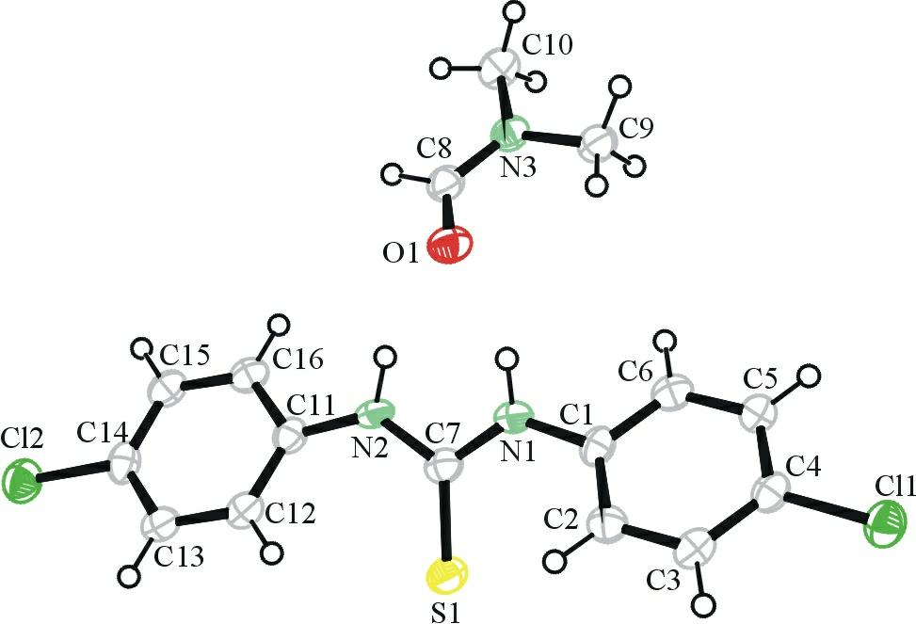 | 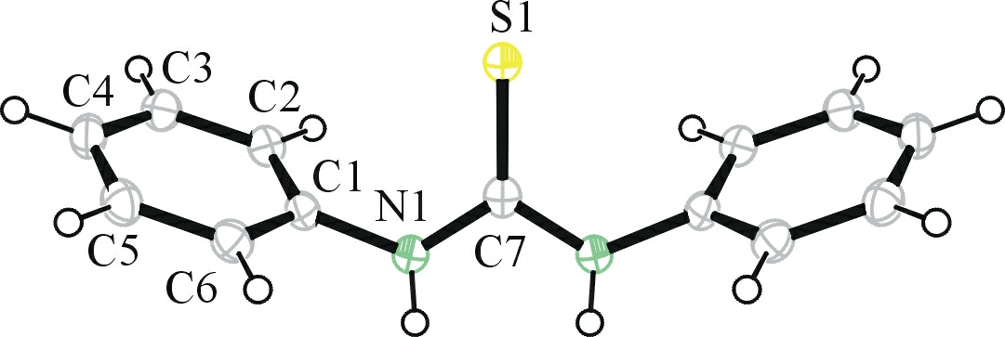 | 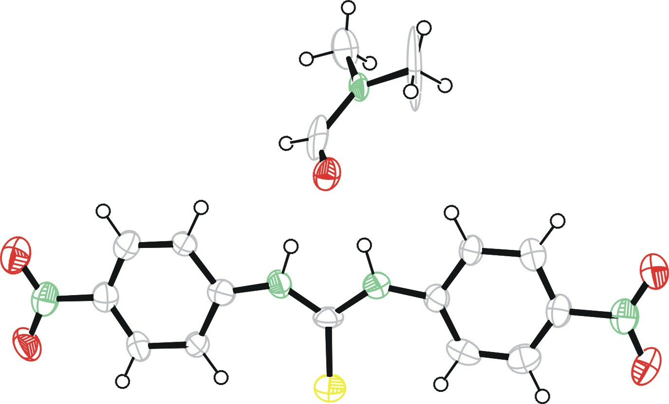
Table: Synthesized compounds and X-ray structures of which only C₁₃H₁₂N₂S is already known.

In particular, Donald synthesized several compounds for which X-ray structures were not known as listed in the table. To obtain these results he had to experiment with PH-values and find the best suitable temperatures for these reactions. These compounds show in part that a reaction between the iso-cyanates and alcohols is possible. In the coming term we are trying to react the iso-cyanates with chiral alcohols and other enantiomorphically pure ligands. Sofar, the attempts with glyceraldehyde resulted in the dimers shown above, of which the structures are known only for C₁₃H₁₂N2S.
We will continue to try the synthesis including small sugar alcohols like galactose and other molecules, where the choice of solvent is not straight forward requiring many more experiments.
Further research will involve determining the morphology of the samples and their refractive indices which can be compared with model calculations based on the structures shown in the table.
Donald will benefit in several ways, first, he will be able to practice his wet chemistry, and keeping a log, He will have a chance to understand the basics of X-ray structure determination and finally, learn to prepare the results for publication.
We already had some success, although the project is in its early stages and we intend to publish the results of the research done so far, which will bring his name on an article, a fact he may find useful to add to his curriculum vitae.

Kaminsky, Box 351700
Department of Chemistry
Seattle, WA 98195
USA
Mary Gates Endowment for Students
Research Training Grants
Office of Undergraduate Education,
310 Mary Gates Hall, Box 352803
University of Washington

Seattle, WA 98195

