1. Turbo Pump: You will need a pump to vacuum the detector.

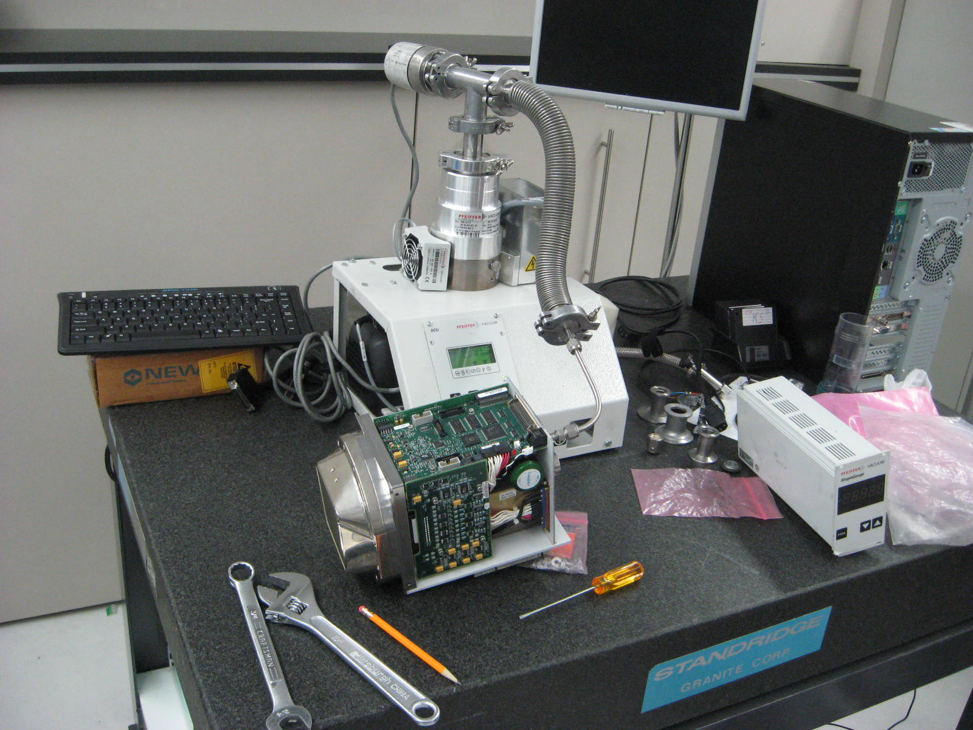

2.       Fitting for Apex: This is the fitting you need to attach to the detector.

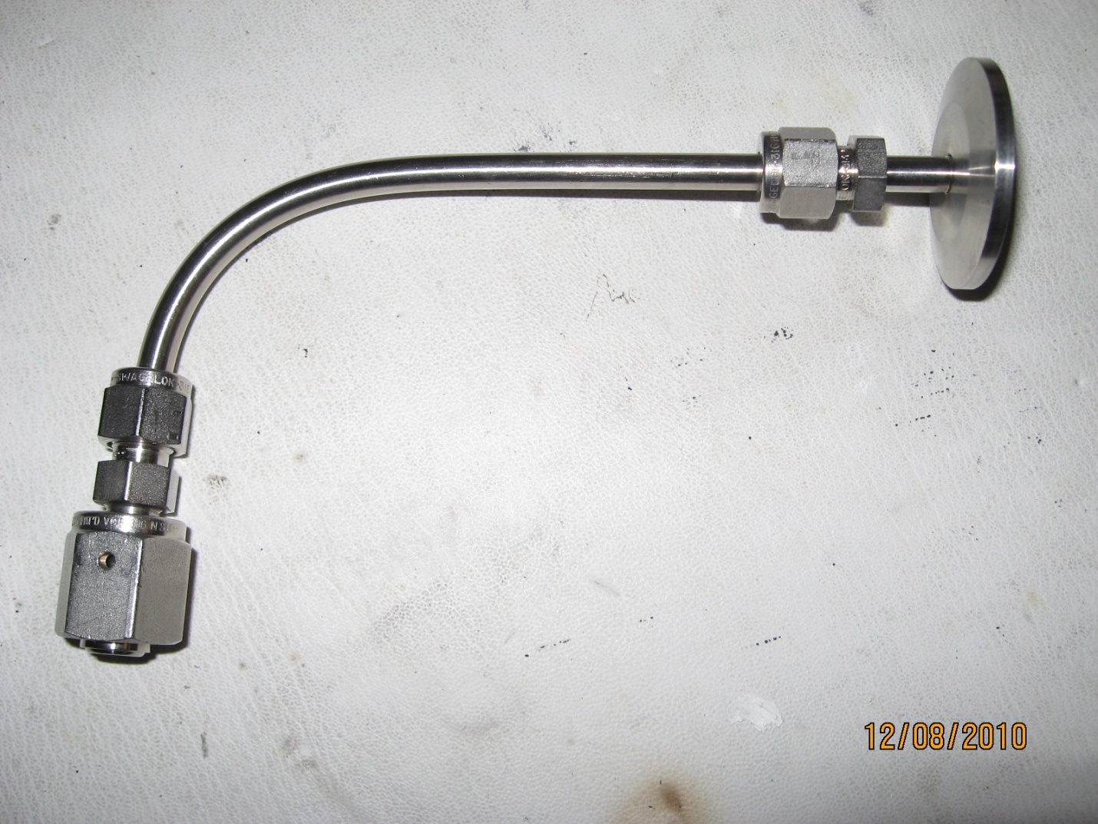

1. Pump + Fitting

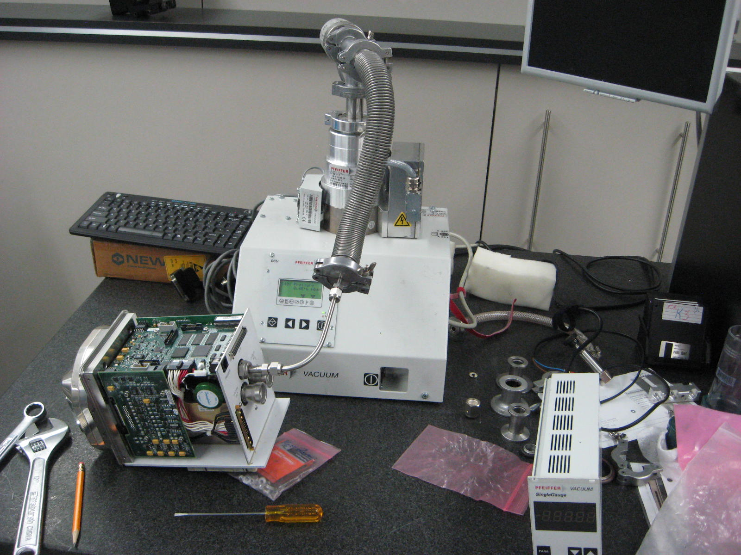

Inside Connection

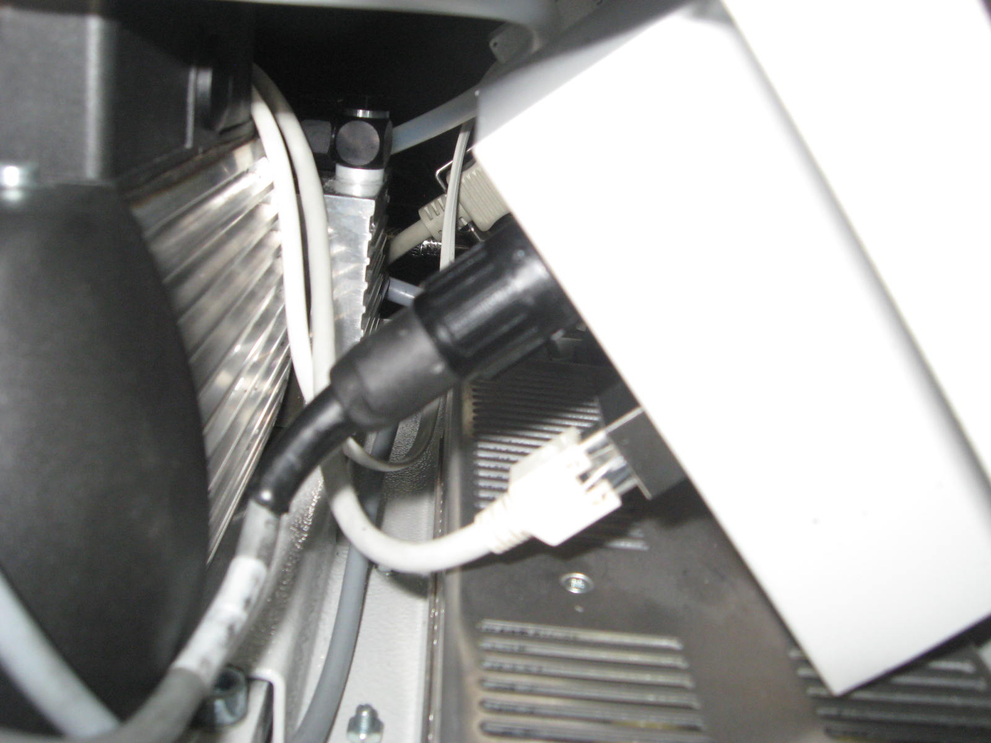

1. Apex - 4 screws need to be removed to take the cover off. 2 on each side (top & bottom) near the face of the detector.

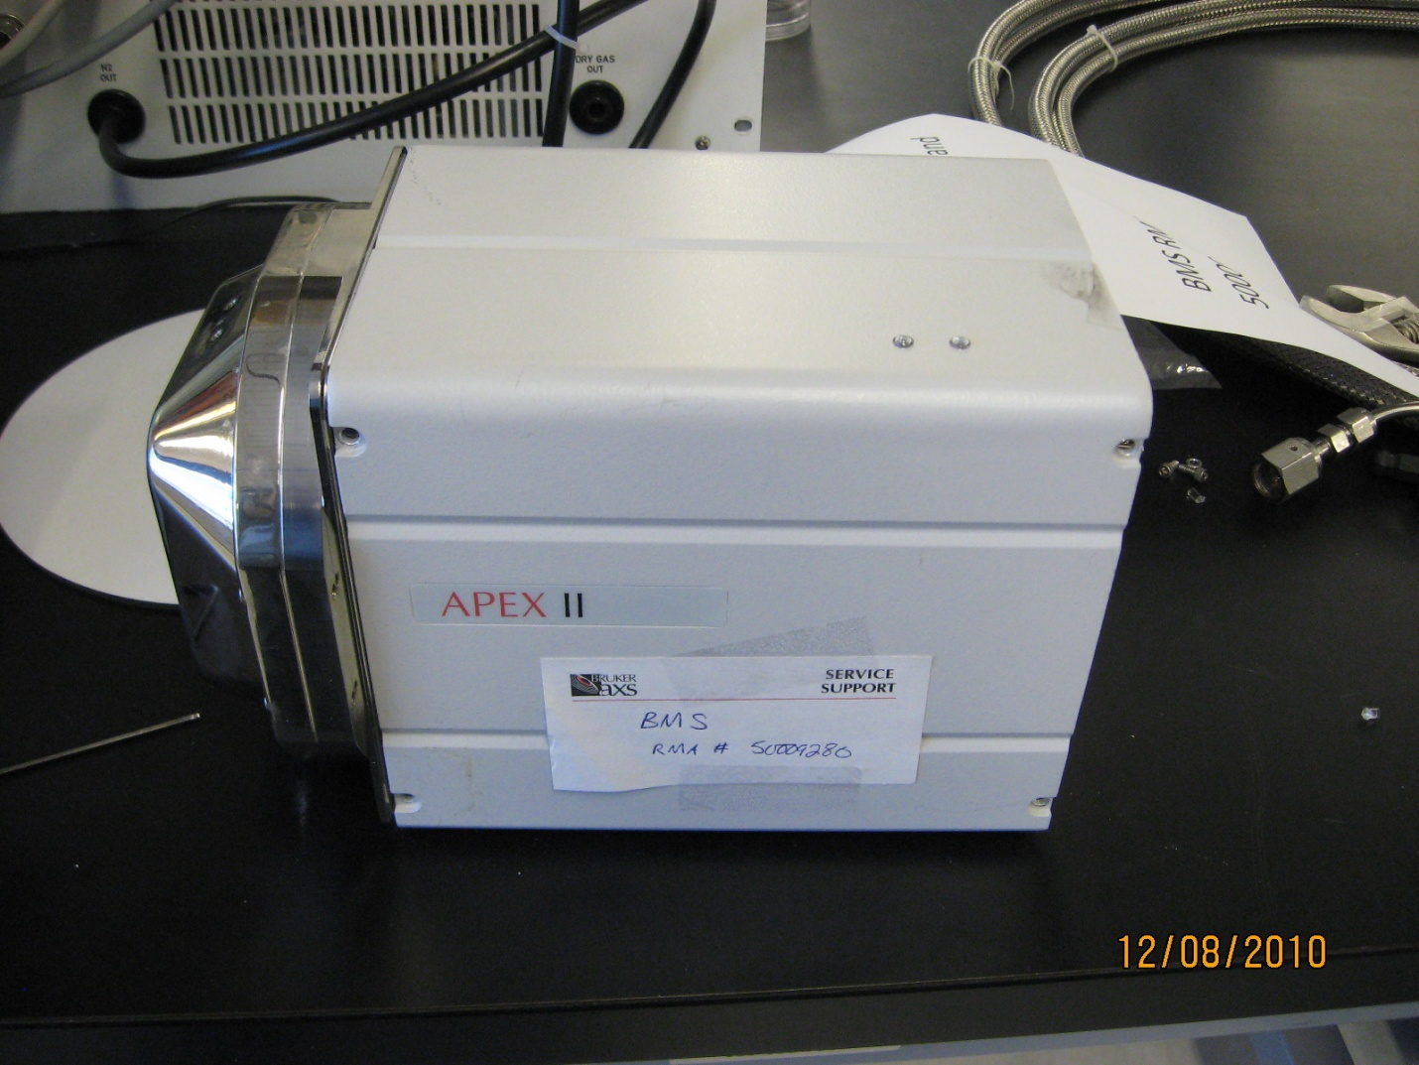

1. Apex II Cover:  The cover needs to be lifted up to remove it. Do not slide it back.

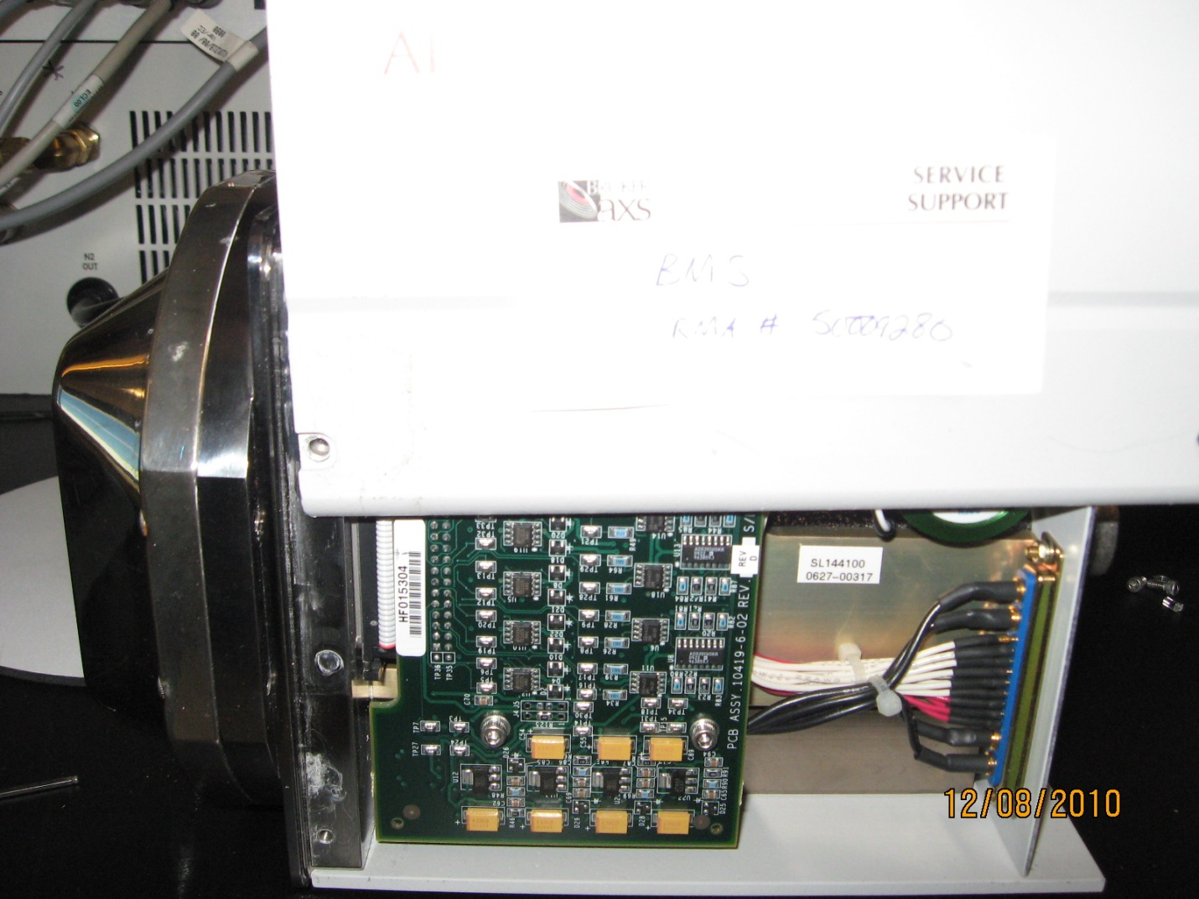

6. Apex II Cover removed: This is what the detector looks like when you remove cover.

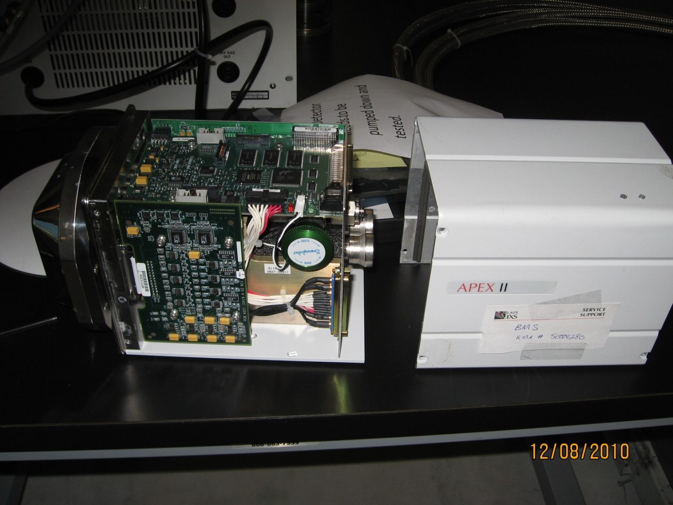

7.       Nut to remove: The nut pointed to needs to be removed.

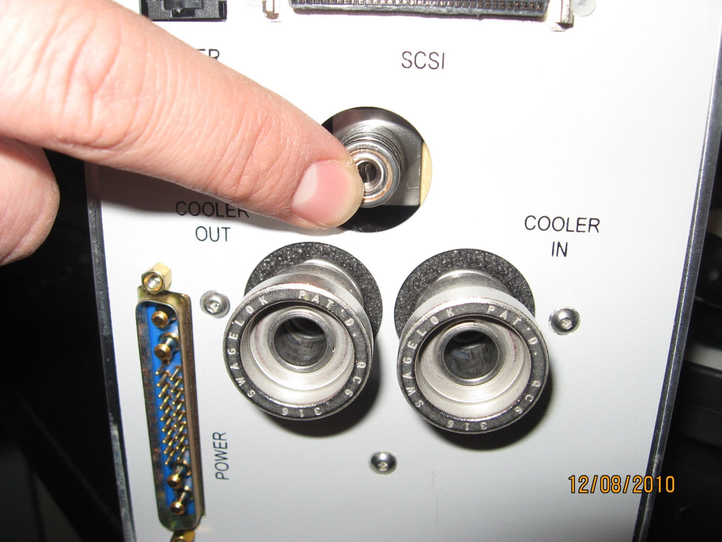

8.       Detector Nut + Insert: The insert inside the nut is needed when attaching the fitting.

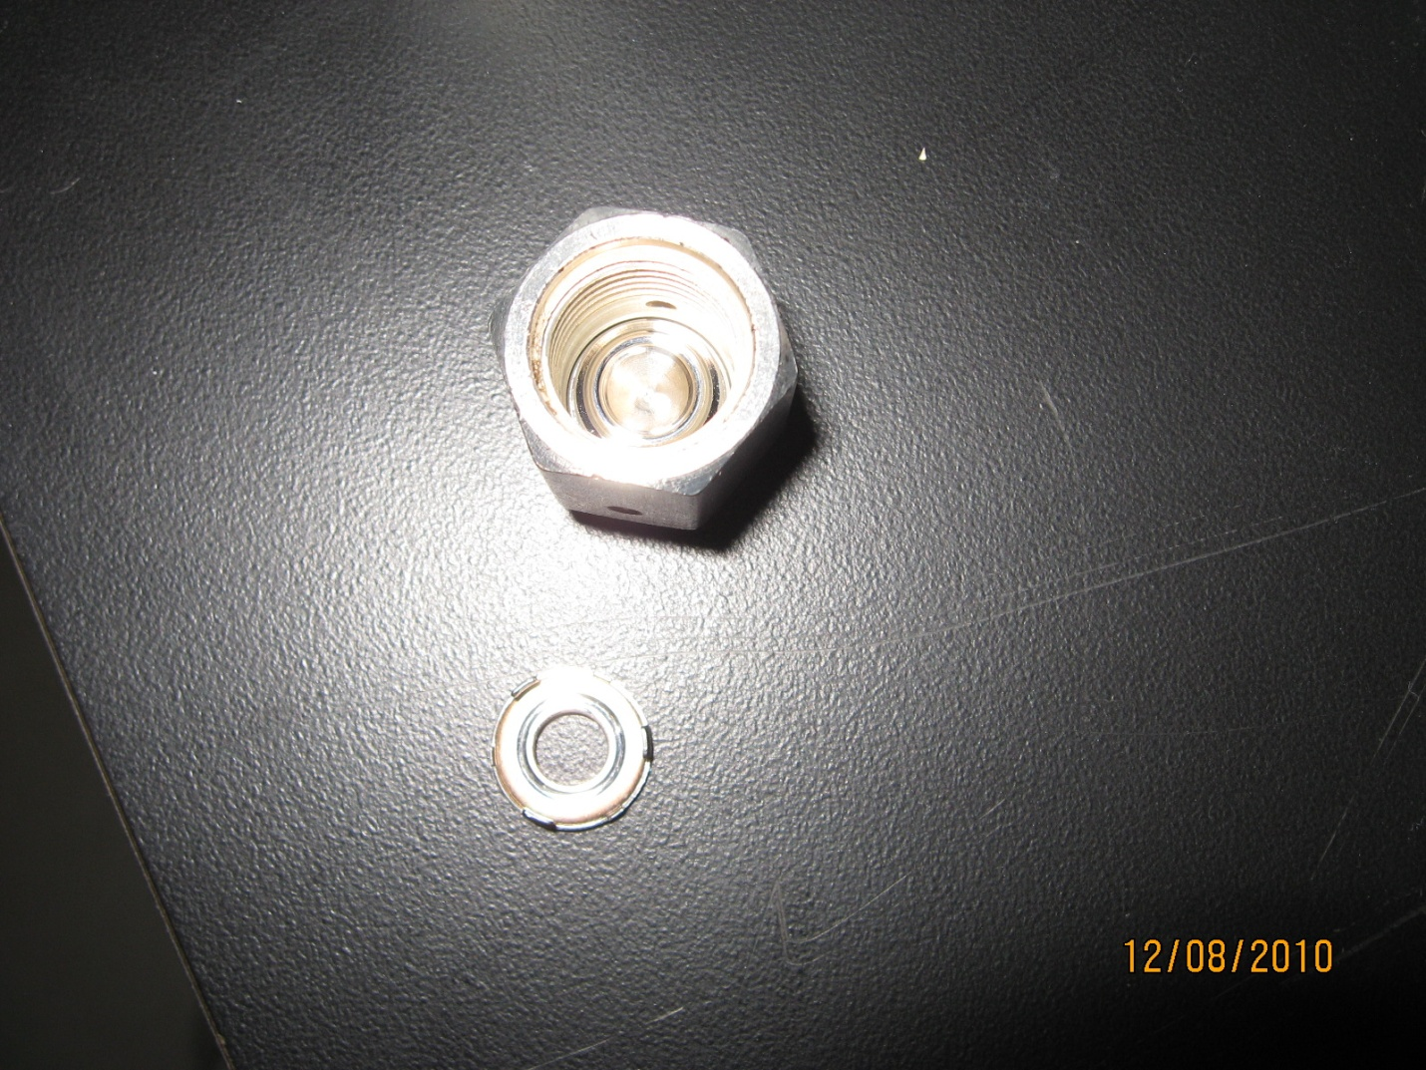

9.       Attach Fitting: Shows the fitting attached to the detector. Turn on the pump and vacuum for 15 minutes.

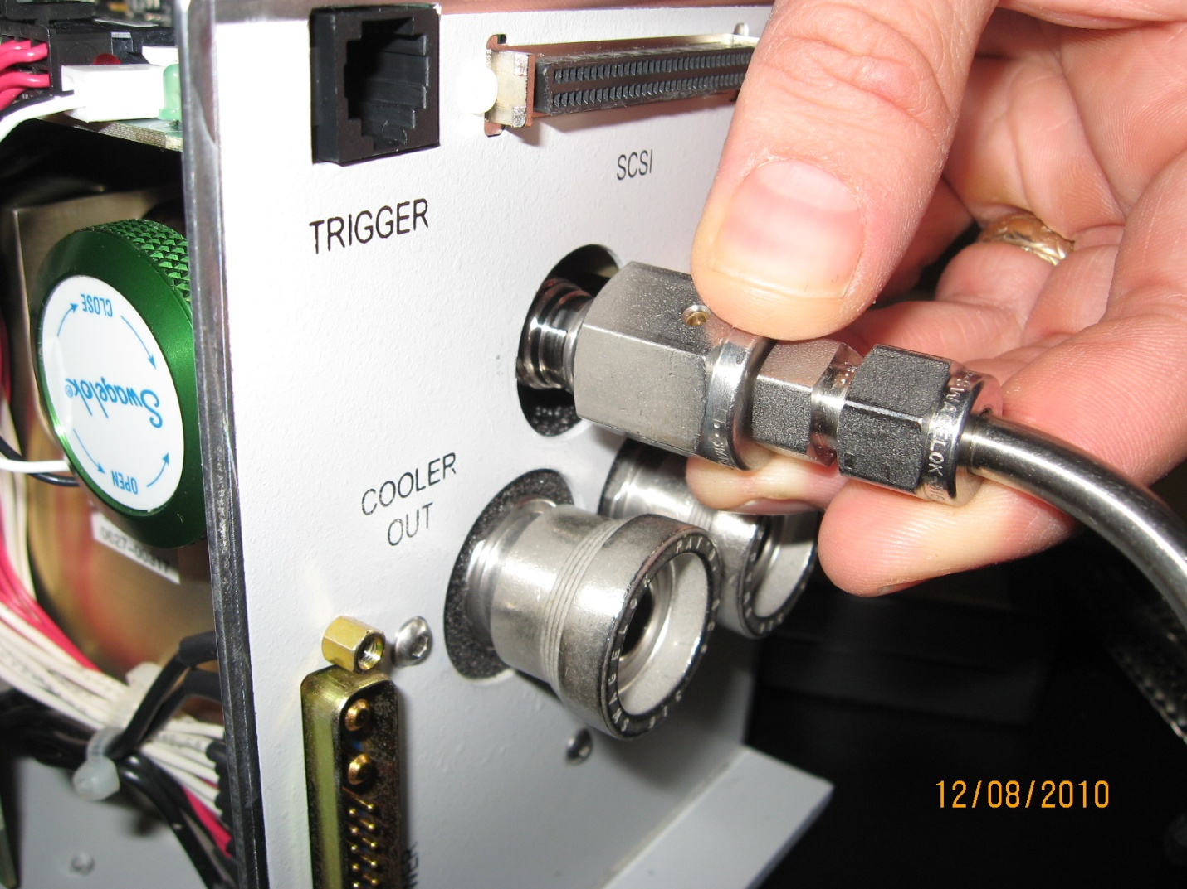

10.   Valve: After vacuuming for 15 minutes, the valve on the side needs to be opened. The vacuum needs to reach ~5 x 10-5 before opening. If this value is not reached in 15 minutes then shut down & recheck the connections.

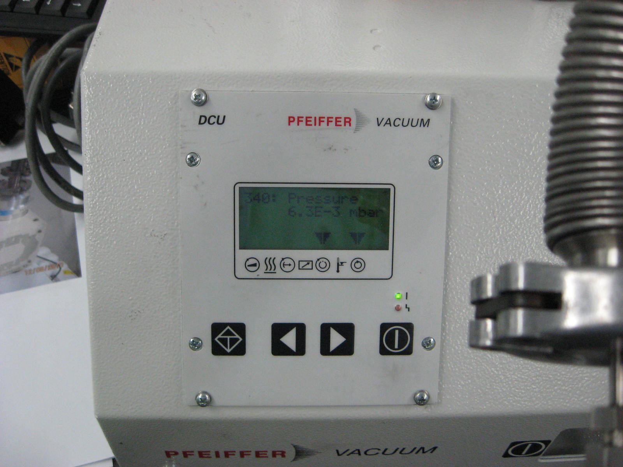

Allow the detector to be vacuumed a minimum of 4 hours (overnight is fine).

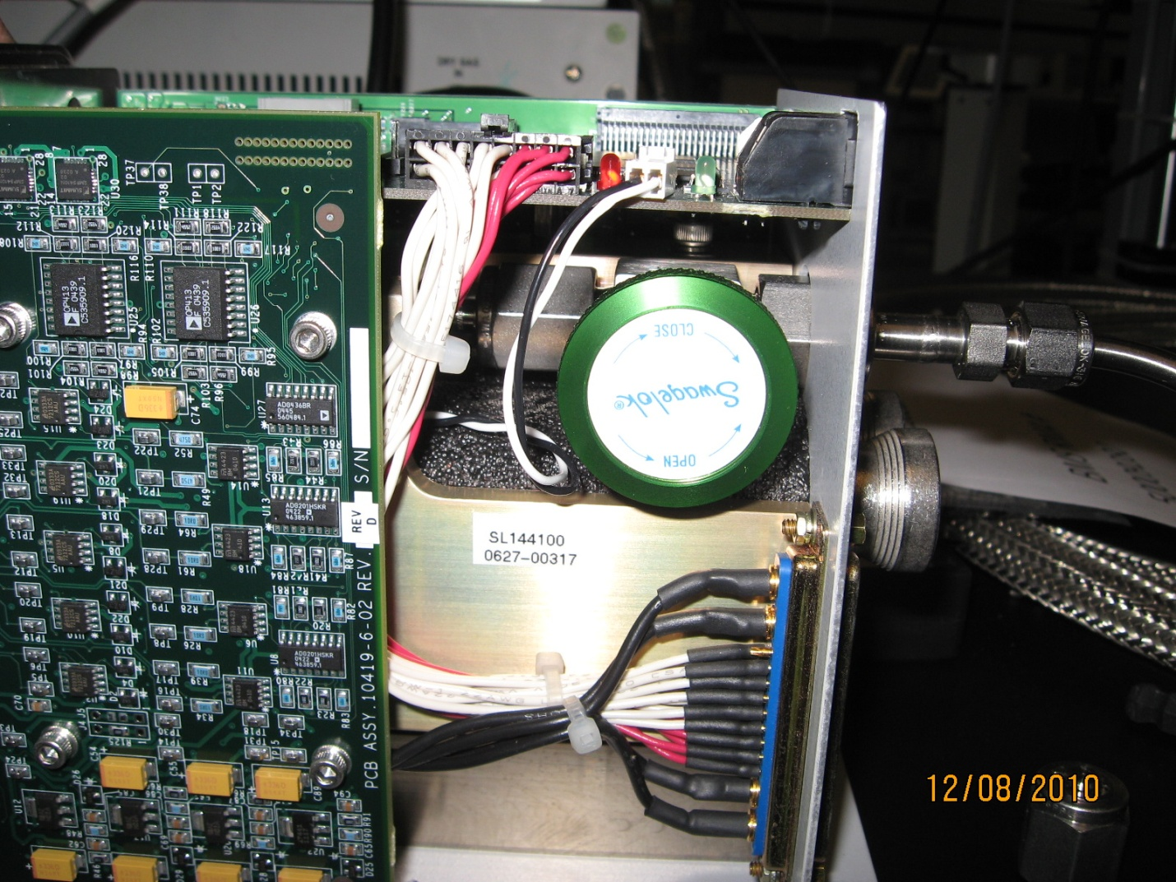

11. After this, close the valve and continue vacuuming for at least 15 minutes. Then stop the pump, remove the fitting, and reassemble.