Crystal Structure Report for K. Goldberg
by Milan Gembicky & Werner Kaminsky
Sample Submitted by Greg Fulmer
ID – GRF017
X-ray Crystallography Laboratory
University of Washington
28. July 2026

Data Collection started:
Documentation finished:

Data backup accessibly through http:
URL: http://cad4.cpac.washington.edu/structures
Username: xray-user
Password: hkl-data

W.Kaminsky: tel. (206) 543 7585
(x-ray lab): tel. (206) 543 0210
Email: kaminsky@chem.washington.edu

Understanding crystallographic information is not trivial. If you discuss a structure in a publication, please let the crystallographers proof-read the final draft of that manuscript before you submit it.
For many structures it is true that crystallography is an intellectual performance (like synthesis or elucidation of mechanisms) and not a routine job. In these cases, particularly when the structures contribute significantly to the content of the publication, the crystallographers should be co-authors. Do not think this is not necessary because you pay for structures.
From a batch of orange spherulites and some clear material was taken a colorless, twinned prism, measuring 0.15 x 0.07 x 0.04 mm³ which was mounted on a loop with oil. Data was collected at -173ºC on a Bruker APEX II single crystal X-ray diffractometer, Mo-radiation. Crystal-to-detector distance was 40 mm and exposure time was 10 seconds per degree for all sets. The scan width was 0.5º. Data collection was 94.2% complete to 25º in ϑ. The sample (Figure 1) showed concave interceptions on its edges which are typical signs of twinning. Additionally, twinning was indicated by the heterogeneity of birefringence and optical eigenray directions across the sample.

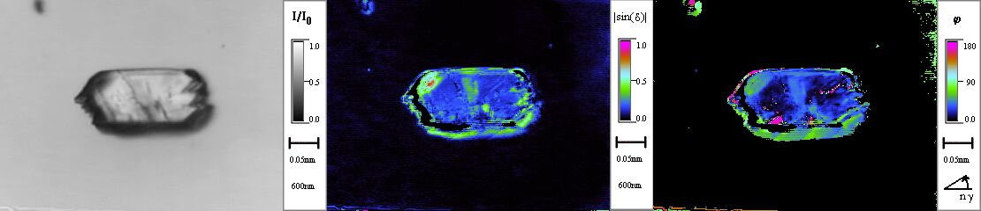
Figure 1. Crystal with signs of twinning, seen in (from left to right) transmission, birefringence and extinction.

The raw data appeared indeed twinned. With CELL_NOW a 6º twin operation about (0.745 -0.131 1.000) or [1.000 -0.655 0.680], consistent with a contact-mirror twin, as seen in Figure 1, was found which, if unresolved, would cause considerable overlap of diffraction peak intensities from different domains of the sample. Multi-domain integration with SAINT within the APEX2 software package by Bruker and absorption correction with twinabs removed the overlap. A total of 5771 (merged) reflections were collected with 2947 symmetry independent reflections covering the indices, h = -10 to 10, k = -11 to 11, l = -14 to 14 with R_{int} = 0.0424 indicated that the twin-refined data was good (average quality 0.07). Indexing and unit cell refinement indicated then a triclinic P lattice. The space group was found to be P‾1 (No.2).
Solution by direct methods (SHELXS, SIR97) produced a complete heavy atom phasing model consistent with the proposed structure. The structure was completed by difference Fourier synthesis with SHELXL97., Scattering factors are from Waasmair and Kirfel. Hydrogen atoms were placed in geometrically idealised positions and constrained to ride on their parent atoms with C−H distances in the range 0.95−1.00 Angstrom. Isotropic thermal parameters U_{eq} were fixed such that they were 1.2U_{eq} of their parent atom Ueq for CH's and 1.5U_{eq} of their parent atom U_{eq} in case of methyl groups. All non-hydrogen atoms were refined anisotropically by full-matrix least-squares

The structure is chemically disor-dered favoring the carboxylic ligand 3:2 over the C=O complex, which leads to 4 possible dimer configurations (Figure 2)
The structure is of high quality and ready for publication. Table 1 summarizes the data collection details. Figure 2 shows an ORTEP of the asymmetric unit with thermal ellipsoids at the 50% probability.

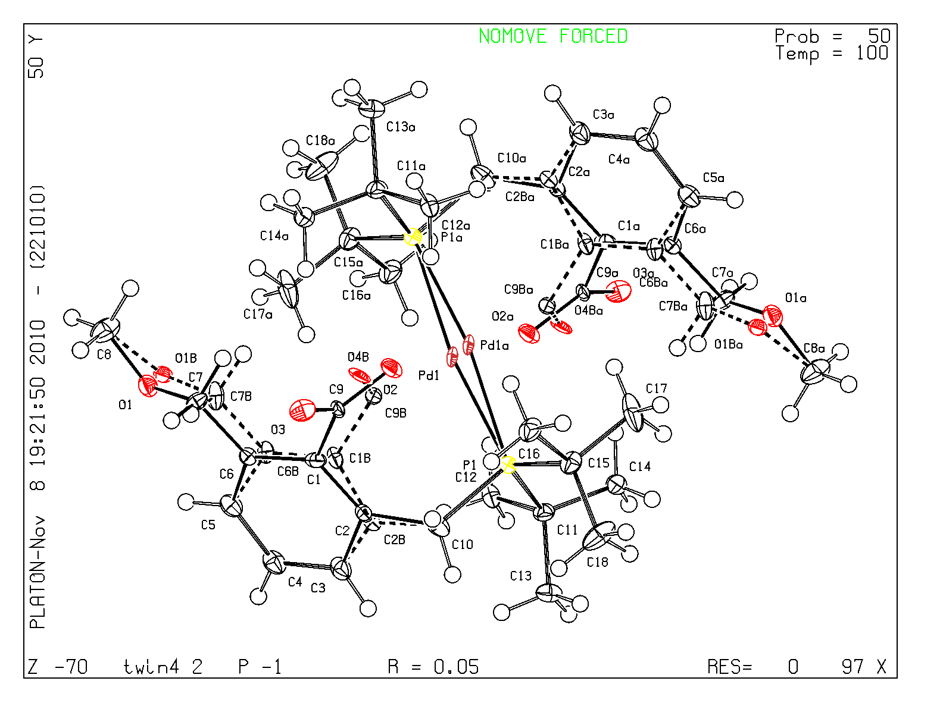

Table 1: Crystallographic data for the structures provided.
Identification code twin4_2
Empirical formula C36 H56 O5.16 P2 Pd
Formula weight 739.71
Temperature 100(2) K
Wavelength 0.71073 Å
Crystal system Triclinic
Space group P -1
Unit cell dimensions a = 8.4191(4) Å α= 71.585(2)°.
b = 9.7162(4) Å β= 70.990(3)°.
c = 11.8675(5) Å γ = 73.491(2)°.
Volume 852.87(6) Å3
Z 1
Density (calculated) 1.440 Mg/m3
Absorption coefficient 0.680 mm-1
F(000) 389.6
Crystal size 0.15 x 0.07 x 0.04 mm3
Theta range for data collection 2.26 to 25.35°.
Index ranges -10<=h<=10, -11<=k<=11, -14<=l<=14
Reflections collected 5771
Independent reflections 2947 [R(int) = 0.0424]
Completeness to theta = 25.00° 94.2 %
Max. and min. transmission 0.9733 and 0.9049
Refinement method Full-matrix least-squares on F2
Data / restraints / parameters 2947 / 96 / 273
Goodness-of-fit on F2 1.146
Final R indices [I>2sigma(I)] R1 = 0.0528, wR2 = 0.1043
R indices (all data) R1 = 0.0726, wR2 = 0.1095
Largest diff. peak and hole 0.722 and -0.723 e.Å-3

W. Kaminsky, E. Gunn, R. Sours, B. Kahr: Simultaneous false-color imaging of birefringence, extinction, and transmittance at camera speed. J Microscopy. 228 (2008) 153-164. W. Kaminsky: Real-time linear-birefringence-detecting polarization microscope. April 21st 2009, US Patent 7522278.
Sheldrick, G. M. (2005). CELL_NOW. University of Goettingen, Germany.
Bruker (2007) APEX2 (Version 2.1-4), SAINT (version 7.34A), SADABS (version 2007/4), BrukerAXS Inc, Madison, Wisconsin, USA.
Sheldrick, G. M. (2007). TWINABS. University of Goettingen, Germany.
(a) Altomare, A.; Burla, C.; Camalli M.; Cascarano L.; Giacovazzo C.; Guagliardi A.; Moliterni A.G.G.; Polidori G.; Spagna R. J. Appl. Cryst. 1999, 32, 115-119; (b) Altomare, A., Cascarano, G., Giacovazzo, C., Guagliardi, A., J. Appl. Cryst. 1993, 26, 343.
Sheldrick, G. M. SHELXL-97: Program for the Refinement of Crystal Structures 1997 University of Gottingen, Germany.
Mackay, S.; Edwards, C.; Henderson, A.; Gilmore, C.; Stewart, N.; Shankland, K.; Donald, A.; MaXus: a computer program for the solution and refinement of crystal structures from diffraction data. University of Glasgow, Scotland, 1997.
Waasmaier, D.; Kirfel, A. Acta Crystallogr. A. 1995, 51, 416.
Farrugia, L. J. Appl. Cryst. 1997, 30, 565

