Crystal Structure Report for
Sei-Hum Jang
by Werner Kaminsky
Sample ID – 03262025_7
X-ray Crystallography Laboratory
University of Washington
31. July 2026

Data Collection started: 3/26/2025
Documentation finished: 4/24/2025

Data backup accessibly through http:
URL: http://cad4.cpac.washington.edu/structures

W.Kaminsky: tel. (206) 543 7585
(x-ray lab): tel. (206) 543 0210
Email: kaminsky@chem.washington.edu

Understanding crystallographic information is not trivial. If you discuss a structure in a publication, please let the crystallographers proof-read the final draft of that manuscript before you submit it.
For many structures it is true that crystallography is an intellectual performance (like synthesis or elucidation of mechanisms) and not a routine job. In these cases, particularly when the structures contribute significantly to the content of the publication, the crystallographers should be co-authors. Do not think this is not necessary because you pay for structures.
A lustrous bronce prism, measuring 0.15 x 0.05 x 0.03 mm³ was mounted on a loop with oil. Data was collected at -173ºC on a Bruker APEX II single crystal X-ray diffractometer, Mo-radiation, equipped with a Miracol X-ray optical collimator.

Crystal-to-detector distance was 40 mm and exposure time was 120 seconds per frame for all sets. The scan width was 1º. Data collection was 94% complete to 17.82º in ϑ. A total of 172567 reflections were collected covering the indices, -14<=h<=14, -17<=k<=17, -32<=l<=33. Indexing and unit cell refinement indicated a triclinic lattice. The space group was found to be P ‾1 (No. 2).

The data was integrated and scaled using SAINT, SADABS within the APEX2 software package by Bruker.

The contribution of disordered solvent to the diffraction pattern was removed with SQUEEZE

Objective outlier removal was achieved with the Bayesian post-processing algorithm from within the SORTAV package.

Solution by direct methods (SHELXT or SIR97) produced a complete heavy atom phasing model consistent with the proposed structure. The structure was completed by difference Fourier synthesis with SHELXL. Scattering factors are from Waasmair and Kirfel. Hydrogen atoms were placed in geometrically idealised positions and constrained to ride on their parent atoms with C---H distances in the range 0.95-1.00 Angstrom. Isotropic thermal parameters U_{eq} were fixed such that they were 1.2U_{eq} of their parent atom Ueq for CH's and 1.5U_{eq} of their parent atom U_{eq} in case of methyl groups. All non-hydrogen atoms were refined anisotropically by full-matrix least-squares.

The data appeared twinned via two-fold rotation about (0 0 1) with most reflections between the twin components overlapping. An artificial hklf5 file was created to allow twin refinement together with solvent treatment utilizing SQUEEZE.
The structure contains infinite solvent filled channels, the contribution to the diffraction patterns was masked entangled side chains

The structure solved badly (only the bromines became visible in P‾1, but a partial solution in P 1 and shifting the atom coordinates accordingly allowed to build the model atom by atom with many restraints serving as scaffold to stabilize the refinement. Most restraints were removed in the final steps, leaving only those absolutely necessary.

The structure is likely not publishable but may serve for research purposes. Table 1 summarizes the data collection details. Figure 1 shows an ORTEP of the asymmetric unit.
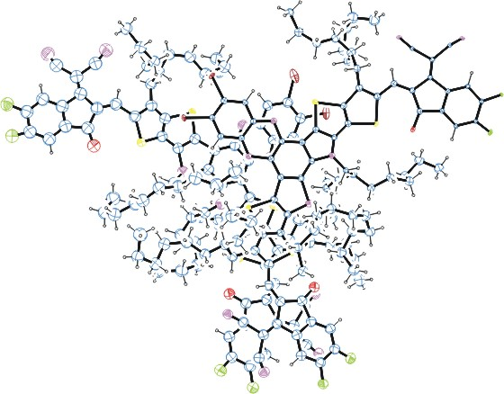
Figure 1. ORTEP of the structure with thermal ellipsoids at the 15% probability level.

Table 1: Crystallographic data for the structures provided.
Empirical formula C98 H108 Br2 F4 N8 O2 S4
Formula weight 1793.98
Temperature 100(2) K
Wavelength 0.71073 Å
Crystal system Triclinic
Space group P -1
Unit cell dimensions a = 17.48(4) Å α= 90.94(11)°.
b = 21.10(3) Å β= 98.03(13)°.
c = 38.66(5) Å γ = 102.01(12)°.
Volume 13794(40) Å3
Z 4
Density (calculated) 0.864 Mg/m3
Absorption coefficient 0.689 mm-1
F(000) 3752
Crystal size 0.150 x 0.050 x 0.030 mm3
Theta range for data collection 0.988 to 17.817°.
Index ranges -14<=h<=14, -17<=k<=17, -32<=l<=33
Reflections collected 172567
Independent reflections 172567 [R(int) = 0.2690]
Completeness to theta = 17.817° 94.0 %
Refinement method Full-matrix least-squares on F2
Data / restraints / parameters 172567 / 3217 / 2020
Goodness-of-fit on F2 1.089
Final R indices [I>2sigma(I)] R1 = 0.2533, wR2 = 0.4973
R indices (all data) R1 = 0.4635, wR2 = 0.6304
Largest diff. peak and hole 1.110 and -0.920 e.Å-3

Bruker (2007) APEX2 (Version 2.1-4), SAINT (version 7.34A), SADABS (version 2007/4), BrukerAXS Inc, Madison, Wisconsin, USA.
(a) A. Spek, J. Appl. Cryst. (2003), 36, 7-13; (b) P. van der Sluis & A. L. Spek, Acta Cryst. (1990). A46, 194-201. (c) Spek, A. L. (2009). Acta. Cryst. D65, 148-155.
(a) S. French and K. Wilson (1979). On the Treatment of Negative Intensity Observations. Acta Cryst. A34, 517-525. (b) Blessing, R. H. (1995). An empirical correction for absorption anisotropy. Acta Cryst. A51 33-38.
(a) Sheldrick GM. (2008) A short history of SHELX. Acta Cryst. A64, 112-122. (b) Sheldrick GM. (2015) SHELXT - Integrated space-group and crystal-structure determination. Acta Cryst. A71, 3-8.
(a) Altomare A, Burla C, Camalli M, Cascarano G L, Giacovazzo C, Guagliardi A, Moliterni AGG, Polidori G, Spagna R. (1999) SIR97: a new tool for crystal structure determination and refinement Journal of Applied Crystallography, 32, 115-119. (b) Altomare A, Cascarano G L, Giacovazzo C, Guagliardi A. (1993) Completion and refinement of crystal structures with SIR 92. Journal of Applied Crystallography, 26, 343-350.
(a) Sheldrick GM. (1997) SHELXL-97, Program for the Refinement of Crystal Structures. University of Göttingen, Germany. (b) Sheldrick GM. (2015) Crystal structure refinement with SHELXL. Acta Cryst. C71, 3–8
Waasmaier, D.; Kirfel, A. (1995) New Analytical Scattering Factor Functions for Free Atoms and Ions. Acta Crystallographica A., 51, 416-430.
Farrugia LJ. (1997) Ortep-3 for Windows. Journal of Applied Crystallography, 30, 565

