Crystal Structure Report for K. Goldberg
by Sarah Flowers and Werner Kaminsky
Sample Submitted by Sophia Cherry
ID – 05SDT105
X-ray Crystallography Laboratory
University of Washington
28. July 2026

Data Collection started: 9/22/15
Documentation finished: 10/2/15

Data backup accessibly through http:
URL: http://cad4.cpac.washington.edu/structures
Username: xray-user
Password: hkl-data

W.Kaminsky: tel. (206) 543 7585
(x-ray lab): tel. (206) 543 0210
Email: kaminsky@chem.washington.edu

Understanding crystallographic information is not trivial. If you discuss a structure in a publication, please let the crystallographers proof-read the final draft of that manuscript before you submit it.
For many structures it is true that crystallography is an intellectual performance (like synthesis or elucidation of mechanisms) and not a routine job. In these cases, particularly when the structures contribute significantly to the content of the publication, the crystallographers should be co-authors. Do not think this is not necessary because you pay for structures. Even I have to pay for my own structures for my research.
A clear yellow piece, measuring 0.15 x 0.11 x 0.080 mm³ was mounted on a loop with oil. Data was collected at -173ºC on a Bruker APEX II single crystal X-ray diffractometer, Mo-radiation.

Crystal-to-detector distance was 40.00 mm and exposure time was 120 seconds per frame for all sets. The scan width was 1.0º. Data collection was 100.0 % complete to 25º in ϑ. A total of 56,547 reflections were collected covering the indices, h = -13 to 13, k = -20 to 20, l = -34 to 34. 10,430 reflections were symmetry independent and the R_{int} = 0.1243 indicated that the data was below average quality (0.07). Indexing and unit cell refinement indicated a Monoclinic lattice. The space group was found to be P 21/c (No.14).

The data was integrated and scaled using SAINT, SADABS within the APEX2 software package by Bruker.

Solution by direct methods (SHELXS, SIR97) produced a complete heavy atom phasing model consistent with the proposed structure. The structure was completed by difference Fourier synthesis with SHELXL97., Scattering factors are from Waasmair and Kirfel. Hydrogen atoms were placed in geometrically idealised positions and constrained to ride on their parent atoms with C---H distances in the range 0.95-1.00 Angstrom. Isotropic thermal parameters U_{eq} were fixed such that they were 1.2U_{eq} of their parent atom Ueq for CH's and 1.5U_{eq} of their parent atom U_{eq} in case of methyl groups. All non-hydrogen atoms were refined anisotropically by full-matrix least-squares.

During refinement of the structure, two large infinite voids around (0.0, 0.0, 0.0) and (0.0, 0.5, 0.5) were discovered and appeared to be filled with disordered pentane. Therefore the application of squeeze⁶ was used to resolve the contribution of solvent in these voids. A total of 358 electrons were found, 179 in each void.

The structure is of high quality and ready for publication. Table 1 summarizes the data collection details. Figure 1 shows an ORTEP⁷ of the asymmetric unit.

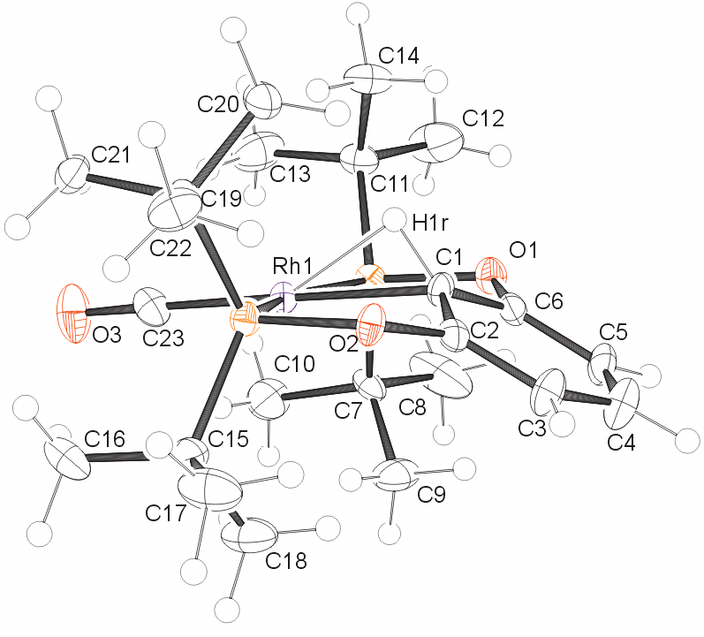

Figure 1. ORTEP of the structure with thermal ellipsoids at the 50% probability level. B(C₆F₅)₄ counter ion omitted for clarity.

Table 1. Crystal data and structure refinement for 05sdt105_0ma.

Empirical formula C47 H40 B F20 O3 P2 Rh
Formula weight 1208.45
Temperature 100(2) K
Wavelength 0.71073 Å
Crystal system Monoclinic
Space group P 1 21/c 1
Unit cell dimensions a = 11.2020(12) Å α= 90°.
b = 16.4233(19) Å β= 95.383(6)°.
c = 27.815(2) Å γ = 90°.
Volume 5094.7(9) Å3
Z 4
Density (calculated) 1.576 Mg/m3
Absorption coefficient 0.511 mm-1
F(000) 2424
Crystal size 0.45 x 0.15 x 0.11 mm3
Theta range for data collection 1.44 to 26.44°.
Index ranges -13<=h<=13, -20<=k<=20, -34<=l<=34
Reflections collected 56547
Independent reflections 10430 [R(int) = 0.1243]
Completeness to theta = 25.00° 100.0 %
Absorption correction Semi-empirical from equivalents
Max. and min. transmission 0.9459 and 0.8026
Refinement method Full-matrix least-squares on F2
Data / restraints / parameters 10430 / 0 / 683
Goodness-of-fit on F2 0.976
Final R indices [I>2sigma(I)] R1 = 0.0575, wR2 = 0.1031
R indices (all data) R1 = 0.1069, wR2 = 0.1211
Largest diff. peak and hole 0.930 and -0.541 e.Å-3

Bruker (2007) APEX2 (Version 2.1-4), SAINT (version 7.34A), SADABS (version 2007/4), BrukerAXS Inc, Madison, Wisconsin, USA.
(a) Altomare A, Burla C, Camalli M, Cascarano G L, Giacovazzo C, Guagliardi A, Moliterni AGG, Polidori G, Spagna R. (1999) SIR97: a new tool for crystal structure determination and refinement Journal of Applied Crystallography, 32, 115-119. (b) Altomare A, Cascarano G L, Giacovazzo C, Guagliardi A. (1993) Completion and refinement of crystal structures with SIR 92. Journal of Applied Crystallography, 26, 343-350.
Sheldrick GM. (1997) SHELXL-97, Program for the Refinement of Crystal Structures. University of Göttingen, Germany.
Mackay, S.; Edwards, C.; Henderson, A.; Gilmore, C.; Stewart, N.; Shankland, K.; Donald, A. (1997) MaXus: a computer program for the solution and refinement of crystal structures from diffraction data. University of Glasgow, Scotland,.
Waasmaier, D.; Kirfel, A. (1995) New Analytical Scattering Factor Functions for Free Atoms and Ions. Acta Crystallographica A., 51, 416-430. 6 P. v.d. Sluis & A.L. Spek, BYPASS: an effective method for the refinement of crystal structures containing disordered solvent regions. Acta Cryst. A46, (1990), 194-201.

