Crystal Structure Report for M Heinekey
by Sarah Flowers & Werner Kaminsky
Sample Submitted by Sophia Cherry
ID – 05SDT180
X-ray Crystallography Laboratory
University of Washington
31. July 2026

Data Collection started: 11/30/2015
Documentation finished: 12/2/2015

Data backup accessibly through http:
URL: http://cad4.cpac.washington.edu/structures

W.Kaminsky: tel. (206) 543 7585
(x-ray lab): tel. (206) 543 0210
Email: kaminsky@chem.washington.edu

Understanding crystallographic information is not trivial. If you discuss a structure in a publication, please let the crystallographers proof-read the final draft of that manuscript before you submit it.
For many structures it is true that crystallography is an intellectual performance (like synthesis or elucidation of mechanisms) and not a routine job. In these cases, particularly when the structures contribute significantly to the content of the publication, the crystallographers should be co-authors. Do not think this is not necessary because you pay for structures. Even I have to pay for my own structures for my research.
A yellow prism, measuring 0.15 x 0.15 x 0.15 mm³ was mounted on a loop with oil. Data was collected at -173ºC on a Bruker APEX II single crystal X-ray diffractometer, Mo-radiation.

Crystal-to-detector distance was 40 mm and exposure time was 10 seconds per frame for all sets. The scan width was 0.5º. Data collection was 99.9% complete to 25º in ϑ.
The data appeared twinned into two domains related by a two-fold rotation about [1 1 0] (CELL_NOW) and after multi-domain integration (SAINT, SADABS within the APEX2 software package by Bruker.) and merging (twinabs) a total of 9438 (merged) reflections covered the indices, -11<=h<=10, -16<=k<=15, 0<=l<=17. 6207 reflections were symmetry independent and the R_{int} = 0.0350 indicated that the data was excellent (average quality 0.07). Indexing and unit cell refinement indicated a primitive monoclinic lattice. The space group was found to be P‾1 (No. 2).

Solution by direct methods (SHELXS, SIR97) produced a complete heavy atom phasing model consistent with the proposed structure. The structure was completed by difference Fourier synthesis with SHELXL97., Scattering factors are from Waasmair and Kirfel. Hydrogen atoms were placed in geometrically idealised positions and constrained to ride on their parent atoms with C---H distances in the range 0.95-1.00 Angstrom. Isotropic thermal parameters U_{eq} were fixed such that they were 1.2U_{eq} of their parent atom Ueq for CH's and 1.5U_{eq} of their parent atom U_{eq} in case of methyl groups. All non-hydrogen atoms were refined anisotropically by full-matrix least-squares.

The structure is of high quality and ready for publication. Table 1 summarizes the data collection details. Figure 1 shows an ORTEP of the asymmetric unit.

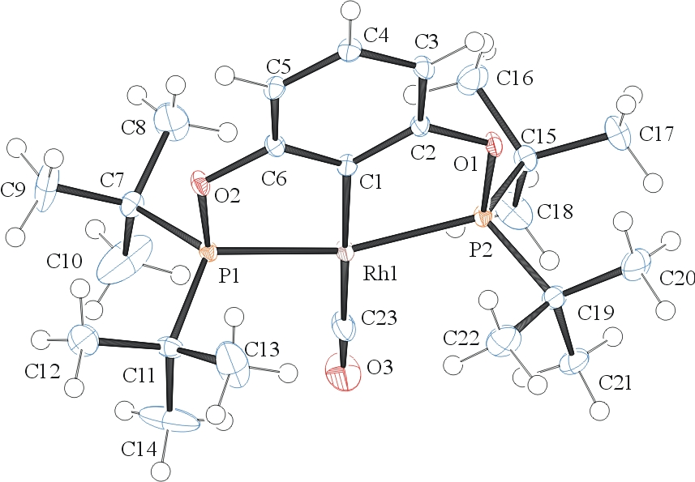
Figure 1. ORTEP of the structure with thermal ellipsoids at the 50% probability level.

Table 1: Crystallographic data for the structures provided.
Empirical formula C23 H39 O3 P2 Rh
Formula weight 528.39
Temperature 100(2) K
Wavelength 0.71073 Å
Crystal system Triclinic
Space group P -1
Unit cell dimensions a = 8.2712(9) Å α= 100.739(5)°.
b = 12.0197(12) Å β= 96.265(5)°.
c = 13.4327(15) Å γ = 103.746(5)°.
Volume 1257.9(2) Å3
Z 2
Density (calculated) 1.395 Mg/m3
Absorption coefficient 0.826 mm-1
F(000) 552
Crystal size 0.150 x 0.150 x 0.150 mm3
Theta range for data collection 1.563 to 28.366°.
Index ranges -11<=h<=10, -16<=k<=15, 0<=l<=17
Reflections collected 81060
Independent reflections 6207 [R(int) = 0.0350]
Completeness to theta = 25.000° 99.9 %
Absorption correction Semi-empirical from equivalents
Max. and min. transmission 0.945 and 0.828
Refinement method Full-matrix least-squares on F2
Data / restraints / parameters 6207 / 0 / 275
Goodness-of-fit on F2 1.131
Final R indices [I>2sigma(I)] R1 = 0.0314, wR2 = 0.0779
R indices (all data) R1 = 0.0347, wR2 = 0.0802
Largest diff. peak and hole 2.014 and -0.723 e.Å-3

Sheldrick, G. M. (2005). CELL_NOW. University of Goettingen, Germany.
Bruker (2007) APEX2 (Version 2.1-4), SAINT (version 7.34A), SADABS (version 2007/4), BrukerAXS Inc, Madison, Wisconsin, USA.
Sheldrick, G. M. (2007). TWINABS. University of Goettingen, Germany.
(a) Altomare A, Burla C, Camalli M, Cascarano G L, Giacovazzo C, Guagliardi A, Moliterni AGG, Polidori G, Spagna R. (1999) SIR97: a new tool for crystal structure determination and refinement Journal of Applied Crystallography, 32, 115-119. (b) Altomare A, Cascarano G L, Giacovazzo C, Guagliardi A. (1993) Completion and refinement of crystal structures with SIR 92. Journal of Applied Crystallography, 26, 343-350.
(a) Sheldrick GM. (1997) SHELXL-97, Program for the Refinement of Crystal Structures. University of Göttingen, Germany. (b) Sheldrick GM. (2013) Crystal structure refinement with SHELXL. Acta Cryst. (2015). C71, 3-8.
Mackay, S.; Edwards, C.; Henderson, A.; Gilmore, C.; Stewart, N.; Shankland, K.; Donald, A. (1997) MaXus: a computer program for the solution and refinement of crystal structures from diffraction data. University of Glasgow, Scotland,.
Waasmaier, D.; Kirfel, A. (1995) New Analytical Scattering Factor Functions for Free Atoms and Ions. Acta Crystallographica A., 51, 416-430.
Farrugia LJ. (1997) Ortep-3 for Windows. Journal of Applied Crystallography, 30, 565

