Crystal Structure Report for J. Kovacs
by Dylan Rogers & Werner Kaminsky
Sample Submitted by Maks Dedushko
ID – 103019_FeTrenSO2
X-ray Crystallography Laboratory
University of Washington
31. July 2026

Data Collection started: 10/30/2019
Documentation finished: 11/8/2019

Data backup accessibly through http:
URL: http://cad4.cpac.washington.edu/structures

W.Kaminsky: tel. (206) 543 7585
(x-ray lab): tel. (206) 543 0210
Email: kaminsky@chem.washington.edu

Understanding crystallographic information is not trivial. If you discuss a structure in a publication, please let the crystallographers proof-read the final draft of that manuscript before you submit it.
For many structures it is true that crystallography is an intellectual performance (like synthesis or elucidation of mechanisms) and not a routine job. In these cases, particularly when the structures contribute significantly to the content of the publication, the crystallographers should be co-authors. Do not think this is not necessary because you pay for structures.
A red piece, measuring 0.08 x 0.08 x 0.08 mm³ was mounted on a loop with oil. Data was collected at -173ºC on a Bruker APEX II single crystal X-ray diffractometer, Mo-radiation.

Crystal-to-detector distance was 40 mm and exposure time was 30 seconds per frame for all sets. The scan width was 0.5º. Data collection was 99.8% complete to 25º in ϑ. A total of 4637 merged reflections were collected covering the indices, -13<=h<=13, -10<=k<=10, -15<=l<=15. 4340 reflections were symmetry independent and the R_{int} = 0.0473 indicated that the data was excellent. Indexing and unit cell refinement indicated a primitive monoclinic lattice. The space group was found to be P 2₁ (No. 4).

The data was integrated and scaled using SAINT, SADABS within the APEX2 software package by Bruker.

Solution by direct methods (SHELXT or SIR97) produced a complete heavy atom phasing model consistent with the proposed structure. The structure was completed by difference Fourier synthesis with SHELXL., Scattering factors are from Waasmair and Kirfel. Hydrogen atoms were placed in geometrically idealised positions and constrained to ride on their parent atoms with C---H distances in the range 0.95-1.00 Angstrom. Isotropic thermal parameters U_{eq} were fixed such that they were 1.2U_{eq} of their parent atom Ueq for CH's and 1.5U_{eq} of their parent atom U_{eq} in case of methyl groups. All non-hydrogen atoms were refined anisotropically by full-matrix least-squares.

The structure solved in space groups P 2₁ and P 2₁/m. The R₁ in the centrosymmetric space group was considerably worse than for the chiral one. In addition, the disorder model in P 2₁ sees the atoms on both sides of a pseudo-mirror plane at very different site occupancies (0.87:0.13), whereas a true mirror would have both sides at 0.5 site occupancy. The pseudo mirror symmetry was simply a result of 1:1 enantiomorphic twinning.

The disordered methoxy group interacts with the disordered PF₆⁻ which exhibits the exact same disorder site occupancies.

The structure is of high quality and ready for publication. Table 1 summarizes the data collection details. Figure 1 shows an ORTEP of the asymmetric unit.

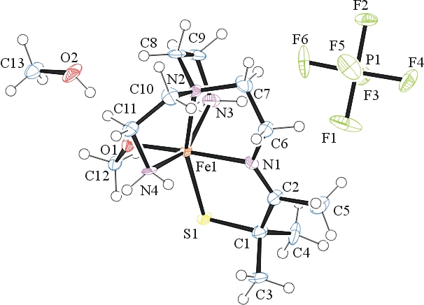
Figure 1. ORTEP of the structure with thermal ellipsoids at the 50% probability level. Disorder omitted for clarity.

Table 1: Crystallographic data for the structures provided.
Empirical formula C13 H32 F6 Fe N4 O2 P S
Formula weight 509.30
Temperature 100(2) K
Wavelength 0.71073 Å
Crystal system Monoclinic
Space group P 2₁
Unit cell dimensions a = 10.4236(9) Å α= 90°.
b = 8.6965(7) Å β= 104.350(5)°.
c = 12.0629(11) Å γ = 90°.
Volume 1059.37(16) Å3
Z 2
Density (calculated) 1.597 Mg/m3
Absorption coefficient 0.954 mm-1
F(000) 530
Crystal size 0.080 x 0.080 x 0.080 mm3
Theta range for data collection 1.743 to 26.476°.
Index ranges -13<=h<=13, -10<=k<=10, -15<=l<=15
Reflections collected 4637
Independent reflections 4340 [R(int) = 0.0473]
Completeness to theta = 25.000° 99.8 %
Refinement method Full-matrix least-squares on F2
Data / restraints / parameters 4340 / 171 / 305
Goodness-of-fit on F2 1.015
Final R indices [I>2sigma(I)] R1 = 0.0562, wR2 = 0.1097
R indices (all data) R1 = 0.1038, wR2 = 0.1287
Absolute structure parameter 0.50(5)
Largest diff. peak and hole 0.469 and -0.580 e.Å-3

Bruker (2007) APEX2 (Version 2.1-4), SAINT (version 7.34A), SADABS (version 2007/4), BrukerAXS Inc, Madison, Wisconsin, USA.
Sheldrick GM. (2015) SHELXT - Integrated space-group and crystal-structure determination. Acta Cryst. A71, 3-8.
(a) Altomare A, Burla C, Camalli M, Cascarano G L, Giacovazzo C, Guagliardi A, Moliterni AGG, Polidori G, Spagna R. (1999) SIR97: a new tool for crystal structure determination and refinement Journal of Applied Crystallography, 32, 115-119. (b) Altomare A, Cascarano G L, Giacovazzo C, Guagliardi A. (1993) Completion and refinement of crystal structures with SIR 92. Journal of Applied Crystallography, 26, 343-350.
(a) Sheldrick GM. (1997) SHELXL-97, Program for the Refinement of Crystal Structures. University of Göttingen, Germany. (b) Sheldrick GM. (2015) Crystal structure refinement with SHELXL. Acta Cryst. (2015). C71, 3–8
Mackay, S.; Edwards, C.; Henderson, A.; Gilmore, C.; Stewart, N.; Shankland, K.; Donald, A. (1997) MaXus: a computer program for the solution and refinement of crystal structures from diffraction data. University of Glasgow, Scotland,.
Waasmaier, D.; Kirfel, A. (1995) New Analytical Scattering Factor Functions for Free Atoms and Ions. Acta Crystallographica A., 51, 416-430.
Farrugia LJ. (1997) Ortep-3 for Windows. Journal of Applied Crystallography, 30, 565

