Crystal Structure Report for
Sei-Hum Jang
by Werner Kaminsky
sample ID: 2024_5_sample1
X-ray Crystallography Laboratory
University of Washington
28. July 2026

Data Collection started: 5/17/2024
Documentation finished: 5/22/2024

Data backup accessibly through http:
URL: http://cad4.cpac.washington.edu/structures

W.Kaminsky: tel. (206) 543 7585
(x-ray lab): tel. (206) 543 0210
Email: kaminsky@chem.washington.edu

Understanding crystallographic information is not trivial. If you discuss a structure in a publication, please let the crystallographers proof-read the final draft of that manuscript before you submit it.
For many structures it is true that crystallography is an intellectual performance (like synthesis or elucidation of mechanisms) and not a routine job. In these cases, particularly when the structures contribute significantly to the content of the publication, the crystallographers should be co-authors. Do not think this is not necessary because you pay for structures.
A black lustrous needle, measuring 0.45 x 0.06 x 0.02 mm³ was mounted on a loop with oil. Data was collected at -173ºC on a Bruker APEX II single crystal X-ray diffractometer, Mo-radiation, equipped with a Miracol X-ray optical collimator.

Crystal-to-detector distance was 40 mm and exposure time was 150 seconds per frame for all sets. The scan width was 1º. Data collection was 99.6% complete to 25º in ϑ. A total of 34150 merged reflections were collected covering the indices, -20<=h<=20, -23<=k<=22, -23<=l<=23. 18783 reflections were symmetry independent and the R_{int} = 0.2728 indicated that the data was of reduced quality (average 0.07). Indexing and unit cell refinement indicated a triclinic lattice. The space group was found to be P‾1 (No. 2).

The data was integrated and scaled using SAINT, SADABS within the APEX2 software package by Bruker.

Solution by direct methods (SHELXT or SIR97) produced a complete heavy atom phasing model consistent with the proposed structure. The structure was completed by difference Fourier synthesis with SHELXL. Scattering factors are from Waasmair and Kirfel. Hydrogen atoms were placed in geometrically idealised positions and constrained to ride on their parent atoms with C---H distances in the range 0.95-1.00 Angstrom. Isotropic thermal parameters U_{eq} were fixed such that they were 1.2U_{eq} of their parent atom Ueq for CH's and 1.5U_{eq} of their parent atom U_{eq} in case of methyl groups. All non-hydrogen atoms were refined anisotropically by full-matrix least-squares.

The needle shaped crystals appeared to split along the needle axis due to solvent loss and had to be rushed into the device as soon they were removed from the growth solution. Thus, the crystal quality limits the data quality.
In addition, the long side chains (some of which disordered) of this chromophore are all 'knotted up' which not only reqired disorder models and several stabilzing restraints and constraints, but also cause large displacement parameters similar to a structure measured at high temperatures, in which case diffraction at larger Bragg angles is strongly decreased while Debeye background diffraction increases.
Since both effects are in proportion to the primary beam intensity, even prolonged data collection is no remedy.
The contribution of disordered solvent to the diffraction pattern was removed with SQUEEZE

The structure is of low quality but publication may be possible with the explanations given here. Table 1 summarizes the data collection details. Figure 1 shows an ORTEP of the asymmetric unit.
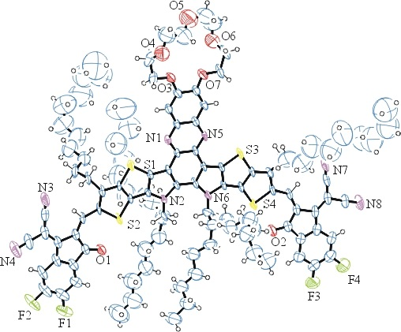
Figure 1. ORTEP of the structure with thermal ellipsoids at the 50% probability level. Disorder omitted for clarity.

Table 1: Crystallographic data for the structures provided.
Identification code shelx
Empirical formula C112 H136 F4 N8 O7 S4
Formula weight 1910.52
Temperature 100(2) K
Wavelength 0.71073 Å
Crystal system Triclinic
Space group P -1
Unit cell dimensions a = 17.162(4) Å α= 119.348(12)°.
b = 19.377(4) Å β= 96.510(14)°.
c = 19.610(4) Å γ = 103.293(14)°.
Volume 5332(2) Å3
Z 2
Density (calculated) 1.190 Mg/m3
Absorption coefficient 0.153 mm-1
F(000) 2040
Crystal size 0.450 x 0.060 x 0.020 mm3
Theta range for data collection 1.214 to 25.027°.
Index ranges -20<=h<=20, -23<=k<=22, -23<=l<=23
Reflections collected 34150
Independent reflections 18783 [R(int) = 0.2728]
Completeness to theta = 25.027° 99.6 %
Refinement method Full-matrix least-squares on F2
Data / restraints / parameters 18783 / 1983 / 1330
Goodness-of-fit on F2 1.272
Final R indices [I>2sigma(I)] R1 = 0.2282, wR2 = 0.4895
R indices (all data) R1 = 0.4909, wR2 = 0.6014

Bruker (2007) APEX2 (Version 2.1-4), SAINT (version 7.34A), SADABS (version 2007/4), BrukerAXS Inc, Madison, Wisconsin, USA.
(a) Sheldrick GM. (2008) A short history of SHELX. Acta Cryst. A64, 112-122. (b) Sheldrick GM. (2015) SHELXT - Integrated space-group and crystal-structure determination. Acta Cryst. A71, 3-8.
(a) Altomare A, Burla C, Camalli M, Cascarano G L, Giacovazzo C, Guagliardi A, Moliterni AGG, Polidori G, Spagna R. (1999) SIR97: a new tool for crystal structure determination and refinement Journal of Applied Crystallography, 32, 115-119. (b) Altomare A, Cascarano G L, Giacovazzo C, Guagliardi A. (1993) Completion and refinement of crystal structures with SIR 92. Journal of Applied Crystallography, 26, 343-350.
(a) Sheldrick GM. (1997) SHELXL-97, Program for the Refinement of Crystal Structures. University of Göttingen, Germany. (b) Sheldrick GM. (2015) Crystal structure refinement with SHELXL. Acta Cryst. C71, 3–8
Waasmaier, D.; Kirfel, A. (1995) New Analytical Scattering Factor Functions for Free Atoms and Ions. Acta Crystallographica A., 51, 416-430.
(a) A. Spek, J. Appl. Cryst. (2003), 36, 7-13; (b) P. van der Sluis & A. L. Spek, Acta Cryst. (1990). A46, 194-201. (c) Spek, A. L. (2009). Acta. Cryst. D65, 148-155.
Farrugia LJ. (1997) Ortep-3 for Windows. Journal of Applied Crystallography, 30, 565

