Crystal Structure Report for A. Jen
by Werner Kaminsky
Sample Submitted by Xueliang Shi
ID – 6TIC
X-ray Crystallography Laboratory
University of Washington
31. July 2026

Data Collection started: 7/17/2018
Documentation finished: 7/20/2018

Data backup accessibly through http:
URL: http://cad4.cpac.washington.edu/structures

W.Kaminsky: tel. (206) 543 7585
(x-ray lab): tel. (206) 543 0210
Email: kaminsky@chem.washington.edu

Understanding crystallographic information is not trivial. If you discuss a structure in a publication, please let the crystallographers proof-read the final draft of that manuscript before you submit it.
For many structures it is true that crystallography is an intellectual performance (like synthesis or elucidation of mechanisms) and not a routine job. In these cases, particularly when the structures contribute significantly to the content of the publication, the crystallographers should be co-authors. Do not think this is not necessary because you pay for structures.
A black plate, measuring 0.45 x 0.10 x 0.01 mm³ was mounted on a loop with oil. Data was collected at -173ºC on a Bruker APEX II single crystal X-ray diffractometer, Mo-radiation.

Crystal-to-detector distance was 40 mm and exposure time was 120 seconds per frame for all sets. The scan width was 1º. Data collection was 97.2% complete to 17.65º in ϑ. A total of 30428 reflections were collected covering the indices, -13<=h<=13, -22<=k<=22, -26<=l<=26. 15357 reflections were symmetry independent and the R_{int} = 0.2896 indicated that the data was problematic. Indexing and unit cell refinement indicated a triclinic lattice. The space group was found to be P‾1 (No. 2).

The data appeared twinned via 180 degrees about (1 0 0) (CELL_NOW) and after multi-domain integration (SAINT, SADABS within the APEX2 software package by Bruker) the data was merged utilizing twinabs.

Solution by direct methods (SHELXS, SIR97) produced a complete heavy atom phasing model consistent with the proposed structure. The structure was completed by difference Fourier synthesis with SHELXL97., Scattering factors are from Waasmair and Kirfel. Hydrogen atoms were placed in geometrically idealised positions and constrained to ride on their parent atoms with C---H distances in the range 0.95-1.00 Angstrom. Isotropic thermal parameters U_{eq} were fixed such that they were 1.2U_{eq} of their parent atom Ueq for CH's and 1.5U_{eq} of their parent atom U_{eq} in case of methyl groups. All non-hydrogen atoms were refined anisotropically by full-matrix least-squares.

The structure contains chloroform filled infinite channels along [1 0 0]. Upon moving crystals from solvent into oil, immediate loss of solvent caused lattice collapse within minutes. As a result, relevant data was limited to a resolution of 1.2 Angstrom despite rapidly mounting the sample on a goniometer and placing it into the nitrogen stream set to 100K.
All tried samples appeared twinned via 180 degrees about (1 0 0) (CELL_NOW) and after multi-domain integration (SAINT, SADABS within the APEX2 software package by Bruker) the data was merged utilizing twinabs.
In addition, most of the chloroform molecules appeared disordered inside the channels and their contribution to the diffraction pattern was removed with SQUEEZE. There are an estimated 22 chloroform solvent molecules in one unit cell.
The large crystal lattice, twinning and low crystal quality, thus, is responsible for low data quality and bad statistical numbers. However, we believe the derived structure, within its heavy restraints and limitations (DELU and ISOR restraints on all atoms and reduced scattering angle as well as idealized phenyl rings and SAME restraints between all equivalent half chromophore units) truthfully represents the crystal.
The asymmetric unit contains 3 half and one full chromophore, leaving a total of 5 independent chromophores for the unit cell.

The structure is low quality. Publication may be pushed by adding ‘the structure was only marginally obtained but included for purpose of completion’.

Table 1 summarizes the data collection details. Figure 1 shows an ORTEP of the asymmetric unit.

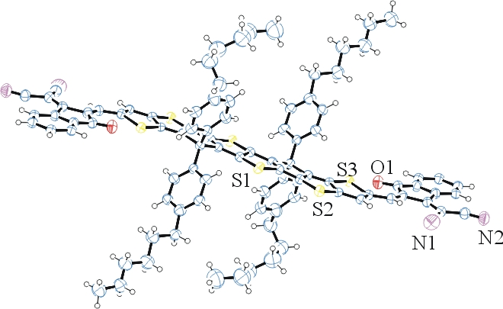

Figure 1. ORTEP of the structure with thermal ellipsoids at the 50% probability level. Only one chromophore of a total of five in the unit cell is shown. Chloroform solvent suppressed via SQUEEZE.

Table 1: Crystallographic data for the structures provided.
Empirical formula C94 H80 N4 O2 S6
Formula weight 1489.98
Temperature 100(2) K
Wavelength 0.71073 Å
Crystal system Triclinic
Space group P -1
Unit cell dimensions a = 16.366(10) Å α= 114.84(3)°.
b = 26.859(14) Å β= 91.61(3)°.
c = 31.68(2) Å γ = 103.38(3)°.
Volume 12172(13) Å3
Z 5
Density (calculated) 1.016 Mg/m3
Absorption coefficient 0.183 mm-1
F(000) 3920
Crystal size 0.450 x 0.100 x 0.010 mm3
Theta range for data collection 1.345 to 17.653°.
Index ranges -13<=h<=13, -22<=k<=22, -26<=l<=26
Reflections collected 30428
Independent reflections 15357 [R(int) = 0.2896]
Completeness to theta = 17.653° 97.2 %
Refinement method Full-matrix least-squares on F2
Data / restraints / parameters 15357 / 3771 / 2207
Goodness-of-fit on F2 1.240
Final R indices [I>2sigma(I)] R1 = 0.2474, wR2 = 0.4997
R indices (all data) R1 = 0.3694, wR2 = 0.5651
Extinction coefficient 0.0039(6)
Largest diff. peak and hole 0.984 and -0.619 e.Å-3

Sheldrick, G. M. (2005). CELL_NOW. University of Goettingen, Germany.
Bruker (2007) APEX2 (Version 2.1-4), SAINT (version 7.34A), SADABS (version 2007/4), BrukerAXS Inc, Madison, Wisconsin, USA.
Sheldrick, G. M. (2007). TWINABS. University of Goettingen, Germany.
(a) Altomare A, Burla C, Camalli M, Cascarano G L, Giacovazzo C, Guagliardi A, Moliterni AGG, Polidori G, Spagna R. (1999) SIR97: a new tool for crystal structure determination and refinement Journal of Applied Crystallography, 32, 115-119. (b) Altomare A, Cascarano G L, Giacovazzo C, Guagliardi A. (1993) Completion and refinement of crystal structures with SIR 92. Journal of Applied Crystallography, 26, 343-350.
(a) Sheldrick GM. (1997) SHELXL-97, Program for the Refinement of Crystal Structures. University of Göttingen, Germany. (b) Sheldrick GM. (2013) Crystal structure refinement with SHELXL. Acta Cryst. (2015). C71, 3-8.
Mackay, S.; Edwards, C.; Henderson, A.; Gilmore, C.; Stewart, N.; Shankland, K.; Donald, A. (1997) MaXus: a computer program for the solution and refinement of crystal structures from diffraction data. University of Glasgow, Scotland,.
Waasmaier, D.; Kirfel, A. (1995) New Analytical Scattering Factor Functions for Free Atoms and Ions. Acta Crystallographica A., 51, 416-430.
Sheldrick, G. M. (2005). CELL_NOW. University of Goettingen, Germany.
Bruker (2007) APEX2 (Version 2.1-4), SAINT (version 7.34A), SADABS (version 2007/4), BrukerAXS Inc, Madison, Wisconsin, USA.
Sheldrick, G. M. (2007). TWINABS. University of Goettingen, Germany.
(a) A. Spek, J. Appl. Cryst. (2003), 36, 7-13; (b) P. van der Sluis & A. L. Spek, Acta Cryst. (1990). A46, 194-201. (c) Spek, A. L. (2009). Acta. Cryst. D65, 148-155.
Farrugia LJ. (1997) Ortep-3 for Windows. Journal of Applied Crystallography, 30, 565

