Crystal Structure Report for D. Xiao
by Sebastian Krajewski & Werner Kaminsky
Sample Submitted by Ashe Kamin
ID – AAK_4245_4_TCE_hept
X-ray Crystallography Laboratory
University of Washington
28. July 2026

Data Collection started: 3/3/2023
Documentation finished: 3/9/2023

Data backup accessibly through http:
URL: http://cad4.cpac.washington.edu/structures

W.Kaminsky: tel. (206) 543 7585
(x-ray lab): tel. (206) 543 0210
Email: kaminsky@chem.washington.edu

Understanding crystallographic information is not trivial. If you discuss a structure in a publication, please let the crystallographers proof-read the final draft of that manuscript before you submit it.
For many structures it is true that crystallography is an intellectual performance (like synthesis or elucidation of mechanisms) and not a routine job. In these cases, particularly when the structures contribute significantly to the content of the publication, the crystallographers should be co-authors. Do not think this is not necessary because you pay for structures.
A yellow needle, measuring 0.60 x 0.15 x 0.09 mm³ was mounted on a loop with oil. Data was collected at -173ºC on a Bruker APEX II single crystal X-ray diffractometer, Mo-radiation, equipped with a Miracol X-ray optical collimator.

Crystal-to-detector distance was 45 mm and exposure time was 180 seconds per frame for all sets. The scan width was 0.5º. Data collection was 99.2% complete to 25º in ϑ. A total of 101139 merged reflections were collected covering the indices, -68<=h<=68, -14<=k<=14, -60<=l<=60. 15535 reflections were symmetry independent and the R_{int} = 0.1097 indicated that the data was appropriate. Indexing and unit cell refinement indicated an F-centered orthorhombic lattice. The space group was found to be F d d 2 (No. 43).

The data was integrated and scaled using SAINT, SADABS within the APEX2 software package by Bruker.

Solution by direct methods (SHELXT or SIR97) produced a complete heavy atom phasing model consistent with the proposed structure. The structure was completed by difference Fourier synthesis with SHELXL. Scattering factors are from Waasmair and Kirfel. Hydrogen atoms were placed in geometrically idealised positions and constrained to ride on their parent atoms with C---H distances in the range 0.95-1.00 Angstrom. Isotropic thermal parameters U_{eq} were fixed such that they were 1.2U_{eq} of their parent atom Ueq for CH's and 1.5U_{eq} of their parent atom U_{eq} in case of methyl groups. All non-hydrogen atoms were refined anisotropically by full-matrix least-squares.

Due to extensive disorder, the diffraction abruptly fell off at a resolution of about 1Å (see below). This effect is intrinsic to these crystals and longer exposure or stronger radiation does not solve the problem
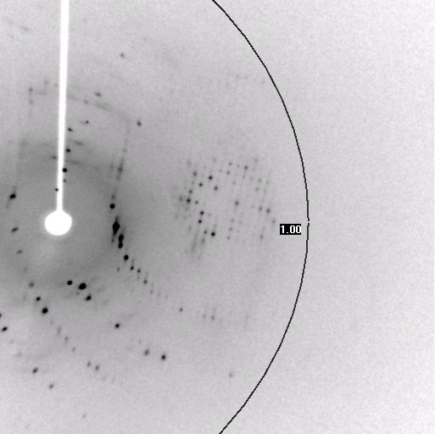
In fact, SQUEEZE analysis showed that a total of 5492 electrons where in solvent accessible voids, the contribution of which to the diffraction pattern was then removed. This is more than halfe of the electrons of the refined structure (F₀ = 9728). One trichloroethylene was found per molecule, but no other solvent molecule could be individually identified. After removal of 116 bad peaks and linking all phenyls with SAME commands in SHELXL, the structure still needed some more restraints. All phenyl-phenyl distance were linked and some thermal displacement parameters were stabilized. A disordered phenyl group was treated accordingly.

The structure is of good quality and publishable. Table 1 summarizes the data collection details. Figure 1 shows an ORTEP of the asymmetric unit.
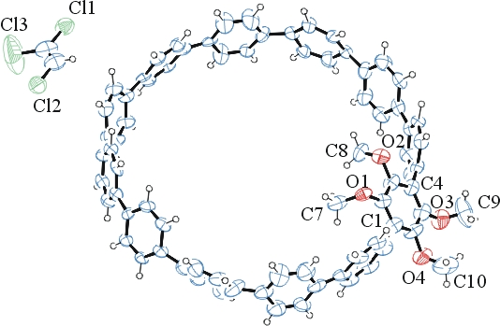
Figure 1. ORTEP of the structure with thermal ellipsoids at the 50% probability level. Disorder omitted for clarity.

Table 1: Crystallographic data for the structures provided.
Empirical formula C78 H57 Cl3 O4
Formula weight 1164.58
Temperature 100(2) K
Wavelength 0.71073 Å
Crystal system Orthorhombic
Space group F d d 2
Unit cell dimensions a = 57.683(4) Å α= 90°.
b = 12.1111(8) Å β= 90°.
c = 50.915(3) Å γ = 90°.
Volume 35569(4) Å3
Z 16
Density (calculated) 0.870 Mg/m3
Absorption coefficient 0.139 mm-1
F(000) 9728
Crystal size 0.600 x 0.150 x 0.090 mm3
Theta range for data collection 2.027 to 25.027°.
Index ranges -68<=h<=68, -14<=k<=14, -60<=l<=60
Reflections collected 101139
Independent reflections 15535 [R(int) = 0.1097]
Completeness to theta = 25.027° 99.2 %
Refinement method Full-matrix least-squares on F2
Data / restraints / parameters 15535 / 1003 / 786
Goodness-of-fit on F2 1.042
Final R indices [I>2sigma(I)] R1 = 0.1183, wR2 = 0.3009
R indices (all data) R1 = 0.1780, wR2 = 0.3488
Absolute structure parameter 0.6(2)
Largest diff. peak and hole 0.443 and -0.493 e.Å-3

Bruker (2007) APEX2 (Version 2.1-4), SAINT (version 7.34A), SADABS (version 2007/4), BrukerAXS Inc, Madison, Wisconsin, USA.
(a) Sheldrick GM. (2008) A short history of SHELX. Acta Cryst. A64, 112-122. (b) Sheldrick GM. (2015) SHELXT - Integrated space-group and crystal-structure determination. Acta Cryst. A71, 3-8.
(a) Altomare A, Burla C, Camalli M, Cascarano G L, Giacovazzo C, Guagliardi A, Moliterni AGG, Polidori G, Spagna R. (1999) SIR97: a new tool for crystal structure determination and refinement Journal of Applied Crystallography, 32, 115-119. (b) Altomare A, Cascarano G L, Giacovazzo C, Guagliardi A. (1993) Completion and refinement of crystal structures with SIR 92. Journal of Applied Crystallography, 26, 343-350.
(a) Sheldrick GM. (1997) SHELXL-97, Program for the Refinement of Crystal Structures. University of Göttingen, Germany. (b) Sheldrick GM. (2015) Crystal structure refinement with SHELXL. Acta Cryst. C71, 3–8
Waasmaier, D.; Kirfel, A. (1995) New Analytical Scattering Factor Functions for Free Atoms and Ions. Acta Crystallographica A., 51, 416-430.
(a) A. Spek, J. Appl. Cryst. (2003), 36, 7-13; (b) P. van der Sluis & A. L. Spek, Acta Cryst. (1990). A46, 194-201. (c) Spek, A. L. (2009). Acta. Cryst. D65, 148-155.
Farrugia LJ. (1997) Ortep-3 for Windows. Journal of Applied Crystallography, 30, 565

