Crystal Structure Report for A. Velian
by Dylan Rogers & Werner Kaminsky
Sample Submitted by Andrei Chirila
ID – ACH_085
X-ray Crystallography Laboratory
University of Washington
31. July 2026

Data Collection started: 8/13/2018
Documentation finished: 8/16/2018

Data backup accessibly through http:
URL: http://cad4.cpac.washington.edu/structures

W.Kaminsky: tel. (206) 543 7585
(x-ray lab): tel. (206) 543 0210
Email: kaminsky@chem.washington.edu

Understanding crystallographic information is not trivial. If you discuss a structure in a publication, please let the crystallographers proof-read the final draft of that manuscript before you submit it.
For many structures it is true that crystallography is an intellectual performance (like synthesis or elucidation of mechanisms) and not a routine job. In these cases, particularly when the structures contribute significantly to the content of the publication, the crystallographers should be co-authors. Do not think this is not necessary because you pay for structures.
A black piece, measuring 0.15 x 0.07 x 0.04 mm³ was mounted on a loop with oil. Data was collected at -173ºC on a Bruker APEX II single crystal X-ray diffractometer, Mo-radiation.

Crystal-to-detector distance was 40 mm and exposure time was 30 seconds per frame for all sets. The scan width was 0.5º. Data collection was 99.9% complete to 25º in ϑ. A total of 39471 merged reflections were collected covering the indices, -23<=h<=23, -34<=k<=34, 0<=l<=23. 20042 reflections were symmetry independent with R_{int} = 0.1524. Indexing and unit cell refinement indicated a primitive monoclinic lattice. The space group was found to be P 2₁/n (No. 14).

The data was integrated and scaled using SAINT, SADABS within the APEX2 software package by Bruker.

Solution by direct methods (SHELXT or SIR97) produced a complete heavy atom phasing model consistent with the proposed structure. The structure was completed by difference Fourier synthesis with SHELXL., Scattering factors are from Waasmair and Kirfel. Hydrogen atoms were placed in geometrically idealised positions and constrained to ride on their parent atoms with C---H distances in the range 0.95-1.00 Angstrom. Isotropic thermal parameters U_{eq} were fixed such that they were 1.2U_{eq} of their parent atom Ueq for CH's and 1.5U_{eq} of their parent atom U_{eq} in case of methyl groups. All non-hydrogen atoms were refined anisotropically by full-matrix least-squares.

The asymmetric unit contains a disordered ethyl ether solvent and a half of a chemically disordered cluster complex, with one component at 88.3(4)% containing Fe, the other at 11.7% lacking the Fe(II) but showing the nitrogen protonated. Additional structural disorder includes split nitrogen positions resulting from the presence versus absence of the Fe and protonation in the other case.

The structure is of high quality and ready for publication. Table 1 summarizes the data collection details. Figure 1 shows an ORTEP of the asymmetric unit.

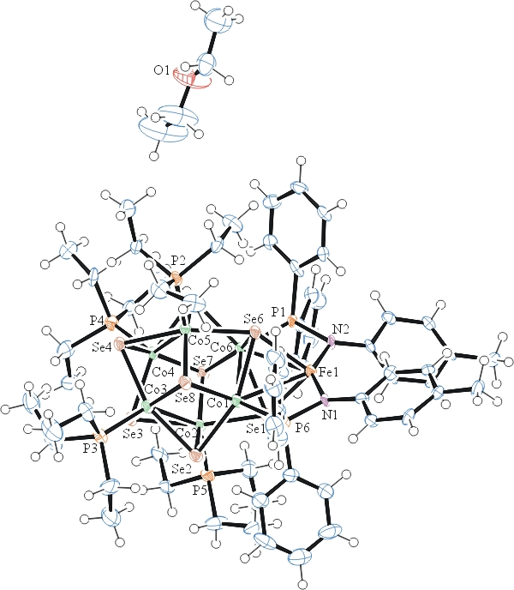
a)
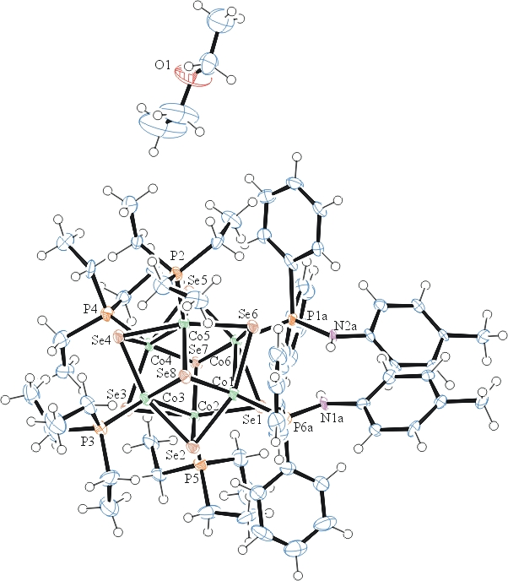
b)

Figure 1a) ORTEP of the cluster complex containing Fe, b) protonated nitrogen, with thermal ellipsoids at the 50% probability level. Some disorder omitted for clarity.

Table 1: Crystallographic data for the structures provided.
Empirical formula C66 H104.23 Co6 Fe0.88 N2 O P6 Se8
Formula weight 2162.11
Temperature 100(2) K
Wavelength 0.71073 Å
Crystal system Monoclinic
Space group P 2₁/n
Unit cell dimensions a = 17.3857(10) Å α= 90°.
b = 26.0557(17) Å β= 93.551(4)°.
c = 17.8253(10) Å γ = 90°.
Volume 8059.3(8) Å3
Z 4
Density (calculated) 1.782 Mg/m3
Absorption coefficient 5.131 mm-1
F(000) 4277
Crystal size 0.150 x 0.070 x 0.040 mm3
Theta range for data collection 1.386 to 28.398°.
Index ranges -23<=h<=23, -34<=k<=34, 0<=l<=23
Reflections collected 39471
Independent reflections 20042 [R(int) = 0.1524]
Completeness to theta = 25.000° 99.9 %
Refinement method Full-matrix least-squares on F2
Data / restraints / parameters 20042 / 116 / 883
Goodness-of-fit on F2 0.906
Final R indices [I>2sigma(I)] R1 = 0.0595, wR2 = 0.1064
R indices (all data) R1 = 0.1950, wR2 = 0.1440
Largest diff. peak and hole 1.294 and -0.924 e.Å-3

Bruker (2007) APEX2 (Version 2.1-4), SAINT (version 7.34A), SADABS (version 2007/4), BrukerAXS Inc, Madison, Wisconsin, USA.
Sheldrick GM. (2015) SHELXT - Integrated space-group and crystal-structure determination. Acta Cryst. A71, 3-8.
(a) Altomare A, Burla C, Camalli M, Cascarano G L, Giacovazzo C, Guagliardi A, Moliterni AGG, Polidori G, Spagna R. (1999) SIR97: a new tool for crystal structure determination and refinement Journal of Applied Crystallography, 32, 115-119. (b) Altomare A, Cascarano G L, Giacovazzo C, Guagliardi A. (1993) Completion and refinement of crystal structures with SIR 92. Journal of Applied Crystallography, 26, 343-350.
(a) Sheldrick GM. (1997) SHELXL-97, Program for the Refinement of Crystal Structures. University of Göttingen, Germany. (b) Sheldrick GM. (2015) Crystal structure refinement with SHELXL. Acta Cryst. (2015). C71, 3–8
Mackay, S.; Edwards, C.; Henderson, A.; Gilmore, C.; Stewart, N.; Shankland, K.; Donald, A. (1997) MaXus: a computer program for the solution and refinement of crystal structures from diffraction data. University of Glasgow, Scotland,.
Waasmaier, D.; Kirfel, A. (1995) New Analytical Scattering Factor Functions for Free Atoms and Ions. Acta Crystallographica A., 51, 416-430.
Farrugia LJ. (1997) Ortep-3 for Windows. Journal of Applied Crystallography, 30, 565

