Crystal Structure Report for A. Velian
by Dylan Rogers & Werner Kaminsky
Sample Submitted by Andrei Chirila
ID – ACH_109
X-ray Crystallography Laboratory
University of Washington
31. July 2026

Data Collection started: 8/30/2018
Documentation finished: 9/10/2018

Data backup accessibly through http:
URL: http://cad4.cpac.washington.edu/structures

W.Kaminsky: tel. (206) 543 7585
(x-ray lab): tel. (206) 543 0210
Email: kaminsky@chem.washington.edu

Understanding crystallographic information is not trivial. If you discuss a structure in a publication, please let the crystallographers proof-read the final draft of that manuscript before you submit it.
For many structures it is true that crystallography is an intellectual performance (like synthesis or elucidation of mechanisms) and not a routine job. In these cases, particularly when the structures contribute significantly to the content of the publication, the crystallographers should be co-authors. Do not think this is not necessary because you pay for structures.
A black prism, measuring 0.10 x 0.08 x 0.06 mm³ was mounted on a loop with oil. Data was collected at -173ºC on a Bruker APEX II single crystal X-ray diffractometer, Mo-radiation.

Crystal-to-detector distance was 40 mm and exposure time was 30 seconds per frame for all sets. The scan width was 0.5º. Data collection was 97.7% complete to 25º in ϑ. A total of 25096 merged reflections were collected covering the indices, -15<=h<=15, -17<=k<=17, -26<=l<=26. 13082 reflections were symmetry independent and the R_{int} = 0.1446 indicated that the data was somewhat problematic. Indexing and unit cell refinement indicated a triclinic lattice. The space group was found to be P‾1 (No. 2).

The data was integrated and scaled using SAINT, SADABS within the APEX2 software package by Bruker.

Solution by direct methods (SHELXT or SIR97) produced a complete heavy atom phasing model consistent with the proposed structure. The structure was completed by difference Fourier synthesis with SHELXL., Scattering factors are from Waasmair and Kirfel. Hydrogen atoms were placed in geometrically idealised positions and constrained to ride on their parent atoms with C---H distances in the range 0.95-1.00 Angstrom. Isotropic thermal parameters U_{eq} were fixed such that they were 1.2U_{eq} of their parent atom Ueq for CH's and 1.5U_{eq} of their parent atom U_{eq} in case of methyl groups. All non-hydrogen atoms were refined anisotropically by full-matrix least-squares.

The structure appears chemically disordered, with an Fe-azide ligand at 63% and Fe-Cl ligand at 37%.

The structure is of high quality and ready for publication. Table 1 summarizes the data collection details. Figure 1 shows an ORTEP of the asymmetric unit.

Figure 1. a) Complex with azide. b) with Cl⁻. ORTEP of the structure with thermal ellipsoids at the 50% probability level.

a)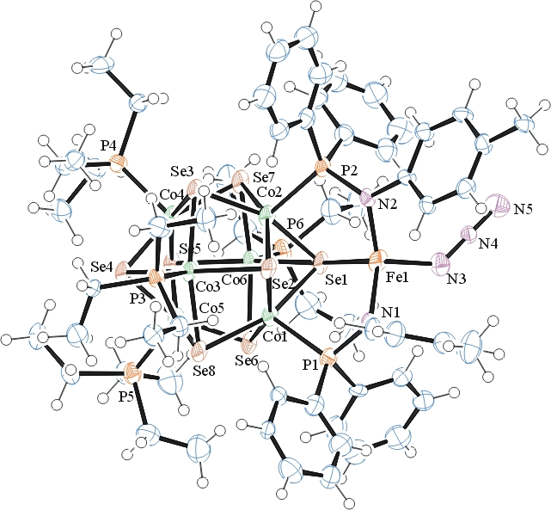
b)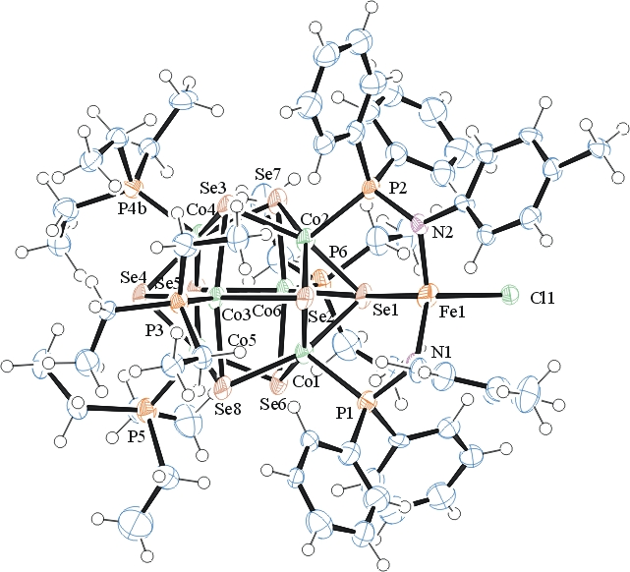

Table 1: Crystallographic data for the structures provided.
Empirical formula C62 H94 Cl0.37 Co6 Fe N3.89 P6 Se8
Formula weight 2133.98
Temperature 100(2) K
Wavelength 0.71073 Å
Crystal system Triclinic
Space group P -1
Unit cell dimensions a = 13.097(2) Å α= 100.494(12)°.
b = 14.533(2) Å β= 90.129(12)°.
c = 22.001(4) Å γ = 114.771(10)°.
Volume 3724.3(11) Å3
Z 2
Density (calculated) 1.903 Mg/m3
Absorption coefficient 5.584 mm-1
F(000) 2099
Crystal size 0.100 x 0.080 x 0.060 mm3
Theta range for data collection 1.576 to 25.188°.
Index ranges -15<=h<=15, -17<=k<=17, -26<=l<=26
Reflections collected 25096
Independent reflections 13082 [R(int) = 0.1446]
Completeness to theta = 25.000° 97.7 %
Refinement method Full-matrix least-squares on F2
Data / restraints / parameters 13082 / 889 / 834
Goodness-of-fit on F2 0.956
Final R indices [I>2sigma(I)] R1 = 0.0987, wR2 = 0.1967
R indices (all data) R1 = 0.2289, wR2 = 0.2476
Extinction coefficient 0.00033(8)
Largest diff. peak and hole 1.474 and -2.041 e.Å-3

Bruker (2007) APEX2 (Version 2.1-4), SAINT (version 7.34A), SADABS (version 2007/4), BrukerAXS Inc, Madison, Wisconsin, USA.
Sheldrick GM. (2015) SHELXT - Integrated space-group and crystal-structure determination. Acta Cryst. A71, 3-8.
(a) Altomare A, Burla C, Camalli M, Cascarano G L, Giacovazzo C, Guagliardi A, Moliterni AGG, Polidori G, Spagna R. (1999) SIR97: a new tool for crystal structure determination and refinement Journal of Applied Crystallography, 32, 115-119. (b) Altomare A, Cascarano G L, Giacovazzo C, Guagliardi A. (1993) Completion and refinement of crystal structures with SIR 92. Journal of Applied Crystallography, 26, 343-350.
(a) Sheldrick GM. (1997) SHELXL-97, Program for the Refinement of Crystal Structures. University of Göttingen, Germany. (b) Sheldrick GM. (2015) Crystal structure refinement with SHELXL. Acta Cryst. (2015). C71, 3–8
Mackay, S.; Edwards, C.; Henderson, A.; Gilmore, C.; Stewart, N.; Shankland, K.; Donald, A. (1997) MaXus: a computer program for the solution and refinement of crystal structures from diffraction data. University of Glasgow, Scotland,.
Waasmaier, D.; Kirfel, A. (1995) New Analytical Scattering Factor Functions for Free Atoms and Ions. Acta Crystallographica A., 51, 416-430.
Farrugia LJ. (1997) Ortep-3 for Windows. Journal of Applied Crystallography, 30, 565

