Crystal Structure Report for J. Kovacs
by Werner Kaminsky & Paige Gannon
Sample Submitted by Alex Downing
ID – AD6006
X-ray Crystallography Laboratory
University of Washington
28. July 2026

Data Collection started: 07/14/2020
Documentation finished: 08/06/2021

Data backup accessibly through http:
URL: http://cad4.cpac.washington.edu/structures

W.Kaminsky: tel. (206) 543 7585
(x-ray lab): tel. (206) 543 0210
Email: kaminsky@chem.washington.edu

Understanding crystallographic information is not trivial. If you discuss a structure in a publication, please let the crystallographers proof-read the final draft of that manuscript before you submit it.
For many structures it is true that crystallography is an intellectual performance (like synthesis or elucidation of mechanisms) and not a routine job. In these cases, particularly when the structures contribute significantly to the content of the publication, the crystallographers should be co-authors. Do not think this is not necessary because you pay for structures.
A clear needle, measuring 0.62 x 0.14 x 0.14 mm³ was mounted on a loop with oil. Data was collected at -173ºC on a Bruker APEX-II CCD single crystal X-ray diffractometer, Mo-radiation, equipped with a Miracol X-ray optical collimator.

Crystal-to-detector distance was 40 mm and exposure time was 10 seconds per degree for all sets. The scan width was 0.5º. Data collection was 100% complete to 25.242º in ϑ. A total of 12737 partial and complete reflections were collected covering the indices, -10<=h<=10, -18<=k<=18, -16<=l<=16. A total of 7809 merged and 6786 symmetry independent reflections with R_{int} = 0.0320 were collected. Indexing and unit cell refinement indicated a monoclinic lattice. The space group was found to be P 2₁ (No.4).

The data was integrated and scaled using SAINT, SADABS within the APEX2 software package by Bruker.

Solution by direct methods (SHELXT or SIR97) produced a complete heavy atom phasing model consistent with the proposed structure. The structure was completed by difference Fourier synthesis with SHELXL., Scattering factors are from Waasmair and Kirfel. Hydrogen atoms were placed in geometrically idealised positions and constrained to ride on their parent atoms with C---H distances in the range 0.95-1.00 Angstrom. Isotropic thermal parameters U_{eq} were fixed such that they were 1.2U_{eq} of their parent atom Ueq for CH's and 1.5U_{eq} of their parent atom U_{eq} in case of methyl groups. All non-hydrogen atoms were refined anisotropically by full-matrix least-squares.

The structure was refined as a 4-component inversion twin. Both PF₆¯anions are disordered.

The structure is of high quality and ready for publication. Table 1 summarizes the data collection details. Figure 1 shows an ORTEP of the asymmetric unit.

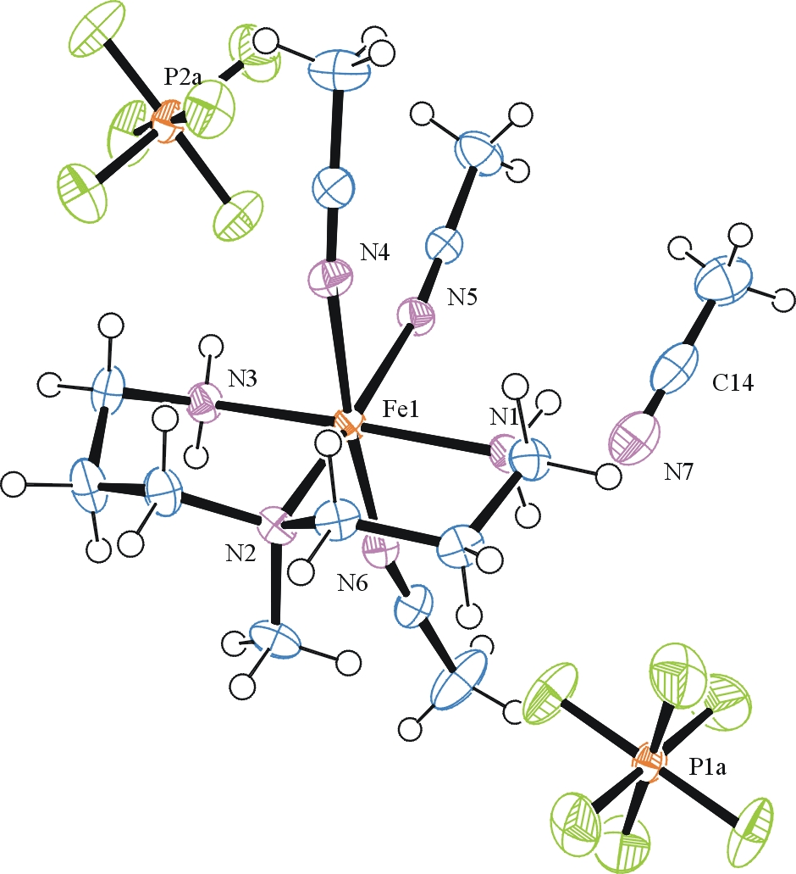

Figure 1. ORTEP of the structure with thermal ellipsoids at the 50% probability level.

Table 1: Crystallographic data for the structures provided.
Empirical formula C15 H31 F12 Fe N7 P2
Formula weight 655.26
Temperature 100(2) K
Wavelength 0.71073 Å
Crystal system Monoclinic
Space group P 2₁
Unit cell dimensions a = 7.7865(5) Å α= 90°.
b = 14.0617(8) Å β= 90.040(3)°.
c = 12.5045(7) Å γ = 90°.
Volume 1369.14(14) Å3
Z 2
Density (calculated) 1.589 Mg/m3
Absorption coefficient 0.768 mm-1
F(000) 668
Crystal size 0.620 x 0.140 x 0.140 mm3
Theta range for data collection 1.448 to 28.335°.
Index ranges -10<=h<=10, -18<=k<=18, -16<=l<=16
Reflections collected 12737
Independent reflections 6786 [R(int) = 0.0320]
Completeness to theta = 25.242° 100.0 %
Refinement method Full-matrix least-squares on F2
Data / restraints / parameters 6786 / 43 / 386
Goodness-of-fit on F2 1.041
Final R indices [I>2sigma(I)] R1 = 0.0286, wR2 = 0.0610
R indices (all data) R1 = 0.0316, wR2 = 0.0629
Absolute structure parameter 0.00(1)
Largest diff. peak and hole 0.281 and -0.387 e.Å-3

Bruker (2007) APEX2 (Version 2.1-4), SAINT (version 7.34A), SADABS (version 2007/4), BrukerAXS Inc, Madison, Wisconsin, USA.
Sheldrick GM. (2015) SHELXT - Integrated space-group and crystal-structure determination. Acta Cryst. A71, 3-8.
(a) Altomare A, Burla C, Camalli M, Cascarano G L, Giacovazzo C, Guagliardi A, Moliterni AGG, Polidori G, Spagna R. (1999) SIR97: a new tool for crystal structure determination and refinement Journal of Applied Crystallography, 32, 115-119. (b) Altomare A, Cascarano G L, Giacovazzo C, Guagliardi A. (1993) Completion and refinement of crystal structures with SIR 92. Journal of Applied Crystallography, 26, 343-350.
(a) Sheldrick GM. (1997) SHELXL-97, Program for the Refinement of Crystal Structures. University of Göttingen, Germany. (b) Sheldrick GM. (2015) Crystal structure refinement with SHELXL. Acta Cryst. (2015). C71, 3–8
Mackay, S.; Edwards, C.; Henderson, A.; Gilmore, C.; Stewart, N.; Shankland, K.; Donald, A. (1997) MaXus: a computer program for the solution and refinement of crystal structures from diffraction data. University of Glasgow, Scotland,.
Waasmaier, D.; Kirfel, A. Acta Crystallogr. A. 1995, 51, 416.
Farrugia, L. J. Appl. Cryst. 1997, 30, 565

