Crystal Structure Report for D. Reed
by Sebastian Krajewski and Werner Kaminsky
Sample Submitted by Jay Lee
ID – AT_20
X-ray Crystallography Laboratory
University of Washington
31. July 2026

Data Collection started: 7/21/2023
Documentation finished: 7/25/2023

Data backup accessibly through http:
URL: http://cad4.cpac.washington.edu/structures

W.Kaminsky: tel. (206) 543 7585
(x-ray lab): tel. (206) 543 0210
Email: kaminsky@chem.washington.edu

Understanding crystallographic information is not trivial. If you discuss a structure in a publication, please let the crystallographers proof-read the final draft of that manuscript before you submit it.
For many structures it is true that crystallography is an intellectual performance (like synthesis or elucidation of mechanisms) and not a routine job. In these cases, particularly when the structures contribute significantly to the content of the publication, the crystallographers should be co-authors. Do not think this is not necessary because you pay for structures.
A purple block, measuring 0.11 x 0.10 x 0.09 mm³ was mounted on a loop with oil. Data was collected at -173ºC on a Bruker APEX II single crystal X-ray diffractometer, Mo-radiation, equipped with a Miracol X-ray optical collimator.

Crystal-to-detector distance was 40 mm and exposure time was 13 seconds per frame for all sets. The scan width was 0.5º. Data collection was 100.0% complete to 25º in ϑ. A total of 26336 reflections were collected covering the indices, -15<=h<=15, -16<=k<=16, -27<=l<=27. 13255 reflections were symmetry independent and the R_{int} = 0.0321 indicated that the data was brilliant. Indexing and unit cell refinement indicated a triclinic lattice. The space group was found to be P‾1 (No. 2).

The data appeared twinned via 180 degrees about reciprocal (0 1 0) (CELL_NOW) and after multi-domain integration (SAINT, SADABS within the APEX2 software package by Bruker) the data was merged utilizing twinabs with a twin fraction of 17%.

Solution by direct methods (SHELXT or SIR97) produced a complete heavy atom phasing model consistent with the proposed structure. The structure was completed by difference Fourier synthesis with SHELXL. Scattering factors are from Waasmair and Kirfel. Hydrogen atoms were placed in geometrically idealised positions and constrained to ride on their parent atoms with C---H distances in the range 0.95-1.00 Angstrom. Isotropic thermal parameters U_{eq} were fixed such that they were 1.2U_{eq} of their parent atom Ueq for CH's and 1.5U_{eq} of their parent atom U_{eq} in case of methyl groups. All non-hydrogen atoms were refined anisotropically by full-matrix least-squares.

DMF solvent apeeared in two locations, one was simply disordered into two solvent orientations, the other seemed to be a mix of disordered DMF and possible other solvent. The contribution to the diffraction pattern of electron density within the second solvent filled void was removed with SQUEEZE

The structure is of high quality and ready for publication. Table 1 summarizes the data collection details. Figure 1 shows an ORTEP of the asymmetric unit.

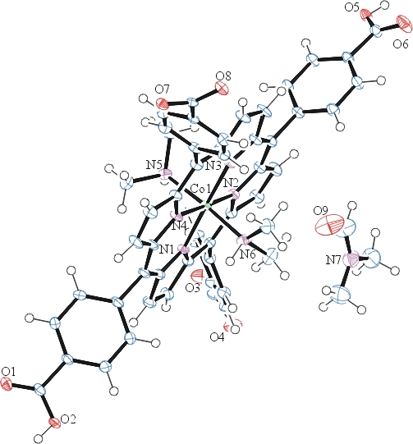
Figure 1. ORTEP of the structure with thermal ellipsoids at the 50% probability level. Disorder and some solvent omitted for clarity.

Table 1: Crystallographic data for the structures provided.
Empirical formula C55 H48 Co N7 O9
Formula weight 1009.93
Temperature 100(2) K
Wavelength 0.71073 Å
Crystal system Triclinic
Space group P -1
Unit cell dimensions a = 11.9355(8) Å α= 84.149(3)°.
b = 12.2167(8) Å β= 78.143(3)°.
c = 20.5718(14) Å γ = 64.932(3)°.
Volume 2658.7(3) Å3
Z 2
Density (calculated) 1.262 Mg/m3
Absorption coefficient 0.384 mm-1
F(000) 1052
Crystal size 0.110 x 0.100 x 0.090 mm3
Theta range for data collection 1.012 to 28.400°.
Index ranges -15<=h<=15, -16<=k<=16, -27<=l<=27
Reflections collected 26336
Independent reflections 13255 [R(int) = 0.0321]
Completeness to theta = 25.242° 100.0 %
Refinement method Full-matrix least-squares on F2
Data / restraints / parameters 13255 / 8 / 709
Goodness-of-fit on F2 1.065
Final R indices [I>2sigma(I)] R1 = 0.0435, wR2 = 0.1051
R indices (all data) R1 = 0.0614, wR2 = 0.1111
Largest diff. peak and hole 0.753 and -0.469 e.Å-3

Sheldrick, G. M. (2005). CELL_NOW. University of Goettingen, Germany.
Bruker (2007) APEX2 (Version 2.1-4), SAINT (version 7.34A), SADABS (version 2007/4), BrukerAXS Inc, Madison, Wisconsin, USA.
Sheldrick, G. M. (2007). TWINABS. University of Goettingen, Germany.
(a) Sheldrick GM. (2008) A short history of SHELX. Acta Cryst. A64, 112-122. (b) Sheldrick GM. (2015) SHELXT - Integrated space-group and crystal-structure determination. Acta Cryst. A71, 3-8.
(a) Altomare A, Burla C, Camalli M, Cascarano G L, Giacovazzo C, Guagliardi A, Moliterni AGG, Polidori G, Spagna R. (1999) SIR97: a new tool for crystal structure determination and refinement Journal of Applied Crystallography, 32, 115-119. (b) Altomare A, Cascarano G L, Giacovazzo C, Guagliardi A. (1993) Completion and refinement of crystal structures with SIR 92. Journal of Applied Crystallography, 26, 343-350.
(a) Sheldrick GM. (1997) SHELXL-97, Program for the Refinement of Crystal Structures. University of Göttingen, Germany. (b) Sheldrick GM. (2015) Crystal structure refinement with SHELXL. Acta Cryst. C71, 3–8
Waasmaier, D.; Kirfel, A. (1995) New Analytical Scattering Factor Functions for Free Atoms and Ions. Acta Crystallographica A., 51, 416-430.
(a) A. Spek, J. Appl. Cryst. (2003), 36, 7-13; (b) P. van der Sluis & A. L. Spek, Acta Cryst. (1990). A46, 194-201. (c) Spek, A. L. (2009). Acta. Cryst. D65, 148-155.
Farrugia LJ. (1997) Ortep-3 for Windows. Journal of Applied Crystallography, 30, 565

