Crystal Structure Report for M. Heinekey
by Sarah Flowers & Werner Kaminsky
Sample Submitted by Byongjoo Bark
ID – BB_I_14
X-ray Crystallography Laboratory
University of Washington
28. July 2026

Data Collection started: 06/24/16
Documentation finished: 07/11/16

Data backup accessibly through http:
URL: http://cad4.cpac.washington.edu/structures

W.Kaminsky: tel. (206) 543 7585
(x-ray lab): tel. (206) 543 0210
Email: kaminsky@chem.washington.edu

Understanding crystallographic information is not trivial. If you discuss a structure in a publication, please let the crystallographers proof-read the final draft of that manuscript before you submit it.
For many structures it is true that crystallography is an intellectual performance (like synthesis or elucidation of mechanisms) and not a routine job. In these cases, particularly when the structures contribute significantly to the content of the publication, the crystallographers should be co-authors. Do not think this is not necessary because you pay for structures.
A clear yellow sheet, measuring 0.15 x 0.075 x 0.045 mm³ was mounted on a loop with oil. These crystals were extremely difficult to work with. They were too thin to catch without paratone oil, but too soluble in paratone oil to stay in the oil for more than a few minutes. As soon as they began to dissolve these crystals crack and form bubbles and no longer diffract. Data was collected at -173ºC on a Bruker APEX II single crystal X-ray diffractometer, Mo-radiation.

Crystal-to-detector distance was 40.00 mm and exposure time was 30 seconds per frame for all sets. The scan width was 0.5º. Data collection was 100.0% complete to 25º in ϑ. A total of 152,176 reflections were collected covering the indices, h = -13 to 13, k = -18 to 18, l = -46 to 46. 6,355 reflections were symmetry independent and the R_{int} = 0.0824 indicated that the data slightly below average quality (0.07). Indexing and unit cell refinement indicated a monoclinic P lattice. The space group was found to be P b c a (No. 61).

The data was integrated and scaled using SAINT, SADABS within the APEX2 software package by Bruker.

Solution by direct methods (SHELXS, SIR97) produced a complete heavy atom phasing model consistent with the proposed structure. The structure was completed by difference Fourier synthesis with SHELXL97., Scattering factors are from Waasmair and Kirfel. Hydrogen atoms were placed in geometrically idealised positions and constrained to ride on their parent atoms with C---H distances in the range 0.95-1.00 Angstrom. Isotropic thermal parameters U_{eq} were fixed such that they were 1.2U_{eq} of their parent atom Ueq for CH's and 1.5U_{eq} of their parent atom U_{eq} in case of methyl groups. All non-hydrogen atoms were refined anisotropically by full-matrix least-squares.

The structure contains an iridium monomer with a tridentate POCOP ligand. The asymmetric unit contains one molecule of dichloromethane.

The structure is of high quality and ready for publication. Table 1 summarizes the data collection details. Figure 1 shows an ORTEP of the asymmetric unit.
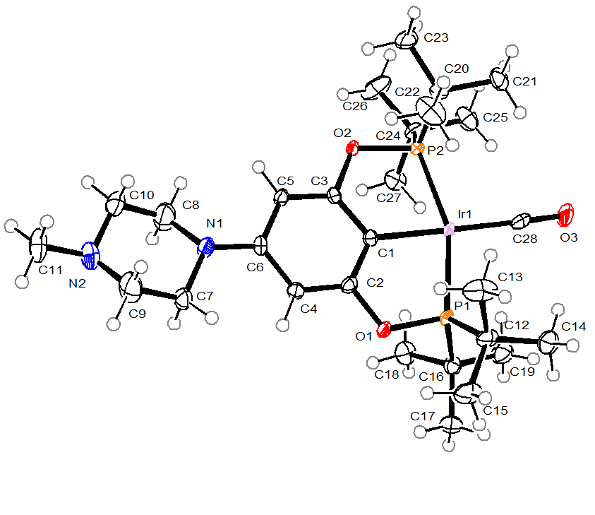

Figure 1. ORTEP of the structure with thermal ellipsoids at the 50% probability level. The dichloromethane molecule was removed for clarity.

Table 1: Crystallographic data for the structures provided.
Identification code bb_i_14_0m
Empirical formula C29 H51 Cl2 Ir N2 O3 P2
Formula weight 800.76
Temperature 100(2) K
Wavelength 0.71073 Å
Crystal system Orthorhombic
Space group P b c a
Unit cell dimensions a = 11.5734(5) Å α= 90°.
b = 15.6094(7) Å β= 90°.
c = 38.1996(18) Å γ = 90°.
Volume 6900.9(5) Å3
Z 8
Density (calculated) 1.541 Mg/m3
Absorption coefficient 4.148 mm-1
F(000) 3232
Crystal size 0.15 x 0.08 x 0.05 mm3
Theta range for data collection 2.06 to 25.43°.
Index ranges -13<=h<=13, -18<=k<=18, -46<=l<=46
Reflections collected 152176
Independent reflections 6355 [R(int) = 0.0824]
Completeness to theta = 25.00° 100.0 %
Absorption correction Semi-empirical from equivalents
Max. and min. transmission 0.8194 and 0.5750
Refinement method Full-matrix least-squares on F2
Data / restraints / parameters 6355 / 0 / 365
Goodness-of-fit on F2 1.073
Final R indices [I>2sigma(I)] R1 = 0.0291, wR2 = 0.0532
R indices (all data) R1 = 0.0431, wR2 = 0.0576
Largest diff. peak and hole 1.161 and -1.567 e.Å-3

Bruker (2007) APEX2 (Version 2.1-4), SAINT (version 7.34A), SADABS (version 2007/4), BrukerAXS Inc, Madison, Wisconsin, USA.
(a) Altomare A, Burla C, Camalli M, Cascarano G L, Giacovazzo C, Guagliardi A, Moliterni AGG, Polidori G, Spagna R. (1999) SIR97: a new tool for crystal structure determination and refinement Journal of Applied Crystallography, 32, 115-119. (b) Altomare A, Cascarano G L, Giacovazzo C, Guagliardi A. (1993) Completion and refinement of crystal structures with SIR 92. Journal of Applied Crystallography, 26, 343-350.
(a) Sheldrick GM. (1997) SHELXL-97, Program for the Refinement of Crystal Structures. University of Göttingen, Germany. (b) Sheldrick GM. (2013) Crystal structure refinement with SHELXL. Acta Cryst. (2015). C71, 3-8.
Mackay, S.; Edwards, C.; Henderson, A.; Gilmore, C.; Stewart, N.; Shankland, K.; Donald, A. (1997) MaXus: a computer program for the solution and refinement of crystal structures from diffraction data. University of Glasgow, Scotland,.
Waasmaier, D.; Kirfel, A. (1995) New Analytical Scattering Factor Functions for Free Atoms and Ions. Acta Crystallographica A., 51, 416-430.
7 Farrugia LJ. (1997) Ortep-3 for Windows. Journal of Applied Crystallography, 30, 565

