Crystal Structure Report for Brian Cook
by Werner Kaminsky
ID – BSC1_85
X-ray Crystallography Laboratory
University of Washington
31. July 2026

Data Collection started: 3/26/2019
Documentation finished: 4/11/2019

Data backup accessibly through http:
URL: http://cad4.cpac.washington.edu/structures

W.Kaminsky: tel. (206) 543 7585
(x-ray lab): tel. (206) 543 0210
Email: kaminsky@chem.washington.edu

Understanding crystallographic information is not trivial. If you discuss a structure in a publication, please let the crystallographers proof-read the final draft of that manuscript before you submit it.
For many structures it is true that crystallography is an intellectual performance (like synthesis or elucidation of mechanisms) and not a routine job. In these cases, particularly when the structures contribute significantly to the content of the publication, the crystallographers should be co-authors. Do not think this is not necessary because you pay for structures.
A yellow piece, measuring 0.35 x 0.12 x 0.10 mm³ was mounted on a loop with oil. Data was collected at -173ºC on a Bruker APEX II single crystal X-ray diffractometer, Mo-radiation.

Crystal-to-detector distance was 40 mm and exposure time was 10 seconds per frame for all sets. The scan width was 0.5º. Data collection was 99.9% complete to 25º in ϑ. A total of 18689 merged reflections were collected covering the indices, -20<=h<=20, -20<=k<=20, -21<=l<=21. with R_{int} = 0.084 indicated that the data was of about average quality (0.07). Indexing and unit cell refinement indicated a primitive monoclinic lattice. The space group was found to be P 2₁/n (No. 14).

The data appeared twinned via 180 degrees about [1 0 0] (CELL_NOW) and after multi-domain integration (SAINT, SADABS within the APEX2 software package by Bruker) the data was merged utilizing twinabs.

Solution by direct methods (SHELXT or SIR97) produced a complete heavy atom phasing model consistent with the proposed structure. The structure was completed by difference Fourier synthesis with SHELXL., Scattering factors are from Waasmair and Kirfel. Hydrogen atoms were placed in geometrically idealised positions and constrained to ride on their parent atoms with C---H distances in the range 0.95-1.00 Angstrom. Isotropic thermal parameters U_{eq} were fixed such that they were 1.2U_{eq} of their parent atom Ueq for CH's and 1.5U_{eq} of their parent atom U_{eq} in case of methyl groups. All non-hydrogen atoms were refined anisotropically by full-matrix least-squares.

The structure is chemically disordered. The major phase a consists of a bicarbonyl group coordinated with the metal, the minor one (b, 22%) has a presumably chlorine on the manganese, with likely a sodium balancing the charge. Most ethyl groups are disordered, each at a different rate.

The structure is of high quality and ready for publication. Table 1 summarizes the data collection details. Figure 1 shows ORTEP diagrams of the asymmetric units.

a)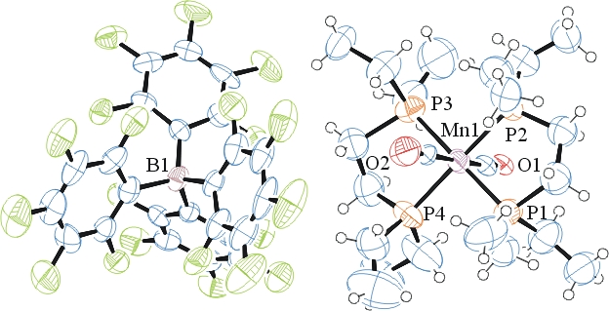
b)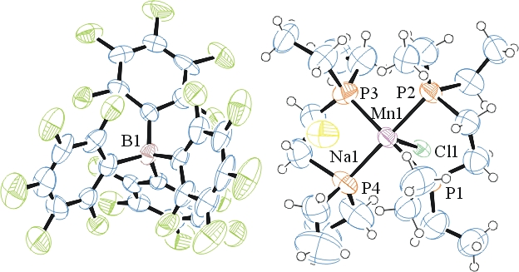
Figure 1. ORTEP of the structures with thermal ellipsoids at the 50% probability level. Disorder omitted for clarity.

Table 1: Crystallographic data for the structures provided.
Empirical formula C45.57 H48 B Cl0.22 F20 Mn Na0.22 O1.57 P4
Formula weight 1202.99
Temperature 100(2) K
Wavelength 0.71073 Å
Crystal system Monoclinic
Space group P 2₁/n
Unit cell dimensions a = 17.3314(18) Å α= 90°.
b = 17.1164(17) Å β= 106.899(6)°.
c = 17.9034(19) Å γ = 90°.
Volume 5081.7(9) Å3
Z 4
Density (calculated) 1.572 Mg/m3
Absorption coefficient 0.509 mm-1
F(000) 2440
Crystal size 0.350 x 0.120 x 0.100 mm3
Theta range for data collection 1.440 to 25.187°.
Index ranges -20<=h<=20, -20<=k<=20, -21<=l<=21
Reflections collected 18689
Independent reflections 18689 [R(int) = 0.084]
Completeness to theta = 25.000° 99.9 %
Refinement method Full-matrix least-squares on F2
Data / restraints / parameters 18689 / 256 / 725
Goodness-of-fit on F2 1.013
Final R indices [I>2sigma(I)] R1 = 0.0909, wR2 = 0.1880
R indices (all data) R1 = 0.1938, wR2 = 0.2356
Largest diff. peak and hole 0.519 and -0.442 e.Å-3

Sheldrick, G. M. (2005). CELL_NOW. University of Goettingen, Germany.
Bruker (2007) APEX2 (Version 2.1-4), SAINT (version 7.34A), SADABS (version 2007/4), BrukerAXS Inc, Madison, Wisconsin, USA.
Sheldrick, G. M. (2007). TWINABS. University of Goettingen, Germany.
Sheldrick GM. (2015) SHELXT - Integrated space-group and crystal-structure determination. Acta Cryst. A71, 3-8.
(a) Altomare A, Burla C, Camalli M, Cascarano G L, Giacovazzo C, Guagliardi A, Moliterni AGG, Polidori G, Spagna R. (1999) SIR97: a new tool for crystal structure determination and refinement Journal of Applied Crystallography, 32, 115-119. (b) Altomare A, Cascarano G L, Giacovazzo C, Guagliardi A. (1993) Completion and refinement of crystal structures with SIR 92. Journal of Applied Crystallography, 26, 343-350.
(a) Sheldrick GM. (1997) SHELXL-97, Program for the Refinement of Crystal Structures. University of Göttingen, Germany. (b) Sheldrick GM. (2015) Crystal structure refinement with SHELXL. Acta Cryst. (2015). C71, 3–8
Mackay, S.; Edwards, C.; Henderson, A.; Gilmore, C.; Stewart, N.; Shankland, K.; Donald, A. (1997) MaXus: a computer program for the solution and refinement of crystal structures from diffraction data. University of Glasgow, Scotland,.
Waasmaier, D.; Kirfel, A. (1995) New Analytical Scattering Factor Functions for Free Atoms and Ions. Acta Crystallographica A., 51, 416-430.
Farrugia LJ. (1997) Ortep-3 for Windows. Journal of Applied Crystallography, 30, 565

