Crystal Structure Report for J. Kovacs
by Sarah Flowers and Werner Kaminsky
Sample Submitted by Ben Leipzig
ID – BKL_A_010
X-ray Crystallography Laboratory
University of Washington
30. July 2026

Data backup accessibly through http:
URL: http://cad4.cpac.washington.edu/structures
Data Collection started: 7/13/2015
Documentation finished: 03/08/2015

W.Kaminsky: tel. (206) 543 7585
(x-ray lab): tel. (206) 543 0210
Email: kaminsky@chem.washington.edu

Understanding crystallographic information is not trivial. If you discuss a structure in a publication, please let the crystallographers proof-read the final draft of that manuscript before you submit it.
For many structures it is true that crystallography is an intellectual performance (like synthesis or elucidation of mechanisms) and not a routine job. In these cases, particularly when the structures contribute significantly to the content of the publication, the crystallographers should be co-authors. Do not think this is not necessary because you pay for structures. Even I have to pay for my own structures for my research.
A dark blue translucent prism, measuring 0.38 x 0.03 x 0.03 mm³ was mounted on a loop with oil. Data was collected at -173ºC on a Bruker APEX II single crystal X-ray diffractometer, Mo-radiation.

Crystal-to-detector distance was 40 mm and exposure time was 120 seconds per frame for all sets. The scan width was 1º. Data collection was 95.5% complete to 25º in ϑ. A total of 46138 reflections were collected covering the indices, h = -46 to 46, k = -46 to 46, l = -8 to 8. 3647 reflections were symmetry independent and the R_{int} = 0.3106 indicated that the crystal was not that good and the data quite week. Indexing and unit cell refinement indicated a R-centered trigonal lattice. The space group was found to be R‾3 (No.148).

The data was integrated and scaled using SAINT, SADABS within the APEX2 software package by Bruker.

Solution by direct methods (SHELXS, SIR97) produced a complete heavy atom phasing model consistent with the proposed structure. The structure was completed by difference Fourier synthesis with SHELXL97., Scattering factors are from Waasmair and Kirfel. Hydrogen atoms were placed in geometrically idealised positions and constrained to ride on their parent atoms with C---H distances in the range 0.95-1.00 Angstrom. Isotropic thermal parameters U_{eq} were fixed such that they were 1.2U_{eq} of their parent atom Ueq for CH's and 1.5U_{eq} of their parent atom U_{eq} in case of methyl groups. All non-hydrogen atoms were refined anisotropically by full-matrix least-squares.

Solvent analysis revealed delocalized acetonitrile and Et₂O solvent molecules inside infinite channels along the c-axis. Contribution of the solvent to the diffraction pattern was removed with SQUEEZE.
Because of solvent disorder, the whole molecule appears slightly disordered, with the exception of the sulfur atom and more or less C3, the major component at about 62% shown in Figure 1.

The structure is of sufficient quality for publication. Table 1 summarizes the data collection details. Figure 1 shows an ORTEP of the asymmetric unit.

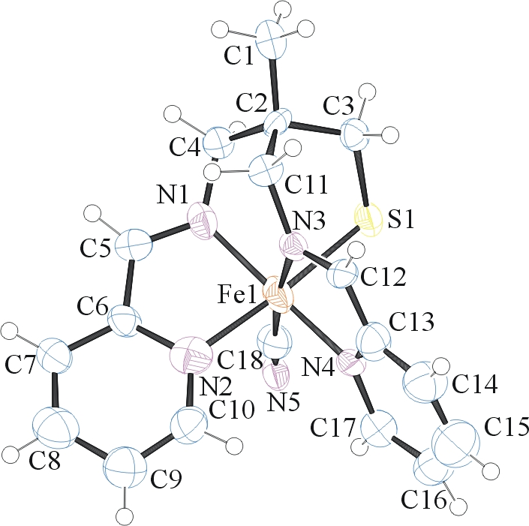

Figure 1. ORTEP of the structure with thermal ellipsoids at the 50% probability level. Disorder omitted for clarity.

Table 1: Crystallographic data for the structures provided.
Empirical formula C108 H114 Fe6 N30 S6
Formula weight 2359.75
Temperature 100(2) K
Wavelength 0.71073 Å
Crystal system Trigonal
Space group R -3
Unit cell dimensions a = 39.021(7) Å α= 90°.
b = 39.021(7) Å β= 90°.
c = 7.0622(14) Å γ = 120°.
Volume 9312(3) Å3
Z 3
Density (calculated) 1.262 Mg/m3
Absorption coefficient 0.839 mm-1
F(000) 3672
Crystal size 0.38 x 0.03 x 0.03 mm3
Theta range for data collection 2.09 to 25.35°.
Index ranges -46<=h<=46, -46<=k<=46, -8<=l<=8
Reflections collected 46138
Independent reflections 3647 [R(int) = 0.3106]
Completeness to theta = 25.00° 95.9 %
Max. and min. transmission 0.9753 and 0.7411
Refinement method Full-matrix least-squares on F2
Data / restraints / parameters 3647 / 352 / 301
Goodness-of-fit on F2 0.968
Final R indices [I>2sigma(I)] R1 = 0.0987, wR2 = 0.1718
R indices (all data) R1 = 0.2270, wR2 = 0.2141
Largest diff. peak and hole 0.439 and -0.432 e.Å-3

Bruker (2007) APEX2 (Version 2.1-4), SAINT (version 7.34A), SADABS (version 2007/4), BrukerAXS Inc, Madison, Wisconsin, USA.
(a) Altomare A, Burla C, Camalli M, Cascarano G L, Giacovazzo C, Guagliardi A, Moliterni AGG, Polidori G, Spagna R. (1999) SIR97: a new tool for crystal structure determination and refinement Journal of Applied Crystallography, 32, 115-119. (b) Altomare A, Cascarano G L, Giacovazzo C, Guagliardi A. (1993) Completion and refinement of crystal structures with SIR 92. Journal of Applied Crystallography, 26, 343-350.
Sheldrick GM. (1997) SHELXL-97, Program for the Refinement of Crystal Structures. University of Göttingen, Germany.
Mackay, S.; Edwards, C.; Henderson, A.; Gilmore, C.; Stewart, N.; Shankland, K.; Donald, A. (1997) MaXus: a computer program for the solution and refinement of crystal structures from diffraction data. University of Glasgow, Scotland,.
Waasmaier, D.; Kirfel, A. (1995) New Analytical Scattering Factor Functions for Free Atoms and Ions. Acta Crystallographica A., 51, 416-430.
A. Spek, J. Appl. Cryst. (2003), 36, 7-13; P. van der Sluis & A. L. Spek, Acta Cryst. (1990). A46, 194-201.
Farrugia LJ. (1997) Ortep-3 for Windows. Journal of Applied Crystallography, 30, 565

