Crystal Structure Report for A. Velian
by Dylan Rogers & Werner Kaminsky
Sample Submitted by Ben Mitchell
ID – BSM123
X-ray Crystallography Laboratory
University of Washington
28. July 2026

Data Collection started: 3/7/2019
Documentation finished: 3/14/2019

Data backup accessibly through http:
URL: http://cad4.cpac.washington.edu/structures

W.Kaminsky: tel. (206) 543 7585
(x-ray lab): tel. (206) 543 0210
Email: kaminsky@chem.washington.edu

Understanding crystallographic information is not trivial. If you discuss a structure in a publication, please let the crystallographers proof-read the final draft of that manuscript before you submit it.
For many structures it is true that crystallography is an intellectual performance (like synthesis or elucidation of mechanisms) and not a routine job. In these cases, particularly when the structures contribute significantly to the content of the publication, the crystallographers should be co-authors. Do not think this is not necessary because you pay for structures.
A black needle, measuring 0.34 x 0.11 x 0.08mm³ was mounted on a loop with oil. Data was collected at -173ºC on a Bruker APEX II single crystal X-ray diffractometer, Mo-radiation.

Crystal-to-detector distance was 40 mm and exposure time was 60 seconds per frame for all sets. The scan width was 0.5º. Data collection was 99.8% complete to 25º in ϑ. A total of 110785 merged reflections were collected covering the indices, -42<=h<=42, -35<=k<=35, -36<=l<=36. 56059 reflections were symmetry independent and the relatively large R_{int} = 0.1494 reflected the small crystal size, large unit cell, low symmetry, and elevated mosaicity. Indexing and unit cell refinement indicated a primitive monoclinic lattice. The space group was found to be P 2₁/c (No. 14).

The data was integrated and scaled using SAINT, SADABS within the APEX2 software package by Bruker.

Solution by direct methods (SHELXT or SIR97) produced a complete heavy atom phasing model consistent with the proposed structure. The structure was completed by difference Fourier synthesis with SHELXL., Scattering factors are from Waasmair and Kirfel. Hydrogen atoms were placed in geometrically idealised positions and constrained to ride on their parent atoms with C---H distances in the range 0.95-1.00 Angstrom. Isotropic thermal parameters U_{eq} were fixed such that they were 1.2U_{eq} of their parent atom Ueq for CH's and 1.5U_{eq} of their parent atom U_{eq} in case of methyl groups. All non-hydrogen atoms were refined anisotropically by full-matrix least-squares.

The contribution of disordered THF and Et₂O solvent accumulated inside a wide infinite channel along the b-axis (Figure 1 below, projection of the unit cell content onto (0 1 0)) to the diffraction pattern was removed with SQUEEZE

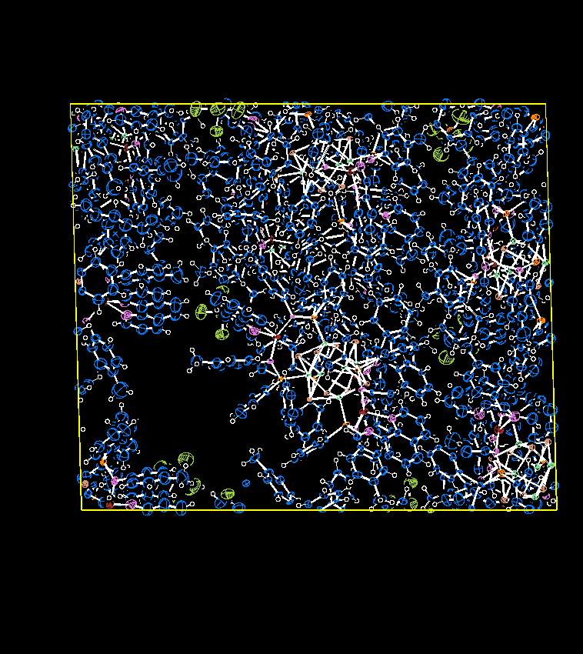

The structure is of sufficient quality for publication. Table 1 summarizes the data collection details. Figure 2 shows an ORTEP of the asymmetric unit.

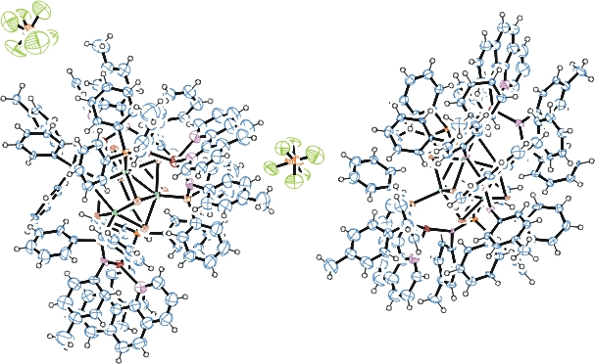

Figure 2. ORTEP of the structure showing two independent molecules with thermal ellipsoids at the 50% probability level. Some PF₆⁻ disorder and solvent omitted for clarity.

Table 1: Crystallographic data for the structures provided.
Empirical formula C150 H126 Co6 F6 N12 P7 Se8 Zn3
Formula weight 3608.78
Temperature 100(2) K
Wavelength 0.71073 Å
Crystal system Monoclinic
Space group P 21/c
Unit cell dimensions a = 35.351(3) Å α= 90°.
b = 29.251(2) Å β= 91.577(4)°.
c = 30.212(2) Å γ = 90°.
Volume 31229(4) Å3
Z 8
Density (calculated) 1.535 Mg/m3
Absorption coefficient 3.067 mm-1
F(000) 14344
Crystal size 0.34 x 0.11 x 0.08 mm3
Theta range for data collection 1.392 to 25.187°.
Index ranges -42<=h<=42, -35<=k<=35, -36<=l<=36
Reflections collected 110785
Independent reflections 56059 [R(int) = 0.1494]
Completeness to theta = 25.000° 99.8 %
Refinement method Full-matrix least-squares on F2
Data / restraints / parameters 56059 / 5367 / 3077
Goodness-of-fit on F2 1.016
Final R indices [I>2sigma(I)] R1 = 0.1078, wR2 = 0.2765
R indices (all data) R1 = 0.2248, wR2 = 0.3640
Largest diff. peak and hole 4.389 and -1.280 e.Å-3

Bruker (2007) APEX2 (Version 2.1-4), SAINT (version 7.34A), SADABS (version 2007/4), BrukerAXS Inc, Madison, Wisconsin, USA.
Sheldrick GM. (2015) SHELXT - Integrated space-group and crystal-structure determination. Acta Cryst. A71, 3-8.
(a) Altomare A, Burla C, Camalli M, Cascarano G L, Giacovazzo C, Guagliardi A, Moliterni AGG, Polidori G, Spagna R. (1999) SIR97: a new tool for crystal structure determination and refinement Journal of Applied Crystallography, 32, 115-119. (b) Altomare A, Cascarano G L, Giacovazzo C, Guagliardi A. (1993) Completion and refinement of crystal structures with SIR 92. Journal of Applied Crystallography, 26, 343-350.
(a) Sheldrick GM. (1997) SHELXL-97, Program for the Refinement of Crystal Structures. University of Göttingen, Germany. (b) Sheldrick GM. (2015) Crystal structure refinement with SHELXL. Acta Cryst. (2015). C71, 3–8
Mackay, S.; Edwards, C.; Henderson, A.; Gilmore, C.; Stewart, N.; Shankland, K.; Donald, A. (1997) MaXus: a computer program for the solution and refinement of crystal structures from diffraction data. University of Glasgow, Scotland,.
Waasmaier, D.; Kirfel, A. (1995) New Analytical Scattering Factor Functions for Free Atoms and Ions. Acta Crystallographica A., 51, 416-430.
(a) A. Spek, J. Appl. Cryst. (2003), 36, 7-13; (b) P. van der Sluis & A. L. Spek, Acta Cryst. (1990). A46, 194-201. (c) Spek, A. L. (2009). Acta. Cryst. D65, 148-155.
Farrugia LJ. (1997) Ortep-3 for Windows. Journal of Applied Crystallography, 30, 565

