Crystal Structure Report for A Velian
by Werner Kaminsky
Sample Submitted by Ben Mitchell
ID – BSM450
X-ray Crystallography Laboratory
University of Washington
31. July 2026

Data Collection started: 9/2/2020
Documentation finished: 9/8/2020

Data backup accessibly through http:
URL: http://cad4.cpac.washington.edu/structures

W.Kaminsky: tel. (206) 543 7585
(x-ray lab): tel. (206) 543 0210
Email: kaminsky@chem.washington.edu

Understanding crystallographic information is not trivial. If you discuss a structure in a publication, please let the crystallographers proof-read the final draft of that manuscript before you submit it.
For many structures it is true that crystallography is an intellectual performance (like synthesis or elucidation of mechanisms) and not a routine job. In these cases, particularly when the structures contribute significantly to the content of the publication, the crystallographers should be co-authors. Do not think this is not necessary because you pay for structures.
A black prism, measuring 0.15 x 0.07 x 0.05 mm³ was mounted on a loop with oil. Data was collected at -173ºC on a Nonius Kappa CCD FR590 single crystal X-ray diffractometer, Mo-radiation.

Crystal-to-detector distance was 40 mm and exposure time was 180 seconds per degree for all sets. The scan width was 1º. Data collection was 98.8% complete to 25º in ϑ. A total of 440958 partial and complete reflections were collected covering the indices, -15<=h<=15, -17<=k<=17, -25<=l<=25. A total of 23750 merged and 12808 symmetry independent reflections with R_{int} = 0.2497 were collected. Indexing and unit cell refinement indicated a triclinic lattice. The space group was found to be P‾1 (No.2).

The data was integrated and scaled using hkl-SCALEPACK.

Solution by direct methods (SHELXT or SIR97) produced a complete heavy atom phasing model consistent with the proposed structure. The structure was completed by difference Fourier synthesis with SHELXL., Scattering factors are from Waasmair and Kirfel. Hydrogen atoms were placed in geometrically idealised positions and constrained to ride on their parent atoms with C---H distances in the range 0.95-1.00 Angstrom. Isotropic thermal parameters U_{eq} were fixed such that they were 1.2U_{eq} of their parent atom Ueq for CH's and 1.5U_{eq} of their parent atom U_{eq} in case of methyl groups. All non-hydrogen atoms were refined anisotropically by full-matrix least-squares.

The best sample found exhibited a mosaicity around 4 which causes intensities to decrease rapidly with increasing diffraction angle. Some Et₃-disorder required positional ‘SAME’ restraints and the displacement parameters for each disordered pair of atoms were coupled with ‘EADP’ (equal anisotropic displacement parameter). The high mosaicity affected displacement parameters mostly of carbon and nitrogen in general which needed help with ‘ISOR’ and for the Et₃ on P5 and P6 the displacement parameters were correlated softly along bonds via ‘DELU’. Only 5 bad reflections had to be omitted.

The structure is of high quality and ready for publication. Table 1 summarizes the data collection details. Figure 1 shows an ORTEP of the asymmetric unit.

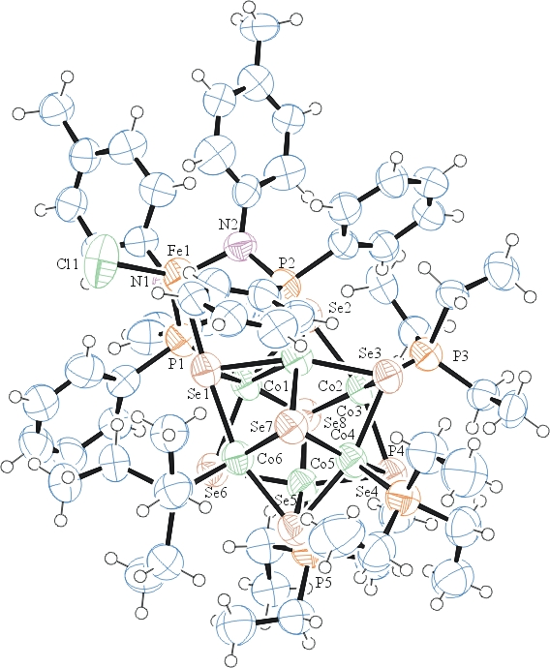
Figure 1. ORTEP of the structure with thermal ellipsoids at the 50% probability level. Disorder omitted for clarity.

Table 1: Crystallographic data for the structures provided.
Empirical formula C62 H94 Cl Co6 Fe N2 P6 Se8
Formula weight 2129.77
Temperature 100(2) K
Wavelength 0.71073 Å
Crystal system Triclinic
Space group P -1
Unit cell dimensions a = 12.9113(11) Å α= 98.310(4)°.
b = 14.5322(14) Å β= 93.126(4)°.
c = 21.834(3) Å γ = 114.232(6)°.
Volume 3667.0(7) Å3
Z 2
Density (calculated) 1.929 Mg/m3
Absorption coefficient 5.693 mm-1
F(000) 2094
Crystal size 0.150 x 0.070 x 0.050 mm3
Theta range for data collection 2.088 to 25.027°.
Index ranges -15<=h<=15, -17<=k<=17, -25<=l<=25
Reflections collected 23750
Independent reflections 12808 [R(int) = 0.2497]
Completeness to theta = 25.000° 98.8 %
Refinement method Full-matrix least-squares on F2
Data / restraints / parameters 12808 / 660 / 821
Goodness-of-fit on F2 0.909
Final R indices [I>2sigma(I)] R1 = 0.0997, wR2 = 0.2106
R indices (all data) R1 = 0.3322, wR2 = 0.3178
Largest diff. peak and hole 1.196 and -0.890 e.Å-3

Otwinowsky, Z.; Minor, W. In: Methods in Enzymology; Carter, C. W., Jr., Sweet, R. M., Eds.; Academic Press: New York, 1997, 276, 307-326.
Sheldrick GM. (2015) SHELXT - Integrated space-group and crystal-structure determination. Acta Cryst. A71, 3-8.
(a) Altomare A, Burla C, Camalli M, Cascarano G L, Giacovazzo C, Guagliardi A, Moliterni AGG, Polidori G, Spagna R. (1999) SIR97: a new tool for crystal structure determination and refinement Journal of Applied Crystallography, 32, 115-119. (b) Altomare A, Cascarano G L, Giacovazzo C, Guagliardi A. (1993) Completion and refinement of crystal structures with SIR 92. Journal of Applied Crystallography, 26, 343-350.
(a) Sheldrick GM. (1997) SHELXL-97, Program for the Refinement of Crystal Structures. University of Göttingen, Germany. (b) Sheldrick GM. (2015) Crystal structure refinement with SHELXL. Acta Cryst. (2015). C71, 3–8
Mackay, S.; Edwards, C.; Henderson, A.; Gilmore, C.; Stewart, N.; Shankland, K.; Donald, A. (1997) MaXus: a computer program for the solution and refinement of crystal structures from diffraction data. University of Glasgow, Scotland,.
Waasmaier, D.; Kirfel, A. Acta Crystallogr. A. 1995, 51, 416.
Farrugia, L. J. Appl. Cryst. 1997, 30, 565

