Crystal Structure Report for A Velian
by Paige Gannon & Werner Kaminsky
Sample Submitted by Ben Mitchell
ID – BSM514
X-ray Crystallography Laboratory
University of Washington
31. July 2026

Data Collection started: 1/6/2022
Documentation finished: 1/11/2022

Data backup accessibly through http:
URL: http://cad4.cpac.washington.edu/structures

W.Kaminsky: tel. (206) 543 7585
(x-ray lab): tel. (206) 543 0210
Email: kaminsky@chem.washington.edu

Understanding crystallographic information is not trivial. If you discuss a structure in a publication, please let the crystallographers proof-read the final draft of that manuscript before you submit it.
For many structures it is true that crystallography is an intellectual performance (like synthesis or elucidation of mechanisms) and not a routine job. In these cases, particularly when the structures contribute significantly to the content of the publication, the crystallographers should be co-authors. Do not think this is not necessary because you pay for structures.
A black shard, measuring 0.19 x 0.11 x 0.03 mm³ was mounted on a loop with oil. Data was collected at -173ºC on a Bruker APEX II single crystal X-ray diffractometer, Mo-radiation, equipped with a Miracol X-ray optical collimator.

Crystal-to-detector distance was 40 mm and exposure time was 60 seconds per frame for all sets. The scan width was 0.5º. Data collection was 93.7% complete to 25º in ϑ. A total of 45918 symmetry independent reflections with R_{int} = 0.2628 were collected covering the indices, -22<=h<=22, -34<=k<=33, -37<=l<=38. Indexing and unit cell refinement indicated a triclinic lattice. The space group was found to be‾1 (No. 2).

The data was integrated and scaled using SAINT, SADABS within the APEX2 software package by Bruker.

Solution by direct methods (SHELXT or SIR97) produced a complete heavy atom phasing model consistent with the proposed structure. The structure was completed by difference Fourier synthesis with SHELXL. Scattering factors are from Waasmair and Kirfel. Hydrogen atoms were placed in geometrically idealised positions and constrained to ride on their parent atoms with C---H distances in the range 0.95-1.00 Angstrom. Isotropic thermal parameters U_{eq} were fixed such that they were 1.2U_{eq} of their parent atom Ueq for CH's and 1.5U_{eq} of their parent atom U_{eq} in case of methyl groups. All non-hydrogen atoms were refined anisotropically by full-matrix least-squares.

The sample was too small to yield data with sufficient statistical quality. However, the model obtained is valid. 15 DCM solvent molecules were explicitly refined (electron density analysis indicates up to 17) together with the dimeric complex and two PF6 anions.

Global ISOR and DELU restraints were applied, excluding Zn, Co, Se. All phenyl groups are idealized and similar moieties like P(phen)2Ntol as well as pyridines are linked with SAME commands. Similar linked are the DCM solvents which fill all remaining space outside the clusters. There is astonishingly little disorder observed (solvent only) and no Ru complex was found.

The structure in its present form is not recommended for publication. A new experiment on a larger sample is recommended to improve on the data statistics. Table 1 summarizes the data collection details. Figure 1 shows an ORTEP of the asymmetric unit.

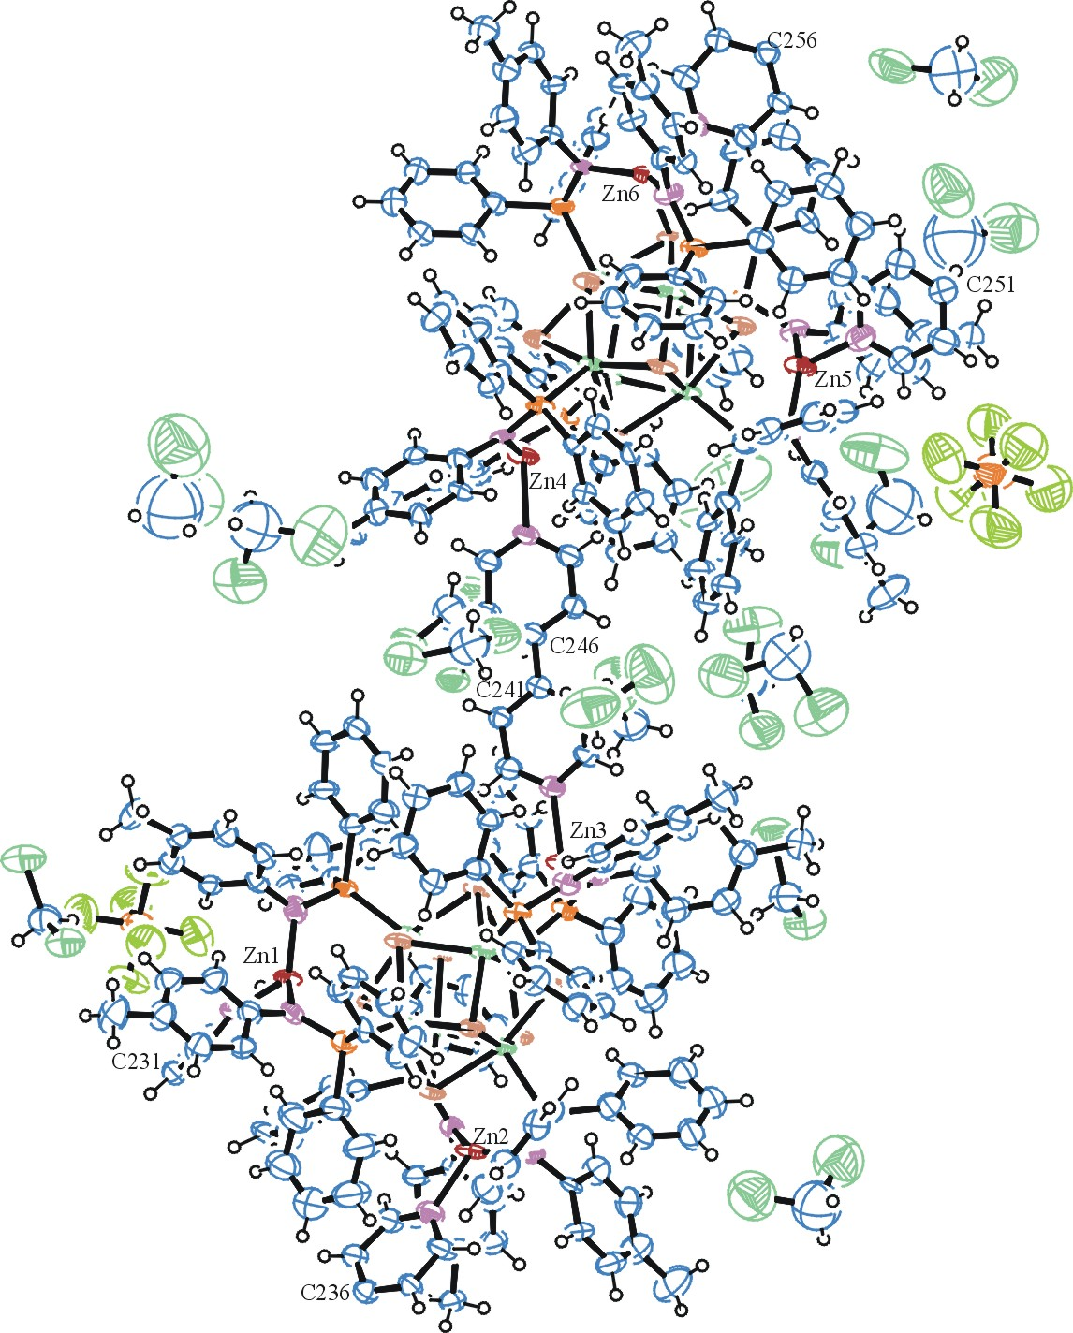
Figure 1. ORTEP of the structure with thermal ellipsoids at the 50% probability level.

Table 1: Crystallographic data for the structures provided.
Empirical formula C273 H257 Cl30 Co12 F12 N18 P14 Se16 Zn6
Formula weight 7877.77
Temperature 100(2) K
Wavelength 0.71073 Å
Crystal system Triclinic
Space group P -1
Unit cell dimensions a = 18.950(6) Å α= 111.353(11)°.
b = 28.132(9) Å β= 97.804(13)°.
c = 31.475(11) Å γ = 101.791(12)°.
Volume 14885(9) Å3
Z 2
Density (calculated) 1.758 Mg/m3
Absorption coefficient 3.485 mm-1
F(000) 7794
Crystal size 0.190 x 0.110 x 0.030 mm3
Theta range for data collection 1.128 to 24.407°.
Index ranges -22<=h<=22, -34<=k<=33, -37<=l<=38
Reflections collected 45918
Independent reflections 45918 [R(int) = 0.2628]
Completeness to theta = 24.407° 93.7 %
Refinement method Full-matrix least-squares on F2
Data / restraints / parameters 45918 / 6990 / 3037
Goodness-of-fit on F2 0.990
Final R indices [I>2sigma(I)] R1 = 0.1296, wR2 = 0.2481
R indices (all data) R1 = 0.2981, wR2 = 0.3356
Largest diff. peak and hole 1.407 and -1.979 e.Å-3

Bruker (2007) APEX2 (Version 2.1-4), SAINT (version 7.34A), SADABS (version 2007/4), BrukerAXS Inc, Madison, Wisconsin, USA.
(a) Sheldrick GM. (2008) A short history of SHELX. Acta Cryst. A64, 112-122. (b) Sheldrick GM. (2015) SHELXT - Integrated space-group and crystal-structure determination. Acta Cryst. A71, 3-8.
(a) Altomare A, Burla C, Camalli M, Cascarano G L, Giacovazzo C, Guagliardi A, Moliterni AGG, Polidori G, Spagna R. (1999) SIR97: a new tool for crystal structure determination and refinement Journal of Applied Crystallography, 32, 115-119. (b) Altomare A, Cascarano G L, Giacovazzo C, Guagliardi A. (1993) Completion and refinement of crystal structures with SIR 92. Journal of Applied Crystallography, 26, 343-350.
(a) Sheldrick GM. (1997) SHELXL-97, Program for the Refinement of Crystal Structures. University of Göttingen, Germany. (b) Sheldrick GM. (2015) Crystal structure refinement with SHELXL. Acta Cryst. C71, 3–8
Waasmaier, D.; Kirfel, A. (1995) New Analytical Scattering Factor Functions for Free Atoms and Ions. Acta Crystallographica A., 51, 416-430.
Farrugia LJ. (1997) Ortep-3 for Windows. Journal of Applied Crystallography, 30, 565

