Crystal Structure Report for A. Velian
by Dylan Rogers & Werner Kaminsky
Sample Submitted by Ben Mitchell
ID – BSM79
X-ray Crystallography Laboratory
University of Washington
31. July 2026

Data Collection started: 1/4/2019
Documentation finished: 1/11/2019

Data backup accessibly through http:
URL: http://cad4.cpac.washington.edu/structures

W.Kaminsky: tel. (206) 543 7585
(x-ray lab): tel. (206) 543 0210
Email: kaminsky@chem.washington.edu

Understanding crystallographic information is not trivial. If you discuss a structure in a publication, please let the crystallographers proof-read the final draft of that manuscript before you submit it.
For many structures it is true that crystallography is an intellectual performance (like synthesis or elucidation of mechanisms) and not a routine job. In these cases, particularly when the structures contribute significantly to the content of the publication, the crystallographers should be co-authors. Do not think this is not necessary because you pay for structures.
A black piece, measuring 0.16 x 0.07 x 0.06 mm³ was mounted on a loop with oil. Data was collected at -173ºC on a Bruker APEX II single crystal X-ray diffractometer, Mo-radiation.

Crystal-to-detector distance was 40 mm and exposure time was 60 seconds per frame for all sets. The scan width was 0.5º. Data collection was 99.9% complete to 25º in ϑ. A total of 66691 merged reflections were collected covering the indices, -68<=h<=68, -28<=k<=28, -37<=l<=37. 33899 reflections were symmetry independent and the R_{int} = 0.1012 indicated that the data was of sufficient quality. Indexing and unit cell refinement indicated a C-centered monoclinic lattice. The space group was found to be C 2/c (No.15).

The data was integrated and scaled using SAINT, SADABS within the APEX2 software package by Bruker.

Solution by direct methods (SHELXT or SIR97) produced a complete heavy atom phasing model consistent with the proposed structure. The structure was completed by difference Fourier synthesis with SHELXL., Scattering factors are from Waasmair and Kirfel. Hydrogen atoms were placed in geometrically idealised positions and constrained to ride on their parent atoms with C---H distances in the range 0.95-1.00 Angstrom. Isotropic thermal parameters U_{eq} were fixed such that they were 1.2U_{eq} of their parent atom Ueq for CH's and 1.5U_{eq} of their parent atom U_{eq} in case of methyl groups. All non-hydrogen atoms were refined anisotropically by full-matrix least-squares.

The structure appears chemically disordered, with some THF and pentane disorder in addition. The moiety formula is:

0.708(C114 H102 Co6 Li4 N6 P6 Se8 Zn), 0.292(C114 H102 Co6 Li2 N6 P6 Se8 Zn2), 6(C4 H8 O), 0.5(C5 H12)

The structure is of high quality and ready for publication. Table 1 summarizes the data collection details. Figure 1a shows an ORTEP of the major component, Figure 2 of the other one.

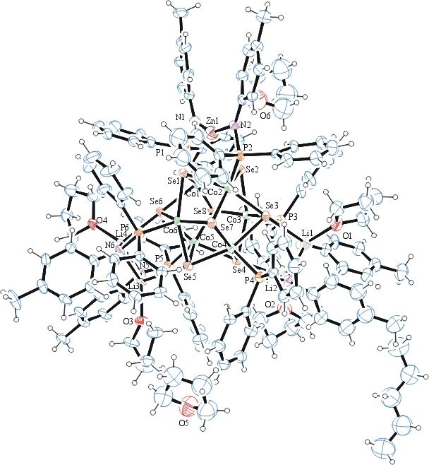
Figure 1. ORTEP of the major component with thermal ellipsoids at the 30% probability level. Disorder omitted for clarity.
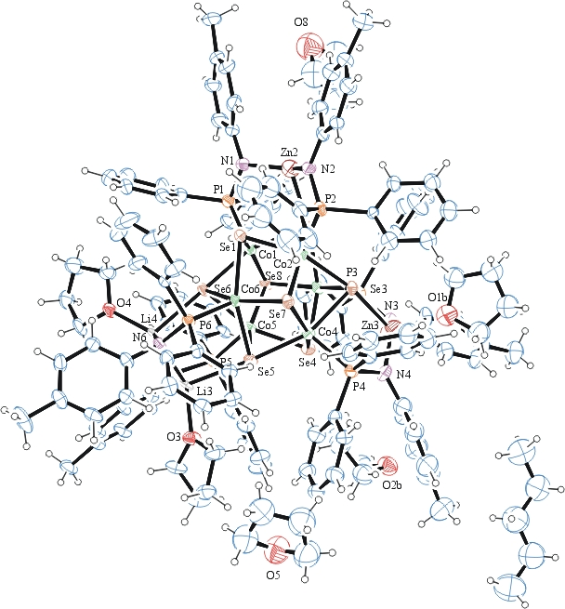
Figure 2. ORTEP of the minor component with thermal ellipsoids at the 30% probability level. Disorder omitted for clarity.

Table 1: Crystallographic data for the structures provided.
Empirical formula C281 H312 Co12 Li6.83 N12 O12 P12 Se16 Zn2.59
Formula weight 6607.97
Temperature 100(2) K
Wavelength 0.71073 Å
Crystal system Monoclinic
Space group C 2/c
Unit cell dimensions a = 51.344(2) Å α= 90°.
b = 21.3353(9) Å β= 118.736(2)°.
c = 28.2770(13) Å γ = 90°.
Volume 27161(2) Å3
Z 4
Density (calculated) 1.616 Mg/m3
Absorption coefficient 3.211 mm-1
F(000) 13296
Crystal size 0.160 x 0.070 x 0.060 mm3
Theta range for data collection 1.445 to 28.391°.
Index ranges -68<=h<=68, -28<=k<=28, -37<=l<=37
Reflections collected 66691
Independent reflections 33899 [R(int) = 0.1012]
Completeness to theta = 25.000° 99.9 %
Refinement method Full-matrix least-squares on F2
Data / restraints / parameters 33899 / 1717 / 1765
Goodness-of-fit on F2 1.015
Final R indices [I>2sigma(I)] R1 = 0.0706, wR2 = 0.1721
R indices (all data) R1 = 0.1908, wR2 = 0.2258
Largest diff. peak and hole 1.121 and -1.907 e.Å-3

Bruker (2007) APEX2 (Version 2.1-4), SAINT (version 7.34A), SADABS (version 2007/4), BrukerAXS Inc, Madison, Wisconsin, USA.
Sheldrick GM. (2015) SHELXT - Integrated space-group and crystal-structure determination. Acta Cryst. A71, 3-8.
(a) Altomare A, Burla C, Camalli M, Cascarano G L, Giacovazzo C, Guagliardi A, Moliterni AGG, Polidori G, Spagna R. (1999) SIR97: a new tool for crystal structure determination and refinement Journal of Applied Crystallography, 32, 115-119. (b) Altomare A, Cascarano G L, Giacovazzo C, Guagliardi A. (1993) Completion and refinement of crystal structures with SIR 92. Journal of Applied Crystallography, 26, 343-350.
(a) Sheldrick GM. (1997) SHELXL-97, Program for the Refinement of Crystal Structures. University of Göttingen, Germany. (b) Sheldrick GM. (2015) Crystal structure refinement with SHELXL. Acta Cryst. (2015). C71, 3–8
Mackay, S.; Edwards, C.; Henderson, A.; Gilmore, C.; Stewart, N.; Shankland, K.; Donald, A. (1997) MaXus: a computer program for the solution and refinement of crystal structures from diffraction data. University of Glasgow, Scotland,.
Waasmaier, D.; Kirfel, A. (1995) New Analytical Scattering Factor Functions for Free Atoms and Ions. Acta Crystallographica A., 51, 416-430.
Farrugia LJ. (1997) Ortep-3 for Windows. Journal of Applied Crystallography, 30, 565

