Crystal Structure Report for Khalil Beyki
by Werner Kaminsky
ID – Beiky013
X-ray Crystallography Laboratory
University of Washington
31. July 2026

Data Collection started: 12/10/2015
Documentation finished: 1/21/2016

Data backup accessibly through http:
URL: http://cad4.cpac.washington.edu/structures
Username: xray-user
Password: hkl-data

W.Kaminsky: tel. (206) 543 7585
(x-ray lab): tel. (206) 543 0210
Email: kaminsky@chem.washington.edu

Understanding crystallographic information is not trivial. If you discuss a structure in a publication, please let the crystallographers proof-read the final draft of that manuscript before you submit it.
For many structures it is true that crystallography is an intellectual performance (like synthesis or elucidation of mechanisms) and not a routine job. In these cases, particularly when the structures contribute significantly to the content of the publication, the crystallographers should be co-authors. Do not think this is not necessary because you pay for structures. Even I have to pay for my own structures for my research.
A colorless prism, measuring 0.50 x 0.10 x 0.07 mm³ was mounted on a loop with oil. Data was collected at 19ºC on a Nonius Kappa CCD FR590 single crystal X-ray diffractometer, Mo-radiation.

Crystal-to-detector distance was 30 mm and exposure time was 120 seconds per degree for all sets. The scan width was 1º. Data collection was 99.0% complete to 25º in ϑ. A total of 6319 merged reflections were collected covering the indices, -7<=h<=7, -24<=k<=24, -17<=l<=17. 3427 reflections were symmetry independent and the R_{int} = 0.0741 indicated that the data was of average quality 0.07. Indexing and unit cell refinement indicated a primitive monoclinic lattice. The space group was found to be P 2₁/n (No.14).

The data was integrated and scaled using hkl-SCALEPACK. This program applies a multiplicative correction factor (S) to the observed intensities (I) and has the following form:

S is calculated from the scale and the B factor determined for each frame and is then applied to I to give the corrected intensity (I_{corr}).

Solution by direct methods (SHELXS, SIR97) produced a complete heavy atom phasing model consistent with the proposed structure. The structure was completed by difference Fourier synthesis with SHELXL97., Scattering factors are from Waasmair and Kirfel. Hydrogen atoms were placed in geometrically idealised positions and constrained to ride on their parent atoms with C---H distances in the range 0.95-1.00 Angstrom. Isotropic thermal parameters U_{eq} were fixed such that they were 1.2U_{eq} of their parent atom Ueq for CH's and 1.5U_{eq} of their parent atom U_{eq} in case of methyl groups. All non-hydrogen atoms were refined anisotropically by full-matrix least-squares.

One half of the molecule is related to the other via crystal symmetry.

The structure is of high quality and ready for publication. Table 1 summarizes the data collection details. Figure 1 shows an ORTEP of the asymmetric unit.
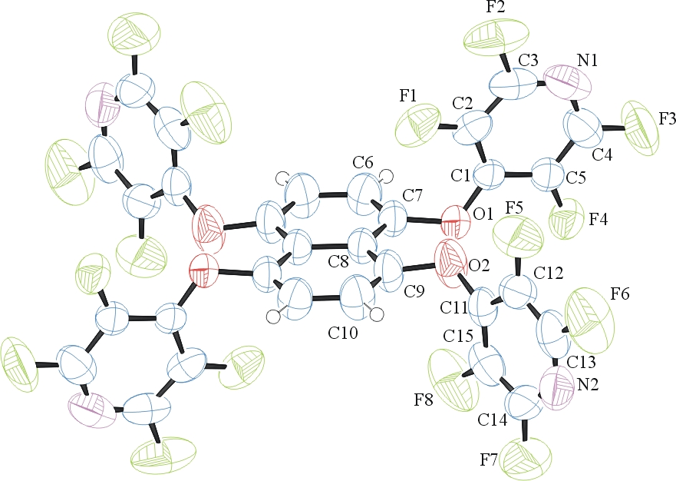

Figure 1. ORTEP of the structure with thermal ellipsoids at the 50% probability level.

Table 1: Crystallographic data for the structures provided.
Empirical formula C30 H4 F16 N4 O4
Formula weight 788.37
Temperature 292(2) K
Wavelength 0.71073 Å
Crystal system Monoclinic
Space group P 2₁/n
Unit cell dimensions a = 5.7900(2) Å α= 90°.
b = 18.8129(8) Å β= 99.049(2)°.
c = 13.3418(5) Å γ = 90°.
Volume 1435.19(10) Å3
Z 2
Density (calculated) 1.824 Mg/m3
Absorption coefficient 0.192 mm-1
F(000) 776
Crystal size 0.50 x 0.10 x 0.07 mm3
Theta range for data collection 2.17 to 28.26°.
Index ranges -7<=h<=7, -24<=k<=24, -17<=l<=17
Reflections collected 6319
Independent reflections 3427 [R(int) = 0.0741]
Completeness to theta = 25.00° 99.0 %
Max. and min. transmission 0.9867 and 0.9100
Refinement method Full-matrix least-squares on F2
Data / restraints / parameters 3427 / 0 / 245
Goodness-of-fit on F2 0.974
Final R indices [I>2sigma(I)] R1 = 0.0687, wR2 = 0.1717
R indices (all data) R1 = 0.1856, wR2 = 0.2229
Extinction coefficient 0.018(5)
Largest diff. peak and hole 0.335 and -0.215 e.Å-3

Otwinowsky, Z.; Minor, W. In: Methods in Enzymology; Carter, C. W., Jr., Sweet, R. M., Eds.; Academic Press: New York, 1997, 276, 307-326.
(a) Altomare, A.; Burla, C.; Camalli M.; Cascarano L.; Giacovazzo C.; Guagliardi A.; Moliterni A.G.G.; Polidori G.; Spagna R. J. Appl. Cryst. 1999, 32, 115-119; (b) Altomare, A., Cascarano, G., Giacovazzo, C., Guagliardi, A., J. Appl. Cryst. 1993, 26, 343.
(a) Sheldrick GM. (1997) SHELXL-97, Program for the Refinement of Crystal Structures. University of Göttingen, Germany. (b) Sheldrick GM. (2013) Crystal structure refinement with SHELXL. Acta Cryst. (2015). C71, 3-8.
Mackay, S.; Edwards, C.; Henderson, A.; Gilmore, C.; Stewart, N.; Shankland, K.; Donald, A.; MaXus: a computer program for the solution and refinement of crystal structures from diffraction data. University of Glasgow, Scotland, 1997.
Waasmaier, D.; Kirfel, A. Acta Crystallogr. A. 1995, 51, 416.
Farrugia, L. J. Appl. Cryst. 1997, 30, 565

