Crystal Structure Report for A Jen
by Werner Kaminsky
Sample Submitted by Ting Zhao
ID – C12PV
X-ray Crystallography Laboratory
University of Washington
31. July 2026

Data Collection started: 7/1/2015
Documentation finished: 8/7/2015

Data backup accessibly through http:
URL: http://cad4.cpac.washington.edu/structures

W.Kaminsky: tel. (206) 543 7585
(x-ray lab): tel. (206) 543 0210
Email: kaminsky@chem.washington.edu

Understanding crystallographic information is not trivial. If you discuss a structure in a publication, please let the crystallographers proof-read the final draft of that manuscript before you submit it.
For many structures it is true that crystallography is an intellectual performance (like synthesis or elucidation of mechanisms) and not a routine job. In these cases, particularly when the structures contribute significantly to the content of the publication, the crystallographers should be co-authors. Do not think this is not necessary because you pay for structures. Even I have to pay for my own structures for my research.
A n yellow plate, measuring 0.13 x 0.12 x 0.01 mm³ was mounted on a loop with oil. Data was collected at -173ºC on a Bruker APEX II single crystal X-ray diffractometer, Mo-radiation.

Crystal-to-detector distance was 40 mm and exposure time was 90 seconds per frame for all sets. The scan width was 0.5º. Data collection was 58.7% complete to 25º in ϑ. A total of 11122 reflections were collected covering the indices, h = -29 to 29, k = -9 to 9, l = -7 to 7. 1887 reflections were symmetry independent and the R_{int} = 0.1660 indicated that the data was difficult. Indexing and unit cell refinement indicated a primitive monoclinic lattice. The space group was found to be P 2₁/c (No. 14).

The data was integrated and scaled using SAINT, SADABS within the APEX2 software package by Bruker.

Solution by direct methods (SHELXS, SIR97) produced a complete heavy atom phasing model consistent with the proposed structure. The structure was completed by difference Fourier synthesis with SHELXL97., Scattering factors are from Waasmair and Kirfel. Hydrogen atoms were placed in geometrically idealised positions and constrained to ride on their parent atoms with C---H distances in the range 0.95-1.00 Angstrom. Isotropic thermal parameters U_{eq} were fixed such that they were 1.2U_{eq} of their parent atom Ueq for CH's and 1.5U_{eq} of their parent atom U_{eq} in case of methyl groups. All non-hydrogen atoms were refined anisotropically by full-matrix least-squares.

Twinning by almost commensurate two-fold rotation about (1 0 0) via transformation (1 0 1, 0 -1 0 , 0 0 -1) implied a pseudo-centered space group with a disordered structure, however, a lower space group was found in which the structure solves non-disordered.
The structure is of low quality, and retaking data on a better sample would be highly recommended before considering this result for publication. Table 1 summarizes the data collection details. Figure 1 shows an ORTEP of the asymmetric unit, Figure 2 packing in the crystal.
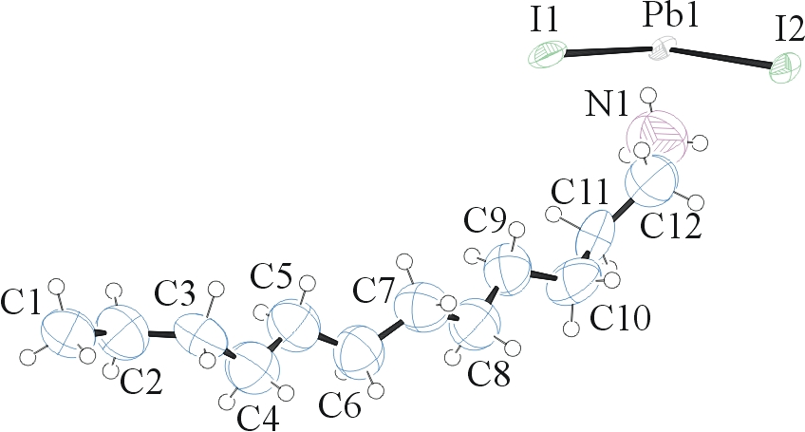
Figure 1. ORTEP of the structure with thermal ellipsoids at the 50% probability level.

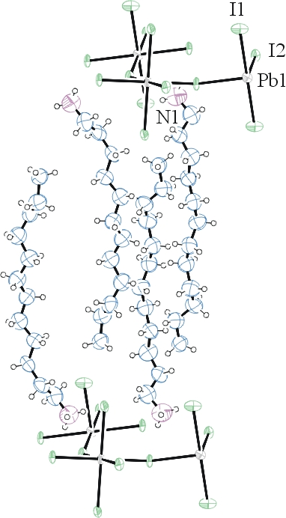
Figure 2. Packing of the structure with thermal ellipsoids at the 50% probability level.

Table 1: Crystallographic data for the structures provided.
Empirical formula C24 H56 I4 N2 Pb
Formula weight 1087.50
Temperature 100(2) K
Wavelength 0.71073 Å
Crystal system Monoclinic
Space group P 2₁/c
Unit cell dimensions a = 24.710(3) Å α= 90°.
b = 8.5026(10) Å β= 99.841(8)°.
c = 8.5201(11) Å γ = 90°.
Volume 1763.7(4) Å3
Z 2
Density (calculated) 2.048 Mg/m3
Absorption coefficient 8.297 mm-1
F(000) 1016
Crystal size 0.13 x 0.12 x 0.01 mm3
Theta range for data collection 1.67 to 25.44°.
Index ranges -29<=h<=29, -9<=k<=9, -7<=l<=7
Reflections collected 11122
Independent reflections 1887 [R(int) = 0.1660]
Completeness to theta = 25.00° 58.7 %
Max. and min. transmission 0.9216 and 0.4118
Refinement method Full-matrix least-squares on F2
Data / restraints / parameters 1887 / 159 / 145
Goodness-of-fit on F2 1.020
Final R indices [I>2sigma(I)] R1 = 0.0914, wR2 = 0.2017
R indices (all data) R1 = 0.1688, wR2 = 0.2530
Largest diff. peak and hole 2.954 and -2.240 e.Å-3

Bruker (2007) APEX2 (Version 2.1-4), SAINT (version 7.34A), SADABS (version 2007/4), BrukerAXS Inc, Madison, Wisconsin, USA.
(a) Altomare A, Burla C, Camalli M, Cascarano G L, Giacovazzo C, Guagliardi A, Moliterni AGG, Polidori G, Spagna R. (1999) SIR97: a new tool for crystal structure determination and refinement Journal of Applied Crystallography, 32, 115-119. (b) Altomare A, Cascarano G L, Giacovazzo C, Guagliardi A. (1993) Completion and refinement of crystal structures with SIR 92. Journal of Applied Crystallography, 26, 343-350.
Sheldrick GM. (1997) SHELXL-97, Program for the Refinement of Crystal Structures. University of Göttingen, Germany.
Mackay, S.; Edwards, C.; Henderson, A.; Gilmore, C.; Stewart, N.; Shankland, K.; Donald, A. (1997) MaXus: a computer program for the solution and refinement of crystal structures from diffraction data. University of Glasgow, Scotland,.
Waasmaier, D.; Kirfel, A. (1995) New Analytical Scattering Factor Functions for Free Atoms and Ions. Acta Crystallographica A., 51, 416-430.
Farrugia LJ. (1997) Ortep-3 for Windows. Journal of Applied Crystallography, 30, 565

