Crystal Structure Report for D. Reed
by Paige Gammon & Werner Kaminsky
Sample Submitted by Connor Dalton
ID – CD_071422_1E
X-ray Crystallography Laboratory
University of Washington
28. July 2026

Data Collection started: 7/26/2022
Documentation finished: 8/2/2022

Data backup accessibly through http:
URL: http://cad4.cpac.washington.edu/structures

W.Kaminsky: tel. (206) 543 7585
(x-ray lab): tel. (206) 543 0210
Email: kaminsky@chem.washington.edu

Understanding crystallographic information is not trivial. If you discuss a structure in a publication, please let the crystallographers proof-read the final draft of that manuscript before you submit it.
For many structures it is true that crystallography is an intellectual performance (like synthesis or elucidation of mechanisms) and not a routine job. In these cases, particularly when the structures contribute significantly to the content of the publication, the crystallographers should be co-authors. Do not think this is not necessary because you pay for structures.
A a yellow prism, measuring 0.11 x 0.10 x 0.10 mm³ was mounted on a loop with oil. Data was collected at -173ºC on a Bruker APEX II single crystal X-ray diffractometer, Mo-radiation, equipped with a Miracol X-ray optical collimator.

Crystal-to-detector distance was 40 mm and exposure time was 30 seconds per frame for all sets. The scan width was 0.5º. Data collection was 97.4% complete to 25º in ϑ. A total of 3116 reflections were collected covering the indices, -12<=h<=11, 0<=k<=24, -9<=l<=40. 1734 reflections were symmetry independent and the R_{int} = 0.0302 indicated that the data was excellent. Indexing and unit cell refinement indicated a face-centered orthorhombic lattice. The space group was found to be F m m m (No. 69).

The data appeared three-fold twinned (CELL_NOW) and after multi-domain integration (SAINT, SADABS within the APEX2 software package by Bruker) the data was merged utilizing twinabs.

Solution by direct methods (SHELXT or SIR97) produced a complete heavy atom phasing model consistent with the proposed structure. The structure was completed by difference Fourier synthesis with SHELXL. Scattering factors are from Waasmair and Kirfel. Hydrogen atoms were placed in geometrically idealised positions and constrained to ride on their parent atoms with C---H distances in the range 0.95-1.00 Angstrom. Isotropic thermal parameters U_{eq} were fixed such that they were 1.2U_{eq} of their parent atom Ueq for CH's and 1.5U_{eq} of their parent atom U_{eq} in case of methyl groups. All non-hydrogen atoms were refined anisotropically by full-matrix least-squares.

After multi-domain integration and scaling of the drilling, the structure solved well, but the silsesquioxane appeared disordered over two locations, and one of the chlorines (Cl3) was split as well. The contribution of some disordered solvent to the diffraction pattern (2 voids each 393Å³ filled with 47 electrons in the unit cell) was analyzed and removed with SQUEEZE

The structure is of high quality and ready for publication. Table 1 summarizes the data collection details. Figure 1 shows the an ORTEP of the asymmetric unit and Figure 2 the partially extended structure. 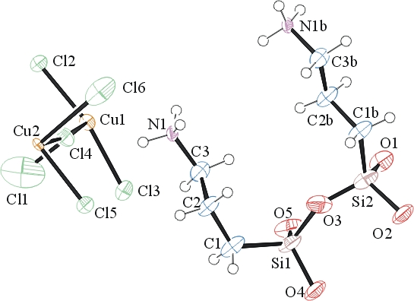 Figure 1

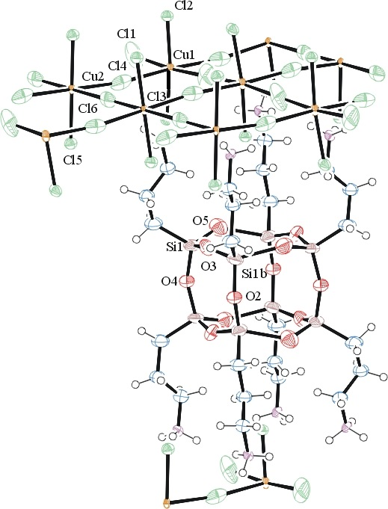
Figure 2. ORTEP of the extended structure with thermal ellipsoids at the 50% probability level. Disorder omitted for clarity.

Table 1: Crystallographic data for the structures provided.
Empirical formula C6 H18 Cl4 Cu N2 O3 Si2
Formula weight 427.74
Temperature 100(2) K
Wavelength 0.71073 Å
Crystal system Orthorhombic
Space group F m m m
Unit cell dimensions a = 10.2369(6) Å α= 90°.
b = 20.4352(12) Å β= 90°.
c = 33.981(2) Å γ = 90°.
Volume 7108.6(8) Å3
Z 16
Density (calculated) 1.599 Mg/m3
Absorption coefficient 1.965 mm-1
F(000) 3472
Crystal size 0.110 x 0.100 x 0.100 mm3
Theta range for data collection 1.198 to 25.154°.
Index ranges -12<=h<=11, 0<=k<=24, -9<=l<=40
Reflections collected 3216
Independent reflections 1734 [R(int) = 0.0302]
Completeness to theta = 25.000° 97.4 %
Refinement method Full-matrix least-squares on F2
Data / restraints / parameters 1734 / 26 / 133
Goodness-of-fit on F2 1.225
Final R indices [I>2sigma(I)] R1 = 0.0881, wR2 = 0.2216
R indices (all data) R1 = 0.0915, wR2 = 0.2248
Largest diff. peak and hole 1.468 and -1.611 e.Å-3

Sheldrick, G. M. (2005). CELL_NOW. University of Goettingen, Germany.
Bruker (2007) APEX2 (Version 2.1-4), SAINT (version 7.34A), SADABS (version 2007/4), BrukerAXS Inc, Madison, Wisconsin, USA.
Sheldrick, G. M. (2007). TWINABS. University of Goettingen, Germany.
(a) Sheldrick GM. (2008) A short history of SHELX. Acta Cryst. A64, 112-122. (b) Sheldrick GM. (2015) SHELXT - Integrated space-group and crystal-structure determination. Acta Cryst. A71, 3-8.
(a) Altomare A, Burla C, Camalli M, Cascarano G L, Giacovazzo C, Guagliardi A, Moliterni AGG, Polidori G, Spagna R. (1999) SIR97: a new tool for crystal structure determination and refinement Journal of Applied Crystallography, 32, 115-119. (b) Altomare A, Cascarano G L, Giacovazzo C, Guagliardi A. (1993) Completion and refinement of crystal structures with SIR 92. Journal of Applied Crystallography, 26, 343-350.
(a) Sheldrick GM. (1997) SHELXL-97, Program for the Refinement of Crystal Structures. University of Göttingen, Germany. (b) Sheldrick GM. (2015) Crystal structure refinement with SHELXL. Acta Cryst. C71, 3–8
Waasmaier, D.; Kirfel, A. (1995) New Analytical Scattering Factor Functions for Free Atoms and Ions. Acta Crystallographica A., 51, 416-430.
(a) A. Spek, J. Appl. Cryst. (2003), 36, 7-13; (b) P. van der Sluis & A. L. Spek, Acta Cryst. (1990). A46, 194-201. (c) Spek, A. L. (2009). Acta. Cryst. D65, 148-155.
Farrugia LJ. (1997) Ortep-3 for Windows. Journal of Applied Crystallography, 30, 565

