Crystal Structure Report for A. Velian
by Dylan Rogers & Werner Kaminsky
Sample Submitted by C. Romero
ID – CGR_25_3
X-ray Crystallography Laboratory
University of Washington
31. July 2026

Data Collection started: 8/22/2019
Documentation finished: 9/25/2019

Data backup accessibly through http:
URL: http://cad4.cpac.washington.edu/structures

W.Kaminsky: tel. (206) 543 7585
(x-ray lab): tel. (206) 543 0210
Email: kaminsky@chem.washington.edu

Understanding crystallographic information is not trivial. If you discuss a structure in a publication, please let the crystallographers proof-read the final draft of that manuscript before you submit it.
For many structures it is true that crystallography is an intellectual performance (like synthesis or elucidation of mechanisms) and not a routine job. In these cases, particularly when the structures contribute significantly to the content of the publication, the crystallographers should be co-authors. Do not think this is not necessary because you pay for structures.
A very small black piece, measuring 0.11 x 0.07 x 0.06 mm³ was mounted on a loop with oil. Data was collected at -173ºC on a Bruker APEX II single crystal X-ray diffractometer, Mo-radiation.

Crystal-to-detector distance was 40 mm and exposure time was 120 seconds per frame for all sets. The scan width was 1º. Data collection was 99.9% complete to 25º in ϑ. A total of 68821 merged reflections were collected covering the indices, -24<=h<=24, -26<=k<=26, -30<=l<=30. 29637 reflections were symmetry independent and the R_{int} = 0.2394 indicated that the data was week. Indexing and unit cell refinement indicated a triclinic lattice. The space group was found to be P‾1 (No.2).

The data was integrated and scaled using SAINT, SADABS within the APEX2 software package by Bruker.

The contribution of disordered toluene solvent to the diffraction pattern was removed with SQUEEZE

Solution by direct methods (SHELXT or SIR97) produced a complete heavy atom phasing model consistent with the proposed structure. The structure was completed by difference Fourier synthesis with SHELXL., Scattering factors are from Waasmair and Kirfel. Hydrogen atoms were placed in geometrically idealised positions and constrained to ride on their parent atoms with C---H distances in the range 0.95-1.00 Angstrom. Isotropic thermal parameters U_{eq} were fixed such that they were 1.2U_{eq} of their parent atom Ueq for CH's and 1.5U_{eq} of their parent atom U_{eq} in case of methyl groups. All non-hydrogen atoms were refined anisotropically by full-matrix least-squares.

The clusters are interlinked via carbons C120, C126, C132 which are part of the ethane in Bis(4-pyridyl)ethane (BPE) extended through symmetry. C120 links to itself, C126 links to C132. Some phenyl, toluene, and BPE disorder is omitted in figure 1.

The structure is of high quality and ready for publication. Table 1 summarizes the data collection details. Figure 1 shows an ORTEP of the asymmetric unit.

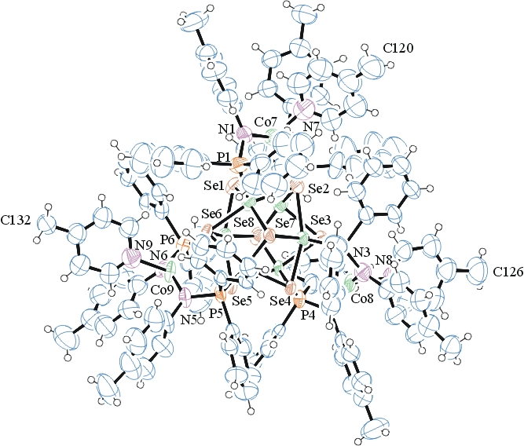
Figure 1. ORTEP of the structure with thermal ellipsoids at the 50% probability level. Disorder and omitted for clarity. Toluene solvent was SQUEEZEd.

Table 1: Crystallographic data for the structures provided.
Empirical formula C132 H120 Co9 N9 P6 Se8
Formula weight 3180.23
Temperature 100(2) K
Wavelength 0.71073 Å
Crystal system Triclinic
Space group P -1
Unit cell dimensions a = 19.461(3) Å α= 111.713(3)°.
b = 21.179(3) Å β= 98.670(4)°.
c = 24.015(4) Å γ = 107.212(4)°.
Volume 8398(2) Å3
Z 2
Density (calculated) 1.258 Mg/m3
Absorption coefficient 2.696 mm-1
F(000) 3160
Crystal size 0.110 x 0.070 x 0.060 mm3
Theta range for data collection 1.483 to 25.027°.
Index ranges -24<=h<=24, -26<=k<=26, -30<=l<=30
Reflections collected 68821
Independent reflections 29637 [R(int) = 0.2394]
Completeness to theta = 25.000° 99.9 %
Refinement method Full-matrix least-squares on F2
Data / restraints / parameters 29637 / 2671 / 1372
Goodness-of-fit on F2 0.820
Final R indices [I>2sigma(I)] R1 = 0.0896, wR2 = 0.2055
R indices (all data) R1 = 0.2824, wR2 = 0.2665
Largest diff. peak and hole 1.360 and -0.799 e.Å-3

Bruker (2007) APEX2 (Version 2.1-4), SAINT (version 7.34A), SADABS (version 2007/4), BrukerAXS Inc, Madison, Wisconsin, USA.
(a) A. Spek, J. Appl. Cryst. (2003), 36, 7-13; (b) P. van der Sluis & A. L. Spek, Acta Cryst. (1990). A46, 194-201. (c) Spek, A. L. (2009). Acta. Cryst. D65, 148-155.
Sheldrick GM. (2015) SHELXT - Integrated space-group and crystal-structure determination. Acta Cryst. A71, 3-8.
(a) Altomare A, Burla C, Camalli M, Cascarano G L, Giacovazzo C, Guagliardi A, Moliterni AGG, Polidori G, Spagna R. (1999) SIR97: a new tool for crystal structure determination and refinement Journal of Applied Crystallography, 32, 115-119. (b) Altomare A, Cascarano G L, Giacovazzo C, Guagliardi A. (1993) Completion and refinement of crystal structures with SIR 92. Journal of Applied Crystallography, 26, 343-350.
(a) Sheldrick GM. (1997) SHELXL-97, Program for the Refinement of Crystal Structures. University of Göttingen, Germany. (b) Sheldrick GM. (2015) Crystal structure refinement with SHELXL. Acta Cryst. (2015). C71, 3–8
Mackay, S.; Edwards, C.; Henderson, A.; Gilmore, C.; Stewart, N.; Shankland, K.; Donald, A. (1997) MaXus: a computer program for the solution and refinement of crystal structures from diffraction data. University of Glasgow, Scotland,.
Waasmaier, D.; Kirfel, A. (1995) New Analytical Scattering Factor Functions for Free Atoms and Ions. Acta Crystallographica A., 51, 416-430.
Farrugia LJ. (1997) Ortep-3 for Windows. Journal of Applied Crystallography, 30, 565

