Crystal Structure Report for A. Velian
by Werner Kaminsky
Sample Submitted by C. Romero
ID – CGR_8_2
X-ray Crystallography Laboratory
University of Washington
31. July 2026

Data Collection started: 8/13/2019
Documentation finished: 8/23/2019

Data backup accessibly through http:
URL: http://cad4.cpac.washington.edu/structures

W.Kaminsky: tel. (206) 543 7585
(x-ray lab): tel. (206) 543 0210
Email: kaminsky@chem.washington.edu

Understanding crystallographic information is not trivial. If you discuss a structure in a publication, please let the crystallographers proof-read the final draft of that manuscript before you submit it.
For many structures it is true that crystallography is an intellectual performance (like synthesis or elucidation of mechanisms) and not a routine job. In these cases, particularly when the structures contribute significantly to the content of the publication, the crystallographers should be co-authors. Do not think this is not necessary because you pay for structures.
A black piece, measuring 0.20 x 0.11 x 0.08 mm³ was mounted on a loop with oil. Data was collected at -173ºC on a Bruker APEX II single crystal X-ray diffractometer, Mo-radiation.

Crystal-to-detector distance was 40 mm and exposure time was 60 seconds per frame for all sets. The scan width was 1º. Data collection was 99.9% complete to 25º in ϑ. A total of 95469 reflections were collected covering the indices, 34<=h<=34, -59<=k<=59, -44<=l<=44. 48160 reflections were symmetry independent and the R_{int} = 0.4053 the protein-size unit cell. Indexing and unit cell refinement indicated a C-centered ortho rhombic lattice. The space group was found to be C 2 2 2₁ (No. 20).

The data was integrated and scaled using SAINT, SADABS within the APEX2 software package by Bruker.

Solution by direct methods (SHELXT or SIR97) produced a complete heavy atom phasing model consistent with the proposed structure. The structure was completed by difference Fourier synthesis with SHELXL., Scattering factors are from Waasmair and Kirfel. Hydrogen atoms were placed in geometrically idealised positions and constrained to ride on their parent atoms with C---H distances in the range 0.95-1.00 Angstrom. Isotropic thermal parameters U_{eq} were fixed such that they were 1.2U_{eq} of their parent atom Ueq for CH's and 1.5U_{eq} of their parent atom U_{eq} in case of methyl groups. All non-hydrogen atoms were refined anisotropically by full-matrix least-squares.

One full and one-half cluster filled the asymmetric unit. About 45% of electron density was attributed to disordered solvent and its contribution to the diffraction pattern was removed with SQUEEZE. The material is a 1:1 enantiomorphic twin.

Each Mn is interlinked via a bipyridine to another, with Mn5 connected to two bipyridines.

The data was very weak, and refinement required heavy restraining.

The structure may be just good enough for publication. Table 1 summarizes the data collection details. Figure 1 shows an ORTEP of the asymmetric unit.

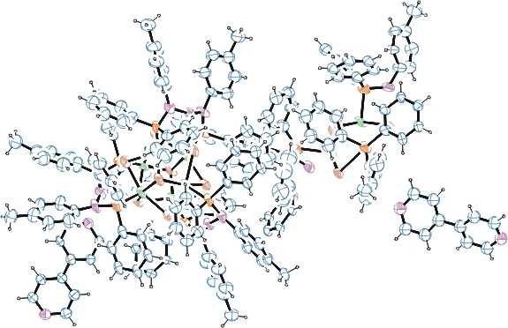

Figure 1. ORTEP of the asymmetric unit with thermal ellipsoids at the 15% probability level. All solvent and some phenyl and toluene disorder omitted for clarity.

Table 1: Crystallographic data for the structures provided.
Empirical formula C391 H343 Co18 Mn9 N28 P18 Se24
Formula weight 9441.61
Temperature 100(2) K
Wavelength 0.71073 Å
Crystal system Orthorhombic
Space group C 2 2 2₁
Unit cell dimensions a = 28.9448(15) Å α= 90°.
b = 50.153(2) Å β= 90°.
c = 37.2848(13) Å γ = 90°.
Volume 54125(4) Å3
Z 4
Density (calculated) 1.159 Mg/m3
Absorption coefficient 2.444 mm-1
F(000) 18728
Crystal size 0.200 x 0.110 x 0.080 mm3
Theta range for data collection 1.361 to 25.091°.
Index ranges -34<=h<=34, -59<=k<=59, -44<=l<=44
Reflections collected 95469
Independent reflections 48160 [R(int) = 0.4053]
Completeness to theta = 25.000° 99.9 %
Refinement method Full-matrix least-squares on F2
Data / restraints / parameters 48160 / 4608 / 1533
Goodness-of-fit on F2 1.106
Final R indices [I>2sigma(I)] R1 = 0.1800, wR2 = 0.4029
R indices (all data) R1 = 0.4467, wR2 = 0.5295
Absolute structure parameter 0.5
Largest diff. peak and hole 2.321 and -0.979 e.Å-3

Bruker (2007) APEX2 (Version 2.1-4), SAINT (version 7.34A), SADABS (version 2007/4), BrukerAXS Inc, Madison, Wisconsin, USA.
Sheldrick GM. (2015) SHELXT - Integrated space-group and crystal-structure determination. Acta Cryst. A71, 3-8.
(a) Altomare A, Burla C, Camalli M, Cascarano G L, Giacovazzo C, Guagliardi A, Moliterni AGG, Polidori G, Spagna R. (1999) SIR97: a new tool for crystal structure determination and refinement Journal of Applied Crystallography, 32, 115-119. (b) Altomare A, Cascarano G L, Giacovazzo C, Guagliardi A. (1993) Completion and refinement of crystal structures with SIR 92. Journal of Applied Crystallography, 26, 343-350.
(a) Sheldrick GM. (1997) SHELXL-97, Program for the Refinement of Crystal Structures. University of Göttingen, Germany. (b) Sheldrick GM. (2015) Crystal structure refinement with SHELXL. Acta Cryst. (2015). C71, 3–8
Mackay, S.; Edwards, C.; Henderson, A.; Gilmore, C.; Stewart, N.; Shankland, K.; Donald, A. (1997) MaXus: a computer program for the solution and refinement of crystal structures from diffraction data. University of Glasgow, Scotland,.
Waasmaier, D.; Kirfel, A. (1995) New Analytical Scattering Factor Functions for Free Atoms and Ions. Acta Crystallographica A., 51, 416-430.
(a) A. Spek, J. Appl. Cryst. (2003), 36, 7-13; (b) P. van der Sluis & A. L. Spek, Acta Cryst. (1990). A46, 194-201. (c) Spek, A. L. (2009). Acta. Cryst. D65, 148-155.
Farrugia LJ. (1997) Ortep-3 for Windows. Journal of Applied Crystallography, 30, 565

