Crystal Structure Report for
Cherif Ben Nasr
by Robert Love and Werner Kaminsky
ID – Cherif_K12
X-ray Crystallography Laboratory
University of Washington
30. July 2026

Data Collection started: 6/4/2025
Documentation finished: 6/17/2025

Data backup accessibly through http:
URL: http://cad4.cpac.washington.edu/structures

W.Kaminsky: tel. (206) 543 7585
(x-ray lab): tel. (206) 543 0210
Email: kaminsky@chem.washington.edu

Understanding crystallographic information is not trivial. If you discuss a structure in a publication, please let the crystallographers proof-read the final draft of that manuscript before you submit it.
For many structures it is true that crystallography is an intellectual performance (like synthesis or elucidation of mechanisms) and not a routine job. In these cases, particularly when the structures contribute significantly to the content of the publication, the crystallographers should be co-authors. Do not think this is not necessary because you pay for structures.
A colorless block, measuring 0.26 x 0.23 x 0.21 mm³ was mounted on a loop with oil. Data was collected at -153ºC on a Bruker APEX II single crystal X-ray diffractometer, Mo-radiation, equipped with a Miracol X-ray optical collimator.

Crystal-to-detector distance was 40 mm and exposure time was 10 seconds per frame for all sets. The scan width was 0.5º. Data collection was 99.6% complete to 25º in ϑ. A total of 45503 reflections were collected covering the indices, -11<=h<=11, -14<=k<=14, -21<=l<=21. 6630 reflections were symmetry independent and the R_{int} = 0.0261 indicated that the data was of excellent quality (average 0.07). Indexing and unit cell refinement indicated a triclinic lattice. The space group was found to be P‾1 (No. 2).

The data was integrated and scaled using SAINT, SADABS within the APEX2 software package by Bruker.

Solution by direct methods (SHELXT or SIR97) produced a complete heavy atom phasing model consistent with the proposed structure. The structure was completed by difference Fourier synthesis with SHELXL. Scattering factors are from Waasmair and Kirfel. Hydrogen atoms were placed in geometrically idealised positions and constrained to ride on their parent atoms with C---H distances in the range 0.95-1.00 Angstrom. Isotropic thermal parameters U_{eq} were fixed such that they were 1.2U_{eq} of their parent atom Ueq for CH's and 1.5U_{eq} of their parent atom U_{eq} in case of methyl groups. All non-hydrogen atoms were refined anisotropically by full-matrix least-squares.

The asymmetric unit contains two independent organics, one ZnCl₄, and one water.

The structure is of high quality and ready for publication. Table 1 summarizes the data collection details. Figure 1 shows an ORTEP of the asymmetric unit.

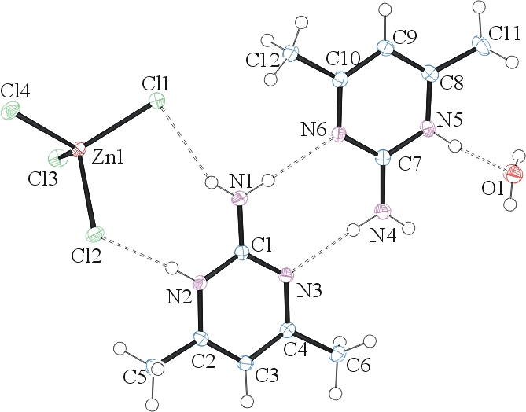
Figure 1. ORTEP of the structure with thermal ellipsoids at the 50% probability level. H-bonds are indicated by dashed lines.

Table 1: Crystallographic data for the structures provided.
Empirical formula C12 H22 Cl4 N6 O Zn
Formula weight 473.52
Temperature 120(2) K
Wavelength 0.71073 Å
Crystal system Triclinic
Space group P -1
Unit cell dimensions a = 7.8228(4) Å α= 72.840(3)°.
b = 9.5103(5) Å β= 74.875(3)°.
c = 14.7035(7) Å γ = 74.939(3)°.
Volume 988.97(9) Å3
Z 2
Density (calculated) 1.590 Mg/m3
Absorption coefficient 1.795 mm-1
F(000) 484
Crystal size 0.260 x 0.230 x 0.210 mm3
Theta range for data collection 1.479 to 31.788°.
Index ranges -11<=h<=11, -14<=k<=14, -21<=l<=21
Reflections collected 45503
Independent reflections 6630 [R(int) = 0.0261]
Completeness to theta = 25.242° 99.6 %
Refinement method Full-matrix least-squares on F2
Data / restraints / parameters 6630 / 0 / 253
Goodness-of-fit on F2 1.057
Final R indices [I>2sigma(I)] R1 = 0.0217, wR2 = 0.0526
R indices (all data) R1 = 0.0264, wR2 = 0.0550
Largest diff. peak and hole 0.467 and -0.400 e.Å-3
Hydrogen bonds for cherif_k12_0m [Å and °].
____________________________________________________________________________
D-H...A d(D-H) d(H...A) d(D...A) <(DHA)
____________________________________________________________________________
O(1)-H(1D)...Cl(3)#1 0.78(2) 2.54(2) 3.2495(11) 152(2)
O(1)-H(1C)...Cl(4)#2 0.78(2) 2.48(2) 3.2474(11) 166(2)
N(1)-H(1B)...Cl(1) 0.85(2) 2.49(2) 3.2790(11) 153.7(16)
N(1)-H(1A)...N(6) 0.884(18) 2.163(18) 3.0469(14) 176.7(16)
N(2)-H(2)...Cl(2) 0.865(18) 2.232(18) 3.0939(10) 174.1(16)
N(4)-H(4B)...N(3) 0.887(19) 2.131(19) 3.0140(14) 173.9(16)
N(5)-H(5)...O(1) 0.883(19) 1.823(19) 2.7007(14) 172.1(17)
____________________________________________________________________________
Symmetry transformations used to generate equivalent atoms:
#1 -x+1,-y+1,-z+1 #2 x+1,y,z-1

Bruker (2007) APEX2 (Version 2.1-4), SAINT (version 7.34A), SADABS (version 2007/4), BrukerAXS Inc, Madison, Wisconsin, USA.
(a) Sheldrick GM. (2008) A short history of SHELX. Acta Cryst. A64, 112-122. (b) Sheldrick GM. (2015) SHELXT - Integrated space-group and crystal-structure determination. Acta Cryst. A71, 3-8.
(a) Altomare A, Burla C, Camalli M, Cascarano G L, Giacovazzo C, Guagliardi A, Moliterni AGG, Polidori G, Spagna R. (1999) SIR97: a new tool for crystal structure determination and refinement Journal of Applied Crystallography, 32, 115-119. (b) Altomare A, Cascarano G L, Giacovazzo C, Guagliardi A. (1993) Completion and refinement of crystal structures with SIR 92. Journal of Applied Crystallography, 26, 343-350.
(a) Sheldrick GM. (1997) SHELXL-97, Program for the Refinement of Crystal Structures. University of Göttingen, Germany. (b) Sheldrick GM. (2015) Crystal structure refinement with SHELXL. Acta Cryst. C71, 3–8
Waasmaier, D.; Kirfel, A. (1995) New Analytical Scattering Factor Functions for Free Atoms and Ions. Acta Crystallographica A., 51, 416-430.
Farrugia LJ. (1997) Ortep-3 for Windows. Journal of Applied Crystallography, 30, 565

