Crystal Structure Report for Cherif Ben Nasr
by Werner Kaminsky
ID – Cherif_k9
X-ray Crystallography Laboratory
University of Washington
30. July 2026

Data Collection started: 06/02/25
Documentation finished: 06/04/25

W.Kaminsky: tel. (206) 543 7585
(x-ray lab): tel. (206) 543 0210
Email: kaminsky@chem.washington.edu

Understanding crystallographic information is not trivial. If you discuss a structure in a publication, please let the crystallographers proof-read the final draft of that manuscript before you submit it.
For many structures it is true that crystallography is an intellectual performance (like synthesis or elucidation of mechanisms) and not a routine job. In these cases, particularly when the structures contribute significantly to the content of the publication, the crystallographers should be co-authors. Do not think this is not necessary because you pay for structures.
A colorless shard, measuring 0.17 x 0.13 x 0.08 mm³ was mounted on a loop with oil. Data was collected at -143ºC on a Bruker APEX II single crystal X-ray diffractometer, Mo-radiation, equipped with a Miracol X-ray optical collimator.

Crystal-to-detector distance was 40 mm and exposure time was 10 seconds per frame for all sets. The scan width was 0.5º. Data collection was 100% complete to 25º in ϑ. A total of 6048 reflections were collected covering the indices, h = -10 to 10, k = 0 to 32, l = 0 to 16. 6048 reflections were symmetry independent and the R_{int} = 0.059 indicated that the data was of better than average quality (0.07). Indexing and unit cell refinement indicated a monoclinic lattice. The space group was found to be P2₁/n (No.14).

The data was integrated and scaled using SAINT, SADABS within the APEX2 software package by Bruker.

The data appeared twinned via 180 degrees about [-2 0 3] (CELL_NOW) and after multi-domain integration (SAINT, SADABS within the APEX2 software package by Bruker) the data was merged utilizing twinabs. The refined mass fractions of the two twin components were determined to be 0.7664(6) and 0.2336(6), respectively.

Solution by direct methods (SHELXT or SIR97) produced a complete heavy atom phasing model consistent with the proposed structure. The structure was completed by difference Fourier synthesis with SHELXL. Scattering factors are from Waasmair and Kirfel. The positions of the acidic hydrogen atoms were refined semi-freely, while all other hydrogen atoms were placed in geometrically idealised positions and constrained to ride on their parent atoms with C---H distances in the range 0.95-1.00 Angstrom. Isotropic thermal parameters U_{eq} were fixed such that they were 1.2U_{eq} of their parent atom Ueq for CH's and 1.5U_{eq} of their parent atom U_{eq} in case of methyl groups. All non-hydrogen atoms were refined anisotropically by full-matrix least-squares.

The structure is of high quality and ready for publication. Table 1 summarizes the data collection details. Figure 1 shows an ORTEP of the asymmetric unit.

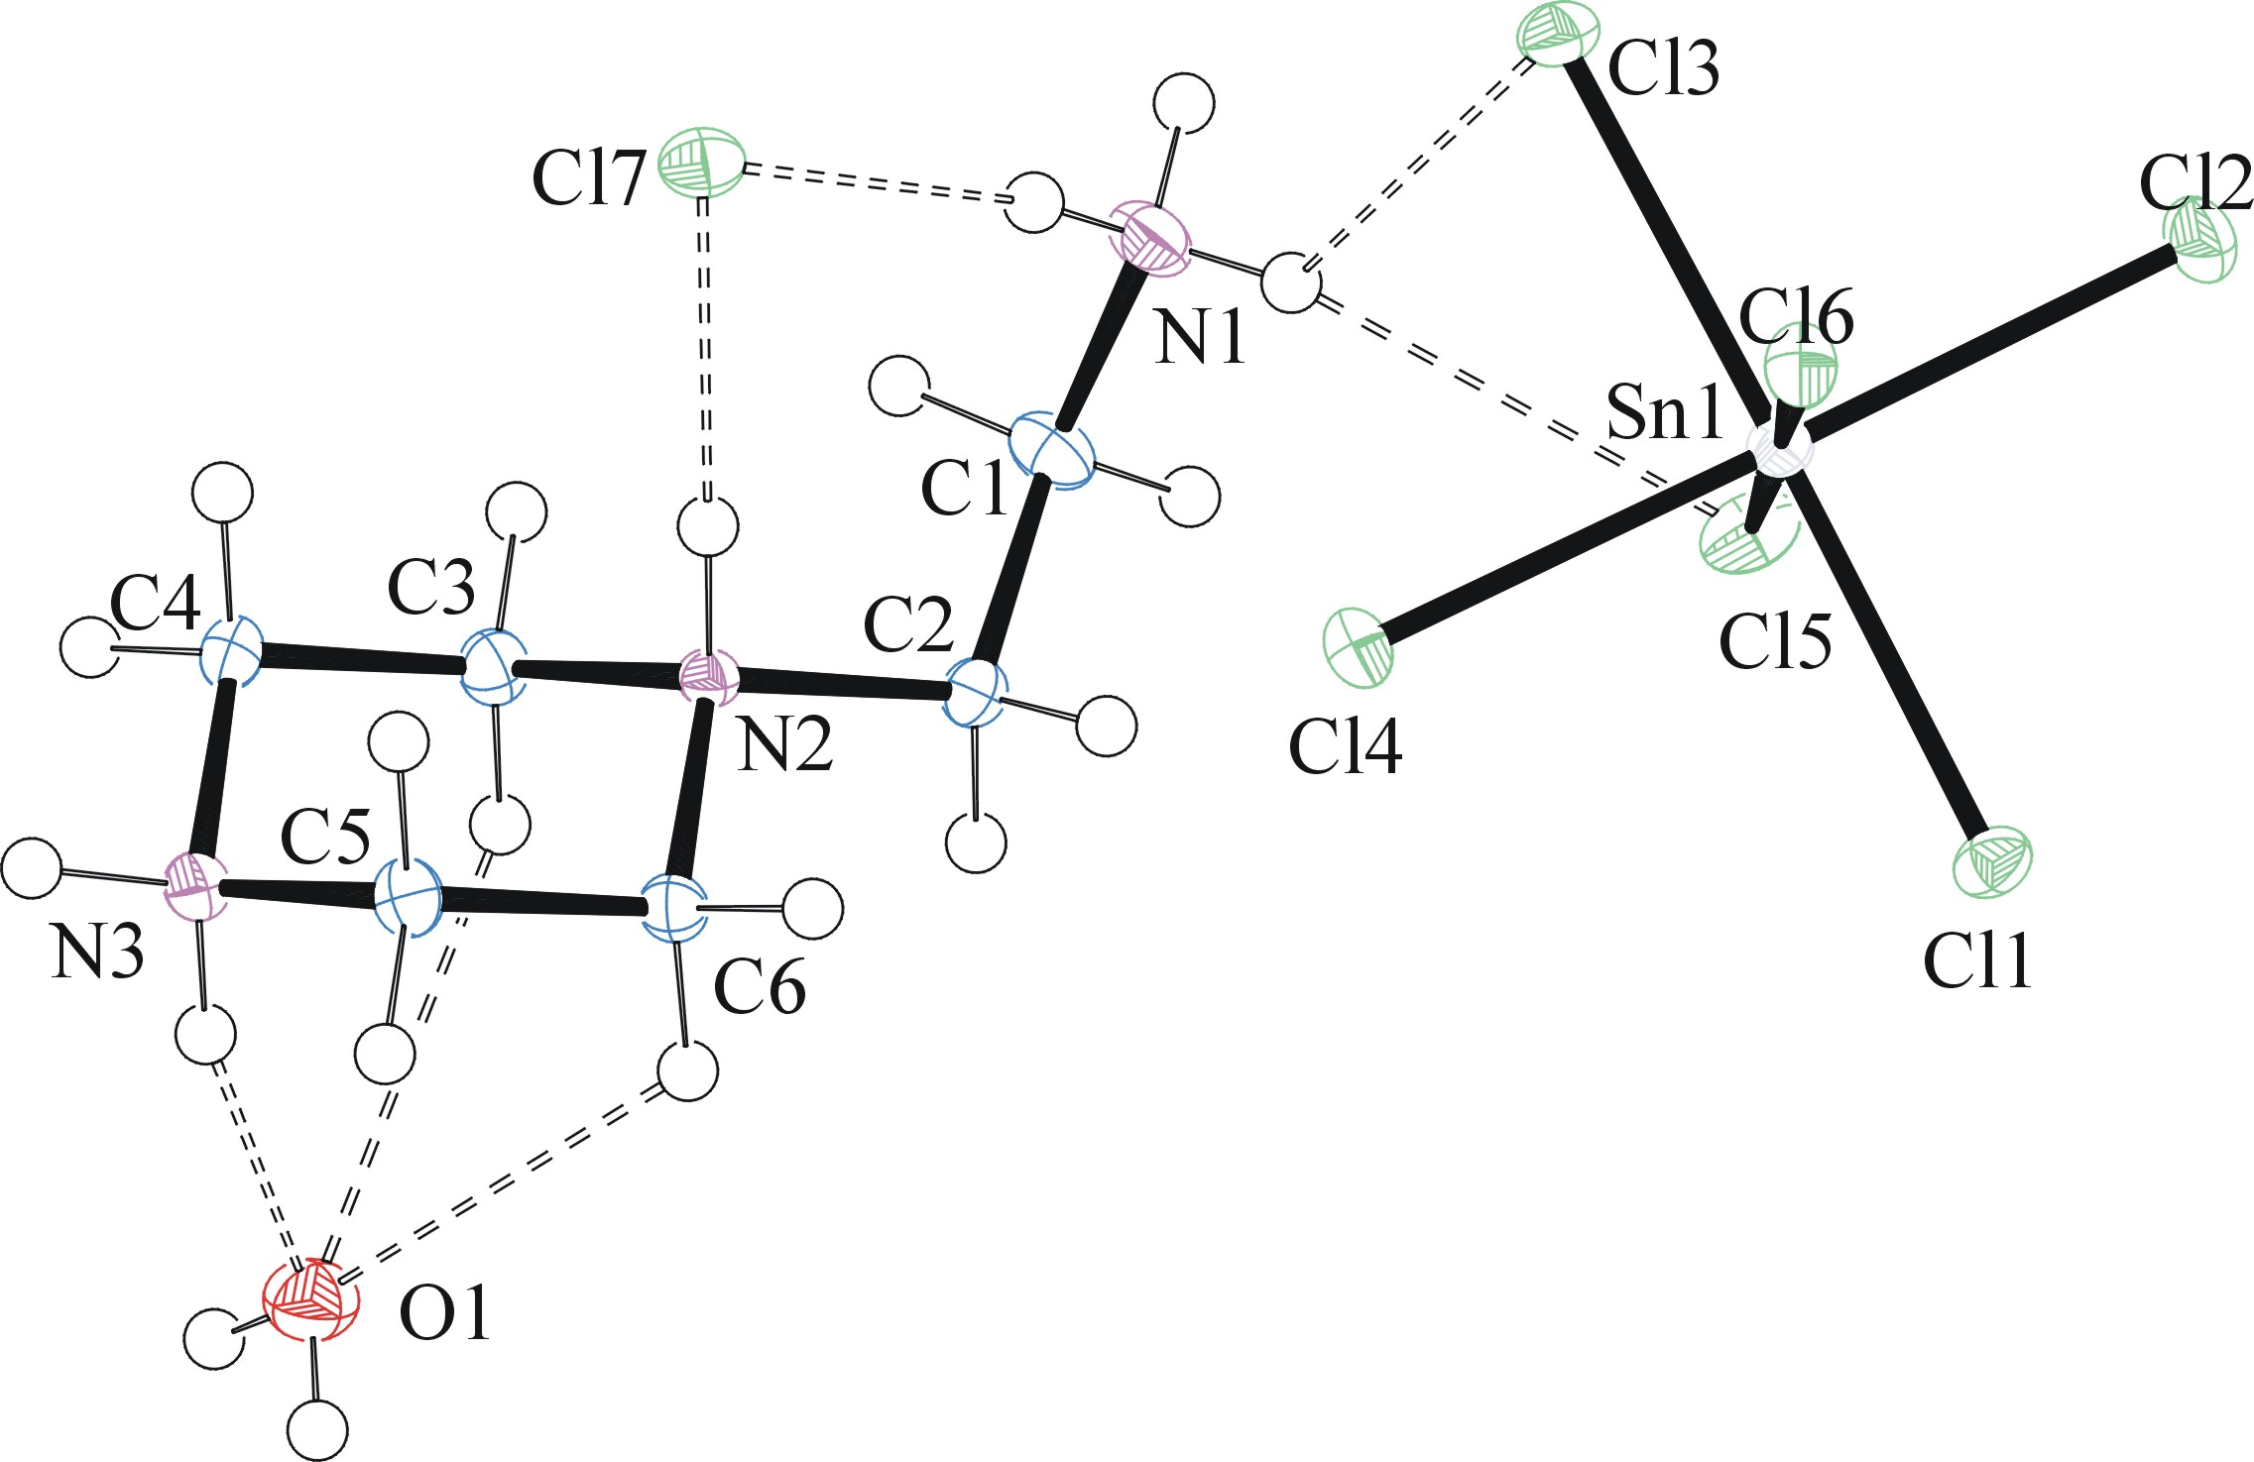

Figure 1. ORTEP of the structure with thermal ellipsoids at the 50% probability level. Dashed lines: potential hydrogen bonds.

Table 1: Crystallographic data for the structures provided.
Identification code | Cherif_k9
Empirical formula | C₆H₂₀Cl₇N₃OSn
Formula weight | 517.09
Temperature/K | 130
Crystal system | monoclinic
Space group | P2₁/n
a/Å | 7.4266(6)
b/Å | 21.9289(19)
c/Å | 11.0447(9)
α/° | 90
β/° | 94.444(4)
γ/° | 90
Volume/Å³ | 1793.3(3)
Z | 4
ρ_{calc}g/cm³ | 1.915
μ/mm⁻¹ | 2.460
F(000) | 1016.0
Crystal size/mm³ | 0.17 × 0.13 × 0.08
Radiation | MoKα (λ = 0.71073)
2Θ range for data collection/° | 3.714 to 63.208
Index ranges | -10 ≤ h ≤ 10, 0 ≤ k ≤ 32, 0 ≤ l ≤ 16
Reflections collected | 6048
Independent reflections | 6048 [R_{int} = 0.059, R_{sigma} = 0.0349]
Data/restraints/parameters | 6048/5/196
Goodness-of-fit on F² | 1.152
Final R indexes [I>=2σ (I)] | R₁ = 0.0270, wR₂ = 0.0661
Final R indexes [all data] | R₁ = 0.0302, wR₂ = 0.0686
Largest diff. peak/hole / e Å⁻³ | 0.63/-0.85
D-H...A d(D-H) d(H...A) d(D...A) <(DHA)
____________________________________________________________________________
C(1)-H(1D)...Cl(1)#1 0.99 2.83 3.459(3) 121.7
C(1)-H(1D)...Cl(2)#2 0.99 2.95 3.772(3) 141.1
C(1)-H(1E)...Cl(4)#1 0.99 2.89 3.565(3) 125.9
C(2)-H(2A)...Cl(1)#2 0.99 2.68 3.499(3) 140.6
C(2)-H(2A)...Cl(5)#2 0.99 2.98 3.816(3) 142.6
C(2)-H(2B)...Cl(4) 0.99 2.78 3.706(3) 155.6
C(3)-H(3D)...Cl(7)#3 0.99 2.81 3.518(3) 129.4
C(4)-H(4A)...Cl(7)#3 0.99 2.95 3.415(3) 110.1
C(4)-H(4B)...Cl(6)#4 0.99 2.86 3.557(3) 127.8
C(5)-H(5B)...Cl(7)#5 0.99 2.81 3.300(3) 111.2
C(6)-H(6A)...Cl(7)#5 0.99 2.83 3.505(3) 125.6
C(6)-H(6B)...Cl(1)#2 0.99 2.98 3.787(3) 139.8
N(2)-H(2)...Cl(7) 0.93(3) 2.10(3) 3.026(2) 175(3)
N(3)-H(3A)...O(1) 0.91(3) 1.88(3) 2.771(3) 164(3)
N(3)-H(3B)...Cl(6)#5 0.91(3) 2.49(3) 3.300(2) 148(3)
N(1)-H(1A)...Cl(7) 0.83(2) 2.24(2) 3.071(3) 172(4)
N(1)-H(1B)...Cl(1)#1 0.82(2) 2.88(4) 3.378(3) 121(3)
N(1)-H(1B)...Cl(6)#1 0.82(2) 2.62(3) 3.400(3) 159(4)
N(1)-H(1C)...Cl(3) 0.83(2) 2.73(4) 3.302(3) 128(4)
N(1)-H(1C)...Cl(5) 0.83(2) 2.68(3) 3.432(3) 151(4)
O(1)-H(1F)...Cl(5)#6 0.77(3) 2.79(4) 3.475(2) 148(4)
O(1)-H(1G)...Cl(1)#4 0.77(3) 2.59(4) 3.357(2) 173(6)
____________________________________________________________________________
Symmetry transformations used to generate equivalent atoms:
#1 x-1,y,z #2 x-1/2,-y+3/2,z-1/2 #3 -x,-y+1,-z+1
#4 x-1,y,z-1 #5 -x+1,-y+1,-z+1 #6 x,y,z-1

Bruker (2007) APEX2 (Version 2.1-4), SAINT (version 7.34A), SADABS (version 2007/4), BrukerAXS Inc, Madison, Wisconsin, USA.
Sheldrick, G. M. (2005). CELL_NOW. University of Goettingen, Germany.
Bruker (2007) APEX2 (Version 2.1-4), SAINT (version 7.34A), SADABS (version 2007/4), BrukerAXS Inc, Madison, Wisconsin, USA.
Sheldrick, G. M. (2007). TWINABS. University of Goettingen, Germany.
(a) Sheldrick GM. (2008) A short history of SHELX. Acta Cryst. A64, 112-122. (b) Sheldrick GM. (2015) SHELXT - Integrated space-group and crystal-structure determination. Acta Cryst. A71, 3-8.
(a) Altomare A, Burla C, Camalli M, Cascarano G L, Giacovazzo C, Guagliardi A, Moliterni AGG, Polidori G, Spagna R. (1999) SIR97: a new tool for crystal structure determination and refinement Journal of Applied Crystallography, 32, 115-119. (b) Altomare A, Cascarano G L, Giacovazzo C, Guagliardi A. (1993) Completion and refinement of crystal structures with SIR 92. Journal of Applied Crystallography, 26, 343-350.
(a) Sheldrick GM. (1997) SHELXL-97, Program for the Refinement of Crystal Structures. University of Göttingen, Germany. (b) Sheldrick GM. (2015) Crystal structure refinement with SHELXL. Acta Cryst. C71, 3–8
Waasmaier, D.; Kirfel, A. (1995) New Analytical Scattering Factor Functions for Free Atoms and Ions. Acta Crystallographica A., 51, 416-430.
Farrugia LJ. (1997) Ortep-3 for Windows. Journal of Applied Crystallography, 30, 565

