Crystal Structure Report for D. Gamlin
by Werner Kaminsky
Sample Submitted by Kyle Kluherz
ID – CsPbCl3
X-ray Crystallography Laboratory
University of Washington
31. July 2026

Data Collection started: 6/10/2021
Documentation finished: 7/15/2021

Data backup accessibly through http:
URL: http://cad4.cpac.washington.edu/structures

W.Kaminsky: tel. (206) 543 7585
(x-ray lab): tel. (206) 543 0210
Email: kaminsky@chem.washington.edu

Understanding crystallographic information is not trivial. If you discuss a structure in a publication, please let the crystallographers proof-read the final draft of that manuscript before you submit it.
For many structures it is true that crystallography is an intellectual performance (like synthesis or elucidation of mechanisms) and not a routine job. In these cases, particularly when the structures contribute significantly to the content of the publication, the crystallographers should be co-authors. Do not think this is not necessary because you pay for structures.
A colorless prism, measuring 0.350 x 0.300 x 0.200 mm³ was mounted inside a closed capillary. Data was collected at 22ºC on a Bruker APEX II single crystal X-ray diffractometer, Mo-radiation, equipped with a Miracol X-ray optical collimator.

Crystal-to-detector distance was 40 mm and exposure time was 10 seconds per frame for all sets. The scan width was 0.5º. Data collection was 99.1% complete to 25º in ϑ. A total of 1756 merged reflections were collected covering the indices, -10<=h<=10, -14<=k<=14, -10<=l<=10. 969 reflections were symmetry independent and the R_{int} = 0.0684 indicated that the data was of average quality (0.07). Indexing and unit cell refinement indicated an orthorhombic lattice (with almost identical a and c axes). The space group was found to be P n m a (No. 62).

The data was integrated and scaled using SAINT, SADABS within the APEX2 software package by Bruker.

Solution by direct methods (SHELXT or SIR97) produced a complete heavy atom phasing model consistent with the proposed structure. The structure was completed by difference Fourier synthesis with SHELXL., Scattering factors are from Waasmair and Kirfel. Hydrogen atoms were placed in geometrically idealised positions and constrained to ride on their parent atoms with C---H distances in the range 0.95-1.00 Angstrom. Isotropic thermal parameters U_{eq} were fixed such that they were 1.2U_{eq} of their parent atom Ueq for CH's and 1.5U_{eq} of their parent atom U_{eq} in case of methyl groups. All non-hydrogen atoms were refined anisotropically by full-matrix least-squares.

The structure was solved including a two-fold rotation twin about [-1 0 1].

There is clear evidence of chlorine disorder.

The size of the sample may have been too large, a quarter or even a tenth of volume may prove helpful to avoid absorption correction problems.

The structure is of high quality and ready for publication. Table 1 summarizes the data collection details. Figure 1 shows an ORTEP of the asymmetric unit.

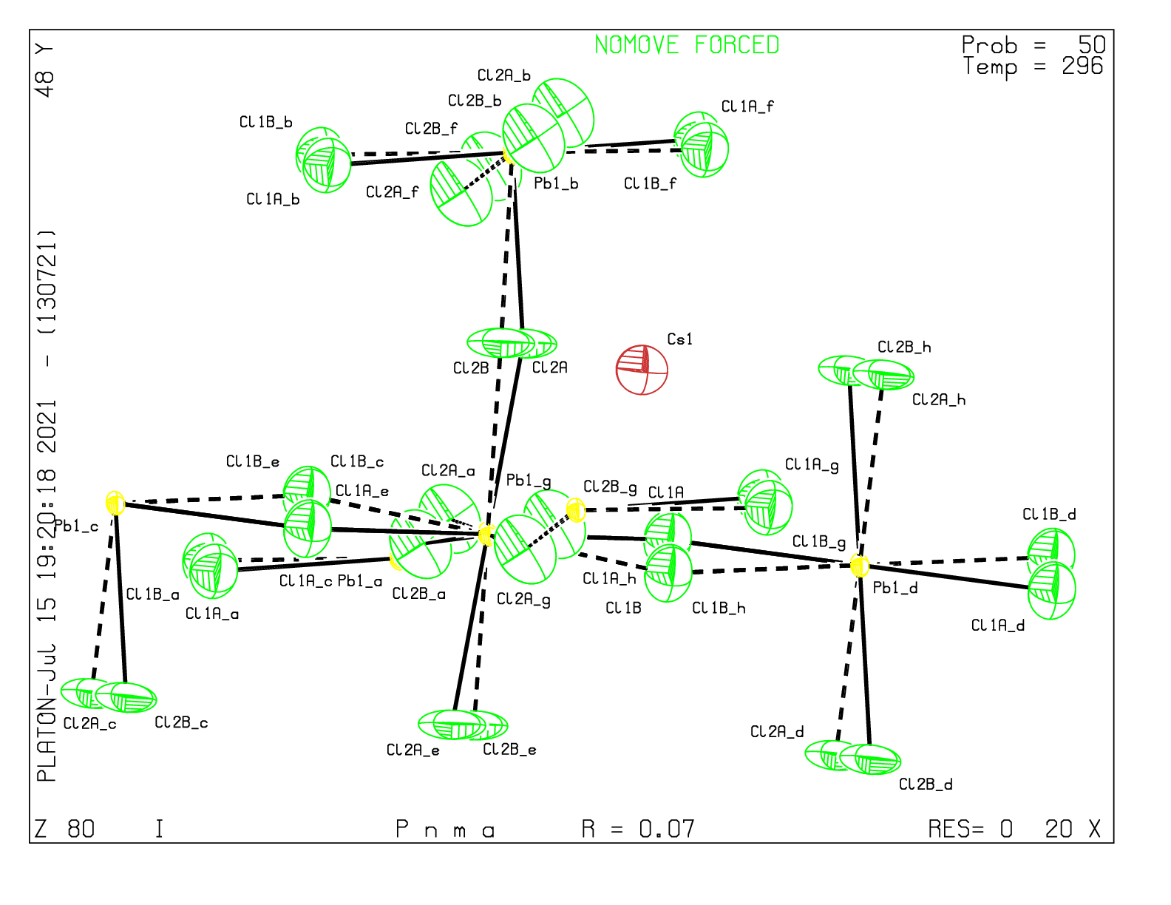
Figure 1. ORTEP of the structure with thermal ellipsoids at the 50% probability level.

Table 1: Crystallographic data for the structures provided.
Empirical formula Cl6 Cs2 Pb2
Formula weight 892.90
Temperature 296(2) K
Wavelength 0.71073 Å
Crystal system Orthorhombic
Space group P n m a
Unit cell dimensions a = 7.9014(13) Å α= 90°.
b = 11.1590(19) Å β= 90°.
c = 7.8996(13) Å γ = 90°.
Volume 696.5(2) Å3
Z 2
Density (calculated) 4.257 Mg/m3
Absorption coefficient 30.388 mm-1
F(000) 752
Crystal size 0.350 x 0.300 x 0.200 mm3
Theta range for data collection 1.825 to 28.439°.
Index ranges -10<=h<=10, -14<=k<=14, -10<=l<=10
Reflections collected 1756
Independent reflections 969 [R(int) = 0.0684]
Completeness to theta = 25.000° 99.1 %
Refinement method Full-matrix least-squares on F2
Data / restraints / parameters 969 / 12 / 37
Goodness-of-fit on F2 1.062
Final R indices [I>2sigma(I)] R1 = 0.0717, wR2 = 0.1713
R indices (all data) R1 = 0.0933, wR2 = 0.1964
Extinction coefficient 0.0106(13)
Largest diff. peak and hole 5.058 and -6.054 e.Å-3

Bruker (2007) APEX2 (Version 2.1-4), SAINT (version 7.34A), SADABS (version 2007/4), BrukerAXS Inc, Madison, Wisconsin, USA.
Sheldrick GM. (2015) SHELXT - Integrated space-group and crystal-structure determination. Acta Cryst. A71, 3-8.
(a) Altomare A, Burla C, Camalli M, Cascarano G L, Giacovazzo C, Guagliardi A, Moliterni AGG, Polidori G, Spagna R. (1999) SIR97: a new tool for crystal structure determination and refinement Journal of Applied Crystallography, 32, 115-119. (b) Altomare A, Cascarano G L, Giacovazzo C, Guagliardi A. (1993) Completion and refinement of crystal structures with SIR 92. Journal of Applied Crystallography, 26, 343-350.
(a) Sheldrick GM. (1997) SHELXL-97, Program for the Refinement of Crystal Structures. University of Göttingen, Germany. (b) Sheldrick GM. (2015) Crystal structure refinement with SHELXL. Acta Cryst. (2015). C71, 3–8
Mackay, S.; Edwards, C.; Henderson, A.; Gilmore, C.; Stewart, N.; Shankland, K.; Donald, A. (1997) MaXus: a computer program for the solution and refinement of crystal structures from diffraction data. University of Glasgow, Scotland,.
Waasmaier, D.; Kirfel, A. (1995) New Analytical Scattering Factor Functions for Free Atoms and Ions. Acta Crystallographica A., 51, 416-430.
Farrugia LJ. (1997) Ortep-3 for Windows. Journal of Applied Crystallography, 30, 565

