Crystal Structure Report for B Cossairt
by Werner Kaminsky
Sample Submitted by D Henckel
ID – DH_033115C
X-ray Crystallography Laboratory
University of Washington
31. July 2026

Data Collection started: 5/11/2015
Documentation finished: 6/2/2015

Data backup accessibly through http:
URL: http://cad4.cpac.washington.edu/structures

W.Kaminsky: tel. (206) 543 7585
(x-ray lab): tel. (206) 543 0210
Email: kaminsky@chem.washington.edu

Understanding crystallographic information is not trivial. If you discuss a structure in a publication, please let the crystallographers proof-read the final draft of that manuscript before you submit it.
For many structures it is true that crystallography is an intellectual performance (like synthesis or elucidation of mechanisms) and not a routine job. In these cases, particularly when the structures contribute significantly to the content of the publication, the crystallographers should be co-authors. Do not think this is not necessary because you pay for structures. Even I have to pay for my own structures for my research.
From a batch of mostly yellow material and some orange crystals, which turned out to be CdSe in SG: F‾4 3 m, with the Se slightly displaced off a Wykoff position and 16-fold disordered, a colorless plate was found, measuring 0.15 x 0.11 x 0.01 mm³ and mounted on a loop with oil. Data was collected at -173ºC on a Bruker APEX II single crystal X-ray diffractometer, Mo-radiation.

Crystal-to-detector distance was 40 mm and exposure time was 60 seconds per frame for all sets. The scan width was 0.5º. Data collection was 95.1% complete to 25º in ϑ.

The data appeared laminarly twinned into two domains, related by a 180 degree rotation about (0 0 1) (CELL_NOW) and after multi-domain integration (SAINT, SADABS within the APEX2 software package by Bruker.) and merging (twinabs) a total of 3314 (merged) reflections covered the indices, h = -6 to 6, k = -8 to 8, l = -11 to 11. 666 reflections were symmetry independent and the R_{int} = 0.0952 indicated that the data was of slightly less than average quality (0.07). Indexing and unit cell refinement indicated a primitive monoclinic lattice. The space group was found to be P 2₁ (No.4).

Solution by direct methods (SHELXS, SIR97) produced a complete heavy atom phasing model consistent with the proposed structure. The structure was completed by difference Fourier synthesis with SHELXL97., Scattering factors are from Waasmair and Kirfel. Hydrogen atoms were placed in geometrically idealised positions and constrained to ride on their parent atoms with C---H distances in the range 0.95-1.00 Angstrom. Isotropic thermal parameters U_{eq} were fixed such that they were 1.2U_{eq} of their parent atom Ueq for CH's and 1.5U_{eq} of their parent atom U_{eq} in case of methyl groups. All non-hydrogen atoms were refined anisotropically by full-matrix least-squares.

This experiment confirms the findings of two previously reported structures, one on a twinned sample, with twinning unresolved and one on an untwinned sample. Here we report a fully resolved twinned structure of enantiopure histidine. Simulation of the crystal morphology revealed flat crystals, with dominating (0 0 1) faces, as observed. The lattice parameters of the current structure are slightly different to the previous one, likely because of differences in temperature:

1993: (P2₁)
a = 5.166(6), b = 7.385(5), c = 9.465(4),
β = 98.16(5)

This report (P2₁, 100K)
a = 5.145(2), b = 7.2654(25), c = 9.4765(34),
β = 97.279(13)

The structure is of high quality and ready for publication. Table 1 summarizes the data collection details. Figure 1 shows an ORTEP of the asymmetric unit.

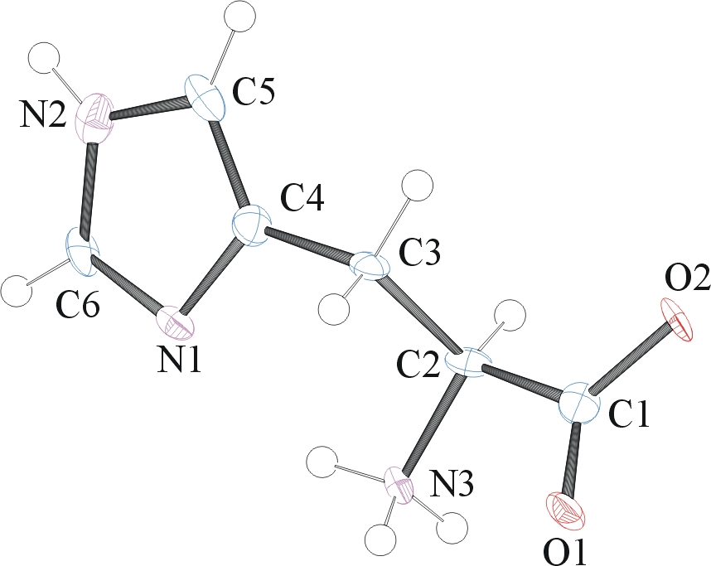

Figure 1. ORTEP of the structure with thermal ellipsoids at the 50% probability level.

Table 1: Crystallographic data for the structures provided.
Empirical formula C6 H9 N3 O2
Formula weight 155.16
Temperature 100(2) K
Wavelength 0.71073 Å
Crystal system Monoclinic
Space group P 2₁
Unit cell dimensions a = 5.145(2) Å α= 90°.
b = 7.265(3) Å β= 97.279(13)°.
c = 9.476(3) Å γ = 90°.
Volume 351.4(2) Å3
Z 2
Density (calculated) 1.467 Mg/m3
Absorption coefficient 0.113 mm-1
F(000) 164
Crystal size 0.15 x 0.11 x 0.01 mm3
Theta range for data collection 2.17 to 25.47°.
Index ranges -6<=h<=6, 0<=k<=8, 0<=l<=11
Reflections collected 3314
Independent reflections 666 [R(int) = 0.0952]
Completeness to theta = 25.00° 95.1 %
Max. and min. transmission 0.9989 and 0.9833
Refinement method Full-matrix least-squares on F2
Data / restraints / parameters 666 / 19 / 104
Goodness-of-fit on F2 0.978
Final R indices [I>2sigma(I)] R1 = 0.0547, wR2 = 0.1003
R indices (all data) R1 = 0.0909, wR2 = 0.1102
Largest diff. peak and hole 0.379 and -0.379 e.Å-3

Sheldrick, G. M. (2005). CELL_NOW. University of Goettingen, Germany.
Bruker (2007) APEX2 (Version 2.1-4), SAINT (version 7.34A), SADABS (version 2007/4), BrukerAXS Inc, Madison, Wisconsin, USA.
Sheldrick, G. M. (2007). TWINABS. University of Goettingen, Germany.
(a) Altomare A, Burla C, Camalli M, Cascarano G L, Giacovazzo C, Guagliardi A, Moliterni AGG, Polidori G, Spagna R. (1999) SIR97: a new tool for crystal structure determination and refinement Journal of Applied Crystallography, 32, 115-119. (b) Altomare A, Cascarano G L, Giacovazzo C, Guagliardi A. (1993) Completion and refinement of crystal structures with SIR 92. Journal of Applied Crystallography, 26, 343-350.
Sheldrick GM. (1997) SHELXL-97, Program for the Refinement of Crystal Structures. University of Göttingen, Germany.
Mackay, S.; Edwards, C.; Henderson, A.; Gilmore, C.; Stewart, N.; Shankland, K.; Donald, A. (1997) MaXus: a computer program for the solution and refinement of crystal structures from diffraction data. University of Glasgow, Scotland,.
Waasmaier, D.; Kirfel, A. (1995) New Analytical Scattering Factor Functions for Free Atoms and Ions. Acta Crystallographica A., 51, 416-430.
Edington, P., Harding, M. M.: The crystal structure of DL-Histidine. Acta Cryst. B 30 (1974) 204.
Μ. T. Averbuch-Pouchot: Crystal structure of L-histidinium phosphite and a structure reinvestigation of the monoclinic form of L-histidine. Z. Kristallogr. 207 (1993) 111-120.
W. Kaminsky: From *.cif to virtual morphology: new aspects of predicting crystal shapes as part of the WinXMorph program. J. Appl. Cryst., 40 (2007) 382-385.
Farrugia LJ. (1997) Ortep-3 for Windows. Journal of Applied Crystallography, 30, 565

