Crystal Structure Report for
Cherif Ben Nasr
by Werner Kaminsky
ID – DRISS
X-ray Crystallography Laboratory
University of Washington
31. July 2026

Data Collection started: 1/23/2017
Documentation finished: 1/25/2017

Data backup accessibly through http:
URL: http://cad4.cpac.washington.edu/structures

W.Kaminsky: tel. (206) 543 7585
(x-ray lab): tel. (206) 543 0210
Email: kaminsky@chem.washington.edu

Understanding crystallographic information is not trivial. If you discuss a structure in a publication, please let the crystallographers proof-read the final draft of that manuscript before you submit it.
For many structures it is true that crystallography is an intellectual performance (like synthesis or elucidation of mechanisms) and not a routine job. In these cases, particularly when the structures contribute significantly to the content of the publication, the crystallographers should be co-authors. Do not think this is not necessary because you pay for structures.
A colorless prism, measuring 0.30 x 0.27 x 0.21 mm³ was mounted on a loop with oil. Data was collected at -143ºC on a Nonius Kappa CCD FR590 single crystal X-ray diffractometer, Mo-radiation.

Crystal-to-detector distance was 32 mm and exposure time was 35 seconds per degree for all sets. The scan width was 1.6º. Data collection was 99.8% complete to 25º in ϑ. A total of 68023 partial and complete reflections were collected covering the indices, -20<=h<=20, -14<=k<=15, -25<=l<=25. 8056 reflections were symmetry independent and the R_{int} = 0.0594 indicated that the data was good. Indexing and unit cell refinement indicated a primitive monoclinic lattice. The space group was found to be P 2₁/n (No. 14).

The data was integrated and scaled using hkl-SCALEPACK. This program applies a multiplicative correction factor (S) to the observed intensities (I) and has the following form:

S is calculated from the scale and the B factor determined for each frame and is then applied to I to give the corrected intensity (I_{corr}).

Solution by direct methods (SHELXS, SIR97) produced a complete heavy atom phasing model consistent with the proposed structure. The structure was completed by difference Fourier synthesis with SHELXL97., Scattering factors are from Waasmair and Kirfel. Hydrogen atoms were placed in geometrically idealised positions and constrained to ride on their parent atoms with C---H distances in the range 0.95-1.00 Angstrom. Isotropic thermal parameters U_{eq} were fixed such that they were 1.2U_{eq} of their parent atom Ueq for CH's and 1.5U_{eq} of their parent atom U_{eq} in case of methyl groups. All non-hydrogen atoms were refined anisotropically by full-matrix least-squares.

Some disorder is related to a small amount of water in the structure.

The structure is of high quality and ready for publication. Table 1 summarizes the data collection details. Figure 1 shows an ORTEP of the asymmetric unit.
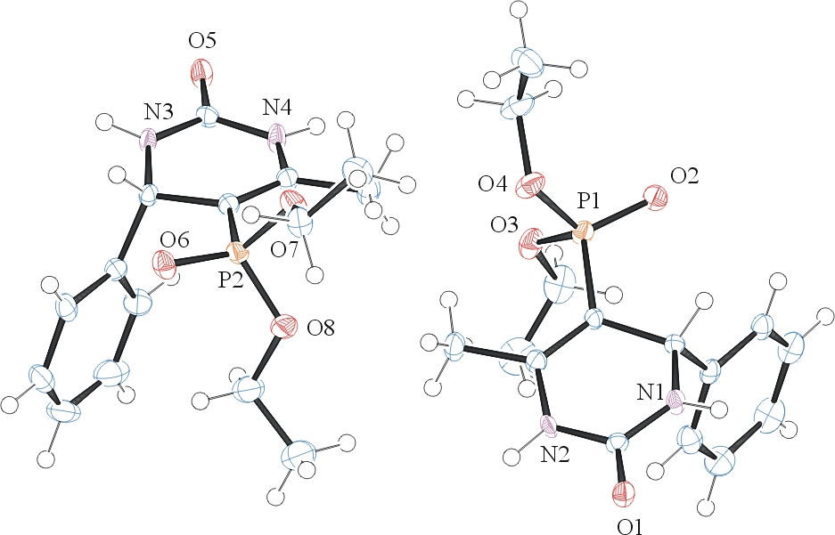

Figure 1. ORTEP of the structure with thermal ellipsoids at the 50% probability level. Disorder and water solvent omitted for clarity.

Table 1: Crystallographic data for the structures provided.
Empirical formula C15 H21.13 N2 O4.06 P
Formula weight 325.43
Temperature 130(2) K
Wavelength 0.71073 Å
Crystal system Monoclinic
Space group P 2₁/n
Unit cell dimensions a = 15.3175(5) Å α= 90°.
b = 11.7656(5) Å β= 111.483(3)°.
c = 19.4907(6) Å γ = 90°.
Volume 3268.6(2) Å3
Z 8
Density (calculated) 1.323 Mg/m3
Absorption coefficient 0.188 mm-1
F(000) 1381
Crystal size 0.30 x 0.27 x 0.21 mm3
Theta range for data collection 2.06 to 28.30°.
Index ranges -20<=h<=20, -14<=k<=15, -25<=l<=25
Reflections collected 68023
Independent reflections 8056 [R(int) = 0.0594]
Completeness to theta = 25.00° 99.8 %
Max. and min. transmission 0.9616 and 0.9458
Refinement method Full-matrix least-squares on F2
Data / restraints / parameters 8056 / 6 / 426
Goodness-of-fit on F2 1.038
Final R indices [I>2sigma(I)] R1 = 0.0526, wR2 = 0.1298
R indices (all data) R1 = 0.1001, wR2 = 0.1457
Largest diff. peak and hole 0.397 and -0.441 e.Å-3

Otwinowsky, Z.; Minor, W. In: Methods in Enzymology; Carter, C. W., Jr., Sweet, R. M., Eds.; Academic Press: New York, 1997, 276, 307-326.
(a) Altomare, A.; Burla, C.; Camalli M.; Cascarano L.; Giacovazzo C.; Guagliardi A.; Moliterni A.G.G.; Polidori G.; Spagna R. J. Appl. Cryst. 1999, 32, 115-119; (b) Altomare, A., Cascarano, G., Giacovazzo, C., Guagliardi, A., J. Appl. Cryst. 1993, 26, 343.
(a) Sheldrick GM. (1997) SHELXL-97, Program for the Refinement of Crystal Structures. University of Göttingen, Germany. (b) Sheldrick GM. (2013) Crystal structure refinement with SHELXL. Acta Cryst. (2015). C71, 3-8.
Mackay, S.; Edwards, C.; Henderson, A.; Gilmore, C.; Stewart, N.; Shankland, K.; Donald, A.; MaXus: a computer program for the solution and refinement of crystal structures from diffraction data. University of Glasgow, Scotland, 1997.
Waasmaier, D.; Kirfel, A. Acta Crystallogr. A. 1995, 51, 416.
Farrugia, L. J. Appl. Cryst. 1997, 30, 565

