Crystal Structure Report for A. Velian
by Sebastian Krajewski &Werner Kaminsky
Sample Submitted by Daniel Zhou
ID – Dz355
X-ray Crystallography Laboratory
University of Washington
31. July 2026

Data Collection started: 9/22/2022
Documentation finished: 9/28/2022

Data backup accessibly through http:
URL: http://cad4.cpac.washington.edu/structures

W.Kaminsky: tel. (206) 543 7585
(x-ray lab): tel. (206) 543 0210
Email: kaminsky@chem.washington.edu

Understanding crystallographic information is not trivial. If you discuss a structure in a publication, please let the crystallographers proof-read the final draft of that manuscript before you submit it.
For many structures it is true that crystallography is an intellectual performance (like synthesis or elucidation of mechanisms) and not a routine job. In these cases, particularly when the structures contribute significantly to the content of the publication, the crystallographers should be co-authors. Do not think this is not necessary because you pay for structures.
A brown block, measuring 0.28 x 0.25 x 0.24 mm³ was mounted on a loop with oil. Data was collected at -173ºC on a Bruker APEX II single crystal X-ray diffractometer, Mo-radiation, equipped with a Miracol X-ray optical collimator.

Crystal-to-detector distance was 40 mm and exposure time was 20 seconds per frame for all sets. The scan width was 0.5º. Data collection was 97.6% complete to 25º in ϑ. A total of 49098 reflections were collected covering the indices, -29<=h<=28, -22<=k<=22, 0<=l<=37. 25012 reflections were symmetry independent and the R_{int} = 0.1161 indicated that the data was good. Indexing and unit cell refinement indicated a primitive monoclinic lattice. The space group was found to be P 2₁/c (No. 14).

The data was integrated and scaled using SAINT, SADABS within the APEX2 software package by Bruker.

Solution by direct methods (SHELXT or SIR97) produced a complete heavy atom phasing model consistent with the proposed structure. The structure was completed by difference Fourier synthesis with SHELXL. Scattering factors are from Waasmair and Kirfel. Hydrogen atoms were placed in geometrically idealised positions and constrained to ride on their parent atoms with C---H distances in the range 0.95-1.00 Angstrom. Isotropic thermal parameters U_{eq} were fixed such that they were 1.2U_{eq} of their parent atom Ueq for CH's and 1.5U_{eq} of their parent atom U_{eq} in case of methyl groups. All non-hydrogen atoms were refined anisotropically by full-matrix least-squares.

The contribution of disordered pentane and DCM solvent to the diffraction pattern was removed with SQUEEZE. Objective outlier removal was achieved with the Bayesian post-processing algorithm from within the SORTAV package. The sample showed signs of some minor twinning, however, by removal of a chunk of bad remaining reflections, residual rest electron density artefacts were successfully removed. C-C bond length accuracy was improved by idealizing phenyl rings and linking symmetry related moieties. Displacement parameters were restraint globally with ISOR for carbon and nitrogen atoms, DELU linking along bonds was applied to C, N, P, and Cr.

The structure is of high quality and ready for publication. Table 1 summarizes the data collection details. Figure 1 shows an ORTEP of the asymmetric unit.

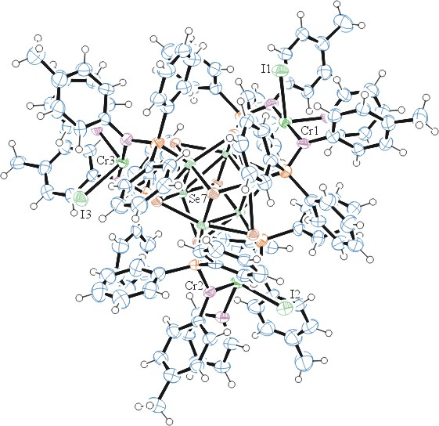

Figure 1. ORTEP of the structure with thermal ellipsoids at the 50% probability level.

Table 1: Crystallographic data for the structures provided.
Empirical formula C129 H117 Co6 Cr3 I3 N9 P6 Se8
Formula weight 3501.09
Temperature 100(2) K
Wavelength 0.71073 Å
Crystal system Monoclinic
Space group P 21/c
Unit cell dimensions a = 24.795(2) Å α= 90°.
b = 18.8486(18) Å β= 103.520(6)°.
c = 31.900(3) Å γ = 90°.
Volume 14495(2) Å3
Z 4
Density (calculated) 1.604 Mg/m3
Absorption coefficient 3.644 mm-1
F(000) 6836
Crystal size 0.280 x 0.250 x 0.240 mm3
Theta range for data collection 1.385 to 25.027°.
Index ranges -29<=h<=28, -22<=k<=22, 0<=l<=37
Reflections collected 49098
Independent reflections 25012 [R(int) = 0.1161]
Completeness to theta = 25.000° 97.6 %
Refinement method Full-matrix least-squares on F2
Data / restraints / parameters 25012 / 2049 / 1267
Goodness-of-fit on F2 0.938
Final R indices [I>2sigma(I)] R1 = 0.1149, wR2 = 0.2132
R indices (all data) R1 = 0.2201, wR2 = 0.2839
Largest diff. peak and hole 2.634 and -1.556 e.Å-3

Bruker (2007) APEX2 (Version 2.1-4), SAINT (version 7.34A), SADABS (version 2007/4), BrukerAXS Inc, Madison, Wisconsin, USA.
(a) Sheldrick GM. (2008) A short history of SHELX. Acta Cryst. A64, 112-122. (b) Sheldrick GM. (2015) SHELXT - Integrated space-group and crystal-structure determination. Acta Cryst. A71, 3-8.
(a) Altomare A, Burla C, Camalli M, Cascarano G L, Giacovazzo C, Guagliardi A, Moliterni AGG, Polidori G, Spagna R. (1999) SIR97: a new tool for crystal structure determination and refinement Journal of Applied Crystallography, 32, 115-119. (b) Altomare A, Cascarano G L, Giacovazzo C, Guagliardi A. (1993) Completion and refinement of crystal structures with SIR 92. Journal of Applied Crystallography, 26, 343-350.
(a) Sheldrick GM. (1997) SHELXL-97, Program for the Refinement of Crystal Structures. University of Göttingen, Germany. (b) Sheldrick GM. (2015) Crystal structure refinement with SHELXL. Acta Cryst. C71, 3–8
Waasmaier, D.; Kirfel, A. (1995) New Analytical Scattering Factor Functions for Free Atoms and Ions. Acta Crystallographica A., 51, 416-430.
(a) A. Spek, J. Appl. Cryst. (2003), 36, 7-13; (b) P. van der Sluis & A. L. Spek, Acta Cryst. (1990). A46, 194-201. (c) Spek, A. L. (2009). Acta. Cryst. D65, 148-155.
(a) S. French and K. Wilson (1979). On the Treatment of Negative Intensity Observations. Acta Cryst. A34, 517-525. (b) Blessing, R. H. (1995). An empirical correction for absorption anisotropy. Acta Cryst. A51 33-38.
Farrugia LJ. (1997) Ortep-3 for Windows. Journal of Applied Crystallography, 30, 565

