Crystal Structure Report for A. Velian
by Sebastian Krajewski &Werner Kaminsky
Sample Submitted by Daniel Zhou
ID – DZ361
X-ray Crystallography Laboratory
University of Washington
31. July 2026

Data Collection started: 10/6/2022
Documentation finished: 10/11/2022

Data backup accessibly through http:
URL: http://cad4.cpac.washington.edu/structures

W.Kaminsky: tel. (206) 543 7585
(x-ray lab): tel. (206) 543 0210
Email: kaminsky@chem.washington.edu

Understanding crystallographic information is not trivial. If you discuss a structure in a publication, please let the crystallographers proof-read the final draft of that manuscript before you submit it.
For many structures it is true that crystallography is an intellectual performance (like synthesis or elucidation of mechanisms) and not a routine job. In these cases, particularly when the structures contribute significantly to the content of the publication, the crystallographers should be co-authors. Do not think this is not necessary because you pay for structures.
A brown plate, measuring 0.26 x 0.17 x 0.02 mm³ was mounted on a loop with oil. Data was collected at -173ºC on a Bruker APEX II single crystal X-ray diffractometer, Mo-radiation, equipped with a Miracol X-ray optical collimator.

Crystal-to-detector distance was 40 mm and exposure time was 90 seconds per frame for all sets. The scan width was 0.5º. Data collection was 98.2% complete to 25º in ϑ. A total of 53629 reflections were collected covering the indices, -36<=h<=36, -23<=k<=23, -34<=l<=34. 28063 reflections were symmetry independent and the very high R_{int} = 0.4679 indicated that the data was very weak (average quality 0.07). Indexing and unit cell refinement indicated a primitive monoclinic lattice. The space group was found to be P 2₁/c (No.14).

The data was integrated and scaled using SAINT, SADABS within the APEX2 software package by Bruker.

Solution by direct methods (SHELXT or SIR97) produced a complete heavy atom phasing model consistent with the proposed structure. The structure was completed by difference Fourier synthesis with SHELXL., Scattering factors are from Waasmair and Kirfel. Hydrogen atoms were placed in geometrically idealised positions and constrained to ride on their parent atoms with C---H distances in the range 0.95-1.00 Angstrom. Isotropic thermal parameters U_{eq} were fixed such that they were 1.2U_{eq} of their parent atom Ueq for CH's and 1.5U_{eq} of their parent atom U_{eq} in case of methyl groups. All non-hydrogen atoms were refined anisotropically by full-matrix least-squares.

The contribution of a tanker load of unidentified disordered solvent to the diffraction pattern was removed with SQUEEZE. Furthermore, displacement parameters of carbon and nitrogen were stabilized with ISOR commands and linked along bonds to itself and phosphorous, iron and Co6. Three protons came too close and were kept apart via DFIX. 50 reflections were excluded.

Within limits of data, it though looks like the structure contains three iron atoms and two azides only.

The structure is of lower quality and probably not publishable. Table 1 summarizes the data collection details. Figure 1 shows an ORTEP of the asymmetric unit.

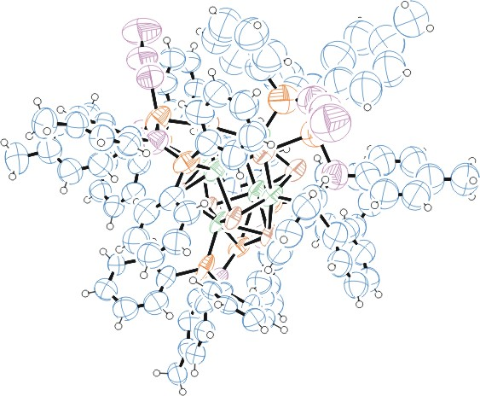
Figure 1. ORTEP of the structure with thermal ellipsoids at the 50% probability level. Solvent omitted via SQUEEZE.

Table 1: Crystallographic data for the structures provided.
Empirical formula C114 H102 Co6 Fe3 N12 P6 Se8
Formula weight 2978.70
Temperature 100(2) K
Wavelength 0.71073 Å
Crystal system Monoclinic
Space group P 21/c
Unit cell dimensions a = 31.001(3) Å α= 90°.
b = 19.4716(14) Å β= 112.526(5)°.
c = 29.032(2) Å γ = 90°.
Volume 16188(2) Å3
Z 4
Density (calculated) 1.222 Mg/m3
Absorption coefficient 2.755 mm-1
F(000) 5888
Crystal size 0.260 x 0.170 x 0.020 mm3
Theta range for data collection 1.409 to 25.026°.
Index ranges -36<=h<=36, -23<=k<=23, -34<=l<=34
Reflections collected 53629
Independent reflections 28063 [R(int) = 0.4679]
Completeness to theta = 25.000° 98.2 %
Refinement method Full-matrix least-squares on F2
Data / restraints / parameters 28063 / 1916 / 1127
Goodness-of-fit on F2 1.019
Final R indices [I>2sigma(I)] R1 = 0.2407, wR2 = 0.4895
R indices (all data) R1 = 0.4402, wR2 = 0.6252
Largest diff. peak and hole 1.785 and -1.079 e.Å-3

Bruker (2007) APEX2 (Version 2.1-4), SAINT (version 7.34A), SADABS (version 2007/4), BrukerAXS Inc, Madison, Wisconsin, USA.
Sheldrick GM. (2015) SHELXT - Integrated space-group and crystal-structure determination. Acta Cryst. A71, 3-8.
(a) Altomare A, Burla C, Camalli M, Cascarano G L, Giacovazzo C, Guagliardi A, Moliterni AGG, Polidori G, Spagna R. (1999) SIR97: a new tool for crystal structure determination and refinement Journal of Applied Crystallography, 32, 115-119. (b) Altomare A, Cascarano G L, Giacovazzo C, Guagliardi A. (1993) Completion and refinement of crystal structures with SIR 92. Journal of Applied Crystallography, 26, 343-350.
’Sheldrick : A short history of SHELX . Acta Cryst. (2008), A64, 112-122
Mackay, S.; Edwards, C.; Henderson, A.; Gilmore, C.; Stewart, N.; Shankland, K.; Donald, A. (1997) MaXus: a computer program for the solution and refinement of crystal structures from diffraction data. University of Glasgow, Scotland,.
Waasmaier, D.; Kirfel, A. (1995) New Analytical Scattering Factor Functions for Free Atoms and Ions. Acta Crystallographica A., 51, 416-430.
(a) A. Spek, J. Appl. Cryst. (2003), 36, 7-13; (b) P. van der Sluis & A. L. Spek, Acta Cryst. (1990). A46, 194-201. (c) Spek, A. L. (2009). Acta. Cryst. D65, 148-155.
Farrugia LJ. (1997) Ortep-3 for Windows. Journal of Applied Crystallography, 30, 565

