Crystal Structure Report for A. Velian
by Sebastian Krajewski &Werner Kaminsky
Sample Submitted by Daniel Zhou
ID – Dz431
X-ray Crystallography Laboratory
University of Washington
31. July 2026

Data Collection started: 1/23/2023
Documentation finished: 1/26/2023

Data backup accessibly through http:
URL: http://cad4.cpac.washington.edu/structures

W.Kaminsky: tel. (206) 543 7585
(x-ray lab): tel. (206) 543 0210
Email: kaminsky@chem.washington.edu

Understanding crystallographic information is not trivial. If you discuss a structure in a publication, please let the crystallographers proof-read the final draft of that manuscript before you submit it.
For many structures it is true that crystallography is an intellectual performance (like synthesis or elucidation of mechanisms) and not a routine job. In these cases, particularly when the structures contribute significantly to the content of the publication, the crystallographers should be co-authors. Do not think this is not necessary because you pay for structures.
A black plate, measuring 0.74 x 0.2 x 0.02 mm³ was mounted on a loop with oil. Data was collected at -173ºC on a Bruker APEX II single crystal X-ray diffractometer, Mo-radiation, equipped with a Miracol X-ray optical collimator.

Crystal-to-detector distance was 45 mm and exposure time was 120 seconds per frame for all sets. The scan width was 0.5º. Data collection was 96.4% complete to 24.407º in ϑ. A total of 237404 reflections were collected covering the indices, -23<=h<=23, -33<=k<=33, -54<=l<=55. 11672 reflections were symmetry independent and the R_{int} = 0.1604 indicated that the data was problematic. Indexing and unit cell refinement indicated a primitive orthorhombic lattice. The space group was found to be Pcab (No. 61).

The data was integrated and scaled using SAINT, SADABS within the APEX2 software package by Bruker. Objective outlier removal was achieved with the Bayesian post-processing algorithm from within the SORTAV package.

Solution by direct methods (SHELXT or SIR97) produced a complete heavy atom phasing model consistent with the proposed structure. The structure was completed by difference Fourier synthesis with SHELXL. Scattering factors are from Waasmair and Kirfel. Hydrogen atoms were placed in geometrically idealised positions and constrained to ride on their parent atoms with C---H distances in the range 0.95-1.00 Angstrom. Isotropic thermal parameters U_{eq} were fixed such that they were 1.2U_{eq} of their parent atom Ueq for CH's and 1.5U_{eq} of their parent atom U_{eq} in case of methyl groups. All non-hydrogen atoms were refined anisotropically by full-matrix least-squares.

The sample looked conglomerated, and it is possible that this caused the symmetry to appear pseudo-orthorhombic, but no other symmetry or twin law was found.

The data was weak and of overall rather bad quality. The refinement was requiring global DELU and ISOR restraints in addition to optimizing phenyl groups and relating geometrically similar moieties via SAME cards. The sulfur of the NCS group is showing considerable uncertainty in its location. The contribution of disordered DCM solvent to the diffraction pattern was removed with SQUEEZE. About 700 bad reflections were removed but this is still a small fraction of the total number.

The structure is of mediocre quality but publishable, given some caveats added to a manuscript as outlined. Table 1 summarizes the data collection details. Figure 1 shows an ORTEP of the asymmetric unit.

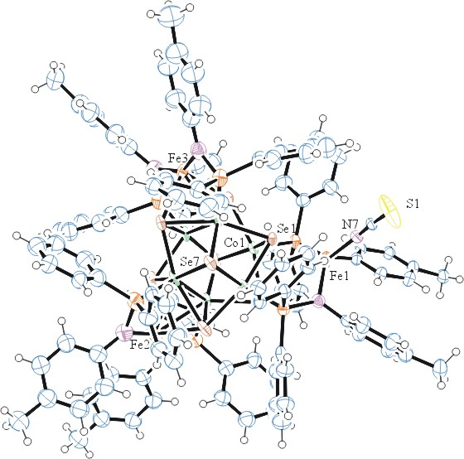
Figure 1. ORTEP of the structure with thermal ellipsoids at the 50% probability level. Solvent omitted for clarity.

Table 1: Crystallographic data for the structures provided.
Empirical formula C115 H102 Co6 Fe3 N7 P6 S Se8
Formula weight 2952.72
Temperature 100(2) K
Wavelength 0.71073 Å
Crystal system Orthorhombic
Space group Pcab
Unit cell dimensions a = 19.402(2) Å α= 90°.
b = 27.951(4) Å β= 90°.
c = 46.141(6) Å γ = 90°.
Volume 25022(5) Å3
Z 8
Density (calculated) 1.568 Mg/m3
Absorption coefficient 3.579 mm-1
F(000) 11672
Crystal size 0.74 x 0.2 x 0.02 mm3
Theta range for data collection 1.796 to 24.407°.
Index ranges -23<=h<=23, -33<=k<=33, -54<=l<=55
Reflections collected 19861
Independent reflections 19861 [R(int) = 0.1604]
Completeness to theta = 24.407° 96.4 %
Refinement method Full-matrix least-squares on F2
Data / restraints / parameters 19861 / 1884 / 1106
Goodness-of-fit on F2 1.004
Final R indices [I>2sigma(I)] R1 = 0.1921, wR2 = 0.3722
R indices (all data) R1 = 0.2741, wR2 = 0.4179
Extinction coefficient 0.00030(3)
Largest diff. peak and hole 2.143 and -2.424 e.Å-3

Bruker (2007) APEX2 (Version 2.1-4), SAINT (version 7.34A), SADABS (version 2007/4), BrukerAXS Inc, Madison, Wisconsin, USA.
(a) S. French and K. Wilson (1979). On the Treatment of Negative Intensity Observations. Acta Cryst. A34, 517-525. (b) Blessing, R. H. (1995). An empirical correction for absorption anisotropy. Acta Cryst. A51 33-38.
(a) Sheldrick GM. (2008) A short history of SHELX. Acta Cryst. A64, 112-122. (b) Sheldrick GM. (2015) SHELXT - Integrated space-group and crystal-structure determination. Acta Cryst. A71, 3-8.
(a) Altomare A, Burla C, Camalli M, Cascarano G L, Giacovazzo C, Guagliardi A, Moliterni AGG, Polidori G, Spagna R. (1999) SIR97: a new tool for crystal structure determination and refinement Journal of Applied Crystallography, 32, 115-119. (b) Altomare A, Cascarano G L, Giacovazzo C, Guagliardi A. (1993) Completion and refinement of crystal structures with SIR 92. Journal of Applied Crystallography, 26, 343-350.
(a) Sheldrick GM. (1997) SHELXL-97, Program for the Refinement of Crystal Structures. University of Göttingen, Germany. (b) Sheldrick GM. (2015) Crystal structure refinement with SHELXL. Acta Cryst. C71, 3–8
Waasmaier, D.; Kirfel, A. (1995) New Analytical Scattering Factor Functions for Free Atoms and Ions. Acta Crystallographica A., 51, 416-430.
(a) A. Spek, J. Appl. Cryst. (2003), 36, 7-13; (b) P. van der Sluis & A. L. Spek, Acta Cryst. (1990). A46, 194-201. (c) Spek, A. L. (2009). Acta. Cryst. D65, 148-155.
Farrugia LJ. (1997) Ortep-3 for Windows. Journal of Applied Crystallography, 30, 565

