Crystal Structure Report for A. Velian
by Sebastian Krajewski &Werner Kaminsky
Sample Submitted by Daniel Zhou
ID – Dz470
X-ray Crystallography Laboratory
University of Washington
31. July 2026

Data Collection started: 3/31/2023
Documentation finished: 4/5/2023

Data backup accessibly through http:
URL: http://cad4.cpac.washington.edu/structures

W.Kaminsky: tel. (206) 543 7585
(x-ray lab): tel. (206) 543 0210
Email: kaminsky@chem.washington.edu

Understanding crystallographic information is not trivial. If you discuss a structure in a publication, please let the crystallographers proof-read the final draft of that manuscript before you submit it.
For many structures it is true that crystallography is an intellectual performance (like synthesis or elucidation of mechanisms) and not a routine job. In these cases, particularly when the structures contribute significantly to the content of the publication, the crystallographers should be co-authors. Do not think this is not necessary because you pay for structures.
A brown plate, measuring 0.25 x 0.06 x 0.03 mm³ was mounted on a loop with oil. Data was collected at -173ºC on a Bruker APEX II single crystal X-ray diffractometer, Mo-radiation, equipped with a Miracol X-ray optical collimator.
Crystal-to-detector distance was 40 mm and exposure time was 120 seconds per frame for all sets. The scan width was 0.75º. Data collection was 99.9% complete to 24.713º in ϑ. A total of 43207 (merged) reflections were collected covering the indices, 0<=h<=35, 0<=k<=35, -66<=l<=66. 21725 reflections were symmetry independent and the R_{int} = 0.0970 indicated that the data was of acceptable quality. Indexing and unit cell refinement indicated a body centered tetragonal lattice. The space group was found to be I41/a:2 (No. 88).
The data was integrated and scaled using SAINT, SADABS within the APEX2 software package by Bruker.
Solution by direct methods (SHELXT or SIR97) produced a complete heavy atom phasing model consistent with the proposed structure. The structure was completed by difference Fourier synthesis with SHELXL. Scattering factors are from Waasmair and Kirfel. Hydrogen atoms were placed in geometrically idealised positions and constrained to ride on their parent atoms with C---H distances in the range 0.95-1.00 Angstrom. Isotropic thermal parameters U_{eq} were fixed such that they were 1.2U_{eq} of their parent atom Ueq for CH's and 1.5U_{eq} of their parent atom U_{eq} in case of methyl groups. All non-hydrogen atoms were refined anisotropically by full-matrix least-squares.

DCM is disordered with some ligands and the structure exhibits chemical disorder, where Cu(II) is disordered with Fe(III)Cl in varying amounts for the three pincer locations. The huge amount of disorder required optimizing the phenyl groups, link similar ligand geometries and apply several strategic restraints to stabilize the displacement parameters.

The structure is of high quality and ready for publication. Table 1 summarizes the data collection details.

Figure 1a, b show ORTEPs of the majority and minority species inside the asymmetric unit.

a)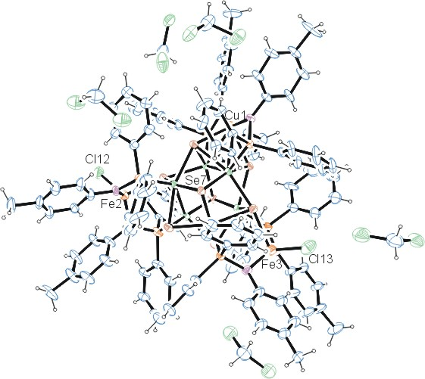
b)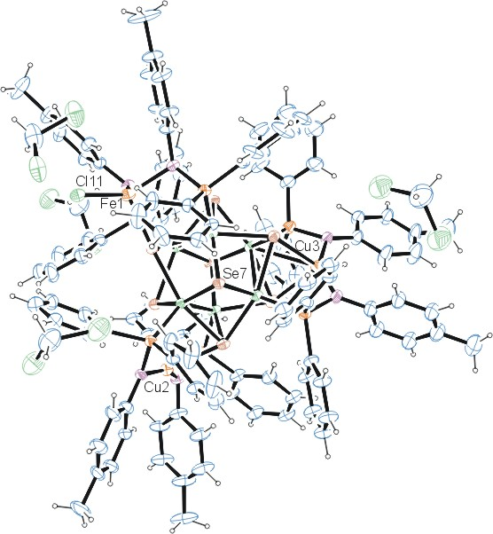
Figure 1a/b. ORTEP of the structures with thermal ellipsoids at the 15% probability level.

Table 1: Crystallographic data for the structures provided.
Empirical formula C116.47 H106.94 Cl6.476 Co6 Cu1.464 Fe1.536 N6 P6 Se8
Formula weight 3170.12
Temperature 100(2) K
Wavelength 0.71073 Å
Crystal system Tetragonal
Space group I 4₁/a
Unit cell dimensions a = 30.0518(19) Å α= 90°.
b = 30.0518(19) Å β= 90°.
c = 56.484(4) Å γ = 90°.
Volume 51011(7) Å3
Z 16
Density (calculated) 1.651 Mg/m3
Absorption coefficient 3.709 mm-1
F(000) 25028
Crystal size 0.250 x 0.060 x 0.030 mm3
Theta range for data collection 1.276 to 24.713°.
Index ranges 0<=h<=35, 0<=k<=35, -66<=l<=66
Reflections collected 43207
Independent reflections 21725 [R(int) = 0.0970]
Completeness to theta = 24.713° 99.9 %
Refinement method Full-matrix least-squares on F2
Data / restraints / parameters 21725 / 1886 / 1338
Goodness-of-fit on F2 1.040
Final R indices [I>2sigma(I)] R1 = 0.0918, wR2 = 0.2157
R indices (all data) R1 = 0.2250, wR2 = 0.2546
Largest diff. peak and hole 1.304 and -0.828 e.Å-3

Bruker (2007) APEX2 (Version 2.1-4), SAINT (version 7.34A), SADABS (version 2007/4), BrukerAXS Inc, Madison, Wisconsin, USA.
(a) Sheldrick GM. (2008) A short history of SHELX. Acta Cryst. A64, 112-122. (b) Sheldrick GM. (2015) SHELXT - Integrated space-group and crystal-structure determination. Acta Cryst. A71, 3-8.
(a) Altomare A, Burla C, Camalli M, Cascarano G L, Giacovazzo C, Guagliardi A, Moliterni AGG, Polidori G, Spagna R. (1999) SIR97: a new tool for crystal structure determination and refinement Journal of Applied Crystallography, 32, 115-119. (b) Altomare A, Cascarano G L, Giacovazzo C, Guagliardi A. (1993) Completion and refinement of crystal structures with SIR 92. Journal of Applied Crystallography, 26, 343-350.
(a) Sheldrick GM. (1997) SHELXL-97, Program for the Refinement of Crystal Structures. University of Göttingen, Germany. (b) Sheldrick GM. (2015) Crystal structure refinement with SHELXL. Acta Cryst. C71, 3–8
Waasmaier, D.; Kirfel, A. (1995) New Analytical Scattering Factor Functions for Free Atoms and Ions. Acta Crystallographica A., 51, 416-430.
Farrugia LJ. (1997) Ortep-3 for Windows. Journal of Applied Crystallography, 30, 565

