Crystal Structure Report for A. Velian
by Sebastian Krajewski &Werner Kaminsky
Sample Submitted by Daniel Zhou
ID – Dz474
X-ray Crystallography Laboratory
University of Washington
31. July 2026

Data Collection started: 3/27/2023
Documentation finished: 3/30/2023

Data backup accessibly through http:
URL: http://cad4.cpac.washington.edu/structures

W.Kaminsky: tel. (206) 543 7585
(x-ray lab): tel. (206) 543 0210
Email: kaminsky@chem.washington.edu

Understanding crystallographic information is not trivial. If you discuss a structure in a publication, please let the crystallographers proof-read the final draft of that manuscript before you submit it.
For many structures it is true that crystallography is an intellectual performance (like synthesis or elucidation of mechanisms) and not a routine job. In these cases, particularly when the structures contribute significantly to the content of the publication, the crystallographers should be co-authors. Do not think this is not necessary because you pay for structures.
A brown chard, measuring 0.40 x 0.16 x 0.05 mm³ was mounted on a loop with oil. Data was collected at -173ºC on a Bruker APEX II single crystal X-ray diffractometer, Mo-radiation, equipped with a Miracol X-ray optical collimator.
Crystal-to-detector distance was 40 mm and exposure time was 30 seconds per frame for all sets. The scan width was 0.5º. Data collection was 99.7% complete to 25º in ϑ. A total of 339061 reflections were collected covering the indices, -25<=h<=25, -39<=k<=39, -30<=l<=30. 32758 reflections were symmetry independent and the R_{int} = 0.0826 indicated that the data was of average quality. Indexing and unit cell refinement indicated a primitive monoclinic lattice. The space group was found to be P 2₁/n (No. 14).
The data was integrated and scaled using SAINT, SADABS within the APEX2 software package by Bruker.
Solution by direct methods (SHELXT or SIR97) produced a complete heavy atom phasing model consistent with the proposed structure. The structure was completed by difference Fourier synthesis with SHELXL. Scattering factors are from Waasmair and Kirfel. Hydrogen atoms were placed in geometrically idealised positions and constrained to ride on their parent atoms with C---H distances in the range 0.95-1.00 Angstrom. Isotropic thermal parameters U_{eq} were fixed such that they were 1.2U_{eq} of their parent atom Ueq for CH's and 1.5U_{eq} of their parent atom U_{eq} in case of methyl groups. All non-hydrogen atoms were refined anisotropically by full-matrix least-squares.

This is a chemically disordered structure, where 21% is the expected cluster-(Fe-NCS)3 species, 79% is the I3 version. The charge of one TBA cation is balanced by a NCS⁻ which appears disordered with one DCM over several locations. Several toluene and phenyl moieties are disordered. To stabilize the displacement parameters and some disordered phenyls, EADP constraints for overlapping atoms and idealization of phenyls were applied in addition to ISOR smoothing of anisotropy for the disordered and some almost disordered moieties. The Fe-N, FeC, and Fe-S distances were linked with SAME and one Fe-NCS was fixed in a AFIX 6 … AFIX 0 loop after setting the N-C, N-S and C-S distance with a strong DFIX. SIMU restraints were applied to I-NCS disordered and NCS DCM disordered moieties.

The structure is of high quality and ready for publication. Table 1 summarizes the data collection details. Figure 1a, b show ORTEPs of the two species inside the asymmetric unit.

a)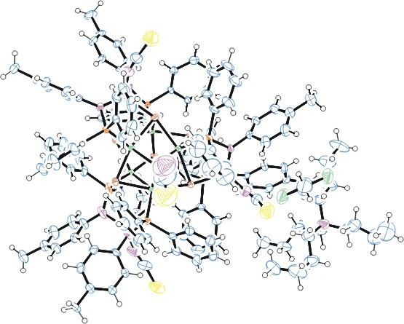
b)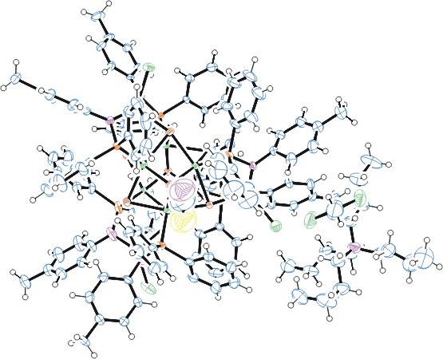
Figure 1a/b. ORTEP of the structures with thermal ellipsoids at the 50% probability level. Disorder omitted for clarity.

Table 1: Crystallographic data for the structures provided.
Empirical formula C132.62 H140 Cl2 Co6 Fe3 I2.38 N8.62 P6 S1.62 Se8
Formula weight 3618.31
Temperature 100(2) K
Wavelength 0.71073 Å
Crystal system Monoclinic
Space group P 21/n
Unit cell dimensions a = 19.5494(12) Å α= 90°.
b = 30.0727(19) Å β= 90.766(3)°.
c = 23.1726(15) Å γ = 90°.
Volume 13622.0(15) Å3
Z 4
Density (calculated) 1.764 Mg/m3
Absorption coefficient 3.884 mm-1
F(000) 7137
Crystal size 0.400 x 0.160 x 0.050 mm3
Theta range for data collection 1.109 to 28.021°.
Index ranges -25<=h<=25, -39<=k<=39, -30<=l<=30
Reflections collected 339061
Independent reflections 32758 [R(int) = 0.0826]
Completeness to theta = 25.242° 99.7 %
Refinement method Full-matrix least-squares on F2
Data / restraints / parameters 32758 / 698 / 1816
Goodness-of-fit on F2 1.100
Final R indices [I>2sigma(I)] R1 = 0.0746, wR2 = 0.1432
R indices (all data) R1 = 0.1185, wR2 = 0.1647
Largest diff. peak and hole 2.034 and -1.555 e.Å-3

Bruker (2007) APEX2 (Version 2.1-4), SAINT (version 7.34A), SADABS (version 2007/4), BrukerAXS Inc, Madison, Wisconsin, USA.
(a) Sheldrick GM. (2008) A short history of SHELX. Acta Cryst. A64, 112-122. (b) Sheldrick GM. (2015) SHELXT - Integrated space-group and crystal-structure determination. Acta Cryst. A71, 3-8.
(a) Altomare A, Burla C, Camalli M, Cascarano G L, Giacovazzo C, Guagliardi A, Moliterni AGG, Polidori G, Spagna R. (1999) SIR97: a new tool for crystal structure determination and refinement Journal of Applied Crystallography, 32, 115-119. (b) Altomare A, Cascarano G L, Giacovazzo C, Guagliardi A. (1993) Completion and refinement of crystal structures with SIR 92. Journal of Applied Crystallography, 26, 343-350.
(a) Sheldrick GM. (1997) SHELXL-97, Program for the Refinement of Crystal Structures. University of Göttingen, Germany. (b) Sheldrick GM. (2015) Crystal structure refinement with SHELXL. Acta Cryst. C71, 3–8
Waasmaier, D.; Kirfel, A. (1995) New Analytical Scattering Factor Functions for Free Atoms and Ions. Acta Crystallographica A., 51, 416-430.
Farrugia LJ. (1997) Ortep-3 for Windows. Journal of Applied Crystallography, 30, 565

