Crystal Structure Report for A. Velian
by Sebastian Krajewski &Werner Kaminsky
Sample Submitted by Daniel Zhou
ID – DZ510
X-ray Crystallography Laboratory
University of Washington
31. July 2026

Data Collection started: 5/30/2023
Documentation finished: 6/6/2023

Data backup accessibly through http:
URL: http://cad4.cpac.washington.edu/structures

W.Kaminsky: tel. (206) 543 7585
(x-ray lab): tel. (206) 543 0210
Email: kaminsky@chem.washington.edu

Understanding crystallographic information is not trivial. If you discuss a structure in a publication, please let the crystallographers proof-read the final draft of that manuscript before you submit it.
For many structures it is true that crystallography is an intellectual performance (like synthesis or elucidation of mechanisms) and not a routine job. In these cases, particularly when the structures contribute significantly to the content of the publication, the crystallographers should be co-authors. Do not think this is not necessary because you pay for structures.
A brown prism, measuring 0.50 x 0.28 x 0.24 mm³ was mounted on a loop with oil. Data was collected at -173ºC on a Bruker APEX II single crystal X-ray diffractometer, Mo-radiation, equipped with a Miracol X-ray optical collimator.

Crystal-to-detector distance was 40 mm and exposure time was 1 seconds per frame for all sets. The scan width was 0.5º. Data collection was 100% complete to 25º in ϑ. A total of 477732 reflections were collected covering the indices, -28<=h<=28, -21<=k<=21, -33<=l<=33. 43120 reflections were symmetry independent, R_{int} = 0.0646. Indexing and unit cell refinement indicated a monoclinic lattice. The space group was found to be P2₁/n (No.xx).

The data was integrated and scaled using SAINT, SADABS within the APEX2 software package by Bruker.

The data appeared twinned and the twinlaw found was used to create a hkl 5 file to allow to remove the contribution of disordered solvent to the diffraction pattern with SQUEEZE.

Solution by direct methods (SHELXT or SIR97) produced a complete heavy atom phasing model consistent with the proposed structure. The structure was completed by difference Fourier synthesis with SHELXL. Scattering factors are from Waasmair and Kirfel. Hydrogen atoms were placed in geometrically idealised positions and constrained to ride on their parent atoms with C---H distances in the range 0.95-1.00 Angstrom. Isotropic thermal parameters U_{eq} were fixed such that they were 1.2U_{eq} of their parent atom Ueq for CH's and 1.5U_{eq} of their parent atom U_{eq} in case of methyl groups. All non-hydrogen atoms were refined anisotropically by full-matrix least-squares.

Part of the cluster and almost half of the ligands are disordered, which required multiple restraints to assure convergence of the refinement.

The structure is of high quality and ready for publication. Table 1 summarizes the data collection details. Figure 1 shows an ORTEP of the asymmetric unit.

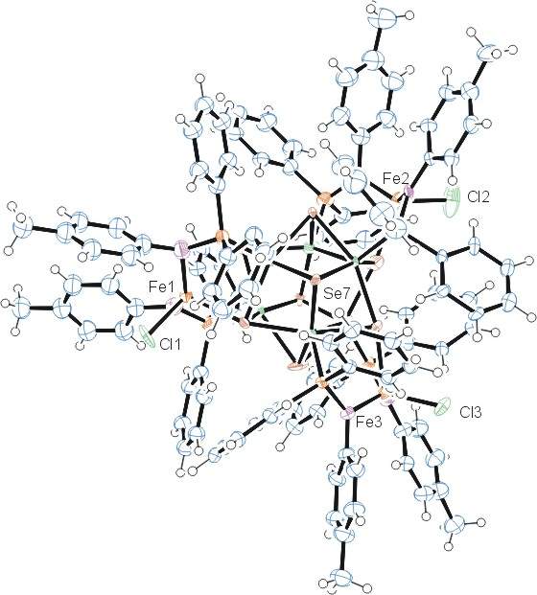
Figure 1. ORTEP of the structure with thermal ellipsoids at the 50% probability level. Disorder omitted for clarity.

Table 1: Crystallographic data for the structures provided.
Empirical formula C114 H102 Cl3 Co6 Fe3 N6 P6 Se8
Formula weight 3000.99
Temperature 100(2) K
Wavelength 0.71073 Å
Crystal system Monoclinic
Space group P 2₁/n
Unit cell dimensions a = 23.789(3) Å α= 90°.
b = 18.349(2) Å β= 91.570(6)°.
c = 28.176(4) Å γ = 90°.
Volume 12295(3) Å3
Z 4
Density (calculated) 1.621 Mg/m3
Absorption coefficient 3.689 mm-1
F(000) 5924
Crystal size 0.500 x 0.280 x 0.240 mm3
Theta range for data collection 1.105 to 25.027°.
Index ranges -28<=h<=28, -21<=k<=21, -33<=l<=33
Reflections collected 477732
Independent reflections 43120 [R(int) = 0.0646]
Completeness to theta = 25.027° 100.0 %
Refinement method Full-matrix least-squares on F2
Data / restraints / parameters 43120 / 5852 / 1612
Goodness-of-fit on F2 1.164
Final R indices [I>2sigma(I)] R1 = 0.1962, wR2 = 0.4231
R indices (all data) R1 = 0.2071, wR2 = 0.4288
Largest diff. peak and hole 3.044 and -3.090 e.Å-3

Bruker (2007) APEX2 (Version 2.1-4), SAINT (version 7.34A), SADABS (version 2007/4), BrukerAXS Inc, Madison, Wisconsin, USA.
(a) A. Spek, J. Appl. Cryst. (2003), 36, 7-13; (b) P. van der Sluis & A. L. Spek, Acta Cryst. (1990). A46, 194-201. (c) Spek, A. L. (2009). Acta. Cryst. D65, 148-155.
(a) Sheldrick GM. (2008) A short history of SHELX. Acta Cryst. A64, 112-122. (b) Sheldrick GM. (2015) SHELXT - Integrated space-group and crystal-structure determination. Acta Cryst. A71, 3-8.
(a) Altomare A, Burla C, Camalli M, Cascarano G L, Giacovazzo C, Guagliardi A, Moliterni AGG, Polidori G, Spagna R. (1999) SIR97: a new tool for crystal structure determination and refinement Journal of Applied Crystallography, 32, 115-119. (b) Altomare A, Cascarano G L, Giacovazzo C, Guagliardi A. (1993) Completion and refinement of crystal structures with SIR 92. Journal of Applied Crystallography, 26, 343-350.
(a) Sheldrick GM. (1997) SHELXL-97, Program for the Refinement of Crystal Structures. University of Göttingen, Germany. (b) Sheldrick GM. (2015) Crystal structure refinement with SHELXL. Acta Cryst. C71, 3–8
Waasmaier, D.; Kirfel, A. (1995) New Analytical Scattering Factor Functions for Free Atoms and Ions. Acta Crystallographica A., 51, 416-430.
Farrugia LJ. (1997) Ortep-3 for Windows. Journal of Applied Crystallography, 30, 565

