Crystal Structure Report for A. Velian
by Sebastian Krajewski & Werner Kaminsky
Sample Submitted by Daniel Zhou
ID – DZ728
X-ray Crystallography Laboratory
University of Washington
31. July 2026

Data Collection started: 4/30/2024
Documentation finished: 5/7/2024

Data backup accessibly through http:
URL: http://cad4.cpac.washington.edu/structures

W.Kaminsky: tel. (206) 543 7585
(x-ray lab): tel. (206) 543 0210
Email: kaminsky@chem.washington.edu

Understanding crystallographic information is not trivial. If you discuss a structure in a publication, please let the crystallographers proof-read the final draft of that manuscript before you submit it.
For many structures it is true that crystallography is an intellectual performance (like synthesis or elucidation of mechanisms) and not a routine job. In these cases, particularly when the structures contribute significantly to the content of the publication, the crystallographers should be co-authors. Do not think this is not necessary because you pay for structures.
A prown prism, measuring 0.26 x 0.03 x 0.02 mm³ was mounted on a loop with oil. Data was collected at -173ºC on a Bruker APEX II single crystal X-ray diffractometer, Mo-radiation, equipped with a Miracol X-ray optical collimator.

Crystal-to-detector distance was xx mm and exposure time was 45 seconds per frame for all sets. The scan width was 0.5º. Data collection was 99.9% complete to 25º in ϑ. A total of 46077 merged reflections were collected covering the indices, -25<=h<=25, -36<=k<=36, -67<=l<=67. 23167 reflections were symmetry independent with R_{int} = 0. Indexing and unit cell refinement indicated a body centered tetragonal lattice lattice. The space group was found to be I 4₁/a (No.xx).

The data was integrated and scaled using SAINT, SADABS within the APEX2 software package by Bruker.

The contribution of disordered solvent to the diffraction pattern was removed with SQUEEZE

Solution by direct methods (SHELXT or SIR97) produced a complete heavy atom phasing model consistent with the proposed structure. The structure was completed by difference Fourier synthesis with SHELXL. Scattering factors are from Waasmair and Kirfel. Hydrogen atoms were placed in geometrically idealised positions and constrained to ride on their parent atoms with C---H distances in the range 0.95-1.00 Angstrom. Isotropic thermal parameters U_{eq} were fixed such that they were 1.2U_{eq} of their parent atom Ueq for CH's and 1.5U_{eq} of their parent atom U_{eq} in case of methyl groups. All non-hydrogen atoms were refined anisotropically by full-matrix least-squares.

After optimaizing the phenyl group geometries and linking some disordered toluenes with one non-dirordered, as well as flattening two disordered toluenes and stabilizing the displacement parameters of named moieties, the refinement converged nicly, while the contribution of some disrordere methylchlorine solvent to the diffraction pattern was removed with SQUEEZE. One Fe-Br complete apears at full site occupancy, a second one is chemically disoredered with an uncoordinated iron spread between two locations.

The structure is of high quality and ready for publication. Table 1 summarizes the data collection details. Figure 1 shows an ORTEP of the asymmetric unit.

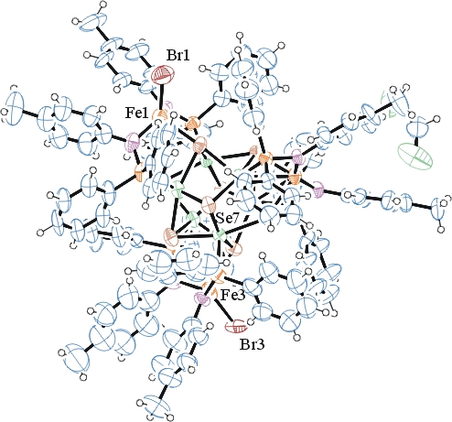

Figure 1. ORTEP of the structure with thermal ellipsoids at the 50% probability level. Disorder and some solvent omitted for clarity.

Table 1: Crystallographic data for the structures provided.
Empirical formula C115 H104 Br1.425 Cl2 Co6 Fe3 N6 P6 Se8
Formula weight 3093.44
Temperature 100(2) K
Wavelength 0.71073 Å
Crystal system Tetragonal
Space group I 41/a
Unit cell dimensions a = 30.1667(16) Å α= 90°.
b = 30.1667(16) Å β= 90°.
c = 56.619(3) Å γ = 90°.
Volume 51525(6) Å3
Z 16
Density (calculated) 1.595 Mg/m3
Absorption coefficient 3.943 mm-1
F(000) 24350
Crystal size 0.260 x 0.030 x 0.020 mm3
Theta range for data collection 1.273 to 25.187°.
Index ranges -25<=h<=25, -36<=k<=36, -67<=l<=67
Reflections collected 46077
Independent reflections 23167 [R(int) = 0.0823]
Completeness to theta = 25.187° 99.9 %
Refinement method Full-matrix least-squares on F2
Data / restraints / parameters 23167 / 694 / 1156
Goodness-of-fit on F2 1.039
Final R indices [I>2sigma(I)] R1 = 0.0809, wR2 = 0.2078
R indices (all data) R1 = 0.1689, wR2 = 0.2551
Largest diff. peak and hole 2.311 and -2.071 e.Å-3

Bruker (2007) APEX2 (Version 2.1-4), SAINT (version 7.34A), SADABS (version 2007/4), BrukerAXS Inc, Madison, Wisconsin, USA.
(a) A. Spek, J. Appl. Cryst. (2003), 36, 7-13; (b) P. van der Sluis & A. L. Spek, Acta Cryst. (1990). A46, 194-201. (c) Spek, A. L. (2009). Acta. Cryst. D65, 148-155.
(a) Sheldrick GM. (2008) A short history of SHELX. Acta Cryst. A64, 112-122. (b) Sheldrick GM. (2015) SHELXT - Integrated space-group and crystal-structure determination. Acta Cryst. A71, 3-8.
(a) Altomare A, Burla C, Camalli M, Cascarano G L, Giacovazzo C, Guagliardi A, Moliterni AGG, Polidori G, Spagna R. (1999) SIR97: a new tool for crystal structure determination and refinement Journal of Applied Crystallography, 32, 115-119. (b) Altomare A, Cascarano G L, Giacovazzo C, Guagliardi A. (1993) Completion and refinement of crystal structures with SIR 92. Journal of Applied Crystallography, 26, 343-350.
(a) Sheldrick GM. (1997) SHELXL-97, Program for the Refinement of Crystal Structures. University of Göttingen, Germany. (b) Sheldrick GM. (2015) Crystal structure refinement with SHELXL. Acta Cryst. C71, 3–8
Waasmaier, D.; Kirfel, A. (1995) New Analytical Scattering Factor Functions for Free Atoms and Ions. Acta Crystallographica A., 51, 416-430.
(a) A. Spek, J. Appl. Cryst. (2003), 36, 7-13; (b) P. van der Sluis & A. L. Spek, Acta Cryst. (1990). A46, 194-201. (c) Spek, A. L. (2009). Acta. Cryst. D65, 148-155.
Farrugia LJ. (1997) Ortep-3 for Windows. Journal of Applied Crystallography, 30, 565

