Crystal Structure Report for A. Velian
by Sebastian Krajewski &Werner Kaminsky
Sample Submitted by Daniel Zhou
ID – DZ833
X-ray Crystallography Laboratory
University of Washington
28. July 2026

Data Collection started: 9/19/2024
Documentation finished: 9/24/2024

Data backup accessibly through http:
URL: http://cad4.cpac.washington.edu/structures

W.Kaminsky: tel. (206) 543 7585
(x-ray lab): tel. (206) 543 0210
Email: kaminsky@chem.washington.edu

Understanding crystallographic information is not trivial. If you discuss a structure in a publication, please let the crystallographers proof-read the final draft of that manuscript before you submit it.
For many structures it is true that crystallography is an intellectual performance (like synthesis or elucidation of mechanisms) and not a routine job. In these cases, particularly when the structures contribute significantly to the content of the publication, the crystallographers should be co-authors. Do not think this is not necessary because you pay for structures.
A red plate, measuring 0.40 x 0.11 x 0.02 mm³ was mounted on a loop with oil. Data was collected at -173ºC on a Bruker APEX II single crystal X-ray diffractometer, Mo-radiation, equipped with a Miracol X-ray optical collimator.

Crystal-to-detector distance was 40 mm and exposure time was 12 seconds per frame for all sets. The scan width was 0.5º. Data collection was 82.9% complete to 25º in ϑ. A total of 70484 full and partial reflections were collected covering the indices, -15<=h<=15, -16<=k<=16, -23<=l<=23. 21428 reflections were symmetry independent and the R_{int} = 0.0581 indicated that the data, despite being rather incomplete, was of good quality. Indexing and unit cell refinement indicated a triclinic lattice. The space group was found to be P‾1 (No. 2).

The data appeared twinned via 180 degrees about (0 0 1) (CELL_NOW) and after multi-domain integration (SAINT, SADABS within the APEX2 software package by Bruker) the data was merged utilizing twinabs.

Solution by direct methods (SHELXT or SIR97) produced a complete heavy atom phasing model consistent with the proposed structure. The structure was completed by difference Fourier synthesis with SHELXL. Scattering factors are from Waasmair and Kirfel. Hydrogen atoms were placed in geometrically idealised positions and constrained to ride on their parent atoms with C---H distances in the range 0.95-1.00 Angstrom. Isotropic thermal parameters U_{eq} were fixed such that they were 1.2U_{eq} of their parent atom Ueq for CH's and 1.5U_{eq} of their parent atom U_{eq} in case of methyl groups. All non-hydrogen atoms were refined anisotropically by full-matrix least-squares.

The structure is chemically disordered with a major component 82.6(3)% with oxygen as bridge between phosphorous and iron, the minor one with Se as bridging atom. Geometrically similar moieties are linked with ‘SAME’ instructions, phenyl groups are optimized via HFIX 66 and the displacement parameters of disordered atoms are stabilized through SIMU cards. The methylene carbons of the disordered DCM are stabilzed via ‘ISOR’ and the DCM are linked with ‘SAME’.

The structure is of high quality and ready for publication. Table 1 summarizes the data collection details. Figure 1 shows an ORTEP of the asymmetric unit.

Figure 1. ORTEP of the structure with thermal ellipsoids at the 50% probability level: a) major component, b) minor component.

a)
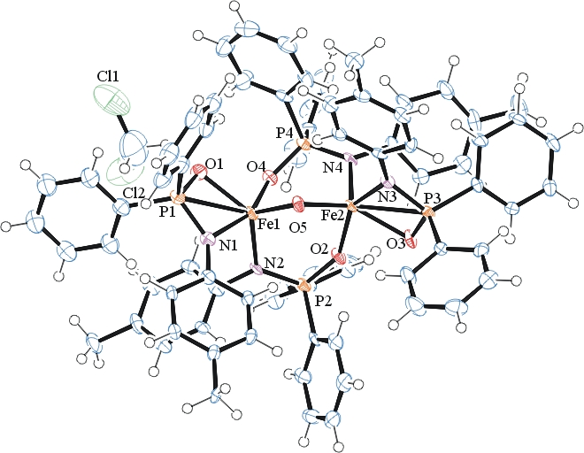
b)
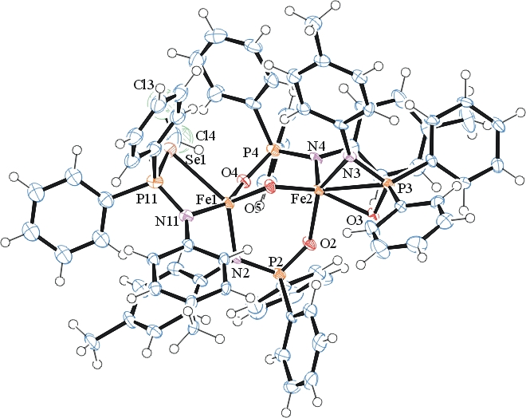

Table 1: Crystallographic data for the structures provided.
Empirical formula C77 H70 Cl2 Fe2 N4 O4.83 P4 Se0.17
Formula weight 1448.55
Temperature 100(2) K
Wavelength 0.71073 Å
Crystal system Triclinic
Space group P -1
Unit cell dimensions a = 13.4405(10) Å α= 86.282(4)°.
b = 14.1355(10) Å β= 89.657(4)°.
c = 19.7337(14) Å γ = 80.184(4)°.
Volume 3686.5(5) Å3
Z 2
Density (calculated) 1.305 Mg/m3
Absorption coefficient 0.688 mm-1
F(000) 1501
Crystal size 0.40 x 0.11 x 0.02 mm3
Theta range for data collection 1.465 to 25.025°.
Index ranges -15<=h<=15, -16<=k<=16, -23<=l<=23
Reflections collected 41991
Independent reflections 21428 [R(int) = 0.0581]
Completeness to theta = 25.025° 82.9 %
Refinement method Full-matrix least-squares on F2
Data / restraints / parameters 21428 / 1265 / 884
Goodness-of-fit on F2 1.071
Final R indices [I>2sigma(I)] R1 = 0.0653, wR2 = 0.1669
R indices (all data) R1 = 0.0819, wR2 = 0.1763
Largest diff. peak and hole 1.049 and -0.510 e.Å-3

Sheldrick, G. M. (2005). CELL_NOW. University of Goettingen, Germany.
Bruker (2007) APEX2 (Version 2.1-4), SAINT (version 7.34A), SADABS (version 2007/4), BrukerAXS Inc, Madison, Wisconsin, USA.
Sheldrick, G. M. (2007). TWINABS. University of Goettingen, Germany.
(a) Sheldrick GM. (2008) A short history of SHELX. Acta Cryst. A64, 112-122. (b) Sheldrick GM. (2015) SHELXT - Integrated space-group and crystal-structure determination. Acta Cryst. A71, 3-8.
(a) Altomare A, Burla C, Camalli M, Cascarano G L, Giacovazzo C, Guagliardi A, Moliterni AGG, Polidori G, Spagna R. (1999) SIR97: a new tool for crystal structure determination and refinement Journal of Applied Crystallography, 32, 115-119. (b) Altomare A, Cascarano G L, Giacovazzo C, Guagliardi A. (1993) Completion and refinement of crystal structures with SIR 92. Journal of Applied Crystallography, 26, 343-350.
(a) Sheldrick GM. (1997) SHELXL-97, Program for the Refinement of Crystal Structures. University of Göttingen, Germany. (b) Sheldrick GM. (2015) Crystal structure refinement with SHELXL. Acta Cryst. C71, 3–8
Waasmaier, D.; Kirfel, A. (1995) New Analytical Scattering Factor Functions for Free Atoms and Ions. Acta Crystallographica A., 51, 416-430.
Farrugia LJ. (1997) Ortep-3 for Windows. Journal of Applied Crystallography, 30, 565

