Crystal Structure Report for A. Velian
by Werner Kaminsky
Sample Submitted by Daniel Zhou
ID – DX-164
X-ray Crystallography Laboratory
University of Washington
28. July 2026

Data Collection started: 12/10 2021
Documentation finished: 12/15/2021

Data backup accessibly through http:
URL: http://cad4.cpac.washington.edu/structures

W.Kaminsky: tel. (206) 543 7585
(x-ray lab): tel. (206) 543 0210
Email: kaminsky@chem.washington.edu

Understanding crystallographic information is not trivial. If you discuss a structure in a publication, please let the crystallographers proof-read the final draft of that manuscript before you submit it.
For many structures it is true that crystallography is an intellectual performance (like synthesis or elucidation of mechanisms) and not a routine job. In these cases, particularly when the structures contribute significantly to the content of the publication, the crystallographers should be co-authors. Do not think this is not necessary because you pay for structures.
A black prism, measuring 0.30 x 0.24 x 0.20 mm³ was mounted on a loop with oil. Data was collected at -173ºC on a Bruker APEX II single crystal X-ray diffractometer, Mo-radiation, equipped with a Miracol X-ray optical collimator.

Crystal-to-detector distance was 40 mm and exposure time was 10 seconds per frame for all sets. The scan width was 0.5º. Data collection was 99.9% complete to 25º in ϑ. A total of 67040 reflections were collected covering the indices, -40<=h<=40, -20<=k<=20, -44<=l<=44. 34183 reflections were symmetry independent and the R_{int} = 0.0358 indicated that the data was of excellent quality. Indexing and unit cell refinement indicated a primitive monoclinic lattice. The space group was found to be P 2₁/c (No.xx).

The data was integrated and scaled using SAINT, SADABS within the APEX2 software package by Bruker.

Solution by direct methods (SHELXT or SIR97) produced a complete heavy atom phasing model consistent with the proposed structure. The structure was completed by difference Fourier synthesis with SHELXL., Scattering factors are from Waasmair and Kirfel. Hydrogen atoms were placed in geometrically idealised positions and constrained to ride on their parent atoms with C---H distances in the range 0.95-1.00 Angstrom. Isotropic thermal parameters U_{eq} were fixed such that they were 1.2U_{eq} of their parent atom Ueq for CH's and 1.5U_{eq} of their parent atom U_{eq} in case of methyl groups. All non-hydrogen atoms were refined anisotropically by full-matrix least-squares.

The structure contains disordered pentane and THF, the treatment of which required application of ISOR and FLAT restraints and for overlapping - ore close to each other - atoms EADP constraints. 33 bad peaks were removed from refinement.

The structure is of high quality and ready for publication. Table 1 summarizes the data collection details. Figure 1 shows an ORTEP of the asymmetric unit.

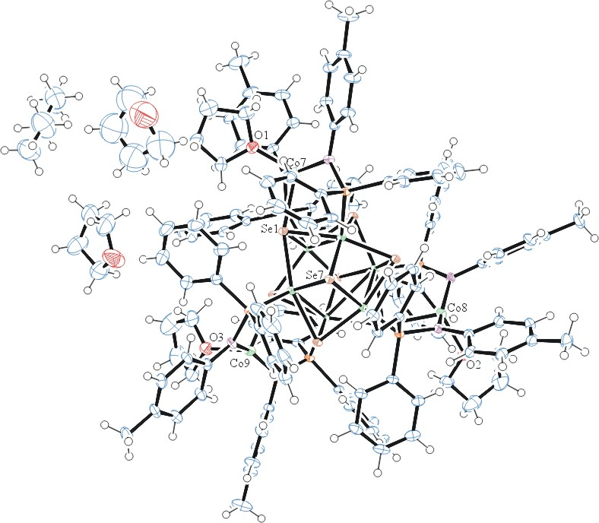

Figure 1. ORTEP of the structure with thermal ellipsoids at the 50% probability level. Disorder omitted for clarity.

Table 1: Crystallographic data for the structures provided.
Empirical formula C139.45 H155.81 Co9 N6 O4.55 P6 Se8
Formula weight 3336.56
Temperature 100(2) K
Wavelength 0.71073 Å
Crystal system Monoclinic
Space group P 2₁/c
Unit cell dimensions a = 30.1139(14) Å α= 90°.
b = 15.2030(7) Å β= 116.513(2)°.
c = 33.465(2) Å γ = 90°.
Volume 13709.5(13) Å3
Z 4
Density (calculated) 1.617 Mg/m3
Absorption coefficient 3.309 mm-1
F(000) 6704
Crystal size 0.300 x 0.240 x 0.200 mm3
Theta range for data collection 1.226 to 28.374°.
Index ranges -40<=h<=40, -20<=k<=20, -44<=l<=44
Reflections collected 67040
Independent reflections 34183 [R(int) = 0.0358]
Completeness to theta = 25.242° 99.9 %
Refinement method Full-matrix least-squares on F2
Data / restraints / parameters 34183 / 464 / 1730
Goodness-of-fit on F2 1.087
Final R indices [I>2sigma(I)] R1 = 0.0423, wR2 = 0.0934
R indices (all data) R1 = 0.0730, wR2 = 0.1069
Largest diff. peak and hole 1.249 and -0.918 e.Å-3

Bruker (2007) APEX2 (Version 2.1-4), SAINT (version 7.34A), SADABS (version 2007/4), BrukerAXS Inc, Madison, Wisconsin, USA.
Sheldrick GM. (2015) SHELXT - Integrated space-group and crystal-structure determination. Acta Cryst. A71, 3-8.
(a) Altomare A, Burla C, Camalli M, Cascarano G L, Giacovazzo C, Guagliardi A, Moliterni AGG, Polidori G, Spagna R. (1999) SIR97: a new tool for crystal structure determination and refinement Journal of Applied Crystallography, 32, 115-119. (b) Altomare A, Cascarano G L, Giacovazzo C, Guagliardi A. (1993) Completion and refinement of crystal structures with SIR 92. Journal of Applied Crystallography, 26, 343-350.
’Sheldrick : A short history of SHELX . Acta Cryst. (2008), A64, 112-122
Mackay, S.; Edwards, C.; Henderson, A.; Gilmore, C.; Stewart, N.; Shankland, K.; Donald, A. (1997) MaXus: a computer program for the solution and refinement of crystal structures from diffraction data. University of Glasgow, Scotland,.
Waasmaier, D.; Kirfel, A. (1995) New Analytical Scattering Factor Functions for Free Atoms and Ions. Acta Crystallographica A., 51, 416-430.
Farrugia LJ. (1997) Ortep-3 for Windows. Journal of Applied Crystallography, 30, 565

