Crystal Structure Report for A. Velian
by Paige M Gannon & Werner Kaminsky
Sample Submitted by Daniel Zhou
ID – DZ_330_THF
X-ray Crystallography Laboratory
University of Washington
28. July 2026

Data Collection started: 8/24/2022
Documentation finished: 8/31/2022

Data backup accessibly through http:
URL: http://cad4.cpac.washington.edu/structures

W.Kaminsky: tel. (206) 543 7585
(x-ray lab): tel. (206) 543 0210
Email: kaminsky@chem.washington.edu

Understanding crystallographic information is not trivial. If you discuss a structure in a publication, please let the crystallographers proof-read the final draft of that manuscript before you submit it.
For many structures it is true that crystallography is an intellectual performance (like synthesis or elucidation of mechanisms) and not a routine job. In these cases, particularly when the structures contribute significantly to the content of the publication, the crystallographers should be co-authors. Do not think this is not necessary because you pay for structures.
A black plate, measuring 0.17 x 0.10 x 0.05 mm³ was mounted on a loop with oil. Data was collected at -173ºC on a Bruker APEX II single crystal X-ray diffractometer, Mo-radiation, equipped with a Miracol X-ray optical collimator.

Crystal-to-detector distance was 40 mm and exposure time was 60 seconds per frame for all sets. The scan width was 0.5º. Data collection was 99.9% complete to 25º in ϑ. A total of 139217 reflections were collected covering the indices, -22<=h<=22, -23<=k<=22, -24<=l<=25. 23677 reflections were symmetry independent and the elevated R_{int} = 0.1774 indicated that the data was weak. Indexing and unit cell refinement indicated a triclinic lattice. The space group was found to be P ‾1 (No. 2).

The data was integrated and scaled using SAINT, SADABS within the APEX2 software package by Bruker.

Solution by direct methods (SHELXT or SIR97) produced a complete heavy atom phasing model consistent with the proposed structure. The structure was completed by difference Fourier synthesis with SHELXL. Scattering factors are from Waasmair and Kirfel. Hydrogen atoms were placed in geometrically idealised positions and constrained to ride on their parent atoms with C---H distances in the range 0.95-1.00 Angstrom. Isotropic thermal parameters U_{eq} were fixed such that they were 1.2U_{eq} of their parent atom Ueq for CH's and 1.5U_{eq} of their parent atom U_{eq} in case of methyl groups. All non-hydrogen atoms were refined anisotropically by full-matrix least-squares.

Due to massive disorder, most atoms display elevated thermal displacements, equivalent to a structure measured at high temperature dispite data being taken at 100K. In this case diffraction intensities at larger bragg angles are affected by the increased diffuse background and are thus causing a low observed reflections ratio.

The contribution of disordered and unrecognizable solvent to the diffraction pattern was removed with SQUEEZE.

Many restraints were needed to stabilize the refinement due to excessive disorder.

The structure is of moderate quality publishable. Table 1 summarizes the data collection details. Figure 1 shows an ORTEP of the asymmetric unit.

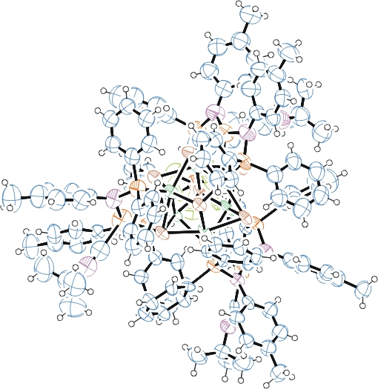
Figure 1. ORTEP of the structure with thermal ellipsoids at the 50% probability level. Disorder omitted for clarity.

Table 1: Crystallographic data for the structures provided.
Empirical formula C129 H129 Co6 F6 Fe3 N9 P7 Se8
Formula weight 3289.00
Temperature 100(2) K
Wavelength 0.71073 Å
Crystal system Triclinic
Space group P -1
Unit cell dimensions a = 18.5837(15) Å α= 88.955(5)°.
b = 19.1788(14) Å β= 84.475(5)°.
c = 20.5737(16) Å γ = 66.800(5)°.
Volume 6706.9(9) Å3
Z 2
Density (calculated) 1.629 Mg/m3
Absorption coefficient 3.350 mm-1
F(000) 3274
Crystal size 0.170 x 0.100 x 0.050 mm3
Theta range for data collection 1.155 to 25.027°.
Index ranges -22<=h<=22, -23<=k<=22, -24<=l<=25
Reflections collected 23677
Independent reflections 23677 [R(int) = 0.1774]
Completeness to theta = 25.000° 99.9 %
Refinement method Full-matrix least-squares on F2
Data / restraints / parameters 23677 / 2895 / 1471
Goodness-of-fit on F2 1.032
Final R indices [I>2sigma(I)] R1 = 0.1271, wR2 = 0.2393
R indices (all data) R1 = 0.3636, wR2 = 0.3085
Largest diff. peak and hole 2.115 and -1.445 e.Å-3

Bruker (2007) APEX2 (Version 2.1-4), SAINT (version 7.34A), SADABS (version 2007/4), BrukerAXS Inc, Madison, Wisconsin, USA.
(a) Sheldrick GM. (2008) A short history of SHELX. Acta Cryst. A64, 112-122. (b) Sheldrick GM. (2015) SHELXT - Integrated space-group and crystal-structure determination. Acta Cryst. A71, 3-8.
(a) Altomare A, Burla C, Camalli M, Cascarano G L, Giacovazzo C, Guagliardi A, Moliterni AGG, Polidori G, Spagna R. (1999) SIR97: a new tool for crystal structure determination and refinement Journal of Applied Crystallography, 32, 115-119. (b) Altomare A, Cascarano G L, Giacovazzo C, Guagliardi A. (1993) Completion and refinement of crystal structures with SIR 92. Journal of Applied Crystallography, 26, 343-350.
(a) Sheldrick GM. (1997) SHELXL-97, Program for the Refinement of Crystal Structures. University of Göttingen, Germany. (b) Sheldrick GM. (2015) Crystal structure refinement with SHELXL. Acta Cryst. C71, 3–8
Waasmaier, D.; Kirfel, A. (1995) New Analytical Scattering Factor Functions for Free Atoms and Ions. Acta Crystallographica A., 51, 416-430.
(a) A. Spek, J. Appl. Cryst. (2003), 36, 7-13; (b) P. van der Sluis & A. L. Spek, Acta Cryst. (1990). A46, 194-201. (c) Spek, A. L. (2009). Acta. Cryst. D65, 148-155.
Farrugia LJ. (1997) Ortep-3 for Windows. Journal of Applied Crystallography, 30, 565

