Crystal Structure Report for B. Cossairt
by Werner Kaminsky
Sample Submitted by
Emily Miura-Stempel
ID – EMS-III-012B
X-ray Crystallography Laboratory
University of Washington
30. July 2026

Data Collection started: 6/7/2024
Documentation finished: 6/13/2024

Data backup accessibly through http:
URL: http://cad4.cpac.washington.edu/structures

W.Kaminsky: tel. (206) 543 7585
(x-ray lab): tel. (206) 543 0210
Email: kaminsky@chem.washington.edu

Understanding crystallographic information is not trivial. If you discuss a structure in a publication, please let the crystallographers proof-read the final draft of that manuscript before you submit it.
For many structures it is true that crystallography is an intellectual performance (like synthesis or elucidation of mechanisms) and not a routine job. In these cases, particularly when the structures contribute significantly to the content of the publication, the crystallographers should be co-authors. Do not think this is not necessary because you pay for structures.
One half of a mirror-plane twinned yellow prism, measuring 0.10 x 0.07 x 0.05 mm³ was mounted on a loop with oil. Data was collected at -173ºC on a Bruker APEX II single crystal X-ray diffractometer, Mo-radiation, equipped with a Miracol X-ray optical collimator.

Crystal-to-detector distance was 60 mm and exposure time was 60 seconds per frame for all sets. The scan width was 0.5º. Data collection was 100% complete to 25º in ϑ. A total of 43081 merged out of 303003 total reflections were collected covering the indices, -34<=h<=34, -33<=k<=33, -35<=l<=35. 22022 reflections were symmetry independent and the R_{int} = 0.0548 indicated that the data was of excellent quality (average 0.07). Indexing and unit cell refinement indicated a C-centered monoclinic lattice lattice. The space group was found to be C2/m (No. 12).

The data was integrated and scaled using SAINT, SADABS within the APEX2 software package by Bruker.

Solution by direct methods (SHELXT or SIR97) produced a complete heavy atom phasing model consistent with the proposed structure. The structure was completed by difference Fourier synthesis with SHELXL. Scattering factors are from Waasmair and Kirfel. Hydrogen atoms were placed in geometrically idealised positions and constrained to ride on their parent atoms with C---H distances in the range 0.95-1.00 Angstrom. Isotropic thermal parameters U_{eq} were fixed such that they were 1.2U_{eq} of their parent atom Ueq for CH's and 1.5U_{eq} of their parent atom U_{eq} in case of methyl groups. All non-hydrogen atoms were refined anisotropically by full-matrix least-squares.

The contribution of disordered solvent to the diffraction pattern was removed with SQUEEZE.

The asymmetric unit consists of two cluster halves, completed by symmetry. The clusters contain several disordered carboxylates which were refined with appropriate restraints.

Hydroxyl groups were identified by their long Ce-O distances (O4, O12, O18, O36, O39). The protons were restraint at 1Å towards the oxygen.

The admixture of Er was tested by refining the cite occupancies of Ce/Er with equal location and displacement parameters. Only a few ‘pairs’ allowed refinement convergence, i.e. Ce1, Ce2, Ce3, Ce11, Ce12, Ce14, Ce16, Ce20, Ce22 with occupancies 0.97, 0.97, 0.965, 0.93, 0.97, 0.98, 0.95, 0.99, 0.93. Ce11 and Ce22 show the largest substitution, however, the total admixture is Ce75.14(40) / Er0.86(40), where the large standard deviation may indicate that this result is to be taken with a grain of salt.

The structure overall is of a much higher quality than the published one (Mitchell et al., 2017), i.e. the published structure is incomplete and full of mistakes, a total of 40 A-level and 14 B-level checkcif alerts, together with plenty of editing errors) and should never have been published together with an otherwise well worked out manuscript (the structure of this report has only 5 minor B-level alerts).

The structure is of high quality and ready for publication. Table 1 summarizes the data collection details. Figure 1 shows an ORTEP of the asymmetric unit.

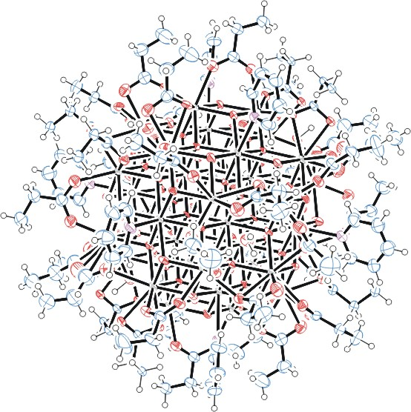

Figure 1. ORTEP of the structure (checkcif printout) with thermal ellipsoids at the 50% probability level. Disorder omitted for clarity.

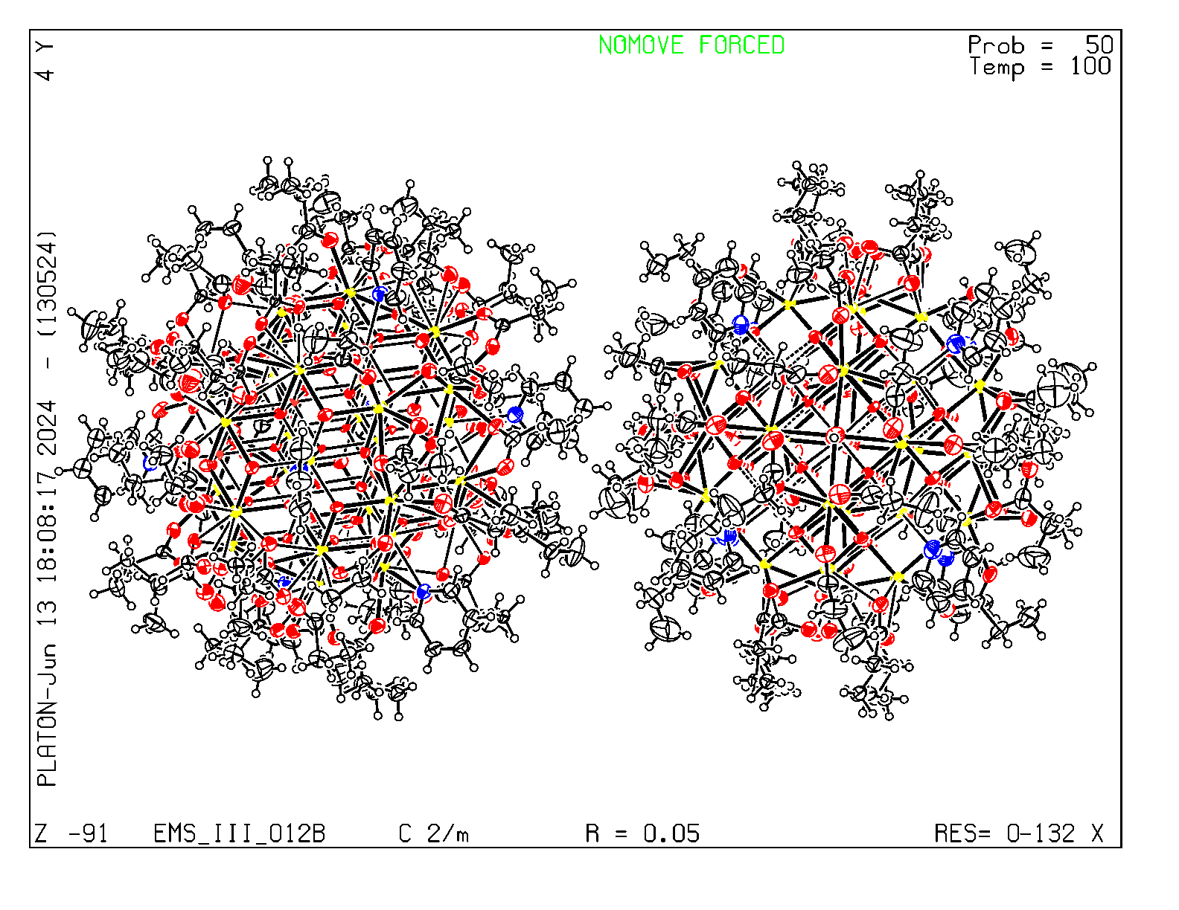
Figure 2. Checkcif plot

Table 1: Crystallographic data for the structures provided.
Empirical formula C296 H452 Ce75.14 Er0.86 N16 O268
Formula weight 19195.17
Temperature 100(2) K
Wavelength 0.71073 Å
Crystal system Monoclinic
Space group C 2/m
Unit cell dimensions a = 29.033(3) Å α= 90°.
b = 28.145(3) Å β= 92.145(5)°.
c = 29.852(3) Å γ = 90°.
Volume 24376(4) Å3
Z 2
Density (calculated) 2.615 Mg/m3
Absorption coefficient 7.093 mm-1
F(000) 17801
Crystal size 0.100 x 0.070 x 0.050 mm3
Theta range for data collection 1.008 to 25.027°.
Index ranges -34<=h<=34, -33<=k<=33, -35<=l<=35
Reflections collected 43081
Independent reflections 22022 [R(int) = 0.0548]
Completeness to theta = 25.027° 100.0 %
Refinement method Full-matrix least-squares on F2
Data / restraints / parameters 22022 / 4091 / 1872
Goodness-of-fit on F2 1.008
Final R indices [I>2sigma(I)] R1 = 0.0520, wR2 = 0.1068
R indices (all data) R1 = 0.1055, wR2 = 0.1405
Largest diff. peak and hole 3.554 and -2.344 e.Å-3

Bruker (2007) APEX2 (Version 2.1-4), SAINT (version 7.34A), SADABS (version 2007/4), BrukerAXS Inc, Madison, Wisconsin, USA.
(a) Sheldrick GM. (2008) A short history of SHELX. Acta Cryst. A64, 112-122. (b) Sheldrick GM. (2015) SHELXT - Integrated space-group and crystal-structure determination. Acta Cryst. A71, 3-8.
(a) Altomare A, Burla C, Camalli M, Cascarano G L, Giacovazzo C, Guagliardi A, Moliterni AGG, Polidori G, Spagna R. (1999) SIR97: a new tool for crystal structure determination and refinement Journal of Applied Crystallography, 32, 115-119. (b) Altomare A, Cascarano G L, Giacovazzo C, Guagliardi A. (1993) Completion and refinement of crystal structures with SIR 92. Journal of Applied Crystallography, 26, 343-350.
(a) Sheldrick GM. (1997) SHELXL-97, Program for the Refinement of Crystal Structures. University of Göttingen, Germany. (b) Sheldrick GM. (2015) Crystal structure refinement with SHELXL. Acta Cryst. C71, 3–8
Waasmaier, D.; Kirfel, A. (1995) New Analytical Scattering Factor Functions for Free Atoms and Ions. Acta Crystallographica A., 51, 416-430.
(a) A. Spek, J. Appl. Cryst. (2003), 36, 7-13; (b) P. van der Sluis & A. L. Spek, Acta Cryst. (1990). A46, 194-201. (c) Spek, A. L. (2009). Acta. Cryst. D65, 148-155.
Farrugia LJ. (1997) Ortep-3 for Windows. Journal of Applied Crystallography, 30, 565

