Crystal Structure Report for G Khalil
Submitted by Kim Lau
Sample ID – H2TFPL
by Werner Kaminsky
X-ray Crystallography Laboratory
University of Washington
29. July 2026

Data Collection started: 07/28/2004
Documentation finished: 16/09/2024

Data backup accessibly through http:
URL: http://cad4.cpac.washington.edu/structures

W.Kaminsky: tel. (206) 543 7585
(x-ray lab): tel. (206) 543 0210
Email: kaminsky@chem.washington.edu

Understanding crystallographic information is not trivial. If you discuss a structure in a publication, please let the crystallographers proof-read the final draft of that manuscript before you submit it.
For many structures it is true that crystallography is an intellectual performance (like synthesis or elucidation of mechanisms) and not a routine job. In these cases, particularly when the structures contribute significantly to the content of the publication, the crystallographers should be co-authors. Do not think this is not necessary because you pay for structures. Even I have to pay for my own structures for my research.
A dark red prism, 0.44 x 0.36 x 0.26 mm³ of size, was mounted on a glass capillary with oil. Data was collected at -143ºC on a Nonius Kappa CCD FR590 single crystal X-ray diffractometer, Mo-radiation.

Scan Type Scanlength (deg.) start (deg.) ϑ ϕ Ω κ
1 ϕ 182.0 3.70 -83.3 160 0
2 Ω 81.5 0 -25.9 -187.5 74.1

Crystal-to-detector distance was 30 mm and exposure time was 40 seconds per degree for all sets. The scan width was 1.5º. Data collection was 99.6 % complete to 25º in ϑ. A total of 6401 merged out of 82461 partial and complete reflections were collected covering the indices, -24<=h<=24, -21<=k<=19, -29<=l<=24. 3618 reflections were symmetry independent and the R_{int} = 0.0416 indicated that the data was good. Indexing and unit cell refinement indicated a primitive rhombohedral lattice. The space group was found to be P‾3 (No. 148).

The data was integrated and scaled using hkl-SCALEPACK. This program applies a multiplicative correction factor (S) to the observed intensities (I) and has the following form:

S is calculated from the scale and the B factor determined for each frame and is then applied to I to give the corrected intensity (I_{corr}).

Solution by direct methods (SHELXT or SIR97) produced a complete heavy atom phasing model consistent with the proposed structure. The structure was completed by difference Fourier synthesis with SHELXL., Scattering factors are from Waasmair and Kirfel. Hydrogen atoms were placed in geometrically idealised positions and constrained to ride on their parent atoms with C---H distances in the range 0.95-1.00 Angstrom. Isotropic thermal parameters U_{eq} were fixed such that they were 1.2U_{eq} of their parent atom Ueq for CH's and 1.5U_{eq} of their parent atom U_{eq} in case of methyl groups. All non-hydrogen atoms were refined anisotropically by full-matrix least-squares.

A lactone moity, disordered with C₄H₂NH, are overlayed on each other on opposite ends of the molecule. A rest of ca. 6% silver lactone porphyrin completes the structure.

The structure is of high quality and was deposited as CSD publication, CCDC# 2383498, DOI: 10.5517/ccdc.csd.cc2l071x.

Table 1 summarizes the data collection details. Figure 1 shows an ORTEP of the asymmetric unit.

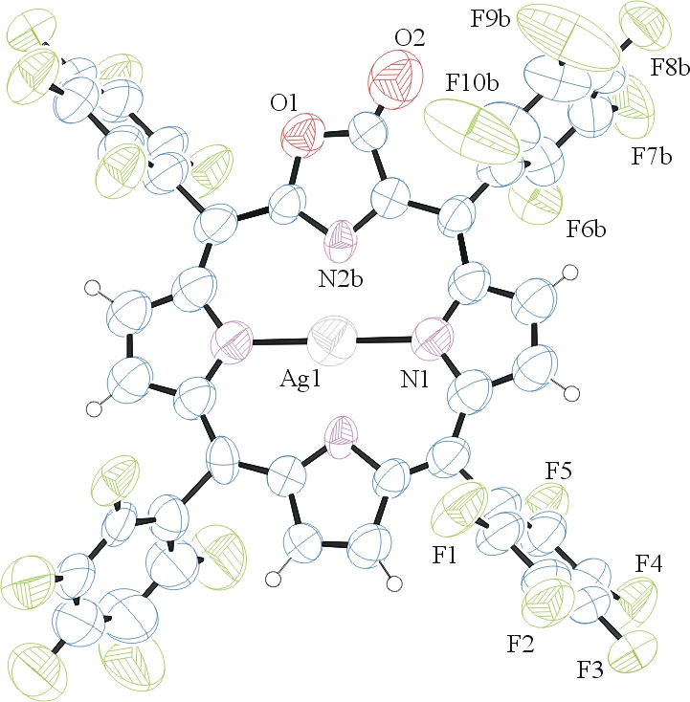

Figure 1. ORTEP of the structure with thermal ellipsoids at the 50% probability level. Disorder omitted for clarity.

Table 1: Crystallographic data for the structures provided.
Empirical formula C43 H7.88 Ag0.06 F20 N4 O2
Formula weight 999.12
Temperature 130(2) K
Wavelength 0.71073 Å
Crystal system Trigonal
Space group R -3 :H
Unit cell dimensions a = 20.1550(10) Å α= 90°.
b = 20.1550(10) Å β= 90°.
c = 23.8680(10) Å γ = 120°.
Volume 8396.8(9) Å3
Z 9
Density (calculated) 1.778 Mg/m3
Absorption coefficient 0.211 mm-1
F(000) 4435
Crystal size 0.440 x 0.360 x 0.260 mm3
Theta range for data collection 2.067 to 26.020°.
Index ranges -24<=h<=24, -21<=k<=19, -29<=l<=24
Reflections collected 6401
Independent reflections 3618 [R(int) = 0.0416]
Completeness to theta = 25.000° 99.6 %
Refinement method Full-matrix least-squares on F2
Data / restraints / parameters 3618 / 135 / 422
Goodness-of-fit on F2 1.000
Final R indices [I>2sigma(I)] R1 = 0.0689, wR2 = 0.2038
R indices (all data) R1 = 0.1614, wR2 = 0.2725
Largest diff. peak and hole 0.579 and -0.242 e.Å-3

Otwinowsky, Z.; Minor, W. In: Methods in Enzymology; Carter, C. W., Jr., Sweet, R. M., Eds.; Academic Press: New York, 1997, 276, 307-326.
Sheldrick GM. (2015) SHELXT - Integrated space-group and crystal-structure determination. Acta Cryst. A71, 3-8.
(a) Altomare A, Burla C, Camalli M, Cascarano G L, Giacovazzo C, Guagliardi A, Moliterni AGG, Polidori G, Spagna R. (1999) SIR97: a new tool for crystal structure determination and refinement Journal of Applied Crystallography, 32, 115-119. (b) Altomare A, Cascarano G L, Giacovazzo C, Guagliardi A. (1993) Completion and refinement of crystal structures with SIR 92. Journal of Applied Crystallography, 26, 343-350.
(a) Sheldrick GM. (1997) SHELXL-97, Program for the Refinement of Crystal Structures. University of Göttingen, Germany. (b) Sheldrick GM. (2015) Crystal structure refinement with SHELXL. Acta Cryst. (2015). C71, 3–8
Mackay, S.; Edwards, C.; Henderson, A.; Gilmore, C.; Stewart, N.; Shankland, K.; Donald, A. (1997) MaXus: a computer program for the solution and refinement of crystal structures from diffraction data. University of Glasgow, Scotland,.
Waasmaier, D.; Kirfel, A. Acta Crystallogr. A. 1995, 51, 416.
Farrugia, L. J. Appl. Cryst. 1997, 30, 565

