Crystal Structure Report for D. Reed
by Claire Gervais & Werner Kaminsky
Sample Submitted by Haojin K
ID – HK-03-076A
X-ray Crystallography Laboratory
University of Washington
29. July 2026

Data Collection started: 7/8/2025
Documentation finished: 7/23/2025

Data backup accessibly through http:
URL: http://cad4.cpac.washington.edu/structures

W.Kaminsky: tel. (206) 543 7585
(x-ray lab): tel. (206) 543 0210
Email: kaminsky@chem.washington.edu

Understanding crystallographic information is not trivial. If you discuss a structure in a publication, please let the crystallographers proof-read the final draft of that manuscript before you submit it.
For many structures it is true that crystallography is an intellectual performance (like synthesis or elucidation of mechanisms) and not a routine job. In these cases, particularly when the structures contribute significantly to the content of the publication, the crystallographers should be co-authors. Do not think this is not necessary because you pay for structures.
A colorless needle, measuring 0.13 x 0.04 x 0.02 mm³ was mounted on a loop with oil. Data was collected at -173ºC on a Bruker APEX II single crystal X-ray diffractometer, Mo-radiation, equipped with a Miracol X-ray optical collimator.

Crystal-to-detector distance was 40 mm and exposure time was 100 seconds per frame for all sets. The scan width was 0.5º. Data collection was 98.9% complete to 25º in ϑ. A total of 21271 reflections were collected covering the indices, -23<=h<=23, -33<=k<=33, -10<=l<=10. 10626 reflections were symmetry independent and the R_{int} = 0.1251 indicated that the data was of less than average quality (0.07). Indexing and unit cell refinement indicated a C-centeres monoclinic lattice. The space group was found to be C 2/c (No. 15).

The data appeared twinned via 180 degrees about ca. (0 1 1) (CELL_NOW) and after multi-domain integration (SAINT, SADABS within the APEX2 software package by Bruker) the data was merged utilizing twinabs.

Solution by direct methods (SHELXT or SIR97) produced a complete heavy atom phasing model consistent with the proposed structure. The structure was completed by difference Fourier synthesis with SHELXL. Scattering factors are from Waasmair and Kirfel. Hydrogen atoms were placed in geometrically idealised positions and constrained to ride on their parent atoms with C---H distances in the range 0.95-1.00 Angstrom. Isotropic thermal parameters U_{eq} were fixed such that they were 1.2U_{eq} of their parent atom Ueq for CH's and 1.5U_{eq} of their parent atom U_{eq} in case of methyl groups. All non-hydrogen atoms were refined anisotropically by full-matrix least-squares.

The contribution of disordered solvent to the diffraction pattern was removed with SQUEEZE

This 1-dim polymeric structure is very similar to that of submission with ID: HK-03-088A. The lattice parameters are slightly different due to different solvents that in both cases were disordered.

The structure is of high quality and ready for publication. Table 1 summarizes the data collection details. Figure 1 shows an ORTEP of the asymmetric unit.

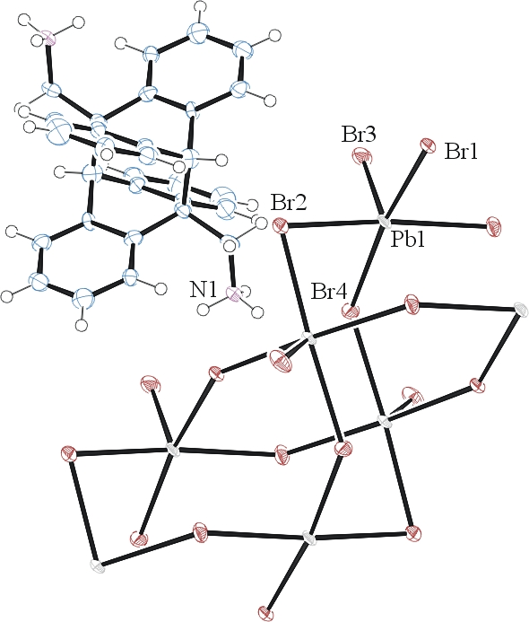
Figure 1. ORTEP of the structure with thermal ellipsoids at the 50% probability level.

Table 1: Crystallographic data for the structures provided.
Empirical formula C15 H14 Br3 N Pb
Formula weight 655.19
Temperature 100(2) K
Wavelength 0.71073 Å
Crystal system Monoclinic
Space group C 2/c
Unit cell dimensions a = 18.731(3) Å α= 90°.
b = 26.727(4) Å β= 92.916(9)°.
c = 8.3344(9) Å γ = 90°.
Volume 4167.0(10) Å3
Z 8
Density (calculated) 2.089 Mg/m3
Absorption coefficient 13.842 mm-1
F(000) 2384
Crystal size 0.130 x 0.040 x 0.020 mm3
Theta range for data collection 1.329 to 26.518°.
Index ranges -23<=h<=23, -33<=k<=33, -10<=l<=10
Reflections collected 10626
Independent reflections 10626 [R(int) = 0.1251]
Completeness to theta = 25.242° 98.9 %
Refinement method Full-matrix least-squares on F2
Data / restraints / parameters 10626 / 105 / 160
Goodness-of-fit on F2 0.999
Final R indices [I>2sigma(I)] R1 = 0.0968, wR2 = 0.2262
R indices (all data) R1 = 0.1465, wR2 = 0.2603
Largest diff. peak and hole 4.331 and -3.606 e.Å-3

Sheldrick, G. M. (2005). CELL_NOW. University of Goettingen, Germany.
Bruker (2007) APEX2 (Version 2.1-4), SAINT (version 7.34A), SADABS (version 2007/4), BrukerAXS Inc, Madison, Wisconsin, USA.
Sheldrick, G. M. (2007). TWINABS. University of Goettingen, Germany.
(a) Sheldrick GM. (2008) A short history of SHELX. Acta Cryst. A64, 112-122. (b) Sheldrick GM. (2015) SHELXT - Integrated space-group and crystal-structure determination. Acta Cryst. A71, 3-8.
(a) Altomare A, Burla C, Camalli M, Cascarano G L, Giacovazzo C, Guagliardi A, Moliterni AGG, Polidori G, Spagna R. (1999) SIR97: a new tool for crystal structure determination and refinement Journal of Applied Crystallography, 32, 115-119. (b) Altomare A, Cascarano G L, Giacovazzo C, Guagliardi A. (1993) Completion and refinement of crystal structures with SIR 92. Journal of Applied Crystallography, 26, 343-350.
(a) Sheldrick GM. (1997) SHELXL-97, Program for the Refinement of Crystal Structures. University of Göttingen, Germany. (b) Sheldrick GM. (2015) Crystal structure refinement with SHELXL. Acta Cryst. C71, 3–8
Waasmaier, D.; Kirfel, A. (1995) New Analytical Scattering Factor Functions for Free Atoms and Ions. Acta Crystallographica A., 51, 416-430.
(a) A. Spek, J. Appl. Cryst. (2003), 36, 7-13; (b) P. van der Sluis & A. L. Spek, Acta Cryst. (1990). A46, 194-201. (c) Spek, A. L. (2009). Acta. Cryst. D65, 148-155.
Farrugia LJ. (1997) Ortep-3 for Windows. Journal of Applied Crystallography, 30, 565

