Crystal Structure Report for K. Goldberg
by Maike Blakely & Werner Kaminsky
Sample Submitted by Hannah Zeitler
ID – HZ_2_81
X-ray Crystallography Laboratory
University of Washington
28. July 2026

Data Collection started: 4/24/2017
Documentation finished: 4/26/2017

Data backup accessibly through http:
URL: http://cad4.cpac.washington.edu/structures

W.Kaminsky: tel. (206) 543 7585
(x-ray lab): tel. (206) 543 0210
Email: kaminsky@chem.washington.edu

Understanding crystallographic information is not trivial. If you discuss a structure in a publication, please let the crystallographers proof-read the final draft of that manuscript before you submit it.
For many structures it is true that crystallography is an intellectual performance (like synthesis or elucidation of mechanisms) and not a routine job. In these cases, particularly when the structures contribute significantly to the content of the publication, the crystallographers should be co-authors. Do not think this is not necessary because you pay for structures.
A yellow prism, measuring 0.21 x 0.18 x 0.09 mm³ was mounted on a loop with oil. Data was collected at -173ºC on a Bruker APEX II single crystal X-ray diffractometer, Mo-radiation.

Crystal-to-detector distance was 40 mm and exposure time was 10 seconds per frame for all sets. The scan width was 0.5º. Data collection was 97% complete to 25º in ϑ. A total of 66666 reflections were collected covering the indices, -11<=h<=12, -12<=k<=13, 0<=l<=26. 7350 reflections were symmetry independent and the R_{int} = 0.0516 indicated that the data was of good quality. Indexing and unit cell refinement indicated a triclinic lattice. The space group was found to be P‾1 (No. 2x).

The data appeared twinned via 180 degrees about (0 0 1) (CELL_NOW) and after multi-domain integration (SAINT, SADABS within the APEX2 software package by Bruker) the data was merged utilizing twinabs.

Solution by direct methods (SHELXS, SIR97) produced a complete heavy atom phasing model consistent with the proposed structure. The structure was completed by difference Fourier synthesis with SHELXL97., Scattering factors are from Waasmair and Kirfel. Hydrogen atoms were placed in geometrically idealised positions and constrained to ride on their parent atoms with C---H distances in the range 0.95-1.00 Angstrom. Isotropic thermal parameters U_{eq} were fixed such that they were 1.2U_{eq} of their parent atom Ueq for CH's and 1.5U_{eq} of their parent atom U_{eq} in case of methyl groups. All non-hydrogen atoms were refined anisotropically by full-matrix least-squares.

1:1 disorder was observed in the deuterated benzenes and phenylacetate.

The structure is of high quality and ready for publication. Table 1 summarizes the data collection details. Figure 1 shows an ORTEP of the asymmetric unit.

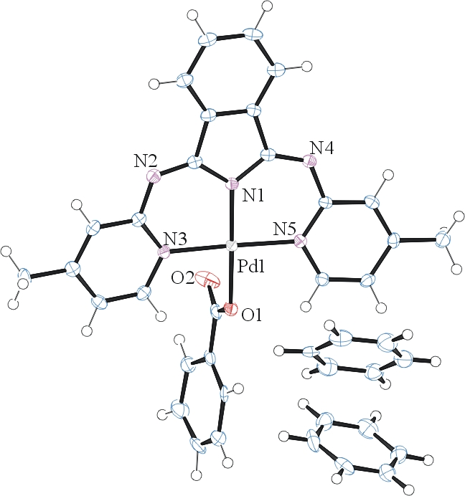
Figure 1. ORTEP of the structure with thermal ellipsoids at the 50% probability level. Disorder omitted for clarity.

Table 1: Crystallographic data for the structures provided.
Empirical formula C39 H21 D12 N5 O2 Pd
Formula weight 722.18
Temperature 100(2) K
Wavelength 0.71073 Å
Crystal system Triclinic
Space group P -1
Unit cell dimensions a = 9.0586(10) Å α= 78.680(6)°.
b = 9.8447(11) Å β= 80.920(5)°.
c = 19.564(2) Å γ = 71.141(5)°.
Volume 1610.5(3) Å3
Z 2
Density (calculated) 1.489 Mg/m3
Absorption coefficient 0.620 mm-1
F(000) 728
Crystal size 0.210 x 0.180 x 0.090 mm3
Theta range for data collection 2.134 to 28.359°.
Index ranges -11<=h<=12, -12<=k<=13, 0<=l<=26
Reflections collected 66666
Independent reflections 7350 [R(int) = 0.0516]
Completeness to theta = 25.000° 97.0 %
Absorption correction Semi-empirical from equivalents
Max. and min. transmission 0.9457 and 0.8947
Refinement method Full-matrix least-squares on F2
Data / restraints / parameters 7350 / 102 / 535
Goodness-of-fit on F2 1.048
Final R indices [I>2sigma(I)] R1 = 0.0331, wR2 = 0.0680
R indices (all data) R1 = 0.0385, wR2 = 0.0698
Largest diff. peak and hole 0.402 and -0.614 e.Å-3

Sheldrick, G. M. (2005). CELL_NOW. University of Goettingen, Germany.
Bruker (2007) APEX2 (Version 2.1-4), SAINT (version 7.34A), SADABS (version 2007/4), BrukerAXS Inc, Madison, Wisconsin, USA.
Sheldrick, G. M. (2007). TWINABS. University of Goettingen, Germany.
(a) Altomare A, Burla C, Camalli M, Cascarano G L, Giacovazzo C, Guagliardi A, Moliterni AGG, Polidori G, Spagna R. (1999) SIR97: a new tool for crystal structure determination and refinement Journal of Applied Crystallography, 32, 115-119. (b) Altomare A, Cascarano G L, Giacovazzo C, Guagliardi A. (1993) Completion and refinement of crystal structures with SIR 92. Journal of Applied Crystallography, 26, 343-350.
(a) Sheldrick GM. (1997) SHELXL-97, Program for the Refinement of Crystal Structures. University of Göttingen, Germany. (b) Sheldrick GM. (2013) Crystal structure refinement with SHELXL. Acta Cryst. (2015). C71, 3-8.
Mackay, S.; Edwards, C.; Henderson, A.; Gilmore, C.; Stewart, N.; Shankland, K.; Donald, A. (1997) MaXus: a computer program for the solution and refinement of crystal structures from diffraction data. University of Glasgow, Scotland,.
Waasmaier, D.; Kirfel, A. (1995) New Analytical Scattering Factor Functions for Free Atoms and Ions. Acta Crystallographica A., 51, 416-430.
Farrugia LJ. (1997) Ortep-3 for Windows. Journal of Applied Crystallography, 30, 565

