Crystal Structure Report for A. Velian
by Werner Kaminsky
Sample Submitted by Isabel Friedrichs
ID – IF13
X-ray Crystallography Laboratory
University of Washington
31. July 2026

Data Collection started: 8/9/2021
Documentation finished: 8/12/2021

Data backup accessibly through http:
URL: http://cad4.cpac.washington.edu/structures

W.Kaminsky: tel. (206) 543 7585
(x-ray lab): tel. (206) 543 0210
Email: kaminsky@chem.washington.edu

Understanding crystallographic information is not trivial. If you discuss a structure in a publication, please let the crystallographers proof-read the final draft of that manuscript before you submit it.
For many structures it is true that crystallography is an intellectual performance (like synthesis or elucidation of mechanisms) and not a routine job. In these cases, particularly when the structures contribute significantly to the content of the publication, the crystallographers should be co-authors. Do not think this is not necessary because you pay for structures.
A brown needle, measuring 0.27 x 0.05 x 0.05 mm³ was mounted on a loop with oil. Data was collected at -173ºC on a Bruker APEX II single crystal X-ray diffractometer, Mo-radiation, equipped with a Miracol X-ray optical collimator.

Crystal-to-detector distance was 40 mm and exposure time was 90 seconds per frame for all sets. The scan width was 1º. Data collection was 97.3% complete to 25º in ϑ. A total of 34342 unique reflections were collected covering the indices, -15<=h<=14, -28<=k<=28, -42<=l<=42, R_{int} = 0.0881. Indexing and unit cell refinement indicated a large triclinic lattice. The space group was found to be P‾1 (No. 2).

The data was integrated and scaled using SAINT, SADABS within the APEX2 software package by Bruker.

Solution by direct methods (SHELXT or SIR97) produced a complete heavy atom phasing model consistent with the proposed structure. The structure was completed by difference Fourier synthesis with SHELXL., Scattering factors are from Waasmair and Kirfel. Hydrogen atoms were placed in geometrically idealised positions and constrained to ride on their parent atoms with C---H distances in the range 0.95-1.00 Angstrom. Isotropic thermal parameters U_{eq} were fixed such that they were 1.2U_{eq} of their parent atom Ueq for CH's and 1.5U_{eq} of their parent atom U_{eq} in case of methyl groups. All non-hydrogen atoms were refined anisotropically by full-matrix least-squares.

The structure exhibits disorder in multiple places, which required one disordered toluene group to be optimized with AFIX 66 loops. A global ISOR was applied to all nitrogen and carbon atoms and a DELU as well including phosphorous and Co15. In addition, some SAME restraints were required on disordered PEt3 and one CNtbutyl, the latter of which required SADI restraints to optimize one CNtbutyl to serve as template for equivalent moieties related with SAME. The displacement parameters of related disordered atoms were linked with EADP cards. A total of 30 bad peaks were excluded from the refinement.

The contribution of disordered solvent (likely toluene) to the diffraction pattern was removed with SQUEEZE

The structure is of moderate quality but possibly publishable with disclaimer. Table 1 summarizes the data collection details. Figure 1 shows an ORTEP of the asymmetric unit.

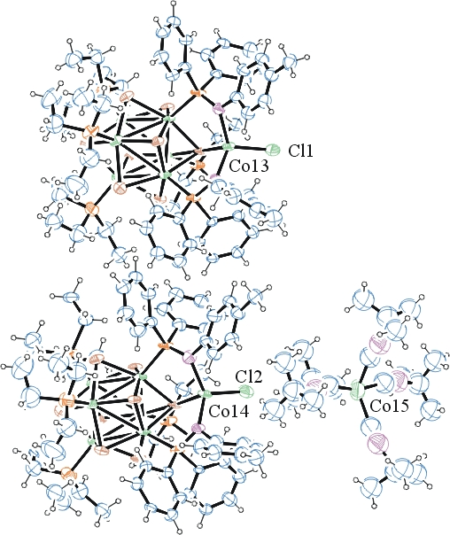
Figure 1. ORTEP of the structure with thermal ellipsoids at the 30% probability level. Disorder omitted for clarity.

Table 1: Crystallographic data for the structures provided.
Empirical formula C149 H233 Cl2 Co15 N9 P12 Se16
Formula weight 4740.28
Temperature 100(2) K
Wavelength 0.71073 Å
Crystal system Triclinic
Space group P -1
Unit cell dimensions a = 12.3418(11) Å α= 104.621(6)°.
b = 23.914(2) Å β= 98.145(6)°.
c = 35.439(3) Å γ = 97.380(6)°.
Volume 9870.6(16) Å3
Z 2
Density (calculated) 1.595 Mg/m3
Absorption coefficient 4.341 mm-1
F(000) 4706
Crystal size 0.270 x 0.050 x 0.050 mm3
Theta range for data collection 1.208 to 25.156°.
Index ranges -15<=h<=14, -28<=k<=28, -42<=l<=42
Reflections collected 34342
Independent reflections 34342 [R(int) = 0.0881]
Completeness to theta = 25.000° 97.3 %
Refinement method Full-matrix least-squares on F2
Data / restraints / parameters 34342 / 2751 / 1799
Goodness-of-fit on F2 0.961
Final R indices [I>2sigma(I)] R1 = 0.1250, wR2 = 0.2095
R indices (all data) R1 = 0.4070, wR2 = 0.2730
Largest diff. peak and hole 1.088 and -1.123 e.Å-3

Bruker (2007) APEX2 (Version 2.1-4), SAINT (version 7.34A), SADABS (version 2007/4), BrukerAXS Inc, Madison, Wisconsin, USA.
Sheldrick GM. (2015) SHELXT - Integrated space-group and crystal-structure determination. Acta Cryst. A71, 3-8.
(a) Altomare A, Burla C, Camalli M, Cascarano G L, Giacovazzo C, Guagliardi A, Moliterni AGG, Polidori G, Spagna R. (1999) SIR97: a new tool for crystal structure determination and refinement Journal of Applied Crystallography, 32, 115-119. (b) Altomare A, Cascarano G L, Giacovazzo C, Guagliardi A. (1993) Completion and refinement of crystal structures with SIR 92. Journal of Applied Crystallography, 26, 343-350.
(a) Sheldrick GM. (1997) SHELXL-97, Program for the Refinement of Crystal Structures. University of Göttingen, Germany. (b) Sheldrick GM. (2015) Crystal structure refinement with SHELXL. Acta Cryst. (2015). C71, 3–8
Mackay, S.; Edwards, C.; Henderson, A.; Gilmore, C.; Stewart, N.; Shankland, K.; Donald, A. (1997) MaXus: a computer program for the solution and refinement of crystal structures from diffraction data. University of Glasgow, Scotland,.
Waasmaier, D.; Kirfel, A. (1995) New Analytical Scattering Factor Functions for Free Atoms and Ions. Acta Crystallographica A., 51, 416-430.
(a) A. Spek, J. Appl. Cryst. (2003), 36, 7-13; (b) P. van der Sluis & A. L. Spek, Acta Cryst. (1990). A46, 194-201. (c) Spek, A. L. (2009). Acta. Cryst. D65, 148-155.
Farrugia LJ. (1997) Ortep-3 for Windows. Journal of Applied Crystallography, 30, 565

