Crystal Structure Report for P Pauzauskie
By Sebastian Krajewski & Werner Kaminsky
Sample Submitted by Ivan Liu
ID – Ivan_x
X-ray Crystallography Laboratory
University of Washington
28. July 2026

Data Collection started: 11/3/2022
Documentation finished: 11/16/2022

Data backup accessibly through http:
URL: http://cad4.cpac.washington.edu/structures

W.Kaminsky: tel. (206) 543 7585
(x-ray lab): tel. (206) 543 0210
Email: kaminsky@chem.washington.edu

Understanding crystallographic information is not trivial. If you discuss a structure in a publication, please let the crystallographers proof-read the final draft of that manuscript before you submit it.
For many structures it is true that crystallography is an intellectual performance (like synthesis or elucidation of mechanisms) and not a routine job. In these cases, particularly when the structures contribute significantly to the content of the publication, the crystallographers should be co-authors. Do not think this is not necessary because you pay for structures.
A colorless plate, measuring 0.21 x 0.11 x 0.04 mm³ was mounted on a loop with oil. Data was collected at -173ºC on a Bruker APEX II single crystal X-ray diffractometer, Mo-radiation, equipped with a Miracol X-ray optical collimator.

Crystal-to-detector distance was 40 mm and exposure time was 120 seconds per frame for all sets. The scan width was 2º. Data collection was 100% complete to 25º in ϑ. A total of 981 reflections were collected covering the indices, -6<=h<=6, -6<=k<=6, -22<=l<=22. 108 reflections were symmetry independent and the elevated R_{int} = 0.0954 indicated that the sample was small (average quality 0.07). Indexing and unit cell refinement indicated a R-centered trigonal/hexagonal lattice. The space group was found to be R ‾3c :H (No. 167).

The data was integrated and scaled using SAINT, SADABS within the APEX2 software package by Bruker.

Solution by direct methods (SHELXT or SIR97) produced a complete heavy atom phasing model consistent with the proposed structure. The structure was completed by difference Fourier synthesis with SHELXL. Scattering factors are from Waasmair and Kirfel. Hydrogen atoms were placed in geometrically idealised positions and constrained to ride on their parent atoms with C---H distances in the range 0.95-1.00 Angstrom. Isotropic thermal parameters U_{eq} were fixed such that they were 1.2U_{eq} of their parent atom Ueq for CH's and 1.5U_{eq} of their parent atom U_{eq} in case of methyl groups. All non-hydrogen atoms were refined anisotropically by full-matrix least-squares.

The structure is of high quality and ready for publication. Table 1 summarizes the data collection details. Figure 1 shows an ORTEP of the asymmetric unit.

Figure 1. ORTEP of the structure with thermal ellipsoids at the 50% probability level. Atoms of asymmetric unit labeled
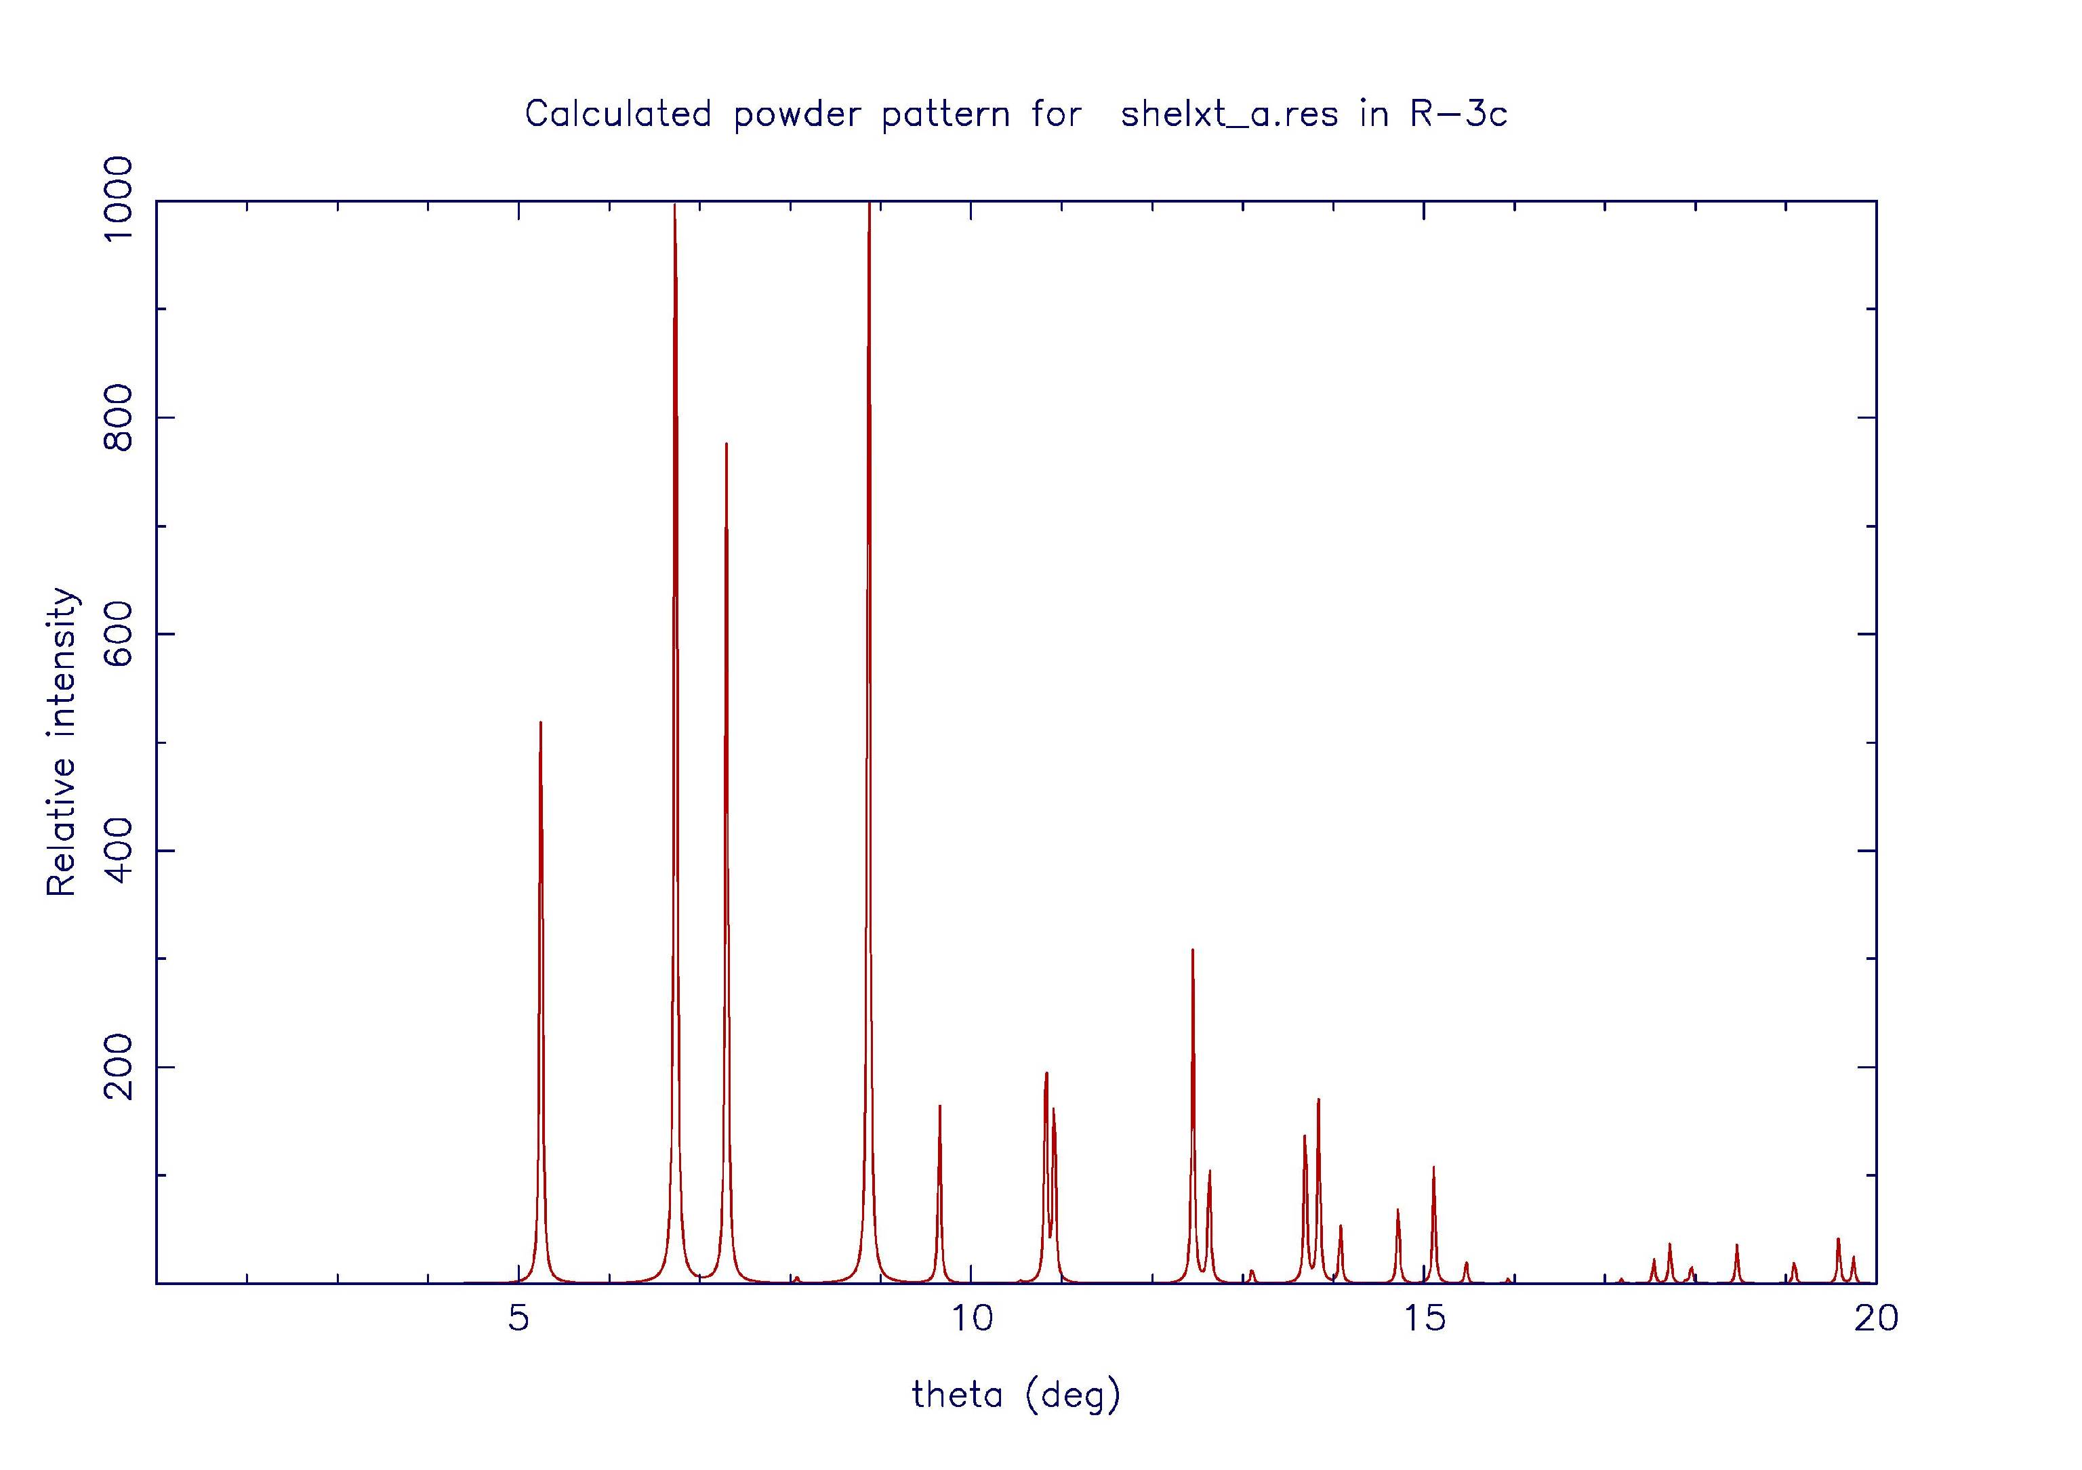
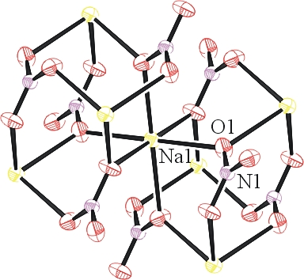.

Table 1: Crystallographic data for the structures provided.
Empirical formula N3 Na3 O9
Formula weight 255.00
Temperature 294(2) K
Wavelength 0.71073 Å
Crystal system Trigonal
Space group R -3 c :H
Unit cell dimensions a = 5.0602(4) Å α= 90°.
b = 5.0602(4) Å β= 90°.
c = 16.7829(15) Å γ = 120°.
Volume 372.16(7) Å3
Z 2
Density (calculated) 2.276 Mg/m3
Absorption coefficient 0.376 mm-1
F(000) 252
Crystal size 0.210 x 0.110 x 0.040 mm3
Theta range for data collection 5.249 to 28.260°.
Index ranges -6<=h<=6, -6<=k<=6, -22<=l<=22
Reflections collected 981
Independent reflections 108 [R(int) = 0.0954]
Completeness to theta = 25.242° 100.0 %
Refinement method Full-matrix least-squares on F2
Data / restraints / parameters 108 / 0 / 11
Goodness-of-fit on F2 1.182
Final R indices [I>2sigma(I)] R1 = 0.0284, wR2 = 0.0578
R indices (all data) R1 = 0.0302, wR2 = 0.0609
Extinction coefficient 0.087(16)
Largest diff. peak and hole 0.200 and -0.355 e.Å-3

Bruker (2007) APEX2 (Version 2.1-4), SAINT (version 7.34A), SADABS (version 2007/4), BrukerAXS Inc, Madison, Wisconsin, USA.
(a) Sheldrick GM. (2008) A short history of SHELX. Acta Cryst. A64, 112-122. (b) Sheldrick GM. (2015) SHELXT - Integrated space-group and crystal-structure determination. Acta Cryst. A71, 3-8.
(a) Altomare A, Burla C, Camalli M, Cascarano G L, Giacovazzo C, Guagliardi A, Moliterni AGG, Polidori G, Spagna R. (1999) SIR97: a new tool for crystal structure determination and refinement Journal of Applied Crystallography, 32, 115-119. (b) Altomare A, Cascarano G L, Giacovazzo C, Guagliardi A. (1993) Completion and refinement of crystal structures with SIR 92. Journal of Applied Crystallography, 26, 343-350.
(a) Sheldrick GM. (1997) SHELXL-97, Program for the Refinement of Crystal Structures. University of Göttingen, Germany. (b) Sheldrick GM. (2015) Crystal structure refinement with SHELXL. Acta Cryst. C71, 3–8
Waasmaier, D.; Kirfel, A. (1995) New Analytical Scattering Factor Functions for Free Atoms and Ions. Acta Crystallographica A., 51, 416-430.
Farrugia LJ. (1997) Ortep-3 for Windows. Journal of Applied Crystallography, 30, 565

