Crystal Structure Report for A. Velian
by Dylan Rogers & Werner Kaminsky
Sample Submitted by Jon Kephart
ID – JAK_483
X-ray Crystallography Laboratory
University of Washington
31. July 2026

Data Collection started: 9/28/2020
Documentation finished: 10/8/2020

Data backup accessibly through http:
URL: http://cad4.cpac.washington.edu/structures

W.Kaminsky: tel. (206) 543 7585
(x-ray lab): tel. (206) 543 0210
Email: kaminsky@chem.washington.edu

Understanding crystallographic information is not trivial. If you discuss a structure in a publication, please let the crystallographers proof-read the final draft of that manuscript before you submit it.
For many structures it is true that crystallography is an intellectual performance (like synthesis or elucidation of mechanisms) and not a routine job. In these cases, particularly when the structures contribute significantly to the content of the publication, the crystallographers should be co-authors.
A black prism, measuring 0.25 x 0.24 x 0.24 mm³ was mounted on a loop with oil. Data was collected at -183ºC on a Nonius Kappa CCD FR590 single crystal X-ray diffractometer, Mo-radiation.

Crystal-to-detector distance was 40 mm and exposure time was 20 seconds per degree for all sets. The scan width was 1º. Data collection was 98.9% complete to 25º in ϑ. A total of 50456 merged reflections were collected covering the indices, -76<=h<=68, -18<=k<=18, 0<=l<=39. 25795 reflections were symmetry independent and the low R_{int} = 0.0345 indicated that the data was excelleny. Indexing and unit cell refinement indicated a triclinic lattice. The space group was found to be C 2/c (No. 15).

The data was integrated and scaled using SAINT, SADABS within the APEX2 software package by Bruker.

Solution by direct methods (SHELXT or SIR) produced a complete heavy atom phasing model consistent with the proposed structure. The structure was completed by difference Fourier synthesis with SHELXL., Scattering factors are from Waasmair and Kirfel. Hydrogen atoms were placed in geometrically idealised positions and constrained to ride on their parent atoms with C---H distances in the range 0.95-1.00 Angstrom. Isotropic thermal parameters U_{eq} were fixed such that they were 1.2U_{eq} of their parent atom Ueq for CH's and 1.5U_{eq} of their parent atom U_{eq} in case of methyl groups. All non-hydrogen atoms were refined anisotropically by full-matrix least-squares.

The contribution of disordered THF, pentane, or ether solvent molecules to the diffraction pattern was removed with SQUEEZE (1911eV in two voids).
Overall, an ISOR for carbons, and nitrogen, to prevent non-positive definite displacement matrices, and a DELU command including carbons, nitrogen and phosphorous were needed relating the displacement parameters along bonds, and 200 bad reflections were removed. A second, very faint, Se-Co cluster was folded into the refined one, which is observed in some notable rest electron density and a slightly elevated R1, possibly because of chemical disorder. Twinning was not detected.

The structure is of high quality and ready for publication. Table 1 summarizes the data collection details. Figure 1 shows an ORTEP of the asymmetric unit.

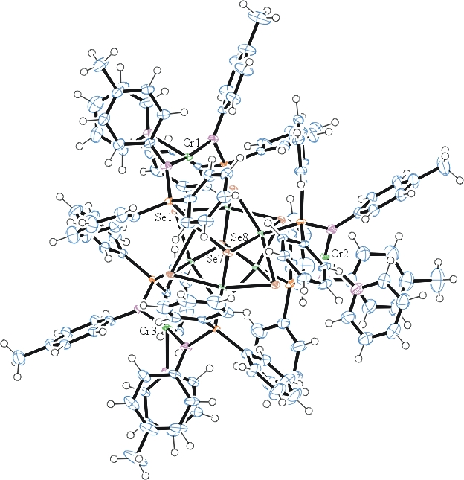
Figure 1. ORTEP of the structure with thermal ellipsoids at the 50% probability level.

Table 1: Crystallographic data for the structures provided.
Empirical formula C129 H117 Co6 Cr3 N9 P6 Se8
Formula weight 3120.39
Temperature 90(2) K
Wavelength 0.71073 Å
Crystal system Monoclinic
Space group C 2/c
Unit cell dimensions a = 64.501(9) Å α= 90°.
b = 15.308(2) Å β= 116.246(6)°.
c = 33.309(4) Å γ = 90°.
Volume 29499(7) Å3
Z 8
Density (calculated) 1.405 Mg/m3
Absorption coefficient 2.953 mm-1
F(000) 12400
Crystal size 0.250 x 0.240 x 0.240 mm3
Theta range for data collection 0.704 to 25.027°.
Index ranges -76<=h<=68, -18<=k<=18, 0<=l<=39
Reflections collected 50456
Independent reflections 25795 [R(int) = 0.0345]
Completeness to theta = 25.000° 98.9 %
Refinement method Full-matrix least-squares on F2
Data / restraints / parameters 25795 / 1182 / 1456
Goodness-of-fit on F2 1.060
Final R indices [I>2sigma(I)] R1 = 0.0790, wR2 = 0.1904
R indices (all data) R1 = 0.0943, wR2 = 0.1984
Largest diff. peak and hole 5.035 and -1.265 e.Å-3

Bruker (2007) APEX2 (Version 2.1-4), SAINT (version 7.34A), SADABS (version 2007/4), BrukerAXS Inc, Madison, Wisconsin, USA.
Sheldrick GM. (2015) SHELXT - Integrated space-group and crystal-structure determination. Acta Cryst. A71, 3-8.
(a) Altomare A, Burla C, Camalli M, Cascarano G L, Giacovazzo C, Guagliardi A, Moliterni AGG, Polidori G, Spagna R. (1999) SIR97: a new tool for crystal structure determination and refinement Journal of Applied Crystallography, 32, 115-119. (b) Altomare A, Cascarano G L, Giacovazzo C, Guagliardi A. (1993) Completion and refinement of crystal structures with SIR 92. Journal of Applied Crystallography, 26, 343-350.
(a) Sheldrick GM. (1997) SHELXL-97, Program for the Refinement of Crystal Structures. University of Göttingen, Germany. (b) Sheldrick GM. (2015) Crystal structure refinement with SHELXL. Acta Cryst. (2015). C71, 3–8
Mackay, S.; Edwards, C.; Henderson, A.; Gilmore, C.; Stewart, N.; Shankland, K.; Donald, A. (1997) MaXus: a computer program for the solution and refinement of crystal structures from diffraction data. University of Glasgow, Scotland,.
Waasmaier, D.; Kirfel, A. Acta Crystallogr. A. 1995, 51, 416.
(a) A. Spek, J. Appl. Cryst. (2003), 36, 7-13; (b) P. van der Sluis & A. L. Spek, Acta Cryst. (1990). A46, 194-201. (c) Spek, A. L. (2009). Acta. Cryst. D65, 148-155.
Farrugia, L. J. Appl. Cryst. 1997, 30, 565

